
Cumulative #3
Back-End

April 18, 2025
Name: Parjad

Update Course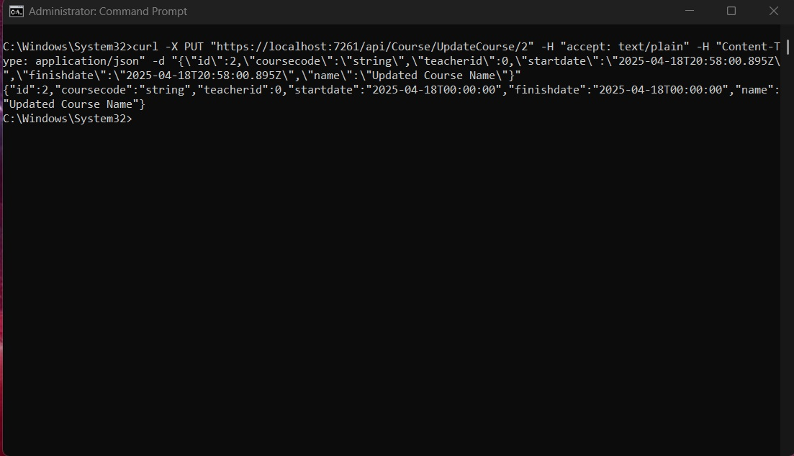

Update student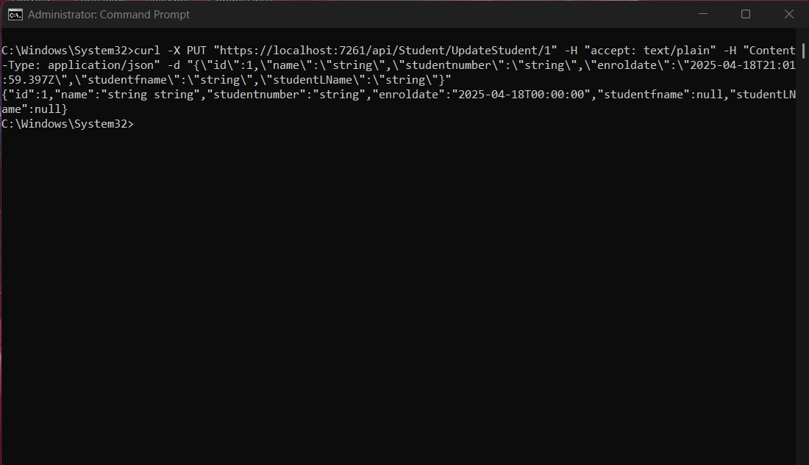

Update Teacher

