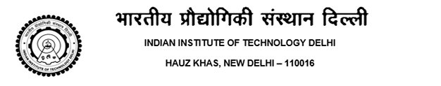

No.: IITD/ACAD(Bon-Cert)/2025 Date: 11/01//2025

NO-OBJECTION CERTIFICATE

This is to certify that ..Name …. Entry No. ………, S/o Mr. Brijesh Vohra and Mrs. Sonia Vohra, is a bonafide student of the 4-Year B.Tech. program in Textile Technology during the academic year 2022-23 at this Institute.

This certificate states that this Institute has no objections to the consideration of the application for University of Birmingham, UK during the summer vacation i.e. the period from 5th June to 31st July 2022 for Internship subjected to adhering to the academic schedule.
In this context, the following may be noted:
- The internship is not a requirement for a degree in IIT Delhi. The internship may help the student in earning Non-Graded Units required for graduation.
- IIT Delhi is permitting internships in the Summer of 2023 during the said period.
- IIT Delhi has no liability for the internship, and all travel requirements including insurance need to be arranged by the student.

AAO./A.R. (Academics)

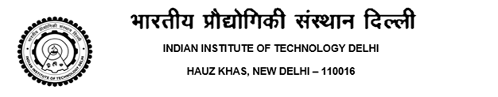

No.: IITD/ACAD(Bon-Cert)/2025 Date: 01/01/2025

BONA FIDE CERTIFICATE

This is to certify that ..Name …. Entry No. ………, S/o Mr. Brijesh Vohra and Mrs. Sonia Vohra, is a bonafide student of the 4-Year B.Tech. program in Textile Technology during the academic year 2022-23 at this Institute. . The programme began in the academic year 2021-22 and the student is currently in second year of study.

This certificate is being issued at his own request for submission to German High Commission for Visa Application.
AAO./A.R. (Academics)



No.: IITD/ACAD(Bon-Cert)/2025 Date: 11/01//2025

BONA FIDE CERTIFICATE

This is to certify that ..Name …. Entry No. ………, S/o Mr. Brijesh Vohra and Mrs. Sonia Vohra, is a bonafide student of the 4-Year B.Tech. program in Textile Technology during the academic year 2024-25 at this Institute.

This certificate is being issued at his own request for submission to Passport Office for Passport Application.
AAO./A.R. (Academics)

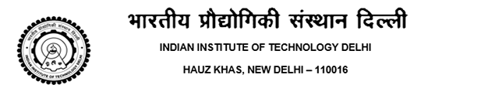

No.: IITD/ACAD(Bon-Cert)/2025 Date: 11/01//2025

CERTIFICATE

This is to certify that Mr Akash Suryawanshi 2019CS50416 S/O Mr. Shailendra Suryawanshi and Mrs. Smita Suryawanshi is a bonafide student of the 5-year B.Tech + M.Tech Dual Degree. programme in Computer Science during the academic year 2021-2022 at this Institute.

This certificate is being issued to the student at his/her own request for submission to NTSE office that ‘W’ grade has no effect on the CGPA of the student for NTSE Scholarship.

AAO./A.R. (Academics)



No.: IITD/ACAD(Bon-Cert)/2025 Date: 11/01//2025

CERTIFICATE

This is to certify that Mr. Name.. Entry No. --------------S/o Mr. Amit Chopra is a bonafide student of the 4-Year B.Tech. program in Textile Technology during the academic year 2022-23 at this Institute.

Fees paid by the student in the academic year of 2022 - 2023 is as under:
Semester | Tuition Fee | Other Charge | Total
1st Sem. | Rs. 100000/- | ----------------- | Rs. 100000/-
2nd Sem. | Rs. 100000/- | ---------------- | Rs. 100000/-

This certificate is being issued to the student at his own request for submission to Income Tax Office for Income Tax Rebate.

AAO./A.R. (Academics)



No.: IITD/ACAD(Bon-Cert)/2025 Date: 02/12/2025

BONA FIDE CERTIFICATE

This is to certify that Mr. Harsh Agrawal Entry No. 2019CS10431 S/O Mr. Shriniwas Agrawal and Mrs.Sulekha Agrawal is a bonafide student of the 4-year B.Tech. programme in Computer Science and Engineering during the academic year 2022-2023 at this Institute. The programme began in the academic year 2021-22 and the student is currently in second year of study.

This certificate is being issued at his own request for submission to German High Commission for Visa Application.
AAO./A.R. (Academics)



No.: IITD/ACAD(Bon-Cert)/2025 Date: 11/01//2025

CERTIFICATE

This is to certify that Mr. Name.. Entry No. --------------S/o Mr. Amit Chopra is a bonafide student of the 4-Year B.Tech. program in Textile Technology during the academic year 2022-23 at this Institute.

Fees paid by the student in the academic year of 2022 - 2023 is as under:
Semester | Tuition Fee | Other Charge | Total
1st Sem. | Rs. 100000/- | ----------------- | Rs. 100000/-
2nd Sem. | Rs. 100000/- | ---------------- | Rs. 100000/-

This certificate is being issued to the student at his own request for submission to MVVY for Outside Scholarship.

AAO./A.R. (Academics)

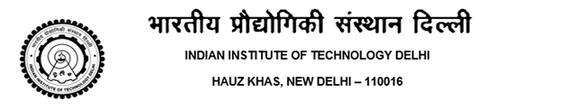
No.: IITD/ACAD(Bon-Cert)/2025 Date: 17/01/2025

Education Loan Certificate
This is to certify that Ms. Niharika ,Entry No. 2024CS50135 D/o Mr. Shiv Kumar Jha and Mrs. Madhu Rani Jha is a bonafide student of the 5-year Dual Degree (B.Tech.+M.Tech) programme in Computer Science and Engineering during the academic year 2024-2025 at this Institute.
Course Details:
- Program: [Dual Degree (B.Tech.+M.Tech)]
- Duration: 5-[Year]
- Commencement Date: [24-07-2024]
- Expected Completion of Graduation Requirements [ Date: 30/04/2029]
Estimeated Fee payable by the student for the course duration of 4 years:
Academic year | Tuition Fee | Other Charge | Total
1st Sem. 2024-25 | Rs.0/- | Rs.14400/- | Rs.14400/-
2nd Sem. 2024-25 | Rs.0/- | Rs.14350/- | Rs.14350/-
1st Sem. 2025-26 | Rs.0/- | Rs.14850/- | Rs.14850/-
2nd Sem. 2025-26 | Rs.0/- | Rs.14350/- | Rs.14350/-
1st Sem. 2026-27 | Rs.0/- | Rs.14850/- | Rs.14850/-
2nd Sem. 2026-27 | Rs.0/- | Rs.14350/- | Rs.14350/-
1st Sem. 2027-28 | Rs.0/- | Rs.14850/- | Rs.14850/-
2nd Sem. 2027-28 | Rs.0/- | Rs.14350/- | Rs.14350/-

This certificate is being issued to the student at his/her own request for availing Education Loan.

AAO./A.R. (Academics)

Disclaimer:Please note that [IIT Delhi] is not responsible for any financial obligations arising from the education loan or any other financial arrangements made by the student. All transactions, repayments, and interactions related to the loan are the sole responsibility of the student and their guarantor. The Institute provides this certificate solely for the purpose of assisting the student in applying for an education loan and makes no guarantees or assumptions regarding the terms and conditions of the loan.


No.: IITD/ACAD(Bon-Cert)/2025 Date: 02/01/2025

Education Loan Certificate

This is to certify that Ms. Niharika ,Entry No. 2024CS50135 D/o Mr. Shiv Kumar Jha and Mrs. Madhu Rani Jha is a bonafide student of the 4-year Degree B.Tech. programme in Computer Science and Engineering during the academic year 2024-2025 at this Institute.
Course Details:
- Program: [B.Tech.]
- Duration: 4-[Year]
- Commencement Date: [24-07-2024]
- Expected Completion of Graduation Requirements [ Date: 30/04/2028]
Fee Estimates (Approx.) payable by the student for the course duration of 4 years:
Academic year | Tuition Fee | Other Charge | Total
1st Sem. 2024-25 | Rs.100000/- | Rs.14350/- | Rs.114350/-
2nd Sem. 2024-25 | Rs.100000/- | Rs.14350/- | Rs.114350/-
1st Sem. 2025-26 | Rs.100000/- | Rs.14350/- | Rs.114350/-
2nd Sem. 2025-26 | Rs.100000/- | Rs.14350/- | Rs.114350/-
1st Sem. 2026-27 | Rs.100000/- | Rs.14350/- | Rs.114350/-
2nd Sem. 2026-27 | Rs.100000/- | Rs.14350/- | Rs.114350/-
1st Sem. 2027-28 | Rs.100000/- | Rs.14350/- | Rs.114350/-
2nd Sem. 2027-28 | Rs.100000/- | Rs.14350/- | Rs.114350/-

This certificate is being issued to the student at his/her own request for availing Education Loan.

AAO./A.R. (Academics)

Disclaimer:
Please note that [IIT Delhi] is not responsible for any financial obligations arising from the education loan or any other financial arrangements made by the student. All transactions, repayments, and interactions related to the loan are the sole responsibility of the student and their guarantor. The Institute provides this certificate solely for the purpose of assisting the student in applying for an education loan and makes no guarantees or assumptions regarding the terms and conditions of the loan.

