
COMSATS University Islamabad, Attock campus Department of Computer Science
Program: BS-SE
Course: Information System(lab)

Name: Sumbal

Reg No: Sp24-BSE-058

Date: 14, October, 2025

Submitted to: Ma’am Ambreen Gul

Transposition Cipher Assignment

1) Handle Different Key Sizes
The encode function pads the plaintext so its length becomes a multiple of the key length. This ensures every column in the transposition grid is filled. The padding character is 'X' by default.

2) Decode Function
A decode function is implemented that reverses the columnar transposition process. It reconstructs the grid based on the key order and returns the original plaintext.

3) Support for Uppercase and Lowercase Letters
The cipher preserves case by not altering the input text. Uppercase and lowercase letters remain unchanged.

4) Encrypt Full Sentences with Spaces
Spaces and punctuation are treated as normal characters. They are preserved during encryption and decryption.

5) Dynamic Key Generation
If the user does not provide a key, a random numeric key (a shuffled permutation) is automatically generated based on the plaintext length.

6) Menu Interface
A simple command-line menu allows the user to choose between encoding, decoding, running a demo, or exiting. This makes testing and usage more convenient.

Full Python Code
import random
import sys

# ---------- Helper Functions ----------

def make_order_from_key(key):
"""
Create column order based on sorted key.
Example: key = '3214' -> order = [2, 0, 1, 3]
"""
enumerated = list(enumerate(key))
sorted_by_char = sorted(enumerated, key=lambda x: (x[1], x[0]))
return [orig_index for orig_index, _ in sorted_by_char]

def pad_plaintext(plaintext, key_len, pad_char='X'):
"""
Pad plaintext so its length is a multiple of key length.
"""
remainder = len(plaintext) % key_len
if remainder == 0:
return plaintext
needed = key_len - remainder
return plaintext + pad_char * needed

# ---------- Encode Function ----------

def encode(key, plaintext, pad_char='X'):
"""
Encode plaintext using columnar transposition cipher.
If key is not given, generate a random one.
"""
if not key:
key_len = max(2, min(len(plaintext), 10))
perm = list(range(1, key_len + 1))
random.shuffle(perm)
key = ''.join(str(x) for x in perm)

key_len = len(key)
plaintext = pad_plaintext(plaintext, key_len, pad_char)
rows = [plaintext[i:i + key_len] for i in range(0, len(plaintext), key_len)]
order = make_order_from_key(key)

ciphertext = ''
for col_index in order:
for row in rows:
ciphertext += row[col_index]

return ciphertext, key

# ---------- Decode Function ----------

def decode(key, ciphertext, pad_char='X'):
"""
Decode ciphertext using the same key.
"""
key_len = len(key)
n_rows = len(ciphertext) // key_len
order = make_order_from_key(key)

cols = [None] * key_len
pos = 0
for idx in range(key_len):
col_idx = order[idx]
cols[col_idx] = ciphertext[pos:pos + n_rows]
pos += n_rows

rows = []
for r in range(n_rows):
row_chars = [cols[c][r] for c in range(key_len)]
rows.append(''.join(row_chars))

plaintext = ''.join(rows).rstrip(pad_char)
return plaintext

# ---------- Menu Interface ----------

def menu():
print("\n--- Transposition Cipher Program ---")
while True:
print("\nChoose an option:")
print("1) Encode a message")
print("2) Decode a message")
print("3) Demo Example")
print("4) Exit")

choice = input("Enter your choice: ")

if choice == '1':
key = input("Enter key (press Enter for random key): ")
plaintext = input("Enter your plaintext: ")
ciphertext, used_key = encode(key, plaintext)
print("\nEncrypted Message:", ciphertext)
print("Key used:", used_key)

elif choice == '2':
key = input("Enter key used for encryption: ")
ciphertext = input("Enter ciphertext: ")
try:
plaintext = decode(key, ciphertext)
print("\nDecrypted Message:", plaintext)
except Exception as e:
print("Error:", e)

elif choice == '3':
key = "3214"
plaintext = "HELLO WORLD"
print("\nDemo Encoding:")
ct, k = encode(key, plaintext)
print("Plaintext:", plaintext)
print("Key:", k)
print("Ciphertext:", ct)
print("\nDecoding Back:", decode(k, ct))

elif choice == '4':
print("Exiting program...")
break

else:
print("Invalid option! Try again.")

# ---------- Run Program ----------

if __name__ == "__main__":
menu()

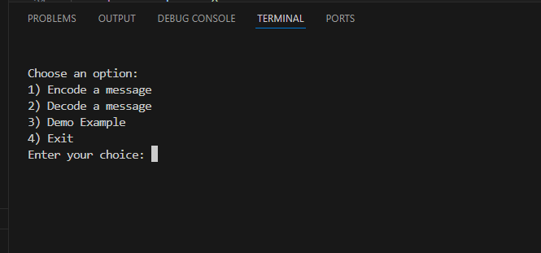
Output Screen Shot 1:

Output Screen Shot 2:
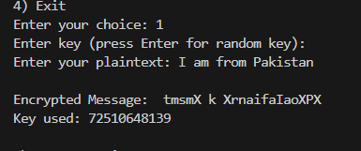
Output Screen Shot 3:
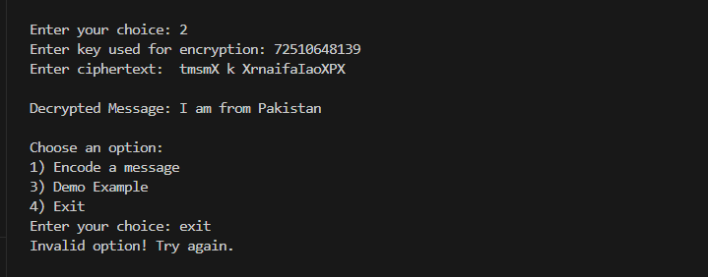
Output Screen Shot 4:
