**Graphical User Interface of MLScratching**

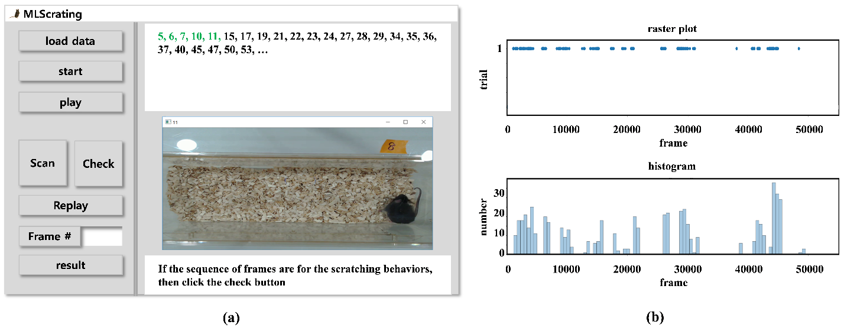

**Figure.** (a) Graphical user interface and (b) an example of an output generated when a user clicks the button ‘result’ in the Management window. The output could be a raster plot showing a comparison of the events of scratching in the time domain (frame number) for one or more sample data (top), in which the axis of the time domain can be zoomed in and out. The output can also be extended by being able to convert a data in the raster plot into a histogram representing the frequencies or rates of occurrence of scratching behaviors in time bins when the user chooses it by double clicking on the raster plot (bottom).

The interface system consists of four windows of Management, Frame Detection, Play and Session as shown in Figure (a). The Management window (left panel) is for loading a data file, starting detections by applying our method to the loaded data, scanning and checking manually the detected frames, showing and saving the results. The Frame Detection window (right top panel) shows the frame numbers detected in ascending order. A user can scan  consecutive frames including additional  frames before and after each of the detected frames, by setting the number  in the text edit box beside the button ‘Frame #’ and then clicking the button ‘Scan’ in the Management window. If the detected frame belongs to a sequence of scratching frame, the user can add it as one of real scratching frames by clicking the button ‘Check’ in the Management window. The numbers of frames scanned or scanning are updated to be differentially displayed in the Frame Detection window. If the subsequent detected frames are inclusively scanned in the previous scanning, then they are skipped for the next scanning. A user can replay all the frames scanned and/or checked at any time as well as after all the detected frames have been scanned and/or checked. The user can also use the cursor ‘right’, ‘left’, and ‘down’ keys on the keyboard instead of the buttons ‘Scan’, ‘Check’, and ‘Replay’ in the Management window, respectively. The Play window (right middle panel) is for playing all the frames of the loaded data during detections using the method, playing consecutive frames during scanning, or replaying scanned and checked frames. The Session window (right bottom panel) shows messages on errors occurring or gives the user comments on the status of the current or next processing. Figure (b) shows an example of an output generated when a user clicks the button ‘result’ in the Management window.