**Graphical User Interface of MLScratching**

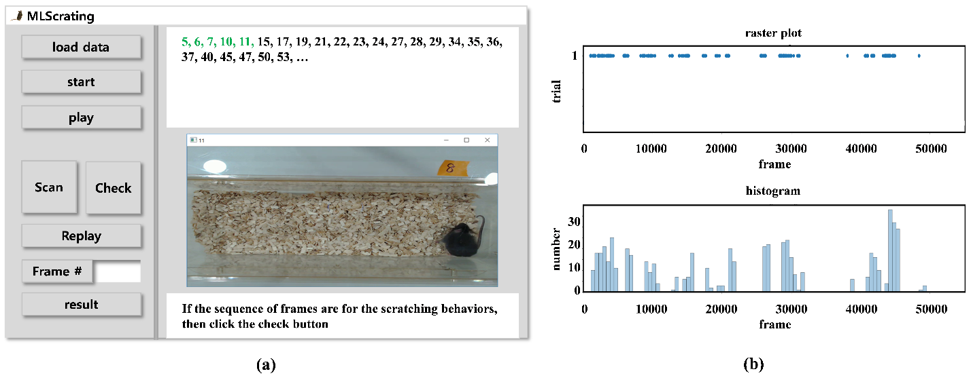

**Figure.** (a) Graphical user interface and (b) an example of an output generated when a user clicks the button ‘result’ in the Management window. The output could be a raster plot showing a comparison of the events of scratching in the time domain (frame number) for one or more sample data (top), in which the axis of the time domain can be zoomed in and out. The output can also be extended by being able to convert a data in the raster plot into a histogram representing the frequencies or rates of occurrence of scratching behaviors in time bins when the user chooses it by double clicking on the raster plot (bottom).

The interface system consists of four windows of Management, Frame Detection, Play and Session as shown in Figure (a). The Management window (left panel) is for loading a data file, starting detections by applying our method to the loaded data, scanning and checking manually the detected frames, showing and saving the results. The Frame Detection window (right top panel) shows the frame numbers detected in ascending order. A user can scan  consecutive frames including additional  frames before and after each of the detected frames, by setting the number  in the text edit box beside the button ‘Frame #’ and then clicking the button ‘Scan’ in the Management window. If the detected frame belongs to a sequence of scratching frame, the user can add it as one of real scratching frames by clicking the button ‘Check’ in the Management window. The numbers of frames scanned or scanning are updated to be differentially displayed in the Frame Detection window. If the subsequent detected frames are inclusively scanned in the previous scanning, then they are skipped for the next scanning. A user can replay all the frames scanned and/or checked at any time as well as after all the detected frames have been scanned and/or checked. The user can also use the cursor ‘right’, ‘left’, and ‘down’ keys on the keyboard instead of the buttons ‘Scan’, ‘Check’, and ‘Replay’ in the Management window, respectively. The Play window (right middle panel) is for playing all the frames of the loaded data during detections using the method, playing consecutive frames during scanning, or replaying scanned and checked frames. The Session window (right bottom panel) shows messages on errors occurring or gives the user comments on the status of the current or next processing. Figure (b) shows an example of an output generated when a user clicks the button ‘result’ in the Management window.

**How to use the GUI**

1. Download the .zip file and unzip all files in a directory, in which two .dll files should be in the same directory with MLScratching.exe.

Files in the .zip file:

* ReadmeGUI.docx – Summary and usage of the GUI
* MLScratching.exe – GUI executable file
* opencv_ffmpeg341.dll – openCV dll
* opencv_ffmpeg341_64.dll – openCV dll
* Input_Video(2min).mp4 – a short version (2min recording) to test the GUI
* Input_Video.mp4 – a full version to test the GUI

1. Click MLScratching.exe then the GUI will be displayed.
2. Then, load data by using the button “Load Data” in the top left of the GUI. If you click the button “Load Data”, a window will be open, where an input data (.mp4) could be loaded.
3. Next, Start the processing by using the button “Start” below the button “Load Data”.

The input data (mp4) will be played while the processing is going on.

The processing time will be depended on the recording time of the input data.

When the processing is done, then the player will be disappeared. And the detected frames will be listed in the edit box “Detected Frames” in the top right of the GUI.

The performance of the method proposed in this paper was based on the Frames listed in the edit box “Detected Frames”.

1. Next, scan the frames one by one using the button “Scan” and check it using the button “Check” if the frame just scanned is of scratching. The buttons “Scan” and “Check” are below the button “Start”.

This scan and check is to select True Positives from the detected frames.

Scanning a frame is playing  consecutive frames including additional  frames before and after the frames, where the default value of  is set to 2.

Checking a frame is to registered the frame just scanned as one of the True Positives.

1. After all the scan and check is done, save the result using the button “Result” in the bottom left of the GUI. Clicking the button “Result” will display a window to set a folder to save files of the result.

The files of the result include a .csv file for all the detected frames, another .csv file for all the checked frames, and a .png file of a raster and a histogram graphs for the checked frames.

The result with all the detected frame numbers as well as all the checked frame numbers will be saved in a .csv file along with a raster and histogram graph of the checked frames.

### Using the key “q”, the processing can be halted in the middle of playing the input data.