Software Requirements Specification (SRS)
Vehicle Parking System
A system for managing parking slots and vehicle tracking
Technology: JavaScript (MERN Stack)

Field | Value
Project | Vehicle Parking System
Problem Statement | A system for managing parking slots and vehicle tracking
Technology | JavaScript — MERN Stack
Version | 1.0
Submitted by | Team 5
Date | 28-09-2026
Status | Final Submission

Revision history
Version | Date | Author | Change Summary | Approval
1.0 | 28-09-2026 | Team 5 | Final baseline aligned with SRS, SAD and Test Plan | Course Coordinator / Evaluator

Approvals
Role | Name | Signature / Date
Course Coordinator
Project Team Lead | Team 5
Project Evaluator

Table of Contents
1. Introduction
2. Overall description
3. External interface requirements
4. System features (detailed)
5. Non-functional requirements (detailed)
6. Quality attributes & Acceptance tests
7. System models and diagrams
8. Requirements Traceability Matrix (RTM)

1. Introduction

1.1 Purpose
This Software Requirements Specification (SRS) defines the functional, non-functional, interface and security requirements for the Vehicle Parking System (VPS). It is the requirements baseline for implementation, the Software Architecture and Design Specification (SAD), and the Software Test Plan (STP). Each baseline requirement is uniquely identified and includes verification information.

1.2 Scope
The VPS is a web-based MERN application for managing parking slots and tracking vehicles within a parking facility. The baseline supports user registration and authentication, vehicle registration and management, slot configuration and availability, vehicle entry and exit, active-vehicle tracking and search, parking history, administrative monitoring and audit logging. Dedicated parking hardware, payment processing, payment gateways and reservation management are outside the baseline scope.

1.3 Audience
- Development and implementation team
- Software architecture/design team
- Software testing and QA team
- Project guide, course coordinator and evaluators
- Team members responsible for maintenance and deployment

1.4 Definitions
Term / Acronym | Definition
VPS | Vehicle Parking System
MERN | MongoDB, Express.js, React and Node.js
UI | User Interface
API | Application Programming Interface
RBAC | Role-Based Access Control
FR / NFR / SR | Functional / Non-functional / Security Requirement
RTM | Requirements Traceability Matrix
Parking Slot | A designated parking position managed by the system
Parking Session | A record of a vehicle’s active or completed parking period
Vehicle Tracking | Recording and retrieving the current or historical parking status/location of a vehicle

2. Overall description

2.1 Product perspective
The VPS follows a client-server model. The React web client communicates with a Node.js/Express.js REST API. Application services enforce business rules and authorization, data-access components isolate persistence, and MongoDB stores users, vehicles, parking slots, parking sessions and audit records.

2.2 Major product functions (detailed)
- Create accounts and authenticate users
- Register and update vehicles owned by an authenticated user
- Create and configure parking slots
- Display current slot availability and status
- Identify an available slot during vehicle entry
- Create and close parking sessions
- Maintain the occupied/available state of slots consistently with sessions
- Search active vehicles and determine their current slots
- Provide permitted parking history
- Provide administrative occupancy and active-vehicle monitoring
- Record security-sensitive and administrative audit events

2.3 User roles and characteristics (expanded)
Role | Characteristics / Responsibilities
Vehicle Owner / User | Uses browser-based functions to register vehicles, view permitted availability/current-slot information and access own parking history.
Parking Staff | Performs operational entry/exit, slot allocation/release and active-vehicle search.
Parking Administrator | Configures parking slots, monitors occupancy and active vehicles, manages operational records and reviews audit information.

2.4 Operating environment
Layer | Environment
Client | Modern desktop/laptop/tablet browser; React web UI
Application | Node.js with Express.js REST API
Database | MongoDB
Network | HTTP/HTTPS for client-server communication; HTTPS required in production
Development/Test | JavaScript/Node.js tooling, test database and supported browsers

2.5 Constraints
- The implementation shall use JavaScript and the MERN Stack.
- Protected functions shall require authentication and role authorization.
- Parking slot state and active parking-session state shall remain consistent.
- Persistent user, vehicle, slot, session and audit records shall be maintained in MongoDB.
- Baseline scope shall not assume payment, reservation or dedicated hardware integration.

2.6 Assumptions and dependencies
- Users have access to a supported browser and network connection.
- MongoDB is reachable by the backend during normal operation.
- Role information is maintained securely by the backend.
- The Test Plan uses the SRS requirement IDs as its verification baseline.
- Future hardware/payment/reservation extensions require an approved requirements change.

2.7 Business rules
ID | Business rule
BR-001 | A user may view or modify only vehicles and parking history permitted for that user.
BR-002 | A vehicle registration number shall uniquely identify an active vehicle record.
BR-003 | A parking slot shall have one operational state: Available, Occupied or Unavailable.
BR-004 | Only a slot in Available state may be allocated to a vehicle entry.
BR-005 | A valid vehicle entry creates exactly one active parking session for that vehicle.
BR-006 | A successful entry changes the allocated slot from Available to Occupied.
BR-007 | A valid exit closes the corresponding active parking session and stores an exit timestamp.
BR-008 | A successful exit changes the session’s slot from Occupied to Available.
BR-009 | A vehicle shall not have more than one active parking session at the same time.
BR-010 | Only Parking Administrators may create or change parking-slot configuration/status where the SRS assigns administrative control.
BR-011 | Security-sensitive and administrative actions shall generate auditable events without storing passwords or authentication secrets.

2.8 Validation rules
ID | Validation rule
VR-001 | Required identity, contact, vehicle and slot fields shall not be empty.
VR-002 | User contact/email values shall conform to the application’s accepted format.
VR-003 | Vehicle registration identifiers shall conform to the application’s accepted vehicle-number format.
VR-004 | Vehicle registration identifiers shall be unique for active records.
VR-005 | Parking-slot identifiers shall be unique within the facility.
VR-006 | Slot status shall be one of Available, Occupied or Unavailable.
VR-007 | An entry request shall reference a registered vehicle.
VR-008 | An entry request shall reference an Available slot.
VR-009 | An entry request shall be rejected when the vehicle already has an active session.
VR-010 | An exit request shall reference an existing active parking session.
VR-011 | Exit time shall not precede entry time.
VR-012 | Unauthorized role operations shall be rejected without state modification.
VR-013 | Search inputs shall be validated before database queries are executed.
VR-014 | Error responses shall not expose passwords, tokens, stack traces or internal database details.

3. External interface requirements

3.1 User interfaces
- Role-specific login and dashboard views.
- Vehicle registration/update forms with validation feedback.
- Parking-slot inventory and availability view.
- Vehicle entry and exit forms for Parking Staff.
- Active-vehicle search and current-slot display.
- Parking-history view for permitted users.
- Administrative occupancy, monitoring and audit views.
- Readable success, validation and error messages without exposing internal details.

3.2 Hardware interfaces
No dedicated parking hardware is required by the baseline problem statement. RFID readers, ANPR cameras, IoT sensors, boom barriers and other physical interfaces are explicitly outside the baseline. If introduced later, each interface shall be specified as an approved requirements change.

3.3 Software interfaces
Interface | Purpose | Data / Protocol
React Web Client | User interaction and presentation | JSON over REST/HTTP(S)
Express.js REST API | Authentication, authorization and business operations | HTTP(S), JSON
Authentication / Authorization | Credential verification and RBAC | Protected API requests
MongoDB | Persistent application data | MongoDB driver / repository layer
Audit service | Security-sensitive and administrative event records | Structured audit documents

3.4 Communications
- The client and backend shall communicate through RESTful HTTP APIs.
- Production credentials and authenticated traffic shall use HTTPS/TLS.
- API responses shall use structured JSON for successful and error responses.
- Authentication information shall not be sent over plaintext HTTP in production.

4. System features (detailed)

4.1 User Management and Authentication
Req ID | Requirement (shall...) | Type | Priority | Stakeholder | Acceptance / Test | Dependencies
VPS-F-001 | The system shall allow a new user to create an account using required identity and contact information. | Functional | High | Vehicle Owner / User | Valid data creates one account; duplicate/invalid data is rejected. | TC-F-001
VPS-F-002 | The system shall authenticate registered users using valid credentials before granting access to protected functions. | Functional | High | Vehicle Owner / User | Valid credentials create an authenticated session/token; invalid credentials are rejected. | TC-F-002

4.2 Vehicle Management
Req ID | Requirement (shall...) | Type | Priority | Stakeholder | Acceptance / Test | Dependencies
VPS-F-003 | The system shall allow an authenticated user to register a vehicle with a unique vehicle identifier/registration number. | Functional | High | Vehicle Owner / User | Valid vehicle data is stored and associated with the user; duplicate active registration is rejected. | TC-F-003
VPS-F-004 | The system shall allow an authenticated user to view and update permitted details of a registered vehicle. | Functional | Medium | Vehicle Owner / User | Authorized changes persist; unauthorized changes are rejected. | TC-F-004

4.3 Parking Slot Management
Req ID | Requirement (shall...) | Type | Priority | Stakeholder | Acceptance / Test | Dependencies
VPS-F-005 | The system shall allow a Parking Administrator to create a parking slot with a unique slot identifier and configured status. | Functional | High | Parking Administrator | Unique slot is created and appears in inventory; duplicate/non-admin creation is rejected. | TC-F-005
VPS-F-006 | The system shall allow a Parking Administrator to update a parking slot status while preserving slot/session consistency. | Functional | High | Parking Administrator | Valid changes persist; conflicting changes are rejected. | TC-F-006
VPS-F-007 | The system shall display the current status of parking slots to authorized users. | Functional | High | User / Staff / Admin | Displayed state matches the latest valid slot state. | TC-F-007
VPS-F-008 | The system shall identify available parking slots when a vehicle entry is being recorded. | Functional | High | Parking Staff | Only Available slots can be selected; non-available allocation is rejected. | TC-F-008

4.4 Vehicle Entry, Exit and Tracking
Req ID | Requirement (shall...) | Type | Priority | Stakeholder | Acceptance / Test | Dependencies
VPS-F-009 | The system shall record a vehicle entry with vehicle identifier, entry time and allocated parking slot. | Functional | High | Parking Staff | One active session is created with vehicle, slot and entry timestamp. | TC-F-009
VPS-F-010 | The system shall mark the allocated parking slot as occupied when a valid vehicle entry is recorded. | Functional | High | Parking Staff | Slot changes Available to Occupied after successful entry; failed operation leaves state unchanged. | TC-F-010
VPS-F-011 | The system shall allow authorized staff to search for an active vehicle using its registered vehicle identifier. | Functional | High | Parking Staff / Admin | Matching active vehicle returns current session and slot; no match returns an appropriate message. | TC-F-011
VPS-F-012 | The system shall provide the current parking slot associated with an actively parked vehicle. | Functional | High | User / Staff / Admin | Correct occupied slot is displayed for an active session. | TC-F-012
VPS-F-013 | The system shall record a vehicle exit with exit time for the corresponding active parking session. | Functional | High | Parking Staff | Valid exit closes the session and stores an exit timestamp. | TC-F-013
VPS-F-014 | The system shall mark the associated parking slot as available after a valid vehicle exit. | Functional | High | Parking Staff | Slot linked to completed session becomes Available. | TC-F-014
VPS-F-015 | The system shall allow an authenticated user to view the parking history of vehicles associated with that user. | Functional | Medium | Vehicle Owner / User | Only permitted vehicle history is returned with entry, exit and slot information. | TC-F-015

4.5 Monitoring and Audit
Req ID | Requirement (shall...) | Type | Priority | Stakeholder | Acceptance / Test | Dependencies
VPS-F-016 | The system shall provide administrators with an occupancy and active-vehicle monitoring view. | Functional | Medium | Parking Administrator | Displayed occupancy and active vehicles match current valid records; non-admin access is rejected. | TC-F-016
VPS-F-017 | The system shall record security-sensitive and administrative events in an audit log. | Functional | High | System / Admin | Required events contain actor, action, timestamp and result. | TC-F-017
VPS-F-018 | The system shall prevent a vehicle from having more than one active parking session at the same time. | Functional | High | System | Second entry is rejected; concurrent requests yield at most one active session. | TC-F-018

5. Non-functional requirements (detailed)
Req ID | Requirement | Category | Priority | Test
VPS-NF-001 | 95% of requests under the defined normal-load profile shall complete within 2 seconds. | Performance | High | TC-NF-001
VPS-NF-002 | The system shall provide at least 99.5% monthly availability, excluding planned maintenance. | Reliability | High | TC-NF-002
VPS-NF-003 | The system shall enforce role-based access control for Vehicle Owner/User, Parking Staff and Parking Administrator operations. | Security | High | TC-S-001 / TC-S-002
VPS-NF-004 | Entry/exit processing shall preserve one-to-one consistency between occupied slots and active parking sessions. | Data Integrity | High | TC-NF-003
VPS-NF-005 | The supported desktop browsers shall render core workflows correctly and display readable validation/error messages. | Usability / Compatibility | Medium | TC-NF-004
VPS-NF-006 | Audit records shall remain retrievable for at least one year. | Audit / Data Retention | Medium | TC-NF-005

5.1 Security

5.1.1 Security Objectives
- SO-001 — Protect user identity and authentication credentials from unauthorized access or disclosure.
- SO-002 — Ensure only authorized roles can perform protected parking and administrative operations.
- SO-003 — Preserve integrity and accountability of parking-slot, parking-session and security-sensitive records.

5.1.2 Security Requirements
Req ID | Security requirement | Type | Priority | Acceptance / Test
VPS-SR-001 | The system shall require authentication before protected functions are accessed. | Security | High | TC-S-001
VPS-SR-002 | The system shall enforce role-based authorization for User, Staff and Admin operations. | Security | High | TC-S-002
VPS-SR-003 | The production system shall use HTTPS/TLS and shall not transmit credentials over plaintext HTTP. | Security | High | TC-S-003
VPS-SR-004 | The system shall store passwords using a secure salted one-way hashing mechanism and shall not store plaintext passwords. | Security | High | TC-S-004
VPS-SR-005 | The system shall record security-sensitive and administrative events without storing passwords, tokens or authentication secrets. | Security | High | TC-S-005

6. Quality attributes & Acceptance tests
Quality Attribute | Acceptance Condition | Evidence / Test
Performance | 95% of normal-load requests complete within 2 seconds. | TC-NF-001
Reliability | Measured availability meets ≥99.5% target excluding planned maintenance. | TC-NF-002
Security | Authentication, RBAC, TLS, password protection and audit controls pass. | TC-S-001 to TC-S-005
Data Integrity | No conflicting active session/slot associations after sequential or concurrent scenarios. | TC-NF-003
Usability / Compatibility | Core workflows render correctly on supported browsers and error messages are readable. | TC-NF-004
Auditability | Required audit events remain retrievable for at least one year. | TC-NF-005

6.1 Acceptance test summary
- Authentication and authorization: valid, invalid, missing-token, expired-token and role-matrix scenarios.
- Vehicle and slot management: uniqueness, permissions, state transitions and validation.
- Entry/exit: active-session creation/closure and atomic slot-state changes.
- Tracking/history: correct current slot and owner-restricted history.
- Security: TLS, password hashing, RBAC, authentication enforcement and audit secrecy.
- Non-functional: response time, availability, consistency, browser compatibility and audit retention.

7. System models and diagrams

7.1 UML Use-Case diagram
Two complementary UML use-case diagrams are provided so that operational and administrative interactions remain readable. Standard UML actors, system boundary and <<include>> relationships are used.
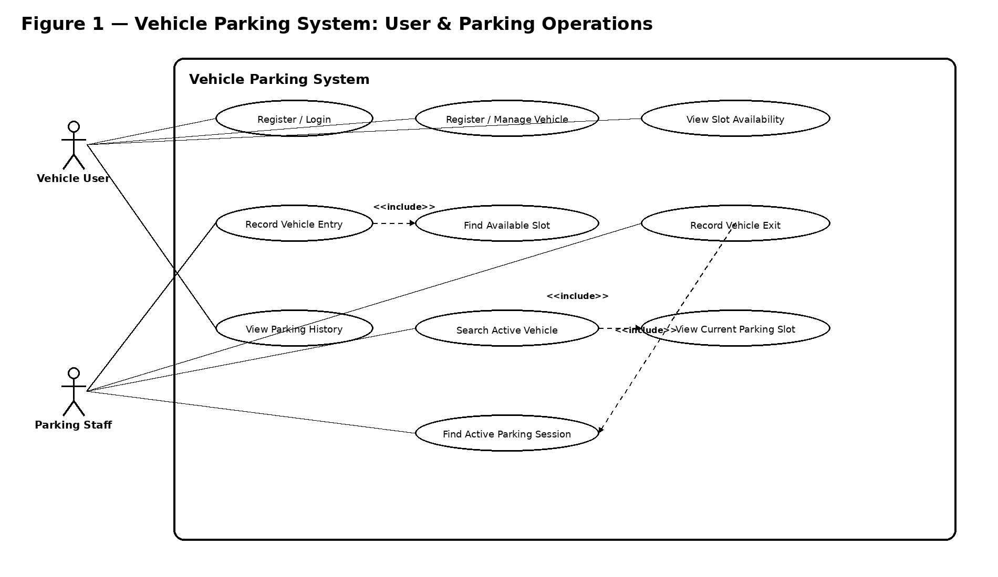
Figure 1. Overall Vehicle Parking System Use-Case Diagram
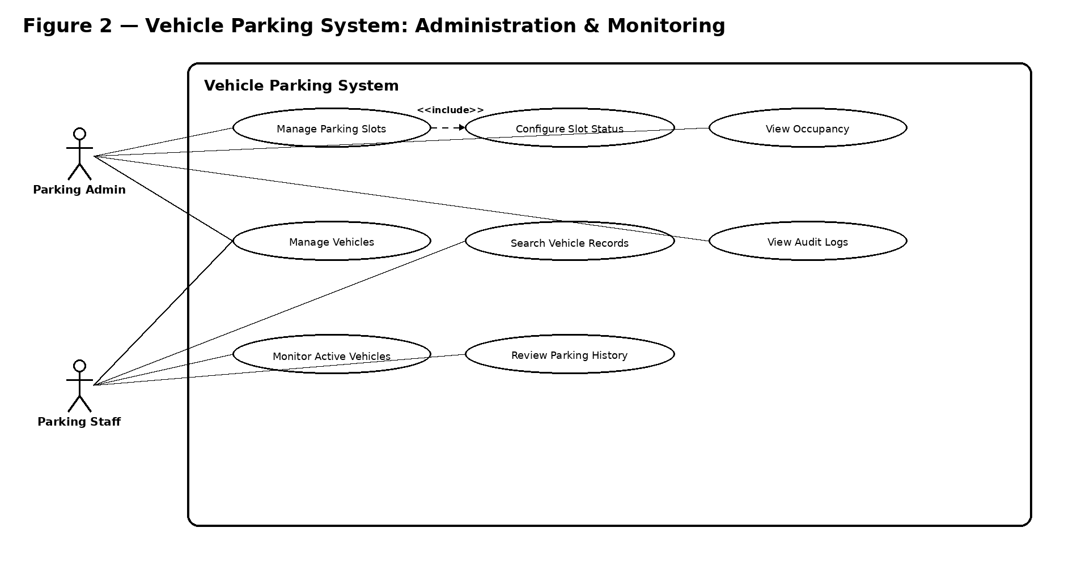
Figure 2. Administration and Monitoring Use-Case Diagram

7.2 Use-case relationship notes
- Record Vehicle Entry <<include>> Find Available Slot because slot identification is mandatory for a successful entry.
- Record Vehicle Exit <<include>> Find Active Parking Session because exit requires the corresponding active session.
- Search Active Vehicle <<include>> View Current Parking Slot because the current slot is part of the requested tracking result.
- Manage Parking Slots <<include>> Configure Slot Status because status configuration is part of slot management.

8. Requirements Traceability Matrix (RTM)
Req ID | Requirement summary | Test case(s) | SAD / Design area
VPS-F-001 | The system shall allow a new user to create an account | TC-F-001 | User/Vehicle/Slot/Session/Audit design
VPS-F-002 | The system shall authenticate registered users using va | TC-F-002 | User/Vehicle/Slot/Session/Audit design
VPS-F-003 | The system shall allow an authenticated user to registe | TC-F-003 | User/Vehicle/Slot/Session/Audit design
VPS-F-004 | The system shall allow an authenticated user to view an | TC-F-004 | User/Vehicle/Slot/Session/Audit design
VPS-F-005 | The system shall allow a Parking Administrator to creat | TC-F-005 | User/Vehicle/Slot/Session/Audit design
VPS-F-006 | The system shall allow a Parking Administrator to updat | TC-F-006 | User/Vehicle/Slot/Session/Audit design
VPS-F-007 | The system shall display the current status of parking | TC-F-007 | User/Vehicle/Slot/Session/Audit design
VPS-F-008 | The system shall identify available parking slots when | TC-F-008 | User/Vehicle/Slot/Session/Audit design
VPS-F-009 | The system shall record a vehicle entry with vehicle id | TC-F-009 | User/Vehicle/Slot/Session/Audit design
VPS-F-010 | The system shall mark the allocated parking slot as occ | TC-F-010 | User/Vehicle/Slot/Session/Audit design
VPS-F-011 | The system shall allow authorized staff to search for a | TC-F-011 | User/Vehicle/Slot/Session/Audit design
VPS-F-012 | The system shall provide the current parking slot assoc | TC-F-012 | User/Vehicle/Slot/Session/Audit design
VPS-F-013 | The system shall record a vehicle exit with exit time f | TC-F-013 | User/Vehicle/Slot/Session/Audit design
VPS-F-014 | The system shall mark the associated parking slot as av | TC-F-014 | User/Vehicle/Slot/Session/Audit design
VPS-F-015 | The system shall allow an authenticated user to view th | TC-F-015 | User/Vehicle/Slot/Session/Audit design
VPS-F-016 | The system shall provide administrators with an occupan | TC-F-016 | User/Vehicle/Slot/Session/Audit design
VPS-F-017 | The system shall record security-sensitive and administ | TC-F-017 | User/Vehicle/Slot/Session/Audit design
VPS-F-018 | The system shall prevent a vehicle from having more tha | TC-F-018 | User/Vehicle/Slot/Session/Audit design
VPS-NF-001 | 95% of requests under the defined normal-load profile s | TC-NF-001 | Performance/Reliability/Security/Integrity/UX design
VPS-NF-002 | The system shall provide at least 99.5% monthly availab | TC-NF-002 | Performance/Reliability/Security/Integrity/UX design
VPS-NF-003 | The system shall enforce role-based access control for | TC-S-001 / TC-S-002 | Performance/Reliability/Security/Integrity/UX design
VPS-NF-004 | Entry/exit processing shall preserve one-to-one consist | TC-NF-003 | Performance/Reliability/Security/Integrity/UX design
VPS-NF-005 | The supported desktop browsers shall render core workfl | TC-NF-004 | Performance/Reliability/Security/Integrity/UX design
VPS-NF-006 | Audit records shall remain retrievable for at least one | TC-NF-005 | Performance/Reliability/Security/Integrity/UX design
VPS-SR-001 | The system shall require authentication before protecte | TC-S-001 | Security architecture / Auth / Audit
VPS-SR-002 | The system shall enforce role-based authorization for U | TC-S-002 | Security architecture / Auth / Audit
VPS-SR-003 | The production system shall use HTTPS/TLS and shall not | TC-S-003 | Security architecture / Auth / Audit
VPS-SR-004 | The system shall store passwords using a secure salted | TC-S-004 | Security architecture / Auth / Audit
VPS-SR-005 | The system shall record security-sensitive and administ | TC-S-005 | Security architecture / Auth / Audit

Baseline coverage: 29 requirements — 18 functional, 6 non-functional and 5 security requirements. The Team 5 Test Plan maps these requirements to 28 test cases, with TC-S-001 covering both VPS-SR-001 and VPS-NF-003.

8.1 Requirement status
Status | Meaning
N | Not started / planned baseline
P | Partially implemented or verified
A | Accepted / verified

