Software Requirements Specification (SRS)
Project: Vehicle Parking System
Problem Statement: A system for managing parking slots and vehicle tracking
Technology: JavaScript (MERN Stack)
Version: 1.0
Authors: Team 5
Date: 28-09-2026
Status: Submission

Revision history
Version | Date | Author | Change summary | Approval
1.0 | 28-09-2026 | Team 5 | Initial SRS for Vehicle Parking System

Approvals
Role | Name | Signature / Email | Date
Course Coordinator
Project Team Lead | Team 5
Project Evaluator

Table of Contents
1. Introduction
2. Overall description
3. External interface requirements
4. System features (detailed)
5. Non-functional requirements (detailed)
6. Quality attributes & Acceptance tests
7. System models and diagrams
8. Requirements Traceability Matrix (RTM)

1. Introduction

1.1 Purpose
This document is a Software Requirements Specification (SRS) for a Vehicle Parking System. It defines the functional and non-functional requirements, interfaces, security requirements, and verification criteria for a system that manages parking slots and tracks vehicles. The SRS serves as the requirements baseline for the project implementation and for the team's separate architecture/design and software test-plan documents.

1.2 Scope
The Vehicle Parking System covers user authentication, vehicle registration, parking-slot management, slot availability monitoring, vehicle entry and exit recording, active vehicle tracking, parking-history access, administrative monitoring, and audit logging. The system is a web-based application implemented using JavaScript and the MERN Stack (MongoDB, Express.js, React, and Node.js).
The baseline scope is limited to parking-slot management and vehicle tracking. Dedicated hardware integration, payment processing, reservation management, and external payment-gateway functionality are not baseline requirements because they are not stated in the project problem statement.

1.3 Audience
- Developers and project implementation team.
- Software architecture and design team.
- Software testing / QA team.
- Project guide, course coordinator, and assessment evaluators.

1.4 Definitions
Term / Acronym | Definition
VPS | Vehicle Parking System
MERN | MongoDB, Express.js, React, and Node.js
UI | User Interface
API | Application Programming Interface
RBAC | Role-Based Access Control
FR | Functional Requirement
NFR | Non-Functional Requirement
RTM | Requirements Traceability Matrix
Parking Slot | A designated parking position managed by the system.
Parking Session | A record of a vehicle's active or completed parking period.
Vehicle Tracking | Recording and retrieving the current or historical parking status/location of a vehicle within the parking facility.

2. Overall description

2.1 Product perspective
The Vehicle Parking System is a web-based client-server application. The React web interface communicates with a Node.js/Express.js backend through REST APIs, while MongoDB provides persistent storage for user, vehicle, parking-slot, parking-session, and audit information.

2.2 Major product functions (detailed)
- User registration and authentication.
- Vehicle registration and management.
- Parking-slot creation and status management.
- Parking-slot availability monitoring.
- Recording vehicle entry and assigning an available parking slot.
- Tracking active vehicles and their occupied slots.
- Recording vehicle exit and releasing the associated slot.
- Searching for an active vehicle and its current parking session.
- Viewing vehicle parking history.
- Administrative occupancy and vehicle-tracking monitoring.
- Audit logging of security-sensitive and administrative actions.

2.3 User roles and characteristics (expanded)
- Vehicle Owner / User: registers vehicles, views parking availability, and views permitted current/history information.
- Parking Staff: records vehicle entry and exit, searches active vehicles, and performs operational tracking.
- Parking Administrator: manages parking slots, monitors occupancy, manages operational records, and reviews audit information.

2.4 Operating environment
Client: modern web browser on desktop, laptop, tablet, or mobile device. Frontend: React. Application server: Node.js with Express.js. Database: MongoDB. Network: HTTP/HTTPS communication between client and server, with HTTPS required for production deployment.

2.5 Constraints
- The system shall be implemented using JavaScript and the MERN Stack as specified in the project statement.
- Protected functions shall be accessible only to authorized users.
- Parking-slot state shall remain consistent with active parking sessions.
- Vehicle and parking records shall be stored persistently.
- The baseline scope is parking-slot management and vehicle tracking; payment and reservation functions are excluded.

3. External interface requirements

3.1 User interfaces
The web interface shall provide role-appropriate views for Vehicle Owners/Users, Parking Staff, and Parking Administrators. It shall display parking-slot status clearly and provide forms and validation messages for authentication, vehicle registration, entry, exit, search, and administrative operations.

3.2 Hardware interfaces
No mandatory dedicated hardware interface is defined by the baseline problem statement. If sensors, RFID readers, cameras, or entry/exit gates are added later, their integration shall be specified separately and shall not change the baseline SRS without approved requirements changes.

3.3 Software interfaces
- React Web Client: presents the user interface and sends requests to the backend.
- Express.js REST API: validates requests, authentication, authorization, and business operations.
- MongoDB: stores users, vehicles, parking slots, parking sessions, and audit records.
- Authentication / Authorization module: validates credentials and enforces role-based access.

3.4 Communications
- The web client and backend shall communicate through RESTful HTTP APIs.
- Production communication shall use HTTPS/TLS.
- API requests and responses shall use JSON.
- Credentials and authentication secrets shall not be transmitted over plaintext HTTP.

4. System features (detailed)
Each requirement below is stated using 'shall', has a unique ID, and includes type, priority, source/stakeholder, measurable acceptance criteria, and a test-case reference.

4.1 User Management and Authentication
Req ID | Requirement (shall...) | Type | Priority | Source / Stakeholder | Acceptance criteria / Test case ref | Comments / Dependencies
VPS-F-001 | The system shall allow a new user to create an account using required identity and contact information. | Functional | High | Vehicle Owner / User | AC-001: Valid required data creates one user account; invalid or duplicate data is rejected. Test: TC-F-001 | User data storage required
VPS-F-002 | The system shall authenticate registered users using valid credentials before granting access to protected functions. | Functional | High | Vehicle Owner / User | AC-002: Valid credentials create an authenticated session; invalid credentials are rejected. Test: TC-F-002 | Authentication module required

4.2 Vehicle Management
Req ID | Requirement (shall...) | Type | Priority | Source / Stakeholder | Acceptance criteria / Test case ref | Comments / Dependencies
VPS-F-003 | The system shall allow an authenticated user to register a vehicle with a unique vehicle identifier/registration number. | Functional | High | Vehicle Owner / User | AC-003: Valid vehicle data is stored and associated with the user; duplicate active registration is rejected. Test: TC-F-003 | Vehicle record required
VPS-F-004 | The system shall allow an authenticated user to view and update the permitted details of a registered vehicle. | Functional | Medium | Vehicle Owner / User | AC-004: Authorized changes are saved and unauthorized changes are rejected. Test: TC-F-004 | Authorization required

4.3 Parking Slot Management
Req ID | Requirement (shall...) | Type | Priority | Source / Stakeholder | Acceptance criteria / Test case ref | Comments / Dependencies
VPS-F-005 | The system shall allow a Parking Administrator to create a parking slot with a unique slot identifier and configured status. | Functional | High | Parking Administrator | AC-005: A unique slot can be created and appears in the slot inventory. Test: TC-F-005 | Slot inventory required
VPS-F-006 | The system shall allow a Parking Administrator to update a parking slot's operational status as available, occupied, or unavailable. | Functional | High | Parking Administrator | AC-006: Authorized status changes are stored and reflected in availability views. Test: TC-F-006 | Must preserve slot/session consistency
VPS-F-007 | The system shall display the current status of parking slots to authorized users. | Functional | High | User / Staff / Admin | AC-007: Displayed status matches the latest valid slot state. Test: TC-F-007 | Availability data required
VPS-F-008 | The system shall identify available parking slots when a vehicle entry is being recorded. | Functional | High | Parking Staff | AC-008: Only slots in available state can be selected for allocation. Test: TC-F-008 | Depends on slot status

4.4 Vehicle Entry, Exit and Tracking
Req ID | Requirement (shall...) | Type | Priority | Source / Stakeholder | Acceptance criteria / Test case ref | Comments / Dependencies
VPS-F-009 | The system shall record a vehicle entry with vehicle identifier, entry time, and allocated parking slot. | Functional | High | Parking Staff | AC-009: A valid entry creates one active parking session containing vehicle, slot, and timestamp. Test: TC-F-009 | Parking session required
VPS-F-010 | The system shall mark the allocated parking slot as occupied when a valid vehicle entry is recorded. | Functional | High | Parking Staff | AC-010: Selected slot changes from available to occupied after successful entry. Test: TC-F-010 | Must be atomic with entry operation
VPS-F-011 | The system shall allow authorized staff to search for an active vehicle using its registered vehicle identifier. | Functional | High | Parking Staff / Admin | AC-011: Matching active vehicle returns its current session and slot; no match returns an appropriate message. Test: TC-F-011 | Search service required
VPS-F-012 | The system shall provide the current parking slot associated with an actively parked vehicle. | Functional | High | User / Staff / Admin | AC-012: For an active session, the system displays the correct occupied slot. Test: TC-F-012 | Depends on active session
VPS-F-013 | The system shall record a vehicle exit with exit time for the corresponding active parking session. | Functional | High | Parking Staff | AC-013: Valid exit closes the active session and stores the exit timestamp. Test: TC-F-013 | Active session required
VPS-F-014 | The system shall mark the associated parking slot as available after a valid vehicle exit. | Functional | High | Parking Staff | AC-014: Slot linked to the completed session changes to available. Test: TC-F-014 | Must be consistent with exit
VPS-F-015 | The system shall allow an authenticated user to view the parking history of vehicles associated with that user. | Functional | Medium | Vehicle Owner / User | AC-015: Only permitted vehicle history is returned with entry, exit, and slot information. Test: TC-F-015 | Authorization required
VPS-F-018 | The system shall prevent a vehicle from having more than one active parking session at the same time. | Functional | High | System | AC-018: A second active session for the same vehicle is rejected until the existing session is closed. Test: TC-F-018 | Database/business-rule constraint

4.5 Monitoring and Audit
Req ID | Requirement (shall...) | Type | Priority | Source / Stakeholder | Acceptance criteria / Test case ref | Comments / Dependencies
VPS-F-016 | The system shall provide the Parking Administrator with occupancy and vehicle-tracking information for operational monitoring. | Functional | Medium | Parking Administrator | AC-016: Administrator view displays current occupancy and active vehicle information. Test: TC-F-016 | Reporting/monitoring view required
VPS-F-017 | The system shall record audit events for security-sensitive and administrative actions, including authentication failures and parking-slot status changes. | Functional | High | Parking Administrator / Security | AC-017: Each applicable event contains actor, action, timestamp, and result. Test: TC-F-017 | Audit storage required

5. Non-functional requirements (detailed)
NFRs below are measurable and tied to acceptance/test plans. IDs follow VPS-NF-###.
Req ID | Requirement | Category | Priority | Acceptance criteria / Measurement | Test case ref
VPS-NF-001 | The system shall return a response to 95% of normal user/API requests within 2 seconds under the defined normal-load test condition. | Performance | High | 95th percentile response time ≤ 2 s. | TC-NF-001
VPS-NF-002 | The system shall maintain at least 99.5% monthly availability excluding planned maintenance windows. | Reliability | High | Monthly availability report ≥ 99.5%. | TC-NF-002
VPS-NF-003 | The system shall enforce role-based access control so that protected operations are accessible only to authorized roles. | Security | High | Authorization tests show no unauthorized protected operation succeeds. | TC-S-001
VPS-NF-004 | The system shall maintain consistency between active parking sessions and occupied slots, with no vehicle or slot having conflicting active associations. | Consistency | High | Consistency validation finds zero conflicting active associations after defined entry/exit scenarios. | TC-NF-003
VPS-NF-005 | The web interface shall support the latest two stable versions of the major desktop browsers used by the project and shall provide readable validation and error messages. | Usability / Compatibility | Medium | Cross-browser acceptance checklist passes for supported browsers. | TC-NF-004
VPS-NF-006 | The system shall retain audit records with actor, action, timestamp, and outcome for at least 1 year or the duration specified by the project/institution, whichever is longer. | Audit / Data Retention | Medium | Audit retrieval test successfully retrieves required records within the retention period. | TC-NF-005

5.1 Security

5.1.1 Security Objectives
- Protect user, vehicle, parking-session, and administrative information from unauthorized access or disclosure.
- Maintain integrity and accountability of parking-slot and vehicle-tracking records by preventing unauthorized modification and recording security-sensitive actions.

5.1.2 Security Requirements
Req ID | Requirement (shall...) | Type | Priority | Acceptance criteria / Test case ref | Comments / Dependencies
VPS-SR-001 | The system shall enforce authentication for all protected functions and shall deny access when credentials are invalid or missing. | Security | High | Authorization tests confirm protected operations reject unauthenticated requests. Test: TC-S-001 | Authentication control
VPS-SR-002 | The system shall enforce role-based authorization for Vehicle Owner/User, Parking Staff, and Parking Administrator operations. | Security | High | A role cannot successfully execute an operation outside its permissions. Test: TC-S-002 | RBAC control
VPS-SR-003 | The system shall use HTTPS/TLS for production client-server communication and shall not transmit credentials over plaintext HTTP. | Security | High | Network inspection confirms protected traffic uses HTTPS/TLS. Test: TC-S-003 | Transport security
VPS-SR-004 | The system shall store passwords using a secure one-way password hashing mechanism and shall not store plaintext passwords. | Security | High | Database inspection confirms passwords are not stored in plaintext. Test: TC-S-004 | Password storage control
VPS-SR-005 | The system shall record security-sensitive and administrative events in an audit log without storing passwords or authentication secrets. | Security | High | Audit records contain actor, action, timestamp, result, and no password/secret values. Test: TC-S-005 | Audit logging control

6. Quality attributes & Acceptance tests
Exit criteria for acceptance: all high-priority functional requirements are implemented and verified, mandatory security requirements pass, no critical defects remain open, and applicable non-functional acceptance criteria are satisfied.
Acceptance test suites: User Authentication, Vehicle Management, Parking Slot Management, Vehicle Entry, Vehicle Tracking, Vehicle Exit, Administrative Monitoring, Audit/Security, Performance, Reliability, Consistency, and Compatibility/Usability.
Quality attribute | Acceptance target | Evidence / Test
Performance | 95% of normal-load requests complete within 2 s. | TC-NF-001 performance results
Reliability | Monthly availability ≥ 99.5%, excluding planned maintenance. | TC-NF-002 availability record
Security | Authentication, authorization, TLS, password protection, and audit controls pass. | TC-S-001 to TC-S-005
Consistency | No conflicting active vehicle-session/slot associations after defined scenarios. | TC-NF-003 consistency validation
Usability / Compatibility | Supported browser checklist passes and validation/error messages are readable. | TC-NF-004 compatibility/usability test
Auditability | Required audit events are retained and retrievable. | TC-NF-005 audit retention test

7. System models and diagrams

7.1 UML Use-Case diagram
At least 2 UML use-case diagrams are included below for the Vehicle Parking System.
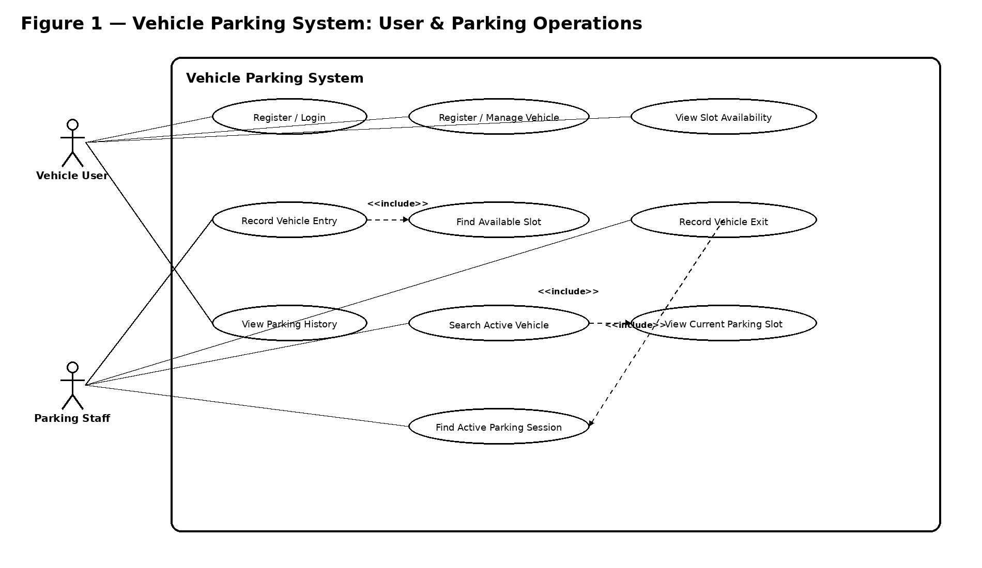
Figure 1. Overall Vehicle Parking System Use-Case Diagram
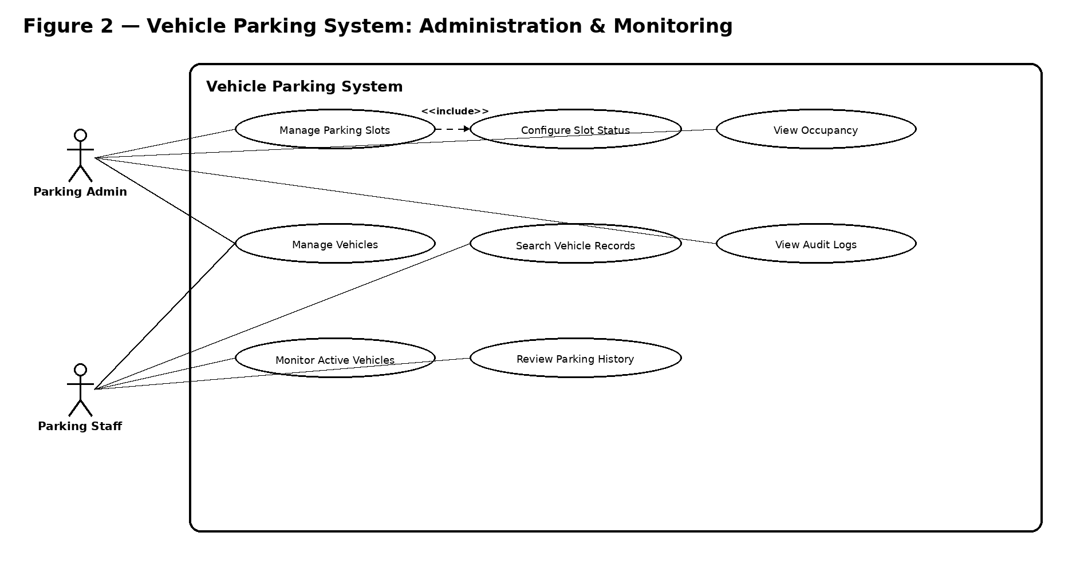
Figure 2. Administration and Monitoring Use-Case Diagram

8. Requirements Traceability Matrix (RTM)
The RTM maps the SRS requirements to logical design areas and planned test cases. The Architecture & Design Specification and Software Test Plan should preserve these requirement IDs.
Req ID | Requirement short | Section ref / Design Spec | Test case(s) | Status (N/P/A) | Comments
VPS-F-001 | User account creation | 4.1 / User Management | TC-F-001 | N
VPS-F-002 | User authentication | 4.1 / Authentication | TC-F-002 | N
VPS-F-003 | Vehicle registration | 4.2 / Vehicle Management | TC-F-003 | N
VPS-F-004 | Vehicle update | 4.2 / Vehicle Management | TC-F-004 | N
VPS-F-005 | Create parking slot | 4.3 / Slot Management | TC-F-005 | N
VPS-F-006 | Update slot status | 4.3 / Slot Management | TC-F-006 | N
VPS-F-007 | View slot status | 4.3 / Availability | TC-F-007 | N
VPS-F-008 | Identify available slot | 4.3 / Parking Operations | TC-F-008 | N
VPS-F-009 | Record vehicle entry | 4.4 / Parking Session | TC-F-009 | N
VPS-F-010 | Mark slot occupied | 4.4 / Slot/Session | TC-F-010 | N
VPS-F-011 | Search active vehicle | 4.4 / Vehicle Tracking | TC-F-011 | N
VPS-F-012 | Current vehicle slot | 4.4 / Vehicle Tracking | TC-F-012 | N
VPS-F-013 | Record vehicle exit | 4.4 / Parking Session | TC-F-013 | N
VPS-F-014 | Release slot on exit | 4.4 / Slot/Session | TC-F-014 | N
VPS-F-015 | View parking history | 4.4 / History | TC-F-015 | N
VPS-F-016 | Occupancy monitoring | 4.5 / Admin Monitoring | TC-F-016 | N
VPS-F-017 | Audit events | 4.5 / Audit Logging | TC-F-017 | N
VPS-F-018 | Prevent multiple active sessions | 4.4 / Session Validation | TC-F-018 | N
VPS-NF-001 | Response time | 5 / Performance | TC-NF-001 | N
VPS-NF-002 | Availability | 5 / Reliability | TC-NF-002 | N
VPS-NF-003 | RBAC | 5 / Security | TC-S-001 | N
VPS-NF-004 | Session-slot consistency | 5 / Consistency | TC-NF-003 | N
VPS-NF-005 | Browser compatibility | 5 / Usability/Compatibility | TC-NF-004 | N
VPS-NF-006 | Audit retention | 5 / Audit/Data Retention | TC-NF-005 | N
VPS-SR-001 | Protected-function authentication | 5.1 / Security | TC-S-001 | N
VPS-SR-002 | Role-based authorization | 5.1 / Security | TC-S-002 | N
VPS-SR-003 | HTTPS/TLS | 5.1 / Security | TC-S-003 | N
VPS-SR-004 | Password hashing | 5.1 / Security | TC-S-004 | N
VPS-SR-005 | Security/admin audit logging | 5.1 / Security | TC-S-005 | N

