Software Architecture and Design Specification (SAD)
Vehicle Parking System
A system for managing parking slots and vehicle tracking
Technology: JavaScript (MERN Stack)

Field | Value
Project | Vehicle Parking System
Problem Statement | A system for managing parking slots and vehicle tracking
Technology | JavaScript — MERN Stack
Version | 1.0
Submitted by | Team 5
Date | 28-09-2026
Status | Final Submission

Revision history
Version | Date | Author | Change Summary | Approval
1.0 | 28-09-2026 | Team 5 | Final baseline aligned with SRS, SAD and Test Plan | Course Coordinator / Evaluator

Approvals
Role | Name | Signature / Date
Course Coordinator
Project Team Lead | Team 5
Project Evaluator

Table of Contents
1. Introduction
2. Document Overview
3. Architecture
4. Design
5. Appendices

1. Introduction

1.1 Purpose
This Software Architecture and Design Specification defines how the Vehicle Parking System requirements are realized through a maintainable MERN architecture, application components, data responsibilities, interfaces, security controls and interaction flows. Requirement IDs are preserved from the SRS so the Test Plan can trace implementation and verification.

1.2 Scope
The baseline covers authentication, vehicle management, parking-slot management, entry/exit, active-vehicle tracking, parking history, administrative monitoring and audit logging. Payment processing, reservations, dedicated hardware and external payment gateways remain outside the baseline.

1.3 Audience
- Developers and implementation team
- QA and testing team
- Project guide and evaluators
- Team members responsible for deployment and maintenance

1.4 Definitions
Term | Definition
SAD | Software Architecture and Design Specification
SRS | Software Requirements Specification
STP | Software Test Plan
REST | Representational State Transfer API style
RBAC | Role-Based Access Control
Repository | Data-access abstraction over MongoDB
ADR | Architecture Decision Record
STRIDE | Threat-model categories: Spoofing, Tampering, Repudiation, Information disclosure, Denial of service and Elevation of privilege

2. Document Overview

2.1 How to use this document
Sections 3 and 4 are the technical baseline for implementation. Component responsibilities define ownership boundaries; sequence diagrams define interaction order; API definitions define contracts; security and error-handling sections define cross-cutting controls. Changes to the SRS must be propagated to the SAD and STP.

2.2 Related Documents
Document | Relationship
Vehicle Parking System SRS v1.0 | Source of 18 FRs, 6 NFRs and 5 SRs
Vehicle Parking System Test Plan v1.0 | Verifies all 29 SRS requirements; 28 test cases
Software Engineering Mini-Project Part-1 guideline | Defines IEEE-style deliverable expectations
SRS Template for SE | Defines SRS section organization used for the requirements baseline

3. Architecture

3.1 Goals & Constraints
Goal / Constraint | Architectural implication
MERN stack required | React, Node.js/Express.js and MongoDB are the baseline stack.
RBAC | Authorization is enforced in backend middleware/services, not only in the UI.
Session/slot consistency | Entry and exit update related records as one logical operation.
Persistent records | MongoDB stores users, vehicles, slots, sessions and audit events.
Performance | API/service/repository layers should support the 95th-percentile 2-second normal-load target.
Availability | Deployment and monitoring should support the 99.5% monthly target excluding planned maintenance.
Baseline scope | No payment, reservation or dedicated hardware component is required.

3.2 Stakeholders & Concerns
Stakeholder | Architecture / design concerns
Vehicle Owner / User | Secure authentication, permitted vehicle access, readable current-slot/history views.
Parking Staff | Fast and reliable entry/exit, correct slot allocation/release and search.
Parking Administrator | Slot configuration, occupancy monitoring, operational records and audit visibility.
Developers | Separation of concerns, maintainability, testability and clear contracts.
QA Team | Deterministic rules, traceable IDs, measurable NFRs and observable failures.
Project Evaluator | Template compliance, UML artifacts, security architecture and traceability.

3.3 Component (UML) Diagram
The architecture uses a layered client-server decomposition. The React client calls Express routes/controllers; services enforce business rules; repositories isolate MongoDB persistence; authentication/RBAC and audit services provide cross-cutting controls.
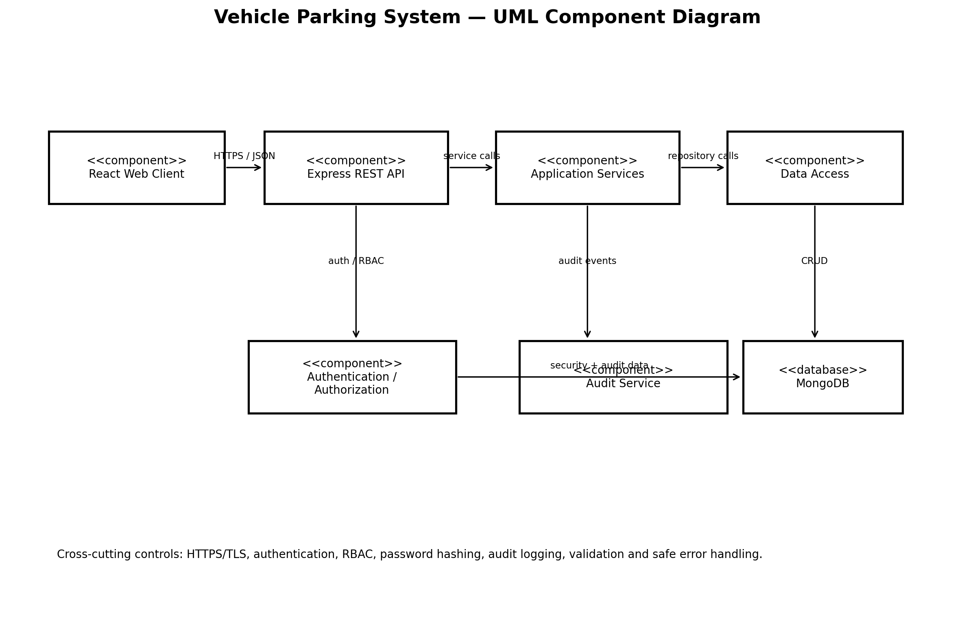
Figure 1. UML Component Diagram — Vehicle Parking System

3.4 Component Descriptions
Component | Detailed responsibility | SRS coverage
React Web Client | Role-specific pages, forms, validation messages, slot status, search, history and admin views. | F-001–F-007, F-011–F-016, NF-005
Express API / Controllers | HTTP routing, request validation, authentication middleware invocation, response mapping. | All FRs via API boundary
Authentication Service | Credential verification, session/token handling and protected-access checks. | F-001, F-002, SR-001, SR-004
RBAC Middleware | Checks authenticated identity and allowed role before protected operations. | NF-003, SR-002
Parking Service | Vehicle registration, slot selection, entry/exit rules and active-session constraint. | F-003–F-015, F-018, NF-004
Vehicle Service | Vehicle ownership, uniqueness and permitted update/search operations. | F-003, F-004, F-011, F-012, F-015
Slot Service | Slot creation/status/availability and state transitions. | F-005–F-010, F-014
Session Service | Creates/closes parking sessions and enforces one-active-session rule. | F-009, F-013, F-018, NF-004
Repository/Data Access | MongoDB queries, persistence and transaction/consistency boundaries. | All persistent requirements
Audit Service | Structured actor/action/timestamp/result records; excludes secrets. | F-017, NF-006, SR-005
MongoDB | Persistent collections for users, vehicles, parkingSlots, parkingSessions and auditLogs. | Persistence baseline

3.5 Chosen Architecture Pattern and Rationale
The baseline uses a layered client-server architecture within a modular MERN application. The layers are Presentation (React), API/Controller (Express), Application/Service (business rules), Data Access/Repository (MongoDB access), and Cross-Cutting Security/Audit. This is appropriate for the academic project scope because it separates responsibilities without introducing the operational complexity of multiple independently deployed microservices.

3.5.1 Architecture Decision Records
ADR | Decision | Alternatives considered | Rationale / consequence
ADR-001 | Use MERN stack | Django/PostgreSQL, Java/Spring | Matches project technology constraint; JavaScript across frontend/backend.
ADR-002 | Layered modular monolith | Microservices | Simpler deployment and debugging while retaining separation of concerns.
ADR-003 | REST/JSON API | GraphQL, direct DB access from UI | Clear HTTP contracts and straightforward testing.
ADR-004 | MongoDB persistence | Relational database | Fits MERN baseline and document-oriented application records.
ADR-005 | Backend-enforced RBAC | UI-only authorization | Prevents bypass through direct API calls.
ADR-006 | Structured audit logging | Ad-hoc console logging | Supports traceability without exposing secrets.
ADR-007 | Logical atomic entry/exit updates | Independent writes | Prevents slot/session divergence when an operation fails.

3.6 Technology Stack & Data Stores
Technology / Store | Role
React | Browser UI
Node.js + Express.js | REST API and application server
MongoDB | Persistent data store
JavaScript | Primary implementation language
HTTPS/TLS | Production transport protection
Jest / Supertest / React Testing Library | Unit and integration testing as defined by STP
Postman/Newman, Cypress/Selenium, JMeter, OWASP ZAP | API/UI/performance/security verification tools per STP

3.7 Risks & Mitigations
Risk | Impact | Mitigation
Concurrent entry requests | Double allocation or duplicate sessions | Unique constraints plus service-level atomic checks; TC-F-018.
Slot/session update failure | Inconsistent state | Single logical operation and rollback/transaction strategy; TC-F-010/TC-NF-003.
Unauthorized API call | Data exposure or privilege escalation | Backend authentication and RBAC middleware; TC-S-001/002.
Sensitive information in logs | Credential disclosure | Audit schema excludes passwords/tokens; TC-S-005.
Performance degradation | NFR failure | Index frequently searched identifiers, avoid unnecessary queries, measure P95; TC-NF-001.
Database outage | Availability loss | Health checks, graceful error handling, recovery/restart procedure; TC-NF-002.

3.8 Traceability to Requirements
Requirement group | Design realization | Test reference
F-001/F-002 | Auth Service + User repository | TC-F-001/002
F-003/F-004 | Vehicle Service + Vehicle repository | TC-F-003/004
F-005/F-006/F-007/F-008 | Slot Service + Slot UI | TC-F-005–008
F-009/F-010/F-013/F-014/F-018 | Parking/Session/Slot services | TC-F-009/010/013/014/018
F-011/F-012/F-015 | Vehicle/Tracking/History services | TC-F-011/012/015
F-016/F-017 | Admin Monitoring + Audit Service | TC-F-016/017
NF-001 | API/Service/Data-access performance | TC-NF-001
NF-002 | Deployment + health monitoring | TC-NF-002
NF-003 + SR-001/002 | Auth + RBAC middleware | TC-S-001/002
NF-004 | Session/Slot consistency boundary | TC-NF-003
NF-005 | React UI + browser support | TC-NF-004
NF-006 + SR-005 | Audit Service + retention policy | TC-NF-005/TC-S-005
SR-003 | TLS-enabled deployment | TC-S-003
SR-004 | Password hashing in Auth Service | TC-S-004

3.9 Security Architecture
Security is layered across the browser, API boundary, application services, persistence and audit subsystem. Authentication establishes identity; RBAC checks the requested operation against the role; validation rejects malformed inputs; repository code isolates persistence; audit records capture security-sensitive events without secrets; TLS protects credentials and authenticated traffic in production.

3.9.1 Threat Model
Threat | Example | Control | Verification
Spoofing | Forged/invalid authentication token | Authentication and token/session validation | TC-S-001
Tampering | Changing slot/session data through unauthorized API calls | RBAC, validation, server-side business rules | TC-S-002 / TC-NF-003
Repudiation | User denies an administrative change | Actor/action/timestamp/result audit record | TC-F-017
Information disclosure | Credential or history leakage | TLS, ownership checks, safe responses | TC-S-003 / TC-F-015
Denial of service | Malformed/oversized request load | Input validation, controlled errors and monitoring | Security validation / monitoring
Elevation of privilege | Owner calls admin operation | Backend RBAC middleware | TC-S-002

3.9.2 Security Architecture Flow
- Browser → HTTPS/TLS → Express API
- API → authentication/session validation → identity established
- API → RBAC middleware → role permitted for operation
- Controller → service validation → business rule enforcement
- Service → repository → MongoDB persistence
- Successful/failed security-sensitive operation → Audit Service → auditLogs

4. Design

4.1 Design Overview
The design separates presentation, API orchestration, business logic and persistence. The most important invariant is the relationship between parking sessions and slots: an active session references exactly one occupied slot, and an occupied slot corresponds to an active session. Entry and exit are therefore designed as consistency boundaries rather than independent writes.

4.1.1 Logical Data Relationships
Entity / Collection | Key fields | Relationships
User | userId, name, email, passwordHash, role | One user owns zero or more Vehicle records.
Vehicle | vehicleId, registrationNumber, ownerId | Belongs to one User; may have at most one active ParkingSession.
ParkingSlot | slotId, status | Referenced by at most one active session; status is Available/Occupied/Unavailable.
ParkingSession | sessionId, vehicleId, slotId, entryTime, exitTime, status | Links one Vehicle to one ParkingSlot; active/complete lifecycle.
AuditLog | auditId, actorId, action, timestamp, result | Records security-sensitive/admin events without secrets.

4.1.2 Entry/Exit State Consistency
Operation | Precondition | State changes | Failure behavior
Entry | Registered vehicle, Available slot, no active session | Create active session; slot Available→Occupied | Reject and preserve prior state.
Exit | Existing active session and occupied slot | Set exit time/status; slot Occupied→Available | Reject if no active session; preserve state.
Concurrent entry | No active session at request start | Exactly one request may create the active session | Conflicting request returns conflict; no duplicate session.
Admin slot status change | No conflicting active session | Persist permitted status change | Reject changes that violate active-session/slot consistency.

4.2 UML Sequence Diagrams
Three sequence diagrams are provided. The first covers authentication; the second covers the primary vehicle-entry allocation flow; the third covers vehicle exit and slot release. The template requirement of at least two sequence diagrams is therefore exceeded.
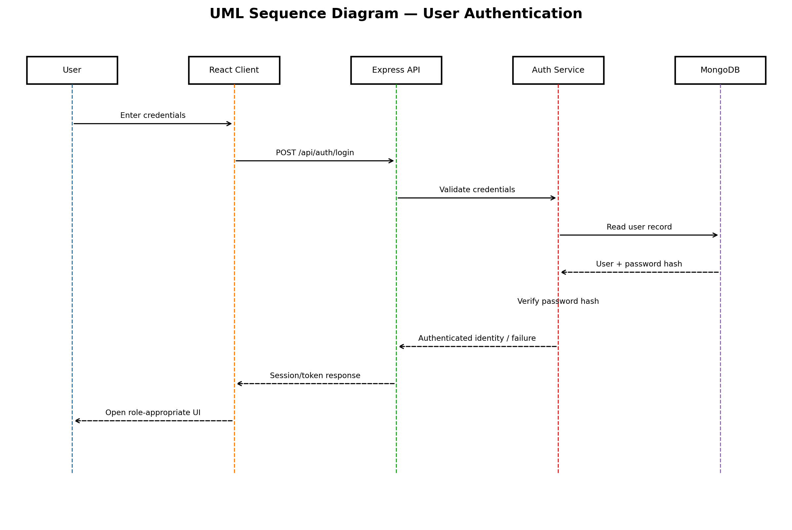
Figure 2. UML Sequence Diagram — User Authentication
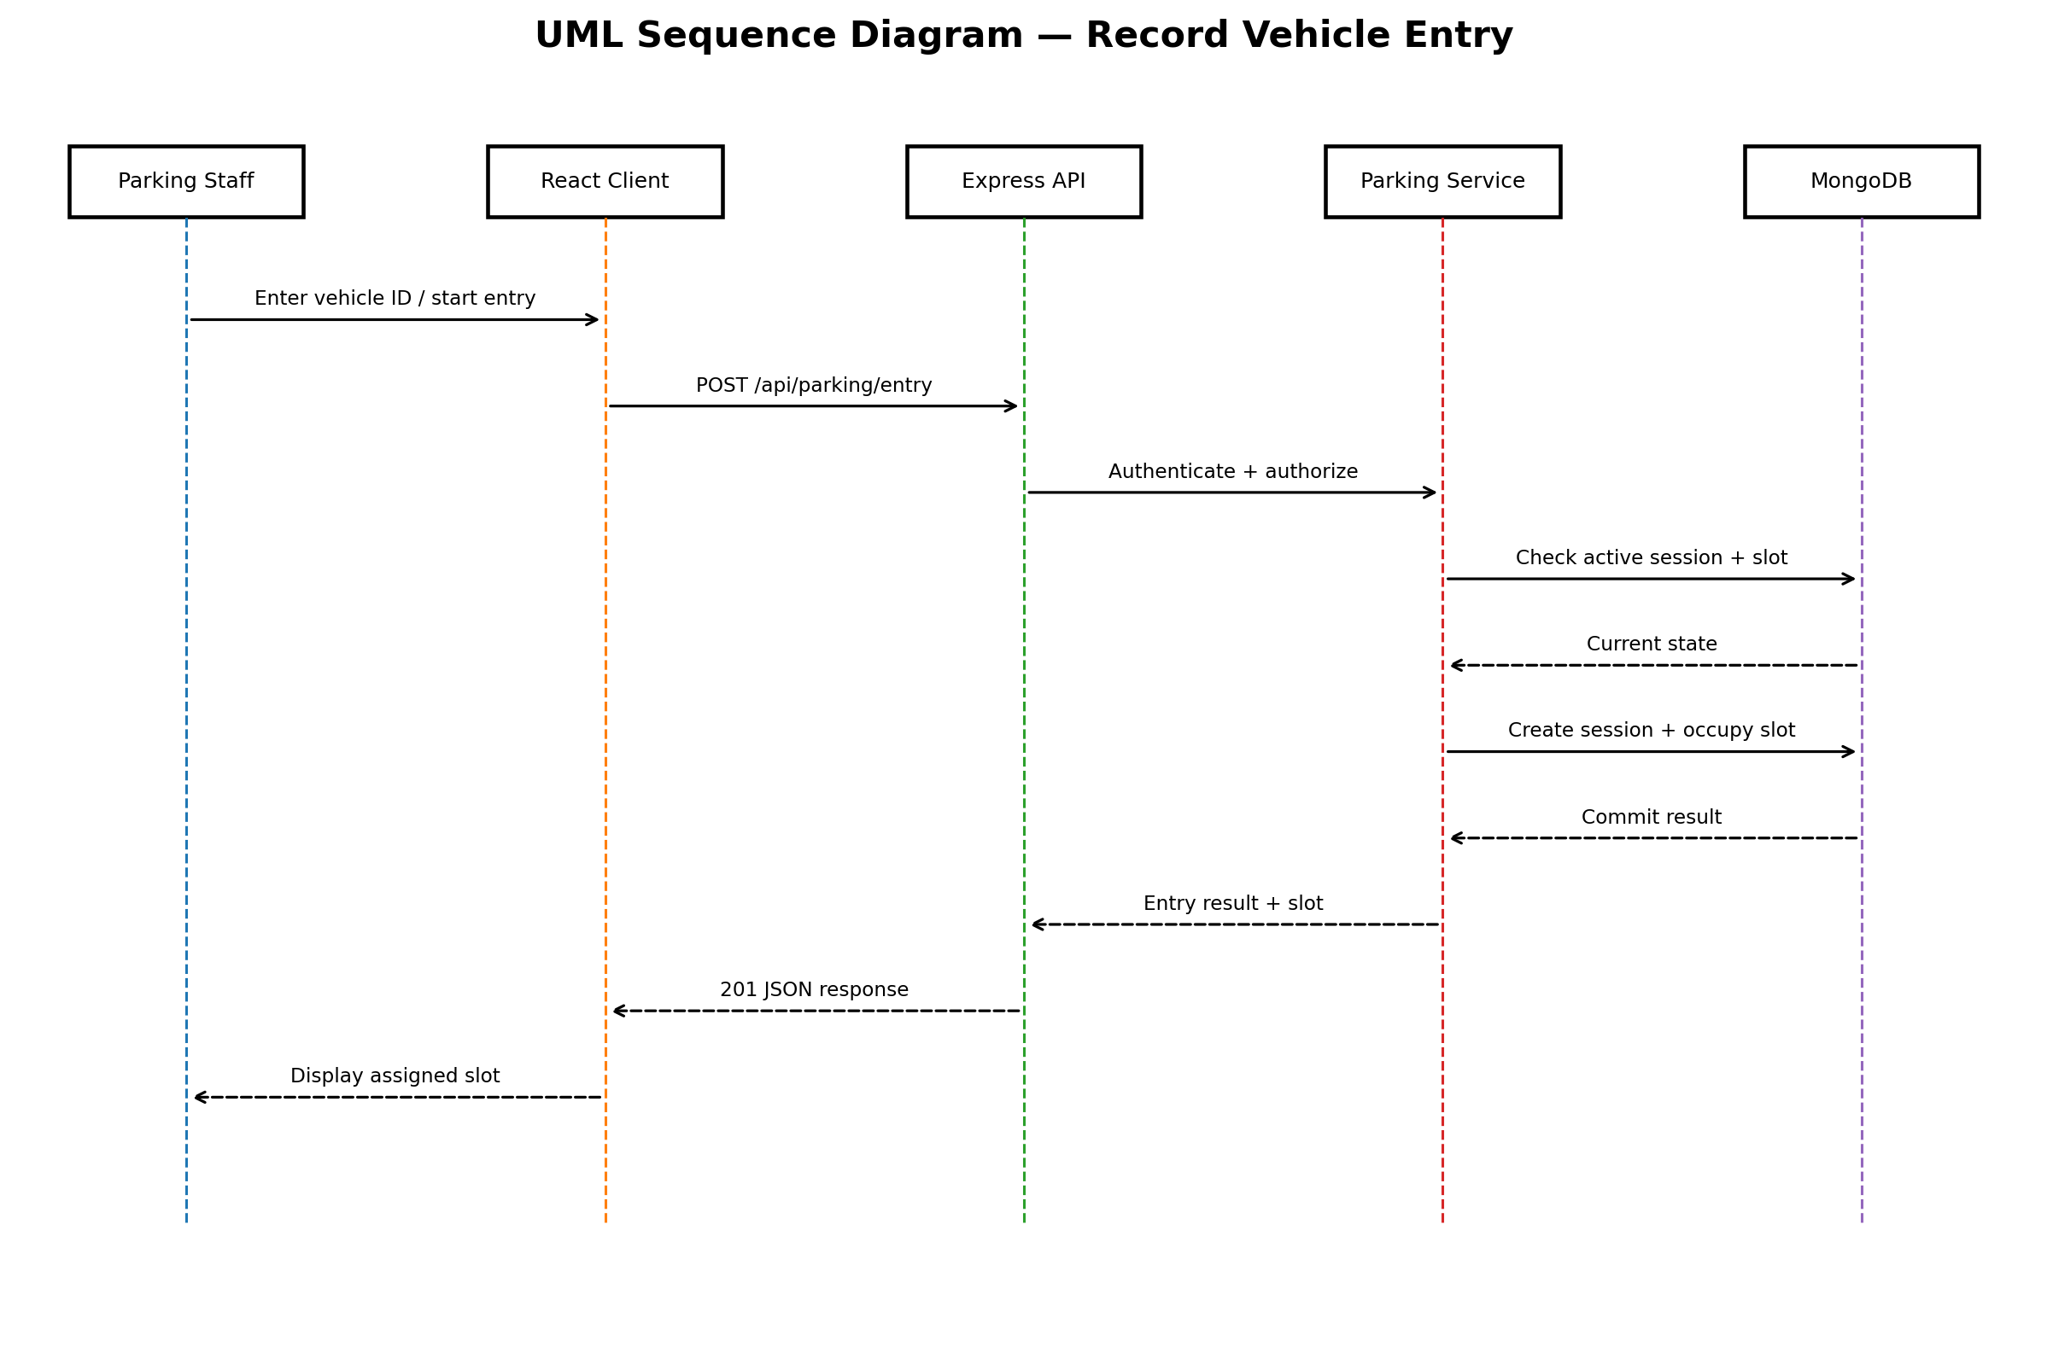
Figure 3. UML Sequence Diagram — Record Vehicle Entry
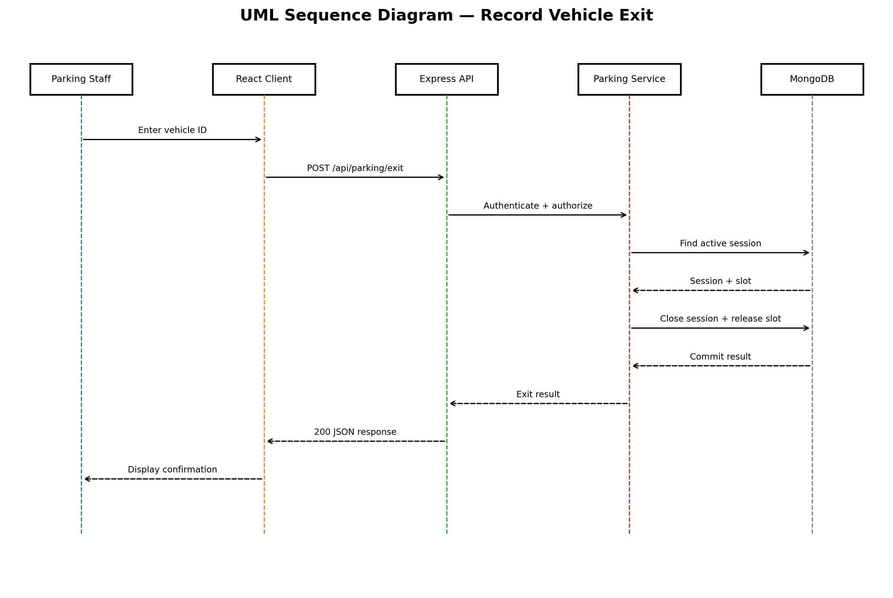
Figure 4. UML Sequence Diagram — Record Vehicle Exit

4.3 API Design

4.3.1 API Request / Response Conventions
- JSON request and response bodies.
- Authentication credentials/tokens are sent only through protected HTTPS requests in production.
- Successful operations return the requested resource/result and an appropriate 2xx status.
- Validation failures use 400; authentication failures use 401; authorization failures use 403; conflicts such as duplicate vehicle/active session use 409; missing resources use 404; unexpected server failures use 500.
- Error responses use a stable shape such as { code, message, requestId } and never expose stack traces or secrets.

4.3.2 Interface Definitions for Core Components
Method | Endpoint | Purpose | Access | Response
POST | /api/auth/register | Create account | Public | User account
POST | /api/auth/login | Authenticate user | Public | Session/token
GET | /api/vehicles | List permitted vehicles | User/Staff/Admin | Vehicle list
POST | /api/vehicles | Register vehicle | User | Vehicle
PATCH | /api/vehicles/:id | Update permitted vehicle | Owner/Admin as defined | Vehicle
GET | /api/slots | View slot states | Authenticated | Slot list
POST | /api/slots | Create slot | Admin | Slot
PATCH | /api/slots/:id/status | Update slot status | Admin | Slot
POST | /api/parking/entry | Record entry and allocate slot | Staff | Parking session
GET | /api/parking/active/:registration | Search active vehicle | Staff/Admin | Session + slot
GET | /api/vehicles/:id/current-slot | Get current slot | Permitted user/staff/admin | Slot
POST | /api/parking/exit | Record exit/release slot | Staff | Completed session
GET | /api/vehicles/:id/history | View parking history | Owner/authorized | History
GET | /api/admin/occupancy | Occupancy monitoring | Admin | Occupancy summary
GET | /api/admin/audit | Audit records | Admin | Audit events
GET | /api/health | Service health | Operational | Health status

4.4 Error Handling, Logging & Monitoring

4.4.1 Error Handling
Scenario | HTTP | Response behavior
Malformed/invalid input | 400 | Validation code/message; no state change.
Missing/invalid authentication | 401 | Generic authentication failure; no protected data.
Insufficient role | 403 | Authorization failure; no state change.
Resource not found | 404 | Resource-not-found message.
Duplicate/conflicting state | 409 | Conflict message; transaction/state remains consistent.
Unexpected server/database error | 500 | Generic message with request ID; detailed diagnostics stay server-side.

4.4.2 Logging and Audit Design
- Application logs contain timestamp, severity, component, request identifier and diagnostic context.
- Audit logs contain actor, action, target/context, timestamp and result.
- Passwords, access tokens and authentication secrets are excluded from audit and application logs.
- Administrative slot changes, authentication failures and other security-sensitive events are auditable.

4.4.3 Monitoring
Metric | Purpose | Related requirement
API response P95 | Detect performance degradation | VPS-NF-001
Health-check availability | Track uptime/recovery | VPS-NF-002
Entry/exit conflict rate | Detect consistency failures | VPS-NF-004
Authentication/authorization failures | Detect security issues | VPS-SR-001/002
Audit write/retrieval status | Verify accountability and retention | VPS-F-017 / NF-006

4.5 UX Design
Role | Primary UI flows | UX requirements
Vehicle Owner/User | Login → vehicles → availability/current slot → history | Clear ownership boundaries, readable validation and status.
Parking Staff | Login → entry → available slot → active search → exit | Minimize steps; show slot/session state immediately after operations.
Parking Administrator | Login → slot management → occupancy → active vehicles → audit | Provide clear administrative status and role-protected actions.

- Validation feedback is displayed next to or near the relevant field.
- State-changing actions provide success/failure feedback.
- Unavailable/occupied slots are visually distinguishable from Available slots.
- Unauthorized functions are hidden where practical and always protected by backend authorization.
- Error messages are understandable without revealing implementation details.

4.6 Open Issues & Next Steps
Item | Status / next step
Implementation endpoint naming | Align concrete route names with the implemented Express project before code freeze.
Normal-load profile | Confirm the operational profile used for TC-NF-001 before measurement.
Availability measurement | Run monitoring for the defined test window and retain evidence for TC-NF-002.
Security validation evidence | Execute STP Section 5.1 checks and attach evidence/results.
Requirement change control | Any payment, reservation or hardware addition requires SRS/SAD/STP revision.
Final traceability | Replace planned N statuses with actual Pass/Fail evidence after execution.

5. Appendices

5.1 Glossary
Term | Meaning
SRS | Software Requirements Specification
SAD | Software Architecture and Design Specification
STP | Software Test Plan
RTM | Requirements Traceability Matrix
FR/NFR/SR | Functional / Non-functional / Security Requirement
RBAC | Role-Based Access Control
REST | Representational State Transfer
TLS | Transport Layer Security
ADR | Architecture Decision Record
P95 | 95th percentile response time
Parking Session | Active or completed record connecting a vehicle and slot

5.2 References
- Vehicle Parking System — Software Requirements Specification (SRS), Team 5, Version 1.0, 28-09-2026.
- Vehicle Parking System — Software Test Plan (STP), Team 5, Version 1.0, 28-09-2026.
- Software Engineering Mini-Project Deliverables Part-1 guideline, ETA 28-09-2026.
- SRS Template for SE, supplied course template.
- OWASP security guidance referenced by the Team 5 Test Plan.

5.3 Tools
- Microsoft Word / python-docx for document preparation
- Draw.io / diagram tooling for UML artifacts
- React, Node.js, Express.js and MongoDB for implementation
- Jest, Supertest, React Testing Library, Postman/Newman, Cypress/Selenium, JMeter and OWASP ZAP as specified in the Test Plan

