**User Interface and Practice**

**Homework 1 2015**

**Tic Tac Toe**

|  |  |
| --- | --- |
| Student Name | Park Young Jun |
| Student ID | 20122379 |

**Group : 가 나 다 라**

AndroidManifest.xml

*<?***xml version="1.0" encoding="utf-8"***?>*<**manifest xmlns:android="http://schemas.android.com/apk/res/android"  
 package="com.example.park.assignment1"** >  
  
 <**uses-permission android:name="android.permission.VIBRATE"**/>  
  
  
 <**application  
 android:allowBackup="true"  
 android:icon="@mipmap/ic_launcher"  
 android:label="@string/app_name"  
 android:theme="@style/AppTheme"** >  
 <**activity  
 android:name=".Start"  
 android:screenOrientation="portrait"  
 android:configChanges="orientation|keyboardHidden"  
 android:theme="@android:style/Theme.NoTitleBar"**/>  
 <**activity  
 android:name=".MainActivity"  
 android:label="@string/app_name"** >  
 <**intent-filter**>  
 <**action android:name="android.intent.action.MAIN"** />  
  
 <**category android:name="android.intent.category.LAUNCHER"** />  
 </**intent-filter**>  
 </**activity**>  
 </**application**>  
  
</**manifest**>

activity_main.xml

<**RelativeLayout xmlns:android="http://schemas.android.com/apk/res/android"  
 xmlns:tools="http://schemas.android.com/tools" android:layout_width="match_parent"  
 android:layout_height="match_parent" android:paddingLeft="@dimen/activity_horizontal_margin"  
 android:paddingRight="@dimen/activity_horizontal_margin"  
 android:paddingTop="@dimen/activity_vertical_margin"  
 android:paddingBottom="@dimen/activity_vertical_margin" tools:context=".MainActivity"  
 android:background="@drawable/back"**>  
  
 <**Button android:id="@+id/resetbutton"  
 android:layout_height="wrap_content"  
 android:layout_width="wrap_content"  
 android:text="New Game"  
 android:textSize="20dp"  
 android:layout_centerHorizontal="true"  
 android:background="#00000000"**/>  
  
 <**TableLayout android:id="@+id/table"  
 android:layout_height="fill_parent"  
 android:layout_width="fill_parent"  
 android:layout_below="@+id/resetbutton"  
 android:layout_marginTop="30dp"**>  
  
 <**TableRow android:layout_width="wrap_content"  
 android:layout_height="wrap_content"**>  
 <**Button  
 android:id="@+id/button11"  
 android:layout_weight="2"**/>  
 <**Button  
 android:id="@+id/button12"  
 android:layout_weight="2"**/>  
 <**Button  
 android:id="@+id/button13"  
 android:layout_weight="2"**/>  
 <**Button  
 android:id="@+id/button14"  
 android:layout_weight="2"**/>  
 <**Button  
 android:id="@+id/button15"  
 android:layout_weight="2"**/>  
 </**TableRow**>  
  
 <**TableRow android:layout_width="match_parent"  
 android:layout_height="wrap_content"**>  
 <**Button  
 android:id="@+id/button21"  
 android:layout_weight="2"**/>  
 <**Button  
 android:id="@+id/button22"  
 android:layout_weight="2"**/>  
 <**Button  
 android:id="@+id/button23"  
 android:layout_weight="2"**/>  
 <**Button  
 android:id="@+id/button24"  
 android:layout_weight="2"**/>  
 <**Button  
 android:id="@+id/button25"  
 android:layout_weight="2"**/>  
 </**TableRow**>  
  
 <**TableRow android:layout_width="match_parent"  
 android:layout_height="wrap_content"**>  
 <**Button  
 android:id="@+id/button31"  
 android:layout_weight="2"**/>  
 <**Button  
 android:id="@+id/button32"  
 android:layout_weight="2"**/>  
 <**Button  
 android:id="@+id/button33"  
 android:layout_weight="2"**/>  
 <**Button  
 android:id="@+id/button34"  
 android:layout_weight="2"**/>  
 <**Button  
 android:id="@+id/button35"  
 android:layout_weight="2"**/>  
 </**TableRow**>  
  
 <**TableRow android:layout_width="match_parent"  
 android:layout_height="wrap_content"**>  
 <**Button  
 android:id="@+id/button41"  
 android:layout_weight="2"**/>  
 <**Button  
 android:id="@+id/button42"  
 android:layout_weight="2"**/>  
 <**Button  
 android:id="@+id/button43"  
 android:layout_weight="2"**/>  
 <**Button  
 android:id="@+id/button44"  
 android:layout_weight="2"**/>  
 <**Button  
 android:id="@+id/button45"  
 android:layout_weight="2"**/>  
 </**TableRow**>  
  
 <**TableRow android:layout_width="match_parent"  
 android:layout_height="wrap_content"**>  
 <**Button  
 android:id="@+id/button51"  
 android:layout_weight="2"**/>  
 <**Button  
 android:id="@+id/button52"  
 android:layout_weight="2"**/>  
 <**Button  
 android:id="@+id/button53"  
 android:layout_weight="2"**/>  
 <**Button  
 android:id="@+id/button54"  
 android:layout_weight="2"** />  
 <**Button  
 android:id="@+id/button55"  
 android:layout_weight="2"** />  
 </**TableRow**>>  
  
 </**TableLayout**>>  
  
</**RelativeLayout**>

start.xml

*<?***xml version="1.0" encoding="utf-8"***?>*<**LinearLayout xmlns:android="http://schemas.android.com/apk/res/android"  
 android:orientation="vertical" android:layout_width="fill_parent"  
 android:layout_height="fill_parent"  
 android:background="#999999"**>  
  
 <**ImageView  
 android:layout_height="fill_parent"  
 android:layout_width="fill_parent"  
 android:src="@drawable/start"  
 android:scaleType="fitXY"**/>  
  
</**LinearLayout**>

inputdialog.xml

*<?***xml version="1.0" encoding="utf-8"***?>*<**RelativeLayout xmlns:android="http://schemas.android.com/apk/res/android"  
 android:orientation="vertical" android:layout_width="match_parent"  
 android:layout_height="match_parent"**>  
  
 <**TextView android:layout_height="45dp"  
 android:layout_width="match_parent"  
 android:background="#00000F"  
 android:text="What is Player1's name?"  
 android:textSize="20dp"  
 android:textColor="#FFFFFF"  
 android:gravity="center"** />  
  
 <**EditText android:id="@+id/dialogtext"  
 android:layout_width="match_parent"  
 android:layout_height="wrap_content"  
 android:layout_marginTop="80dp"  
 android:layout_marginBottom="20dp"** />  
  
 <**Button android:id="@+id/yes"  
 android:layout_below="@+id/dialogtext"  
 android:layout_width="wrap_content"  
 android:layout_height="wrap_content"  
 android:text="OK"  
 android:onClick="ye"  
 android:layout_centerHorizontal="true"** />  
  
</**RelativeLayout**>

inputdialog2.xml

*<?***xml version="1.0" encoding="utf-8"***?>*<**RelativeLayout xmlns:android="http://schemas.android.com/apk/res/android"  
 android:orientation="vertical" android:layout_width="match_parent"  
 android:layout_height="match_parent"**>  
  
 <**TextView android:layout_height="45dp"  
 android:layout_width="match_parent"  
 android:background="#00000F"  
 android:text="What is Player2's name?"  
 android:textSize="20dp"  
 android:textColor="#FFFFFF"  
 android:gravity="center"** />  
  
 <**EditText android:id="@+id/dialogtext"  
 android:layout_width="match_parent"  
 android:layout_height="wrap_content"  
 android:layout_marginTop="80dp"  
 android:layout_marginBottom="20dp"** />  
  
 <**Button android:id="@+id/yes"  
 android:layout_below="@+id/dialogtext"  
 android:layout_width="wrap_content"  
 android:layout_height="wrap_content"  
 android:text="OK"  
 android:onClick="ye"  
 android:layout_centerHorizontal="true"** />  
  
</**RelativeLayout**>

MainActivity.java

**package** com.example.park.assignment1;  
  
**import** android.annotation.TargetApi;  
**import** android.app.Dialog;  
**import** android.app.FragmentManager;  
**import** android.content.Context;  
**import** android.content.Intent;  
**import** android.graphics.Bitmap;  
**import** android.graphics.BitmapFactory;  
**import** android.graphics.drawable.BitmapDrawable;  
**import** android.graphics.drawable.Drawable;  
**import** android.media.MediaPlayer;  
**import** android.os.Build;  
**import** android.os.Vibrator;  
**import** android.support.v7.app.AppCompatActivity;  
**import** android.os.Bundle;  
**import** android.view.Menu;  
**import** android.view.MenuItem;  
**import** android.view.View;  
**import** android.widget.Button;  
**import** android.widget.Toast;  
  
**public class** MainActivity **extends** AppCompatActivity {  
 **int locate**[][];  
 **int num**;  
  
 Button **reset**;  
 Button **button11**, **button12**, **button13**, **button14**, **button15**;  
 Button **button21**, **button22**, **button23**, **button24**, **button25**;  
 Button **button31**, **button32**, **button33**, **button34**, **button35**;  
 Button **button41**, **button42**, **button43**, **button44**, **button45**;  
 Button **button51**, **button52**, **button53**, **button54**, **button55**;  
  
 Bitmap **bit1**, **bit2**, **bit3**;  
 Drawable **draw1**, **draw2**, **draw3**;  
 FragmentManager **fm** = getFragmentManager();  
  
 MediaPlayer **sound_background**;  
 Vibrator **vibe**;  
  
 @Override  
 **protected void** onCreate(Bundle savedInstanceState){  
 **super**.onCreate(savedInstanceState);  
 setContentView(R.layout.***activity_main***);  
  
 startActivity(**new** Intent(**this**, Start.**class**));  
  
 **sound_background** = MediaPlayer.*create*(**this**,R.raw.***bgm***);  
 **sound_background**.start();  
 **sound_background**.setLooping(**true**);  
  
 **vibe** = (Vibrator) getSystemService(Context.***VIBRATOR_SERVICE***);  
  
 **reset** = (Button) findViewById(R.id.***resetbutton***);  
 **button11** = (Button) findViewById(R.id.***button11***);  
 **button12** = (Button) findViewById(R.id.***button12***);  
 **button13** = (Button) findViewById(R.id.***button13***);  
 **button14** = (Button) findViewById(R.id.***button14***);  
 **button15** = (Button) findViewById(R.id.***button15***);  
 **button21** = (Button) findViewById(R.id.***button21***);  
 **button22** = (Button) findViewById(R.id.***button22***);  
 **button23** = (Button) findViewById(R.id.***button23***);  
 **button24** = (Button) findViewById(R.id.***button24***);  
 **button25** = (Button) findViewById(R.id.***button25***);  
 **button31** = (Button) findViewById(R.id.***button31***);  
 **button32** = (Button) findViewById(R.id.***button32***);  
 **button33** = (Button) findViewById(R.id.***button33***);  
 **button34** = (Button) findViewById(R.id.***button34***);  
 **button35** = (Button) findViewById(R.id.***button35***);  
 **button41** = (Button) findViewById(R.id.***button41***);  
 **button42** = (Button) findViewById(R.id.***button42***);  
 **button43** = (Button) findViewById(R.id.***button43***);  
 **button44** = (Button) findViewById(R.id.***button44***);  
 **button45** = (Button) findViewById(R.id.***button45***);  
 **button51** = (Button) findViewById(R.id.***button51***);  
 **button52** = (Button) findViewById(R.id.***button52***);  
 **button53** = (Button) findViewById(R.id.***button53***);  
 **button54** = (Button) findViewById(R.id.***button54***);  
 **button55** = (Button) findViewById(R.id.***button55***);  
  
 **num** = 0; *// odd or even number deter player* **locate** = **new int**[5][5]; *//* **for** (**int** i = 0; i < 5; ++i)  
 **for** (**int** j = 0; j < 5; ++j)  
 **locate**[i][j] = -1;  
  
 **bit1** = BitmapFactory.*decodeResource*(getResources(), R.drawable.***images1***);  
 **bit2** = BitmapFactory.*decodeResource*(getResources(), R.drawable.***images2***);  
 **bit3** = BitmapFactory.*decodeResource*(getResources(), R.drawable.***images3***);  
  
 **draw1** = **new** BitmapDrawable(getResources(), **bit1**);  
 **draw2** = **new** BitmapDrawable(getResources(), **bit2**);  
 **draw3** = **new** BitmapDrawable(getResources(), **bit3**);  
  
 picreset();  
  
 **reset**.setOnClickListener(**new** View.OnClickListener(){  
 **public void** onClick(View view){  
  
 **sound_background**.start();  
  
 picreset();  
  
 **for**(**int** i = 0 ; i < 5 ; ++i)  
 **for**(**int** j = 0 ; j < 5 ; ++j)  
 **locate**[i][j] = -1;  
  
 **num**=0;  
  
 }  
 });  
  
 **button11**.setOnClickListener(**new** View.OnClickListener() {  
 @TargetApi(Build.VERSION_CODES.***JELLY_BEAN***)  
 **public void** onClick(View view) {  
 **if** (**locate**[0][0] == -1) {  
 **if** ((++**num**) % 2 == 1) {  
 **button11**.setBackground(**draw1**);  
 **locate**[0][0] = 1;  
 } **else** {  
 **button11**.setBackground(**draw2**);  
 **locate**[0][0] = 2;  
 }  
  
 Checkfin();  
  
 } **else if**(**locate**[0][0] == 3){  
 Finished();  
 }**else** Checked();  
 }  
 });  
 **button12**.setOnClickListener(**new** View.OnClickListener() {  
 @TargetApi(Build.VERSION_CODES.***JELLY_BEAN***)  
 **public void** onClick(View view) {  
 **if** (**locate**[0][1] == -1) {  
 **if** ((++**num**) % 2 == 1) {  
 **button12**.setBackground(**draw1**);  
 **locate**[0][1] = 1;  
 } **else** {  
 **button12**.setBackground(**draw2**);  
 **locate**[0][1] = 2;  
 }  
  
 Checkfin();  
  
 } **else if**(**locate**[0][1] == 3){  
 Finished();  
 }**else** Checked();  
 }  
 });  
 **button13**.setOnClickListener(**new** View.OnClickListener() {  
 @TargetApi(Build.VERSION_CODES.***JELLY_BEAN***)  
 **public void** onClick(View view) {  
 **if** (**locate**[0][2] == -1) {  
 **if** ((++**num**) % 2 == 1) {  
 **button13**.setBackground(**draw1**);  
 **locate**[0][2] = 1;  
 } **else** {  
 **button13**.setBackground(**draw2**);  
 **locate**[0][2] = 2;  
 }  
  
 Checkfin();  
  
 } **else if**(**locate**[0][2] == 3){  
 Finished();  
 }**else** Checked();  
 }  
 });  
 **button14**.setOnClickListener(**new** View.OnClickListener() {  
 @TargetApi(Build.VERSION_CODES.***JELLY_BEAN***)  
 **public void** onClick(View view) {  
 **if** (**locate**[0][3] == -1) {  
 **if** ((++**num**) % 2 == 1) {  
 **button14**.setBackground(**draw1**);  
 **locate**[0][3] = 1;  
 } **else** {  
 **button14**.setBackground(**draw2**);  
 **locate**[0][3] = 2;  
 }  
  
 Checkfin();  
  
 } **else if**(**locate**[0][3] == 3){  
 Finished();  
 }**else** Checked();  
 }  
 });  
 **button15**.setOnClickListener(**new** View.OnClickListener() {  
 @TargetApi(Build.VERSION_CODES.***JELLY_BEAN***)  
 **public void** onClick(View view) {  
 **if** (**locate**[0][4] == -1) {  
 **if** ((++**num**) % 2 == 1) {  
 **button15**.setBackground(**draw1**);  
 **locate**[0][4] = 1;  
 } **else** {  
 **button15**.setBackground(**draw2**);  
 **locate**[0][4] = 2;  
 }  
  
 Checkfin();  
  
 } **else if**(**locate**[0][4] == 3){  
 Finished();  
 }**else** Checked();  
 }  
 });  
 **button21**.setOnClickListener(**new** View.OnClickListener() {  
 @TargetApi(Build.VERSION_CODES.***JELLY_BEAN***)  
 **public void** onClick(View view) {  
 **if** (**locate**[1][0] == -1) {  
 **if** ((++**num**) % 2 == 1) {  
 **button21**.setBackground(**draw1**);  
 **locate**[1][0] = 1;  
 } **else** {  
 **button21**.setBackground(**draw2**);  
 **locate**[1][0] = 2;  
 }  
  
 Checkfin();  
  
 } **else if**(**locate**[1][0] == 3){  
 Finished();  
 }**else** Checked();  
 }  
 });  
 **button22**.setOnClickListener(**new** View.OnClickListener() {  
 @TargetApi(Build.VERSION_CODES.***JELLY_BEAN***)  
 **public void** onClick(View view) {  
 **if** (**locate**[1][1] == -1) {  
 **if** ((++**num**) % 2 == 1) {  
 **button22**.setBackground(**draw1**);  
 **locate**[1][1] = 1;  
 } **else** {  
 **button22**.setBackground(**draw2**);  
 **locate**[1][1] = 2;  
 }  
  
 Checkfin();  
  
 } **else if**(**locate**[1][1] == 3){  
 Finished();  
 }**else** Checked();  
 }  
 });  
 **button23**.setOnClickListener(**new** View.OnClickListener() {  
 @TargetApi(Build.VERSION_CODES.***JELLY_BEAN***)  
 **public void** onClick(View view) {  
 **if** (**locate**[1][2] == -1) {  
 **if** ((++**num**) % 2 == 1) {  
 **button23**.setBackground(**draw1**);  
 **locate**[1][2] = 1;  
 } **else** {  
 **button23**.setBackground(**draw2**);  
 **locate**[1][2] = 2;  
 }  
  
 Checkfin();  
  
 } **else if**(**locate**[1][2] == 3){  
 Finished();  
 }**else** Checked();  
 }  
 });  
 **button24**.setOnClickListener(**new** View.OnClickListener() {  
 @TargetApi(Build.VERSION_CODES.***JELLY_BEAN***)  
 **public void** onClick(View view) {  
 **if** (**locate**[1][3] == -1) {  
 **if** ((++**num**) % 2 == 1) {  
 **button24**.setBackground(**draw1**);  
 **locate**[1][3] = 1;  
 } **else** {  
 **button24**.setBackground(**draw2**);  
 **locate**[1][3] = 2;  
 }  
  
 Checkfin();  
  
 } **else if**(**locate**[1][3] == 3){  
 Finished();  
 }**else** Checked();  
 }  
 });  
 **button25**.setOnClickListener(**new** View.OnClickListener() {  
 @TargetApi(Build.VERSION_CODES.***JELLY_BEAN***)  
 **public void** onClick(View view) {  
 **if** (**locate**[1][4] == -1) {  
 **if** ((++**num**) % 2 == 1) {  
 **button25**.setBackground(**draw1**);  
 **locate**[1][4] = 1;  
 } **else** {  
 **button25**.setBackground(**draw2**);  
 **locate**[1][4] = 2;  
 }  
  
 Checkfin();  
  
 } **else if**(**locate**[1][4] == 3){  
 Finished();  
 }**else** Checked();  
 }  
 });  
 **button31**.setOnClickListener(**new** View.OnClickListener() {  
 @TargetApi(Build.VERSION_CODES.***JELLY_BEAN***)  
 **public void** onClick(View view) {  
 **if** (**locate**[2][0] == -1) {  
 **if** ((++**num**) % 2 == 1) {  
 **button31**.setBackground(**draw1**);  
 **locate**[2][0] = 1;  
 } **else** {  
 **button31**.setBackground(**draw2**);  
 **locate**[2][0] = 2;  
 }  
  
 Checkfin();  
  
 } **else if**(**locate**[2][0] == 3){  
 Finished();  
 }**else** Checked();  
 }  
 });  
 **button32**.setOnClickListener(**new** View.OnClickListener() {  
 @TargetApi(Build.VERSION_CODES.***JELLY_BEAN***)  
 **public void** onClick(View view) {  
 **if** (**locate**[2][1] == -1) {  
 **if** ((++**num**) % 2 == 1) {  
 **button32**.setBackground(**draw1**);  
 **locate**[2][1] = 1;  
 } **else** {  
 **button32**.setBackground(**draw2**);  
 **locate**[2][1] = 2;  
 }  
  
 Checkfin();  
  
 } **else if**(**locate**[2][1] == 3){  
 Finished();  
 }**else** Checked();  
 }  
 });  
 **button33**.setOnClickListener(**new** View.OnClickListener() {  
 @TargetApi(Build.VERSION_CODES.***JELLY_BEAN***)  
 **public void** onClick(View view) {  
 **if** (**locate**[2][2] == -1) {  
 **if** ((++**num**) % 2 == 1) {  
 **button33**.setBackground(**draw1**);  
 **locate**[2][2] = 1;  
 } **else** {  
 **button33**.setBackground(**draw2**);  
 **locate**[2][2] = 2;  
 }  
  
 Checkfin();  
  
 } **else if**(**locate**[2][2] == 3){  
 Finished();  
 }**else** Checked();  
 }  
 });  
 **button34**.setOnClickListener(**new** View.OnClickListener() {  
 @TargetApi(Build.VERSION_CODES.***JELLY_BEAN***)  
 **public void** onClick(View view) {  
 **if** (**locate**[2][3] == -1) {  
 **if** ((++**num**) % 2 == 1) {  
 **button34**.setBackground(**draw1**);  
 **locate**[2][3] = 1;  
 } **else** {  
 **button34**.setBackground(**draw2**);  
 **locate**[2][3] = 2;  
 }  
  
 Checkfin();  
  
 } **else if**(**locate**[2][3] == 3){  
 Finished();  
 }**else** Checked();  
 }  
 });  
 **button35**.setOnClickListener(**new** View.OnClickListener() {  
 @TargetApi(Build.VERSION_CODES.***JELLY_BEAN***)  
 **public void** onClick(View view) {  
 **if** (**locate**[2][4] == -1) {  
 **if** ((++**num**) % 2 == 1) {  
 **button35**.setBackground(**draw1**);  
 **locate**[2][4] = 1;  
 } **else** {  
 **button35**.setBackground(**draw2**);  
 **locate**[2][4] = 2;  
 }  
  
 Checkfin();  
  
 } **else if**(**locate**[2][4] == 3){  
 Finished();  
 }**else** Checked();  
 }  
 });  
 **button41**.setOnClickListener(**new** View.OnClickListener() {  
 @TargetApi(Build.VERSION_CODES.***JELLY_BEAN***)  
 **public void** onClick(View view) {  
 **if** (**locate**[3][0] == -1) {  
 **if** ((++**num**) % 2 == 1) {  
 **button41**.setBackground(**draw1**);  
 **locate**[3][0] = 1;  
 } **else** {  
 **button41**.setBackground(**draw2**);  
 **locate**[3][0] = 2;  
 }  
  
 Checkfin();  
  
 } **else if**(**locate**[3][0] == 3){  
 Finished();  
 }**else** Checked();  
 }  
 });  
 **button42**.setOnClickListener(**new** View.OnClickListener() {  
 @TargetApi(Build.VERSION_CODES.***JELLY_BEAN***)  
 **public void** onClick(View view) {  
 **if** (**locate**[3][1] == -1) {  
 **if** ((++**num**) % 2 == 1) {  
 **button42**.setBackground(**draw1**);  
 **locate**[3][1] = 1;  
 } **else** {  
 **button42**.setBackground(**draw2**);  
 **locate**[3][1] = 2;  
 }  
  
 Checkfin();  
  
 } **else if**(**locate**[3][1] == 3){  
 Finished();  
 }**else** Checked();  
 }  
 });  
 **button43**.setOnClickListener(**new** View.OnClickListener() {  
 @TargetApi(Build.VERSION_CODES.***JELLY_BEAN***)  
 **public void** onClick(View view) {  
 **if** (**locate**[3][2] == -1) {  
 **if** ((++**num**) % 2 == 1) {  
 **button43**.setBackground(**draw1**);  
 **locate**[3][2] = 1;  
 } **else** {  
 **button43**.setBackground(**draw2**);  
 **locate**[3][2] = 2;  
 }  
  
 Checkfin();  
  
 } **else if**(**locate**[3][2] == 3){  
 Finished();  
 }**else** Checked();  
 }  
 });  
 **button44**.setOnClickListener(**new** View.OnClickListener() {  
 @TargetApi(Build.VERSION_CODES.***JELLY_BEAN***)  
 **public void** onClick(View view) {  
 **if** (**locate**[3][3] == -1) {  
 **if** ((++**num**) % 2 == 1) {  
 **button44**.setBackground(**draw1**);  
 **locate**[3][3] = 1;  
 } **else** {  
 **button44**.setBackground(**draw2**);  
 **locate**[3][3] = 2;  
 }  
  
 Checkfin();  
  
 } **else if**(**locate**[3][3] == 3){  
 Finished();  
 }**else** Checked();  
 }  
 });  
 **button45**.setOnClickListener(**new** View.OnClickListener() {  
 @TargetApi(Build.VERSION_CODES.***JELLY_BEAN***)  
 **public void** onClick(View view) {  
 **if** (**locate**[3][4] == -1) {  
 **if** ((++**num**) % 2 == 1) {  
 **button45**.setBackground(**draw1**);  
 **locate**[3][4] = 1;  
 } **else** {  
 **button45**.setBackground(**draw2**);  
 **locate**[3][4] = 2;  
 }  
  
 Checkfin();  
  
 } **else if**(**locate**[3][4] == 3){  
 Finished();  
 }**else** Checked();  
 }  
 });  
 **button51**.setOnClickListener(**new** View.OnClickListener() {  
 @TargetApi(Build.VERSION_CODES.***JELLY_BEAN***)  
 **public void** onClick(View view) {  
 **if** (**locate**[4][0] == -1) {  
 **if** ((++**num**) % 2 == 1) {  
 **button51**.setBackground(**draw1**);  
 **locate**[4][0] = 1;  
 } **else** {  
 **button51**.setBackground(**draw2**);  
 **locate**[4][0] = 2;  
 }  
  
 Checkfin();  
  
 } **else if**(**locate**[4][0] == 3){  
 Finished();  
 }**else** Checked();  
 }  
 });  
 **button52**.setOnClickListener(**new** View.OnClickListener() {  
 @TargetApi(Build.VERSION_CODES.***JELLY_BEAN***)  
 **public void** onClick(View view) {  
 **if** (**locate**[4][1] == -1) {  
 **if** ((++**num**) % 2 == 1) {  
 **button52**.setBackground(**draw1**);  
 **locate**[4][1] = 1;  
 } **else** {  
 **button52**.setBackground(**draw2**);  
 **locate**[4][1] = 2;  
 }  
  
 Checkfin();  
  
 } **else if**(**locate**[4][1] == 3){  
 Finished();  
 }**else** Checked();  
 }  
 });  
 **button53**.setOnClickListener(**new** View.OnClickListener() {  
 @TargetApi(Build.VERSION_CODES.***JELLY_BEAN***)  
 **public void** onClick(View view) {  
 **if** (**locate**[4][2] == -1) {  
 **if** ((++**num**) % 2 == 1) {  
 **button53**.setBackground(**draw1**);  
 **locate**[4][2] = 1;  
 } **else** {  
 **button53**.setBackground(**draw2**);  
 **locate**[4][2] = 2;  
 }  
  
 Checkfin();  
  
 } **else if**(**locate**[4][2] == 3){  
 Finished();  
 }**else** Checked();  
 }  
 });  
 **button54**.setOnClickListener(**new** View.OnClickListener() {  
 @TargetApi(Build.VERSION_CODES.***JELLY_BEAN***)  
 **public void** onClick(View view) {  
 **if** (**locate**[4][3] == -1) {  
 **if** ((++**num**) % 2 == 1) {  
 **button54**.setBackground(**draw1**);  
 **locate**[4][3] = 1;  
 } **else** {  
 **button54**.setBackground(**draw2**);  
 **locate**[4][3] = 2;  
 }  
  
 Checkfin();  
  
 } **else if**(**locate**[4][3] == 3){  
 Finished();  
 }**else** Checked();  
 }  
 });  
 **button55**.setOnClickListener(**new** View.OnClickListener() {  
 @TargetApi(Build.VERSION_CODES.***JELLY_BEAN***)  
 **public void** onClick(View view) {  
 **if** (**locate**[4][4] == -1) {  
 **if** ((++**num**) % 2 == 1) {  
 **button55**.setBackground(**draw1**);  
 **locate**[4][4] = 1;  
 } **else** {  
 **button55**.setBackground(**draw2**);  
 **locate**[4][4] = 2;  
 }  
  
 Checkfin();  
  
 } **else if**(**locate**[4][4] == 3){  
 Finished();  
 }**else** Checked();  
 }  
 });  
  
 }  
  
 @Override  
 **public boolean** onCreateOptionsMenu(Menu menu) {  
 *// Inflate the menu; this adds items to the action bar if it is present.* getMenuInflater().inflate(R.menu.***menu_main***, menu);  
 **return true**;  
 }  
  
 @Override  
 **public boolean** onOptionsItemSelected(MenuItem item) {  
 *// Handle action bar item clicks here. The action bar will  
 // automatically handle clicks on the Home/Up button, so long  
 // as you specify a parent activity in AndroidManifest.xml.* **int** id = item.getItemId();  
  
 *//noinspection SimplifiableIfStatement* **if** (id == R.id.***action_settings***) {  
 **return true**;  
 }  
  
 **return super**.onOptionsItemSelected(item);  
 }  
  
 @TargetApi(Build.VERSION_CODES.***JELLY_BEAN***)  
 **public void** picreset()  
 {  
 **button11**.setBackground(**draw3**);  
 **button12**.setBackground(**draw3**);  
 **button13**.setBackground(**draw3**);  
 **button14**.setBackground(**draw3**);  
 **button15**.setBackground(**draw3**);  
 **button21**.setBackground(**draw3**);  
 **button22**.setBackground(**draw3**);  
 **button23**.setBackground(**draw3**);  
 **button24**.setBackground(**draw3**);  
 **button25**.setBackground(**draw3**);  
 **button31**.setBackground(**draw3**);  
 **button32**.setBackground(**draw3**);  
 **button33**.setBackground(**draw3**);  
 **button34**.setBackground(**draw3**);  
 **button35**.setBackground(**draw3**);  
 **button41**.setBackground(**draw3**);  
 **button42**.setBackground(**draw3**);  
 **button43**.setBackground(**draw3**);  
 **button44**.setBackground(**draw3**);  
 **button45**.setBackground(**draw3**);  
 **button51**.setBackground(**draw3**);  
 **button52**.setBackground(**draw3**);  
 **button53**.setBackground(**draw3**);  
 **button54**.setBackground(**draw3**);  
 **button55**.setBackground(**draw3**);  
 }  
  
 **public void** Checked() {  
  
 **vibe**.vibrate(200);  
  
 Toast.*makeText*(**this**, **"Aleady Checked Choose different one"**, Toast.***LENGTH_LONG***).show();  
 }  
  
 **public void** Finished(){  
  
 **vibe**.vibrate(200);  
  
 Toast.*makeText*(**this**, **"Aleady finished"**, Toast.***LENGTH_LONG***).show();  
  
 }  
  
 **public boolean** Checkfin() {  
  
 **vibe**.vibrate(200);  
  
 **int** temp1;  
 **boolean** finish;  
  
 finish = **true**;  
 **int** winner = 0;  
  
  
 temp1 = **locate**[0][0];  
  
 **if**(temp1 != -1) {  
 **for** (**int** i = 0; i < 5; ++i) {  
 **if** (temp1 != **locate**[i][i]) {  
 finish = **false**;  
 **break**;  
 }  
 }  
  
 **if**(finish == **true**)  
 winner = temp1;  
 }  
 **else** finish = **false**;  
  
 **if**(finish == **false**) {  
 finish = **true**;  
  
 temp1 = **locate**[0][4];  
  
 **if** (temp1 != -1) {  
 **int** j = 0;  
 **for** (**int** i = 4; i >= 0; --i) {  
 **if** (temp1 != **locate**[i][j]) {  
 finish = **false**;  
 **break**;  
 }  
 j++;  
 }  
  
 **if** (finish == **true**)  
 winner = temp1;  
 } **else** finish = **false**;  
 }  
  
 **if** (finish != **true**) {  
 **int** whet = 0;  
 **for** (**int** i = 0; i < 5; ++i) {  
 **if** (finish == **true**) {  
 winner = **locate**[i-1][0];  
 whet = 1;  
 **break**;  
 }  
 temp1 = **locate**[i][0];  
 **if**(temp1 == -1)  
 {  
 **if**(i == 4)  
 **break**;  
 }  
 **else** {  
 finish = **true**;  
 **for** (**int** j = 0; j < 5; ++j) {  
 **if** (temp1 != **locate**[i][j])  
 finish = **false**;  
 }  
 }  
 }  
  
 **if**(whet != 1 && finish == **true**)  
 winner = **locate**[4][0];  
  
 }  
  
 **if** (finish != **true**) {  
 **int** whet = 0;  
  
 **for** (**int** i = 0; i < 5; ++i) {  
 **if** (finish == **true**) {  
 winner = **locate**[0][i-1];  
 whet = 1;  
 **break**;  
 }  
 temp1 = **locate**[0][i];  
 **if**(temp1 == -1)  
 {  
 **if**(i == 4)  
 {  
 **break**;  
 }  
 }**else** {  
 finish = **true**;  
 **for** (**int** j = 0; j < 5; ++j) {  
 **if** (temp1 != **locate**[j][i])  
 finish = **false**;  
 }  
 }  
 }  
  
 **if**(whet != 1 && finish == **true**)  
 winner = **locate**[0][4];  
 }  
  
  
 **if** (finish == **true**) {  
 **sound_background**.pause();  
  
 **if**(winner == 1) {  
 Inputfrag input1 = **new** Inputfrag();  
 input1.show(**fm**, **"What is Player's name ?"**);  
 }  
 **else** {  
 Inputfrag2 input2 = **new** Inputfrag2();  
 input2.show(**fm**,**"What is Player's name?"**);  
 }  
  
 **for**(**int** i = 0 ; i < 5 ; i++)  
 **for**(**int** j = 0 ; j < 5 ; j++)  
 **locate**[i][j] = 3;  
  
 **return true**;  
  
 } **else** {  
 finish = **true**;  
  
 **for** (**int** i = 0; i < 5; ++i)  
 **for** (**int** j = 0; j < 5; ++j) {  
 **if** (**locate**[i][j] == -1) {  
 finish = **false**;  
 **break**;  
 }  
 }  
  
 **if**(finish == **true**) {  
 **for**(**int** i = 0 ; i < 5 ; i++)  
 **for**(**int** j = 0 ; j < 5 ; j++)  
 **locate**[i][j] = 3;  
  
 Dialog a = **new** Dialog(**this**);  
 a.setTitle(**" No Winner!! "**);  
 a.show();  
 }  
 **return false**;  
 }  
 }  
  
}

Start.java

**package** com.example.park.assignment1;  
  
**import** android.app.Activity;  
**import** android.os.Bundle;  
**import** android.os.Handler;  
**import** android.os.Message;  
  
*/**  
 * Created by Park on 2015-10-31.  
 */***public class** Start **extends** Activity {  
  
 **public void** onCreate(Bundle savedInstanceState){  
 **super**.onCreate(savedInstanceState);  
 setContentView(R.layout.***start***);  
  
 Handler handler = **new** Handler() {  
 @Override  
 **public void** handleMessage(Message msg){  
 finish();  
 }  
 };  
  
 handler.sendEmptyMessageDelayed(0,3000);  
 }  
  
}

Inputfrag.java

**package** com.example.park.assignment1;  
  
**import** android.app.AlertDialog;  
**import** android.app.Dialog;  
**import** android.app.DialogFragment;  
**import** android.content.DialogInterface;  
**import** android.media.AudioManager;  
**import** android.media.SoundPool;  
**import** android.os.Bundle;  
**import** android.view.LayoutInflater;  
**import** android.view.View;  
**import** android.widget.Button;  
**import** android.widget.EditText;  
**import** android.widget.TextView;  
**import** android.widget.Toast;  
  
*/**  
 * Created by Park on 2015-10-24.  
 */***public class** Inputfrag **extends** DialogFragment {  
 EditText **edit**;  
 Button **ok**;  
 SoundPool **pool**;  
 **int congrat**;  
  
  
 @Override  
 **public** Dialog onCreateDialog( Bundle savedInstanceState)  
 {  
 AlertDialog.Builder a = **new** AlertDialog.Builder(getActivity());  
 **final** LayoutInflater inflater = getActivity().getLayoutInflater();  
 View view = inflater.inflate(R.layout.***inputdialog***,**null**);  
  
 **pool** = **new** SoundPool(1, AudioManager.***STREAM_MUSIC***, 0);  
  
 **congrat** = **pool**.load(getActivity(),R.raw.***victory***,1);  
  
 **edit** = (EditText)view.findViewById(R.id.***dialogtext***);  
  
 **ok** = (Button)view.findViewById(R.id.***yes***);  
  
 **ok**.setOnClickListener(**new** View.OnClickListener() {  
 **public void** onClick(View view) {  
 AlertDialog.Builder win = **new** AlertDialog.Builder(getActivity());  
  
 **if**(**edit**.getText().toString().length() != 0) {  
  
 win.setTitle(**"Winner is ~~~~"**);  
  
 win.setMessage(**" "**+**edit**.getText().toString()+**" !!!"**);  
  
 win.setPositiveButton(**"OK"**, **new** DialogInterface.OnClickListener() {  
 @Override  
 **public void** onClick(DialogInterface dialog, **int** which) {  
 }  
 });  
  
 **pool**.play(**congrat**, 1, 1, 0, 0, 1);  
  
 win.show();  
 }  
 **else** Toast.*makeText*(getActivity(), **"Please Insert Player1's Name"**, Toast.***LENGTH_LONG***).show();  
  
 }  
 });  
  
 a.setView(view);  
  
 **return** a.create();  
 }  
  
}

Inputfrag2.java

**package** com.example.park.assignment1;  
  
**import** android.app.AlertDialog;  
**import** android.app.Dialog;  
**import** android.app.DialogFragment;  
**import** android.content.DialogInterface;  
**import** android.media.AudioManager;  
**import** android.media.SoundPool;  
**import** android.os.Bundle;  
**import** android.view.LayoutInflater;  
**import** android.view.View;  
**import** android.widget.Button;  
**import** android.widget.EditText;  
**import** android.widget.TextView;  
**import** android.widget.Toast;  
  
*/**  
 * Created by Park on 2015-10-24.  
 */***public class** Inputfrag2 **extends** DialogFragment {  
 EditText **edit**;  
 Button **ok**;  
 SoundPool **pool**;  
 **int congrat**;  
  
  
 @Override  
 **public** Dialog onCreateDialog( Bundle savedInstanceState)  
 {  
 AlertDialog.Builder a = **new** AlertDialog.Builder(getActivity());  
 **final** LayoutInflater inflater = getActivity().getLayoutInflater();  
 View view = inflater.inflate(R.layout.***inputdialog2***,**null**);  
  
 **pool** = **new** SoundPool(1, AudioManager.***STREAM_MUSIC***, 0);  
  
 **congrat** = **pool**.load(getActivity(),R.raw.***victory***,1);  
  
 **edit** = (EditText)view.findViewById(R.id.***dialogtext***);  
  
 **ok** = (Button)view.findViewById(R.id.***yes***);  
  
 **ok**.setOnClickListener(**new** View.OnClickListener() {  
 **public void** onClick(View view) {  
 AlertDialog.Builder win = **new** AlertDialog.Builder(getActivity());  
  
 **if**(**edit**.getText().toString().length() != 0) {  
  
 win.setTitle(**"Winner is ~~~~"**);  
  
 win.setMessage(**" "**+ **edit**.getText().toString() + **" !!!"**);  
  
 win.setPositiveButton(**"OK"**, **new** DialogInterface.OnClickListener() {  
 @Override  
 **public void** onClick(DialogInterface dialog, **int** which) {  
 }  
 });  
  
 **pool**.play(**congrat**, 1, 1, 0, 0, 1);  
  
 win.show();  
 }  
 **else** Toast.*makeText*(getActivity(), **"Please Insert Player2's Name"**, Toast.***LENGTH_LONG***).show();  
  
 }  
 });  
  
 a.setView(view);  
  
 **return** a.create();  
 }  
  
}

ScreenShot

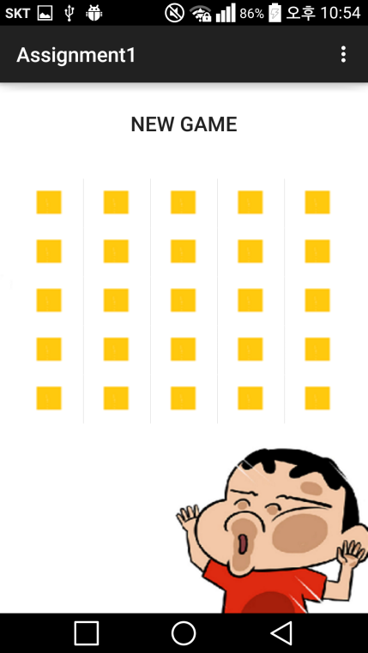

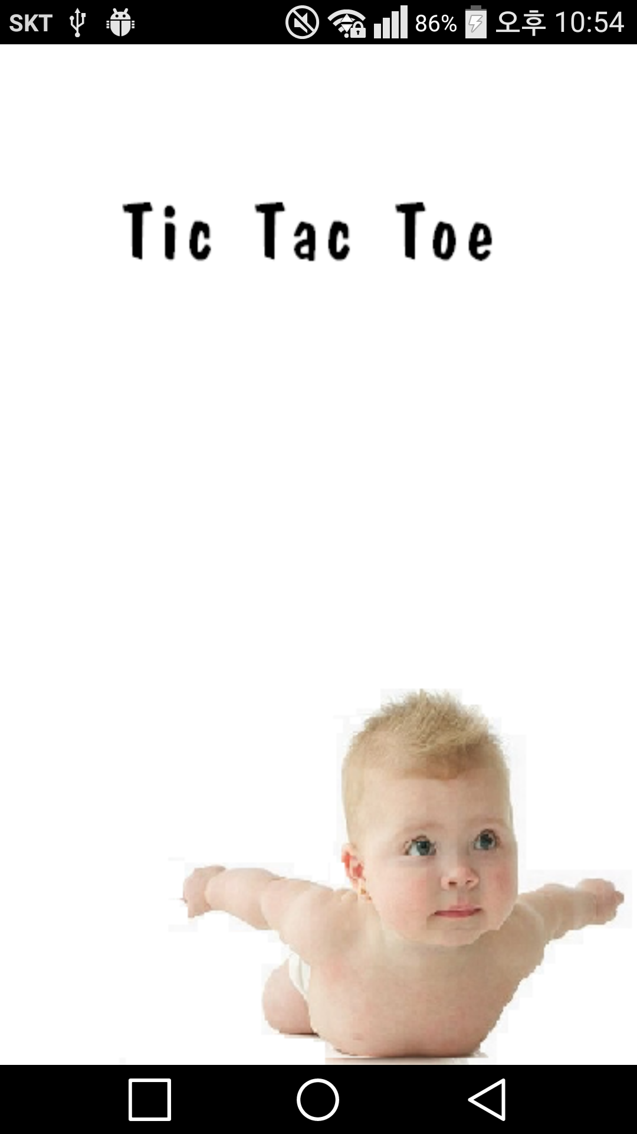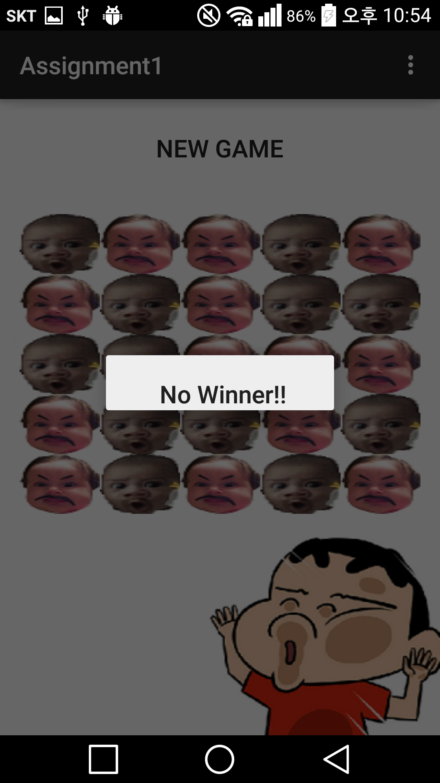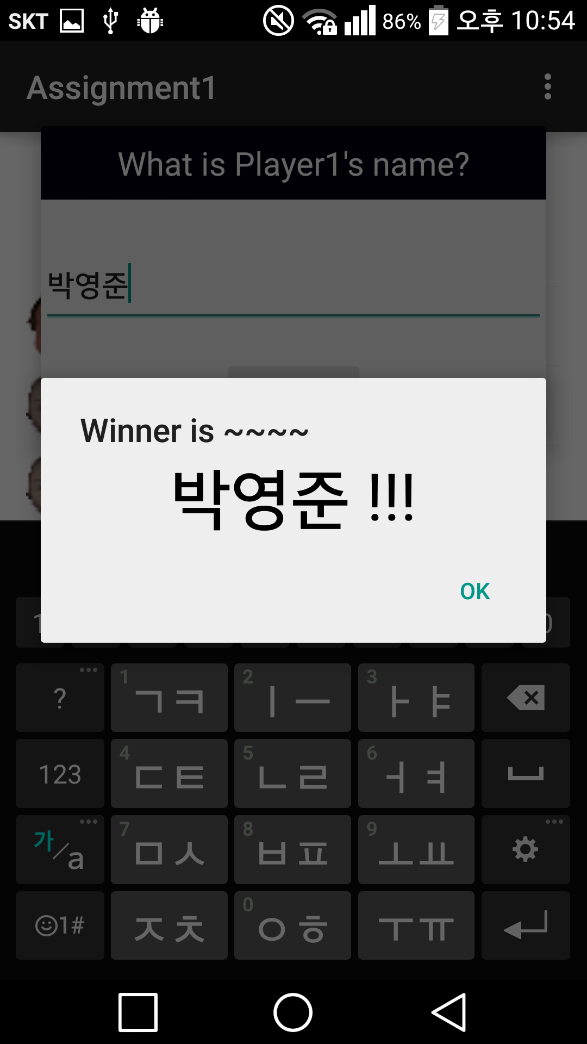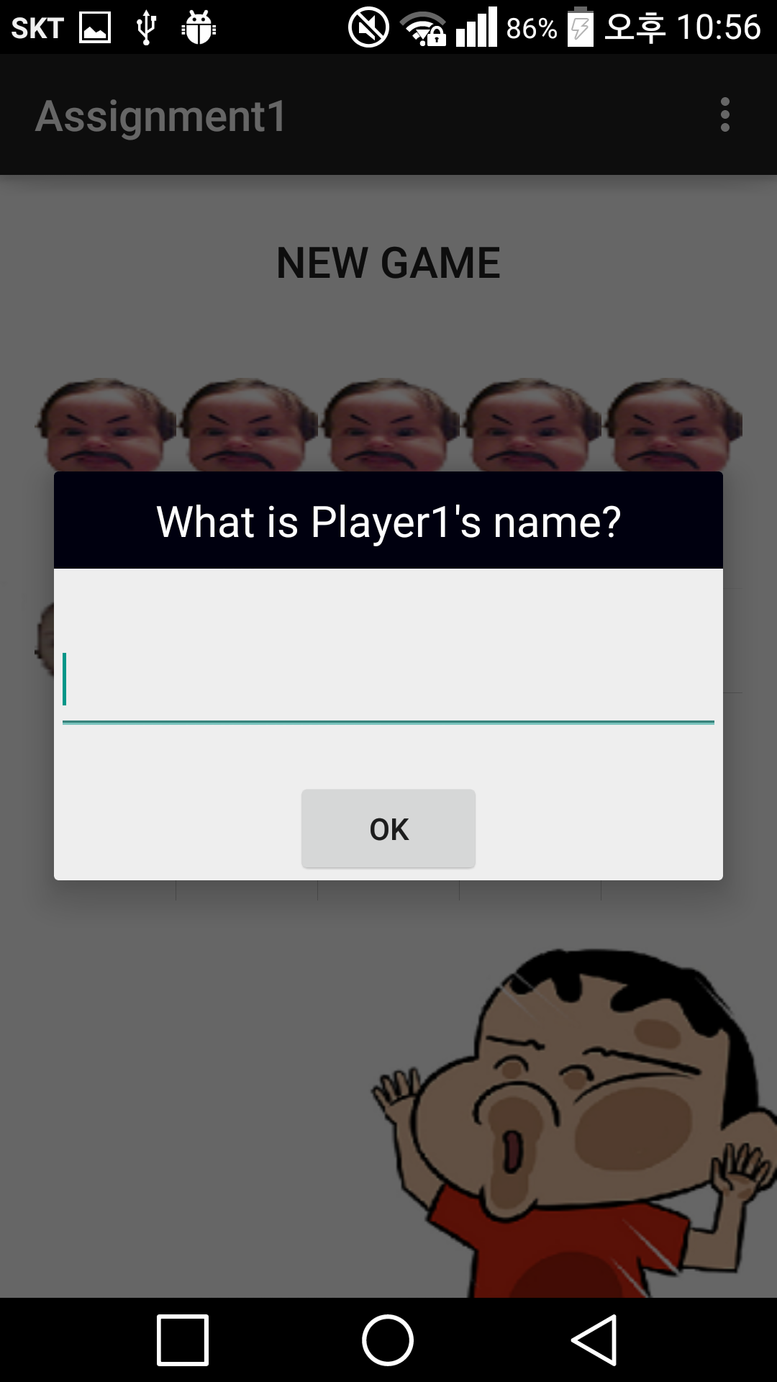

Exception

Aleady Checked Do not Insert Aleady Finished

