**Practical 1:**

**Part A:**

Objective: Explore how to use built-in functions in Microsoft Excel to compute statistics formula.

**Instructions:**

1. Create 100 random numbers in Excel.   
   Hints: RAND( ) and RANDBETWEEN(bottom, top)
2. By using the built-in functions in Excel, find Max, Min, Average, Standard Deviation, Variance, Median and Range for data in ①.

Sample Output (Please replace this with your output):

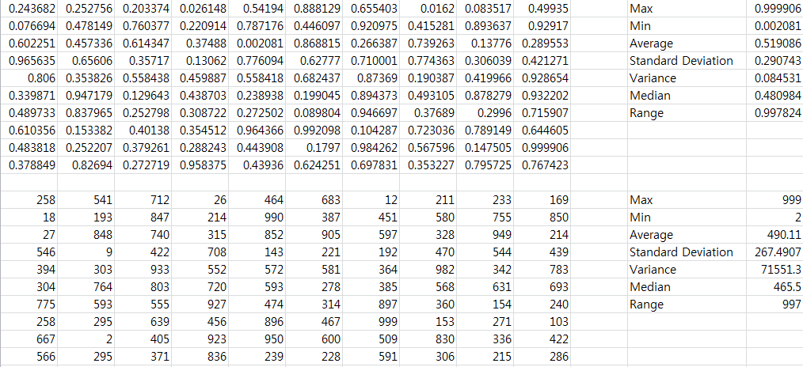

**Part B:**

Objective: In this section, we will explore how to define a dataset in an R session. The most straight forward way to store a list of numbers is through an assignment using the c command. (c stands for "combine.") The idea is that a list of numbers is stored under a given name, and the name is used to refer to the data. A list is specified with the c command, and assignment is specified with the "<-" symbols.

Example: x<-c(1,2,3) or x=c(1,2,3)

**Question 1**: Based on the following dataset, find

|  |  |  |  |  |
| --- | --- | --- | --- | --- |
| 2 | 2.5 | 3.5 | 7.89 | 5 |
| 6.1 | 54 | 2.3 | 5.2 | 4.4 |

> x<-c(2,2.5,3.5,7.89,5,6.1,54,2.3,5.2,4.4)

1. Maximum number

> max(x)

[1] 54

1. Minimum number

> min(x)

[1] 2

1. Average

> mean(x)

[1] 9.289

1. Standard deviation

> sd(x)

[1] 15.8177

1. Variance

> var(x)

[1] 250.1997

1. Median

> median(x)

[1] 4.7

1. Range

> max(x)-min(x)

[1] 52

**Question 2**: Generate 100 random numbers between 1 to 1000.

**> x<-sample(1:1000,size=100)**

**> x**

**[1] 82 515 71 26 828 899 345 173 830 792 253 309 803 526 241 118**

**[17] 433 377 150 534 316 482 237 711 926 985 738 888 474 355 291 216**

**[33] 865 937 15 541 16 839 726 764 996 66 301 182 514 952 404 904**

**[49] 781 9 206 560 233 449 998 979 162 608 891 509 983 479 10 199**

**[65] 2 637 646 50 967 290 838 325 225 854 972 597 157 456 758 882**

**[81] 594 931 732 113 644 35 705 210 961 246 221 721 910 599 640 625**

**[97] 349 340 457 725**

Compute the followings:

1. Minimum

> min(x)

[1] 2

1. 1st Quartile

> quantile(x,probs=(0.25))

25%

236

1. Median

> median(x)

[1] 514.5

1. 3rd Quartile

> quantile(x,probs=(0.75))

75%

794.75

1. Maximum

> max(x)

[1] 998

1. Average

> mean(x)

[1] 514.16

1. Standard deviation

> sd(x)

[1] 310.5748

1. Variance

> var(x)

[1] 96456.68

1. Range

> max(x)-min(x)

[1] 996

**Part C:**

Objective: Import dataset from Excel to R Program.

**Instructions:**

1. Download and copy the “simple.csv” file into

C:\Program Files\R\R-2.15.1\tests directory

1. Run the following command:

> x <- read.csv(file="C:/Program Files/R/R-3.2.2/tests/simple.csv")

> x

1. Run the following commands and explain each function:
   1. >names(x)

> names(x)

[1] "Lab.Test" "Final" "Pre.Test" "Report" "Project"

[6] "Coursework" "Att" "Practical"

* 1. >x$Final

> x$Final

[1] 34.5 0.0 28.5 23.8 12.1 31.3 31.9 12.1 17.7 29.4 18.7 22.4 28.9

[14] 23.3 32.2 21.9 15.9 27.5 33.3 14.5 32.2 34.5 7.0 17.7 17.3 18.4

[27] 0.0 31.3 28.9 20.1 32.8 30.3 18.7 20.1 19.6 20.1 27.5

* 1. >x$Practical

> x$Practical

[1] 10 0 10 8 10 10 10 8 10 10 10 10 10 10 10 10 10 10 10 10 10 10

[23] 8 10 10 10 8 10 10 10 10 10 10 10 10 10 10

* 1. >x[8]

> x[8]

Practical

1 10

2 0

3 10

4 8

5 10

6 10

7 10

8 8

9 10

10 10

11 10

12 10

13 10

14 10

15 10

16 10

17 10

18 10

19 10

20 10

21 10

22 10

23 8

24 10

25 10

26 10

27 8

28 10

29 10

30 10

31 10

32 10

33 10

34 10

35 10

36 10

37 10

* 1. >x[1, ]

> x[1,]

Lab.Test Final Pre.Test Report Project Coursework Att Practical

1 74 34.5 10 14 24 34 10 10

* 1. >x[ ,1]

> x[,1]

[1] 74 0 61 51 26 67 73 26 38 63 40 48 62 50 69 47 34 59 76 31 69 74 15 38 37 42 0 67 62 43 75 65 40 43 42 46

[37] 59

* 1. >sum(x)

> sum(x)

[1] 5889.9

* 1. >sum(x[1, ])

> sum(x[1,])

[1] 210.5

1. By using the R Program, complete the following table.

|  |  |  |  |  |  |  |  |  |  |
| --- | --- | --- | --- | --- | --- | --- | --- | --- | --- |
|  | **Min** | **1st Quartile** | **Median** | **3rd Quartile** | **Max** | **Mean** | **Standard Deviation** | **Variance** | **Range** |
| **Lab Test** | 0 | 38 | 48 | 65 | 76 | 48.97297 | 19.80108 | 392.0826 | 76 |
| **Final** | 0 | 17.7 | 22.4 | 30.3 | 34.5 | 22.60541 | 9.039941 | 81.72053 | 34.5 |
| **Pre-Test** | 0 | 8 | 9 | 9.5 | 10 | 8.527027 | 2.171786 | 4.804805 | 10 |
| **Report** | 0 | 11 | 12 | 12 | 14 | 11.18919 | 2.856161 | 8.157658 | 14 |
| **Project** | 0 | 20 | 20.5 | 21.5 | 24 | 19.71622 | 4.967311 | 24.67417 | 24 |
| **Coursework** | 0 | 29.5 | 30.5 | 31.5 | 34 | 29.22973 | 6.34056 | 40.2027 | 34 |
| **Attendance** | 0 | 10 | 10 | 10 | 10 | 9.432432 | 1.787931 | 3.196697 | 10 |
| **Practical** | 0 | 10 | 10 | 10 | 10 | 9.513514 | 1.725972 | 2.978979 | 10 |