**SPSS Practical 10:**

**// independent, no interaction**

**Part A**:

// independent variable = category data (method)

// normality = only independent in t-test, anova

In this experimental study, we are trying to assess the effects of teaching methods (Traditional, Traditional and Progressive, Progressive) on math achievement by comparing the average math achievement score in different teaching method groups after controlling the effects of student IQ. **Does teaching method impact mathematics achievement controlling for IQ?**

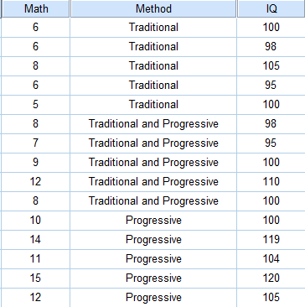

Perform the following tasks:

1. Testing **the independence of the independent variable and covariate**.

Analyze -> G.L.M -> Univariate -> factor에 independent data, iq = dependent variable

|  |  |  |  |  |  |
| --- | --- | --- | --- | --- | --- |
| **Tests of Between-Subjects Effects** | | | | | |
| Dependent Variable: IQ | | | | | |
| Source | Type III Sum of Squares | df | Mean Square | F | Sig. |
| Corrected Model | 303.333a | 2 | 151.667 | 3.489 | .064 |
| Intercept | 159960.067 | 1 | 159960.067 | 3680.063 | .000 |
| Method | 303.333 | 2 | 151.667 | 3.489 | .064 |
| Error | 521.600 | 12 | 43.467 |  |  |
| Total | 160785.000 | 15 |  |  |  |
| Corrected Total | 824.933 | 14 |  |  |  |
| a. R Squared = .368 (Adjusted R Squared = .262) | | | | | |
| // independent 안하면 anova로 $H_{0}$ : The covariate was roughly equal across levels of the independent variable $H_{1}$ : The covariate was roughly not equal across levels of the independent variable | | | | | |

F(2,12) = 3.489, sig=0.064(>0.05)

This test is non-significant

Accept $H_{0}$

Conclusion : It is appropriate to use IQ as a covariate in the analysis

1. Assessment of the Assumption of **Regression Homogeneity**

Analyze -> GLM -> univariate (math = dependent variable), factor=method, covariate=iq -> model -> custom -> main effect에 둘 다 넣고, 둘 다 한꺼번에 누르고 interaction에 넣기

|  |  |  |  |  |  |
| --- | --- | --- | --- | --- | --- |
| **Tests of Between-Subjects Effects** | | | | | |
| Dependent Variable: Math | | | | | |
| Source | Type III Sum of Squares | df | Mean Square | F | Sig. |
| Corrected Model | 129.632a | 5 | 25.926 | 56.886 | .000 |
| Intercept | 8.213 | 1 | 8.213 | 18.021 | .002 |
| Method | 1.556 | 2 | .778 | 1.707 | .235 |
| IQ | 18.991 | 1 | 18.991 | 41.669 | .000 |
| Method * IQ | 1.385 | 2 | .693 | 1.520 | .270 |
| Error | 4.102 | 9 | .456 |  |  |
| Total | 1385.000 | 15 |  |  |  |
| Corrected Total | 133.733 | 14 |  |  |  |
| a. R Squared = .969 (Adjusted R Squared = .952) | | | | | |
| $H_{0}$: Homogeneity of regression slopes can be assumed $H_{1}$ : Homogeneity of regression slopes can not be assumed | | | | | |

F(2, 9) = 1.520, sig=0.270(>0.05)

This test is non-significant

Accept $H_{0}$

Conclusion : Homogeneity of regression slopes can be assumed.

Note: interaction effect 가 없어야 iq를 컨트롤 할 수 있음

1. Assessment of the Main Effect of Teaching Method Controlling for IQ.

// analyze -> G.M.L -> univariate -> 위랑 똑같이 하고 interaction effect만 지움

// **ancova**

|  |  |  |  |  |  |
| --- | --- | --- | --- | --- | --- |
| **Tests of Between-Subjects Effects** | | | | | |
| Dependent Variable: Math | | | | | |
| Source | Type III Sum of Squares | df | Mean Square | F | Sig. |
| Corrected Model | 128.246a | 3 | 42.749 | 85.699 | .000 |
| Intercept | 12.745 | 1 | 12.745 | 25.551 | .000 |
| Method | 26.673 | 2 | 13.337 | 26.736 | .000 |
| IQ | 31.313 | 1 | 31.313 | 62.774 | .000 |
| Error | 5.487 | 11 | .499 |  |  |
| Total | 1385.000 | 15 |  |  |  |
| Corrected Total | 133.733 | 14 |  |  |  |
| a. R Squared = .959 (Adjusted R Squared = .948) | | | | | |

|  |
| --- |
| : All adjusted means are the same $H_{1}$ : At least two adjusted means are different |

F(2, 11) = 26.736, sig=0.000(<0.05)

This test is non-significant

Reject $H_{0}$

Conclusion : : At least two adjusted means are different

// 만약 covariate와 depependent variable가 관련 없으면 안됨, 있어야 error컨트롤 가능

|  |
| --- |
| !! $H_{0}$ : There is no relationship between the covariate and the dependent variable $H_{1}$ : There is a relationship between the covariate and the dependent variable |

F(1, 11) = 62.774, sig=0.000(<0.05)

This test is significant

Reject $H_{0}$

Conclusion : There is a relationship between IQ and Math

1. Computes all the means (before and after the test) for math achievement in each method.

// additional impormation이 없으므로 contrast는 못씀 따라서 post hoc test

// gml -> uni - > 그대로 -> option -> meth를 display mean for에 넣고 compare 체크, sidak, descriptive, homogeneity

|  |  |  |  |  |  |  |
| --- | --- | --- | --- | --- | --- | --- |
| **Pairwise Comparisons** | | | | | | |
| Dependent Variable: Math | | | | | | |
| (I) Method | (J) Method | Mean Difference (I-J) | Std. Error | Sig.b | 95% Confidence Interval for Differenceb | |
| Lower Bound | Upper Bound |
| Traditonal | Traitonal and Progressive | -2.355* | .448 | .001 | -3.613 | -1.097 |
| Progressive | -3.750* | .543 | .000 | -5.277 | -2.223 |
| Traitonal and Progressive | Traditonal | 2.355* | .448 | .001 | 1.097 | 3.613 |
| Progressive | -1.395 | .526 | .066 | -2.874 | .084 |
| Progressive | Traditonal | 3.750* | .543 | .000 | 2.223 | 5.277 |
| Traitonal and Progressive | 1.395 | .526 | .066 | -.084 | 2.874 |
| Based on estimated marginal means | | | | | | |
| *. The mean difference is significant at the .05 level. | | | | | | |
| b. Adjustment for multiple comparisons: Sidak. | | | | | | |
| Comparison 1: $H_{0}$ : ${μ'}_{T}= {μ'}_{TP}$ $H_{1}$: ${μ'}_{T}≠ {μ'}_{TP}$ | | | | | | | |

sig=0.001(<0.05)

This test is significant

Reject $H_{0}$

Conclusion : : ${μ'}_{T}≠ {μ'}_{TP}$

|  |
| --- |
| Comparison 2: $H_{0}$ : ${μ'}_{T}= {μ'}_{P}$ $H_{1}$: ${μ'}_{T}≠ {μ'}_{P}$ |

sig=0.000(<0.05)

This test is significant

Reject $H_{0}$

Conclusion : : ${μ'}_{T}≠ {μ'}_{P}$

|  |
| --- |
| Comparison 3: $H_{0}$ : ${μ'}_{TP}= {μ'}_{P}$ $H_{1}$: ${μ'}_{TP}≠ {μ'}_{P}$ |

sig=0.066(>0.05)

This test is non-significant

Accept $H_{0}$

Conclusion : : ${μ'}_{TP}= {μ'}_{P}$

$${μ'}_{T} ≠ {μ^{'}}_{TP}= {μ'}_{P}$$

Post Hoc test revealed that Traditional and Progressive method (M = 9.453,SE =0.326) produced significant better scores than Traditional method (M = 7.098, SE = 0.336) but produced non-significant better scores with Progressive method (M = 10.848, SE =0.372), after controlling for the effect of IQ

Original mean

|  |  |  |  |
| --- | --- | --- | --- |
| **Descriptive Statistics** | | | |
| Dependent Variable: Math | | | |
| Method | Mean | Std. Deviation | N |
| Traditonal | 6.20 | 1.095 | 5 |
| Traitonal and Progressive | 8.80 | 1.924 | 5 |
| Progressive | 12.40 | 2.074 | 5 |
| Total | 9.13 | 3.091 | 15 |

Adjusted mean

|  |  |  |  |  |
| --- | --- | --- | --- | --- |
| **Estimates** | | | | |
| Dependent Variable: Math | | | | |
| Method | Mean | Std. Error | 95% Confidence Interval | |
| Lower Bound | Upper Bound |
| Traditonal | 7.098a | .336 | 6.360 | 7.837 |
| Traitonal and Progressive | 9.453a | .326 | 8.735 | 10.172 |
| Progressive | 10.848a | .372 | 10.030 | 11.666 |
| a. Covariates appearing in the model are evaluated at the following values: IQ = 103.27. | | | | |

**Part B**:

**Does instruction method impact achievement controlling for motivation?**

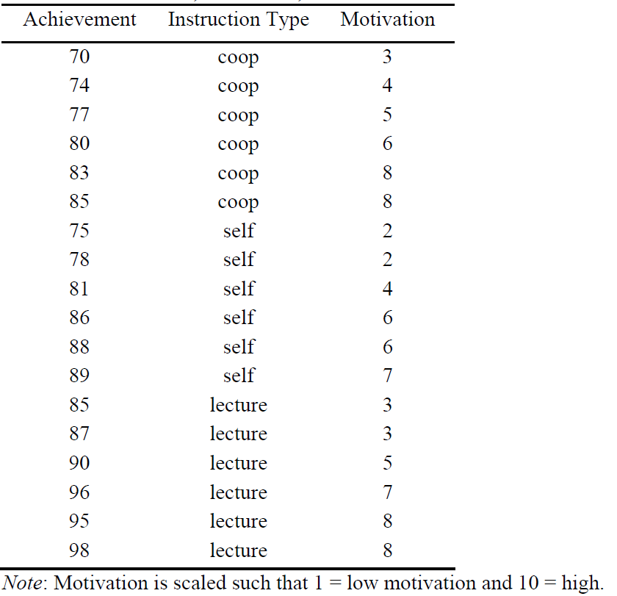

Perform the following tasks:

1. Testing the independence of the independent variable and covariate.

|  |  |  |  |  |  |
| --- | --- | --- | --- | --- | --- |
| **Tests of Between-Subjects Effects** | | | | | |
| Dependent Variable: Motivation | | | | | |
| Source | Type III Sum of Squares | df | Mean Square | F | Sig. |
| Corrected Model | 5.444a | 2 | 2.722 | .566 | .580 |
| Intercept | 501.389 | 1 | 501.389 | 104.215 | .000 |
| Instruction_Type | 5.444 | 2 | 2.722 | .566 | .580 |
| Error | 72.167 | 15 | 4.811 |  |  |
| Total | 579.000 | 18 |  |  |  |
| Corrected Total | 77.611 | 17 |  |  |  |
| a. R Squared = .070 (Adjusted R Squared = -.054) | | | | | |

|  |
| --- |
| : The covariate was roughly equal across levels of the independent variable $H_{1}$ : The covariate was roughly not equal across levels of the independent variable |

F(2, 15) = 0.566, sig=0.580(>0.05)

This test is non-significant

Accept $H_{0}$

Conclusion : It is appropriate to use Motivation as a covariate in the analysis

1. Assessment of the Assumption of Regression Homogeneity

|  |  |  |  |  |  |
| --- | --- | --- | --- | --- | --- |
| **Tests of Between-Subjects Effects** | | | | | |
| Dependent Variable: Achievement | | | | | |
| Source | Type III Sum of Squares | df | Mean Square | F | Sig. |
| Corrected Model | 1019.198a | 5 | 203.840 | 119.827 | .000 |
| Intercept | 11293.731 | 1 | 11293.731 | 6639.017 | .000 |
| Instruction_Type | 91.048 | 2 | 45.524 | 26.761 | .000 |
| Motivation | 439.845 | 1 | 439.845 | 258.563 | .000 |
| Instruction_Type * Motivation | 3.510 | 2 | 1.755 | 1.032 | .386 |
| Error | 20.413 | 12 | 1.701 |  |  |
| Total | 128889.000 | 18 |  |  |  |
| Corrected Total | 1039.611 | 17 |  |  |  |
| a. R Squared = .980 (Adjusted R Squared = .972) | | | | | |
| $H_{0}$: Homogeneity of regression slopes can be assumed $H_{1}$ : Homogeneity of regression slopes can not be assumed | | | | | |

F(2, 12) = 1.032, sig=0.386(>0.05)

This test is non-significant

Accept $H_{0}$

Conclusion : Homogeneity of regression slopes can be assumed

1. Assessment of the Main Effect of Instruction Type Controlling for Motivation.

|  |  |  |  |  |  |
| --- | --- | --- | --- | --- | --- |
| **Tests of Between-Subjects Effects** | | | | | |
| Dependent Variable: Achievement | | | | | |
| Source | Type III Sum of Squares | df | Mean Square | F | Sig. |
| Corrected Model | 1019.198a | 5 | 203.840 | 119.827 | .000 |
| Intercept | 11293.731 | 1 | 11293.731 | 6639.017 | .000 |
| Instruction_Type | 91.048 | 2 | 45.524 | 26.761 | .000 |
| Motivation | 439.845 | 1 | 439.845 | 258.563 | .000 |
| Instruction_Type * Motivation | 3.510 | 2 | 1.755 | 1.032 | .386 |
| Error | 20.413 | 12 | 1.701 |  |  |
| Total | 128889.000 | 18 |  |  |  |
| Corrected Total | 1039.611 | 17 |  |  |  |
| a. R Squared = .980 (Adjusted R Squared = .972) | | | | | |

|  |
| --- |
| : All adjusted means are the same $H_{1}$ : At least two adjusted means are different |

F(2, 12) = 26.761, sig=0.000(<0.05)

This test is non-significant

Reject $H_{0}$

Conclusion : : At least two adjusted means are different

1. Computes all the means (before and after the test) for achievement in each instruction type.

|  |  |  |  |  |  |  |
| --- | --- | --- | --- | --- | --- | --- |
| **Pairwise Comparisons** | | | | | | |
| Dependent Variable: Achievement | | | | | | |
| (I) Instruction_Type | (J) Instruction_Type | Mean Difference (I-J) | Std. Error | Sig.b | 95% Confidence Interval for Differenceb | |
| Lower Bound | Upper Bound |
| coop | self | -7.536* | .776 | .000 | -9.638 | -5.435 |
| lecture | -13.667* | .755 | .000 | -15.711 | -11.622 |
| self | coop | 7.536* | .776 | .000 | 5.435 | 9.638 |
| lecture | -6.130* | .776 | .000 | -8.232 | -4.029 |
| lecture | coop | 13.667* | .755 | .000 | 11.622 | 15.711 |
| self | 6.130* | .776 | .000 | 4.029 | 8.232 |
| Based on estimated marginal means | | | | | | |
| *. The mean difference is significant at the .05 level. | | | | | | |
| b. Adjustment for multiple comparisons: Sidak. | | | | | | |
| Comparison 1: $H_{0}$ : ${μ'}_{C}= {μ'}_{S}$ $H_{1}$: ${μ'}_{C}≠ {μ'}_{S}$ | | | | | | | |

sig=0.000(<0.05)

This test is significant

Reject $H_{0}$

Conclusion : : ${μ'}_{C}≠ {μ'}_{S}$

|  |
| --- |
| Comparison 2: $H_{0}$ : ${μ'}_{C}= {μ'}_{L}$ $H_{1}$: ${μ'}_{C}≠ {μ'}_{L}$ |

sig=0.000(<0.05)

This test is significant

Reject $H_{0}$

Conclusion : : ${μ'}_{C}≠ {μ'}_{L}$

|  |
| --- |
| Comparison 3: $H_{0}$ : ${μ'}_{S}= {μ'}_{L}$ $H_{1}$: ${μ'}_{S}≠ {μ'}_{L}$ |

sig=0.000(<0.05)

This test is non-significant

Rject $H_{0}$

Conclusion : : ${μ'}_{S}≠ {μ'}_{L}$

$${μ'}_{C}≠ {μ'}_{S}≠ {μ'}_{L}$$

Post Hoc test revealed that self method (M = 84.746,SE =0.547) produced significant better scores than coop method (M = 77.210, SE = 0.537) but produced significant better scores with lecture method (M = 90.877, SE =0.532), after controlling for the effect of Motivation

Original mean

|  |  |  |  |
| --- | --- | --- | --- |
| **Descriptive Statistics** | | | |
| Dependent Variable: Achievement | | | |
| Instruction_Type | Mean | Std. Deviation | N |
| coop | 78.17 | 5.636 | 6 |
| self | 82.83 | 5.707 | 6 |
| lecture | 91.83 | 5.269 | 6 |
| Total | 84.28 | 7.820 | 18 |

Adjusted mean

|  |  |  |  |  |
| --- | --- | --- | --- | --- |
| **Estimates** | | | | |
| Dependent Variable: Achievement | | | | |
| Instruction_Type | Mean | Std. Error | 95% Confidence Interval | |
| Lower Bound | Upper Bound |
| coop | 77.210a | .537 | 76.058 | 78.362 |
| self | 84.746a | .547 | 83.573 | 85.919 |
| lecture | 90.877a | .537 | 89.725 | 92.029 |
| a. Covariates appearing in the model are evaluated at the following values: Motivation = 5.28. | | | | |