**SPSS Practical 11:**

**Objective**: We run two-way factorial ANOVA when we want to study the effect of two independent categorical variables on the dependent variable. In a two-way factorial ANOVA, we can test the main effect of each independent variable. We can also test if the effect of one independent variable on the dependent variable is the same across all level of the other independent variable, that is, if there is any interaction between the independent variables.

**Part A**

In the study, people were randomly assigned either to come to class all the time, or never come to class or to get the lecture notes from the World Wide Web. Those who came to class are in the Lecture condition, while those who did not come to class are in the Distance Learning condition. The students were also divided according to their GPA prior to the class. There were people with Higher GPAs and people with Lower GPAs. The dependent variable was the total number of points they received in the class (out of 400 possible points.) The following table summarizes the data:

// 2 independent variable(gpa,class)

// lab-test에는 엄청 많음

|  |  |  |  |  |  |
| --- | --- | --- | --- | --- | --- |
| **Class** | **GPA** | **Points in Class** | **Class** | **GPA** | **Points in Class** |
| Lecture | High | 354.67 | Distance | High | 332.00 |
| Lecture | High | 353.50 | Distance | High | 380.00 |
| Lecture | High | 304.00 | Distance | High | 371.00 |
| Lecture | High | 365.00 | Distance | High | 366.00 |
| Lecture | High | 339.00 | Distance | High | 354.00 |
| Lecture | Low | 306.00 | Distance | Low | 259.50 |
| Lecture | Low | 339.00 | Distance | Low | 302.50 |
| Lecture | Low | 353.00 | Distance | Low | 296.00 |
| Lecture | Low | 351.00 | Distance | Low | 349.00 |
| Lecture | Low | 333.00 | Distance | Low | 309.00 |

Conduct a Two-way ANOVA for the following statistical tests:

// assumption(normality test and so on)이 따로 없고 interaction effect만 알면 됨.

// Analyze->GLM->Uni->dependent에 outcome, independent를 fixed factor에 -> option에서 확인, overall제외하고 다 오른쪽으로 넘겨주고, display에서 descript, homogeneity 체크, 맨 밑에 significance 확인

// class를 앞에 (순서 조심)

|  |  |  |  |
| --- | --- | --- | --- |
| **Levene's Test of Equality of Error Variancesa** | | | |
| Dependent Variable: Points_in_Class | | | |
| F | df1 | df2 | Sig. |
| .240 | 3 | 16 | .867 |
| Tests the null hypothesis that the error variance of the dependent variable is equal across groups. | | | |
| a. Design: Intercept + Class + GPA + Class * GPA | | | |
|  | | | |

$$H_{0 } :Homogeneity of variance can be assumed$$

$$H_{1 } : Homogeneity of variance cannot be assumed$$

F(3,16) = 0.240, sig=0.867(>0.05)

This test is non-significant.

Accept $H_{0 }$

Conclusion : $Homogeneity of variance can be assumed$

|  |  |  |  |  |  |
| --- | --- | --- | --- | --- | --- |
| **Tests of Between-Subjects Effects** | | | | | |
| Dependent Variable: Points_in_Class | | | | | |
| Source | Type III Sum of Squares | df | Mean Square | F | Sig. |
| Corrected Model | 8667.053a | 3 | 2889.018 | 5.043 | .012 |
| Intercept | 2256018.640 | 1 | 2256018.640 | 3937.693 | .000 |
| Class | 313.394 | 1 | 313.394 | .547 | .470 |
| GPA | 5157.508 | 1 | 5157.508 | 9.002 | .008 |
| Class * GPA | 3196.150 | 1 | 3196.150 | 5.579 | .031 |
| Error | 9166.865 | 16 | 572.929 |  |  |
| Total | 2273852.559 | 20 |  |  |  |
| Corrected Total | 17833.918 | 19 |  |  |  |
| a. R Squared = .486 (Adjusted R Squared = .390) | | | | | |

1. Main Effect of Type of Class

|  |  |  |  |  |
| --- | --- | --- | --- | --- |
| **1. Class** | | | | |
| Dependent Variable: Points_in_Class | | | | |
| Class | Mean | Std. Error | 95% Confidence Interval | |
| Lower Bound | Upper Bound |
| Lecture | 339.817 | 7.569 | 323.771 | 355.863 |
| Distance | 331.900 | 7.569 | 315.854 | 347.946 |

$$H_{0 } : μ_{Lecture}= μ_{Distance}$$

$$H_{1 } : μ_{Lecture}≠ μ_{Distance}$$

F(1,16) = 0.547, sig=0.47(>0.05)

This test is non-significant.

Accept $H_{0 }$

The test failed to reveal a main effect of Class

1. Main Effect of GPA.

// 값들은 큰 테이블에서 따옴

|  |  |  |  |  |
| --- | --- | --- | --- | --- |
| **2. GPA** | | | | |
| Dependent Variable: Points_in_Class | | | | |
| GPA | Mean | Std. Error | 95% Confidence Interval | |
| Lower Bound | Upper Bound |
| High | 351.917 | 7.569 | 335.871 | 367.963 |
| Low | 319.800 | 7.569 | 303.754 | 335.846 |

$$H_{0 } : μ_{High}= μ_{Low}$$

$$H_{1 } : μ_{High}≠ μ_{Low}$$

F(1,16) = 9.002, sig=0.008(<0.05)

This test is significant.

Reject $H_{0 }$

The test revealed a main effect of GPA

1. Interaction Effect of Type of Class and GPA.

|  |  |  |  |  |  |
| --- | --- | --- | --- | --- | --- |
| **3. Class * GPA** | | | | | |
| Dependent Variable: Points_in_Class | | | | | |
| Class | GPA | Mean | Std. Error | 95% Confidence Interval | |
| Lower Bound | Upper Bound |
| Lecture | High | 343.234 | 10.704 | 320.542 | 365.926 |
| Low | 336.400 | 10.704 | 313.708 | 359.092 |
| Distance | High | 360.600 | 10.704 | 337.908 | 383.292 |
| Low | 303.200 | 10.704 | 280.508 | 325.892 |

$$H_{0 } : μ_{Lecture,High- }μ_{Lecture,Low}= μ_{Distance,High}- μ_{Distance,Low}$$

$$H_{1 } : μ_{Lecture,High}-μ_{Lecture,Low}≠ μ_{Distance,High}- μ_{Distance,Low}$$

F(1,16) = 5.579, sig=0.031(<0.05)

This test is significant.

Reject $H_{0 }$

The test revealed an interaction effect of Class and GPA

**// univariate -> 다 똑같이 넣고 plot, class는 horizontal, gpa는 separate 넣고 add, 반대로 넣고 또 add**

**// 교차점이 있으면 interaction effect 가 있다는 것**

**Profile Plot**

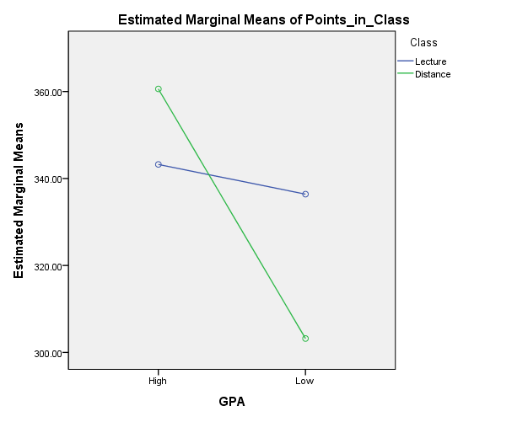

There is an interaction effect of Class and GPA

**Part B**

A professor of a statistics course was interested in the effect of teaching method (punishment, indifferent, reward) and the language used (English, Korean) in the exam paper.

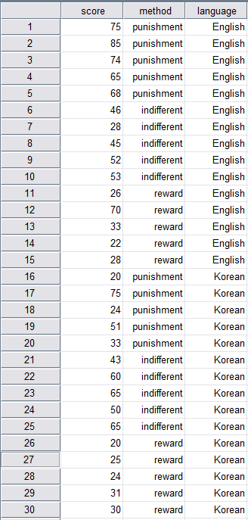

Conduct a Two-way ANOVA for the following statistical tests:

|  |  |  |  |
| --- | --- | --- | --- |
| **Levene's Test of Equality of Error Variancesa** | | | |
| Dependent Variable: Score | | | |
| F | df1 | df2 | Sig. |
| 2.606 | 5 | 24 | .051 |
| Tests the null hypothesis that the error variance of the dependent variable is equal across groups. | | | |
| a. Design: Intercept + Method + Language + Method * Language | | | |

$$H_{0 } :Homogeneity of variance can be assumed$$

$$H_{1 } : Homogeneity of variance cannot be assumed$$

F(5,24) = 2.606, sig=0.051(>0.05)

This test is non-significant.

Accept $H_{0 }$

Conclusion : $Homogeneity of variance can be assumed$

|  |  |  |  |  |  |
| --- | --- | --- | --- | --- | --- |
| **Tests of Between-Subjects Effects** | | | | | |
| Dependent Variable: Score | | | | | |
| Source | Type III Sum of Squares | df | Mean Square | F | Sig. |
| Corrected Model | 6987.600a | 5 | 1397.520 | 7.171 | .000 |
| Intercept | 64033.200 | 1 | 64033.200 | 328.572 | .000 |
| Method | 3709.800 | 2 | 1854.900 | 9.518 | .001 |
| Language | 790.533 | 1 | 790.533 | 4.056 | .055 |
| Method * Language | 2487.267 | 2 | 1243.633 | 6.381 | .006 |
| Error | 4677.200 | 24 | 194.883 |  |  |
| Total | 75698.000 | 30 |  |  |  |
| Corrected Total | 11664.800 | 29 |  |  |  |
| a. R Squared = .599 (Adjusted R Squared = .515) | | | | | |

1. Main Effect of Teaching Method.

|  |  |  |  |  |
| --- | --- | --- | --- | --- |
| **1. Method** | | | | |
| Dependent Variable: Score | | | | |
| Method | Mean | Std. Error | 95% Confidence Interval | |
| Lower Bound | Upper Bound |
| punishment | 57.000 | 4.415 | 47.889 | 66.111 |
| indifferent | 50.700 | 4.415 | 41.589 | 59.811 |
| reward | 30.900 | 4.415 | 21.789 | 40.011 |

$$H_{0 } : All the means are the same$$

$$H_{1 } :At least two means are different$$

F(2, 24) = 9.518, sig=0.001(<0.05)

This test is significant.

Reject $H_{0 }$

The test revealed a main effect of Method

// univariate 똑같이 입력(language 빼고), post hoc, method 오른쪽에 넣고 tukey체크

|  |  |  |  |  |  |  |
| --- | --- | --- | --- | --- | --- | --- |
| **Multiple Comparisons** | | | | | | |
| Dependent Variable: Score | | | | | | |
| Tukey HSD | | | | | | |
| (I) Method | (J) Method | Mean Difference (I-J) | Std. Error | Sig. | 95% Confidence Interval | |
| Lower Bound | Upper Bound |
| punishment | indifferent | 6.30 | 7.676 | .694 | -12.73 | 25.33 |
| reward | 26.10* | 7.676 | .006 | 7.07 | 45.13 |
| indifferent | punishment | -6.30 | 7.676 | .694 | -25.33 | 12.73 |
| reward | 19.80* | 7.676 | .040 | .77 | 38.83 |
| reward | punishment | -26.10* | 7.676 | .006 | -45.13 | -7.07 |
| indifferent | -19.80* | 7.676 | .040 | -38.83 | -.77 |
| Based on observed means.  The error term is Mean Square(Error) = 294.630. | | | | | | |
| *. The mean difference is significant at the .05 level. | | | | | | |

Comparison 1:

$$H_{0 } : μ_{punishment}= μ_{indifferent}$$

$$H_{1 } : μ_{punishment}≠ μ_{indifferent}$$

Since sig=0.694(>0.05)

This test is non-significant

${Assept H}_{0 }$

$μ_{punishment}= μ_{indifferent}$

Comparison 2:

$$H_{0 } : μ_{punishment}= μ_{reward}$$

$$H_{1 } : μ_{punishment}≠ μ_{reward}$$

Since sig=0.006(<0.05)

This test is significant

${Reject H}_{0 }$

$μ_{punishment}≠ μ_{reward}$

Conclusion :

$$μ_{punishment}= μ_{indifferent} ≠ μ_{reward}$$

|  |
| --- |
|  |
|  |
|  |

1. Main Effect of Language Used.

|  |  |  |  |  |
| --- | --- | --- | --- | --- |
| **2. Language** | | | | |
| Dependent Variable: Score | | | | |
| Language | Mean | Std. Error | 95% Confidence Interval | |
| Lower Bound | Upper Bound |
| English | 51.333 | 3.604 | 43.894 | 58.773 |
| Korean | 41.067 | 3.604 | 33.627 | 48.506 |

$$H_{0 } : μ_{English}= μ_{Korean}$$

$$H_{1 } : μ_{English}≠ μ_{Korean}$$

F(1, 24) = 4.056, sig=0.055(>0.05)

This test is non-significant

${Assept H}_{0 }$

The test failed to reveal a main effect of Language

1. Interaction Effect of Teaching Method and Language Used.

|  |  |  |  |  |  |
| --- | --- | --- | --- | --- | --- |
| **3. Method * Language** | | | | | |
| Dependent Variable: Score | | | | | |
| Method | Language | Mean | Std. Error | 95% Confidence Interval | |
| Lower Bound | Upper Bound |
| punishment | English | 73.400 | 6.243 | 60.515 | 86.285 |
| Korean | 40.600 | 6.243 | 27.715 | 53.485 |
| indifferent | English | 44.800 | 6.243 | 31.915 | 57.685 |
| Korean | 56.600 | 6.243 | 43.715 | 69.485 |
| reward | English | 35.800 | 6.243 | 22.915 | 48.685 |
| Korean | 26.000 | 6.243 | 13.115 | 38.885 |

$$H_{0 } : All interaction means are the same$$

$$H_{1 } : At least two interaction means are different$$

F(2,24) = 6.3810, sig=0.006(<0.05)

This test is significant

${Reject H}_{0 }$

$The test revealed an interaction effect of Method and Language$

Profile Plot

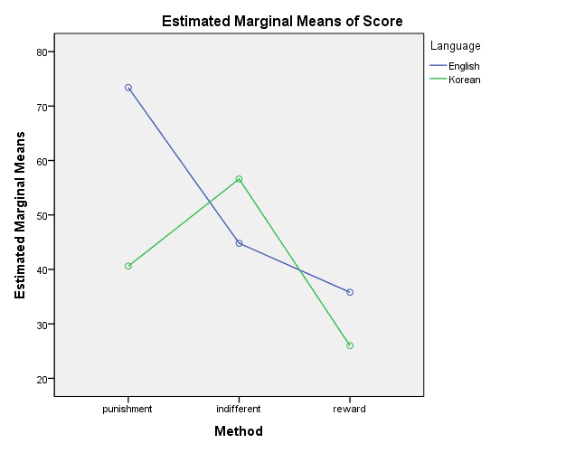

There is an interaction effect of Method and Language.

|  |  |  |  |
| --- | --- | --- | --- |
| **Between-Subjects Factors** | | | |
|  | | Value Label | N |
| Method | 0 | punishment | 10 |
| 1 | indifferent | 10 |
| 2 | reward | 10 |
| Language | 0 | English | 15 |
| 1 | Korean | 15 |

|  |  |
| --- | --- |
| Group | Interaction |
| 1 | method=0, language=0 |
| 2 | method=0, language=1 |
| 3 | method=1, language=0 |
| 4 | method=1, language=1 |
| 5 | method=2, language=0 |
| 6 | method=2, language=1 |

// group 만드는 법 transform, compute variable, target = group, numeric에 group number쓰고 if… include if case 체크, method = 0 & language = 0 이런 식으로 입력해줌

// univate -> group 넣고 tukey

|  |  |  |  |  |  |  |
| --- | --- | --- | --- | --- | --- | --- |
| **Multiple Comparisons** | | | | | | |
| Dependent Variable: Score | | | | | | |
| Tukey HSD | | | | | | |
| (I) Group | (J) Group | Mean Difference (I-J) | Std. Error | Sig. | 95% Confidence Interval | |
| Lower Bound | Upper Bound |
| 1 | 2 | 32.80* | 8.829 | .012 | 5.50 | 60.10 |
| 3 | 28.60* | 8.829 | .036 | 1.30 | 55.90 |
| 4 | 16.80 | 8.829 | .425 | -10.50 | 44.10 |
| 5 | 37.60* | 8.829 | .003 | 10.30 | 64.90 |
| 6 | 47.40* | 8.829 | .000 | 20.10 | 74.70 |
| 2 | 1 | -32.80* | 8.829 | .012 | -60.10 | -5.50 |
| 3 | -4.20 | 8.829 | .997 | -31.50 | 23.10 |
| 4 | -16.00 | 8.829 | .477 | -43.30 | 11.30 |
| 5 | 4.80 | 8.829 | .994 | -22.50 | 32.10 |
| 6 | 14.60 | 8.829 | .573 | -12.70 | 41.90 |
| 3 | 1 | -28.60* | 8.829 | .036 | -55.90 | -1.30 |
| 2 | 4.20 | 8.829 | .997 | -23.10 | 31.50 |
| 4 | -11.80 | 8.829 | .762 | -39.10 | 15.50 |
| 5 | 9.00 | 8.829 | .907 | -18.30 | 36.30 |
| 6 | 18.80 | 8.829 | .306 | -8.50 | 46.10 |
| 4 | 1 | -16.80 | 8.829 | .425 | -44.10 | 10.50 |
| 2 | 16.00 | 8.829 | .477 | -11.30 | 43.30 |
| 3 | 11.80 | 8.829 | .762 | -15.50 | 39.10 |
| 5 | 20.80 | 8.829 | .212 | -6.50 | 48.10 |
| 6 | 30.60* | 8.829 | .022 | 3.30 | 57.90 |
| 5 | 1 | -37.60* | 8.829 | .003 | -64.90 | -10.30 |
| 2 | -4.80 | 8.829 | .994 | -32.10 | 22.50 |
| 3 | -9.00 | 8.829 | .907 | -36.30 | 18.30 |
| 4 | -20.80 | 8.829 | .212 | -48.10 | 6.50 |
| 6 | 9.80 | 8.829 | .872 | -17.50 | 37.10 |
| 6 | 1 | -47.40* | 8.829 | .000 | -74.70 | -20.10 |
| 2 | -14.60 | 8.829 | .573 | -41.90 | 12.70 |
| 3 | -18.80 | 8.829 | .306 | -46.10 | 8.50 |
| 4 | -30.60* | 8.829 | .022 | -57.90 | -3.30 |
| 5 | -9.80 | 8.829 | .872 | -37.10 | 17.50 |
| Based on observed means.  The error term is Mean Square(Error) = 194.883. | | | | | | |
| *. The mean difference is significant at the .05 level. | | | | | | |

Comparison 1(group 1 & 2):

$$H_{0 } : μ_{punishment, English}= μ_{punishment,korean}$$

$$H_{1 } :μ_{punishment, English}≠ μ_{punishment,korean}$$

Since sig=0.012(<0.05)

This test is significant

$Reject{ H}_{0 }$

$Conclusion : μ_{punishment, English}≠ μ_{punishment,korean}$

Comparison 2(group 3 & 4):

$$H_{0 } : μ_{indifferent,English}= μ_{Indifferent,korean}$$

$$H_{1 } :μ_{indifferent,English}≠ μ_{Indifferent,korean}$$

Since sig=0.997(>0.05)

This test is non-significant

$Assept{ H}_{0 }$

$${Conclusion : μ}_{indifferent,English}= μ_{Indifferent,korean}$$

Comparison 3(group 5 & 6):

$$H_{0 } : μ_{reward,English}= μ_{reward,korean}$$

$$H_{1 } :μ_{reward,English}≠ μ_{reward,korean}$$

Since sig=0.872(>0.05)

This test is non-significant

$Assept{ H}_{0 }$

$${Conclusion : μ}_{reward,English}= μ_{reward,korean}$$

Conclusion :

$$μ_{punishment, English}- μ_{punishment,korean}≠ μ_{indifferent,English}- μ_{Indifferent,korean}$$

= $μ_{reward,English}- μ_{reward,korean}$