**Practical 3:**

**Part A:** Exploring data using SPSS Chart Builder.

1. Based on the “Smoking_Survey.sav” file, generate the following graphs for Age:
   1. Simple Histogram

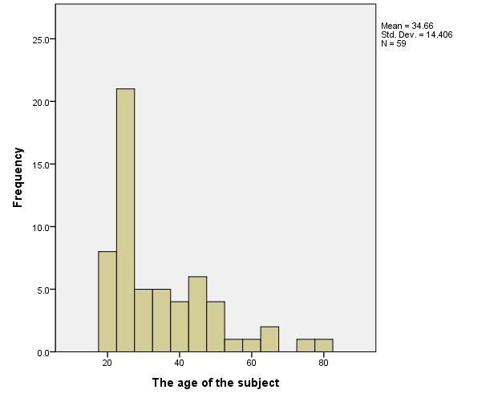

* 1. Stacked Histogram (based on the Gender)

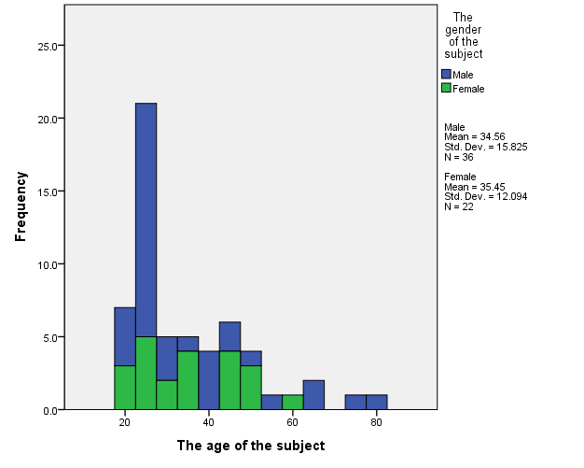

* 1. Boxplot

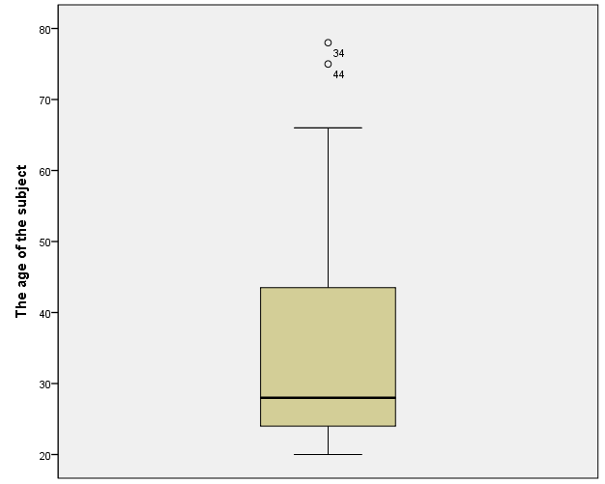

* 1. Boxplot (based on the Gender)

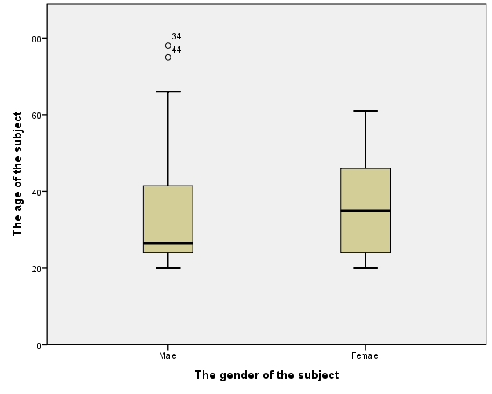

* 1. Normal Curve

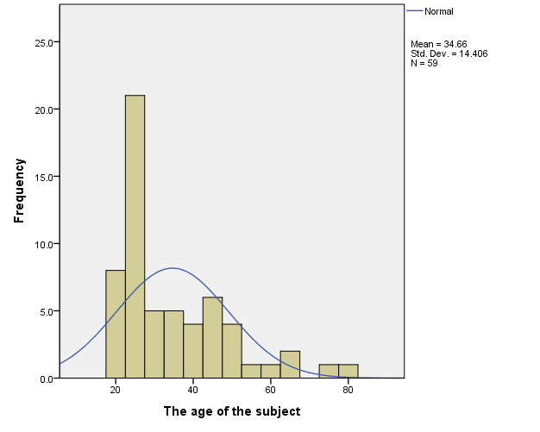

* 1. Scatterplot for age (axis-X) and the number of cigarettes smoked (axis-Y) with the regression line.

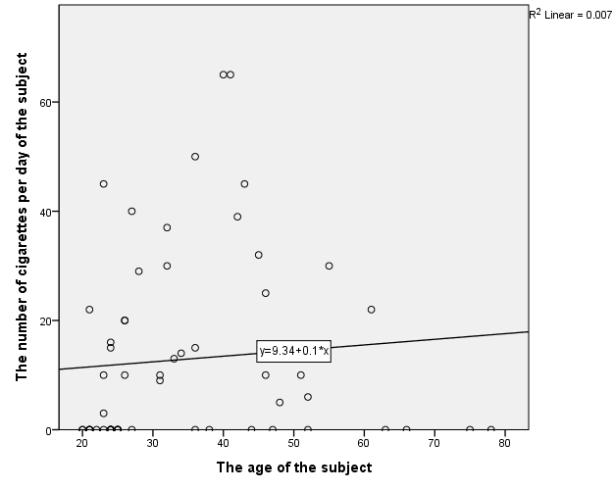

* 1. Grouped scatter for age (axis-X) and the number of cigarettes smoked (axis-Y) with the regression lines.

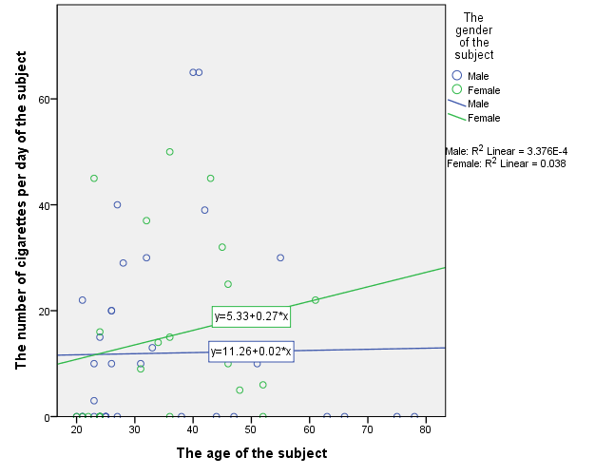

**Part B:** Explore data using R Program.

1. Based on the data from “Smoking_Survey.sav” file, plot the following graphs (by using R Program):
2. Histogram for Age

hist(x$Age)

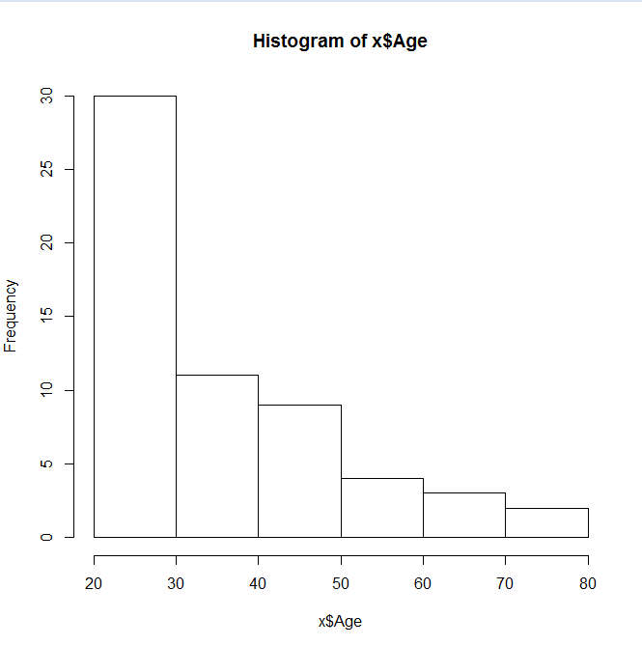

1. Boxplot for Age

boxplot(x$Age)

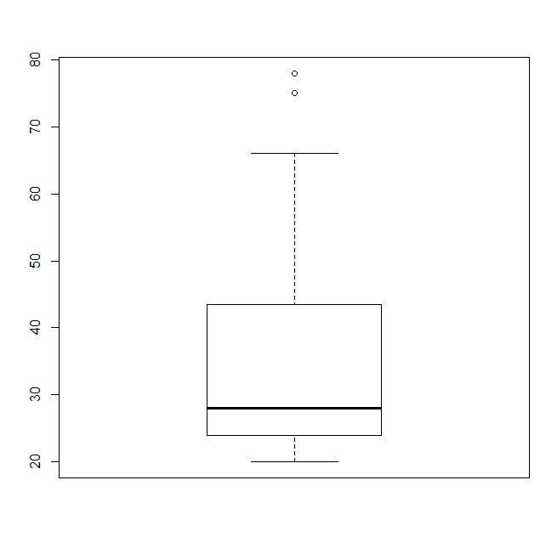

1. Scatterplot for Age and Number of years smoked.

plot(x$Age,x$Smoked_years)

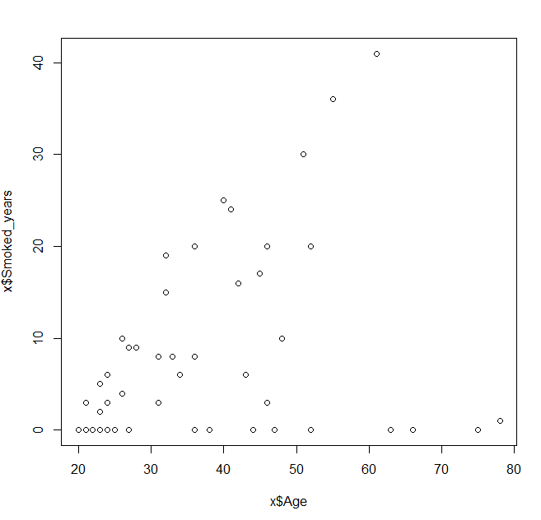

1. Scatterplot for Age and Number of years smoked with a regression line.

plot(x$Age,x$Smoked_years)

abline(lm(x$Smoked_years~x$Age),col="red")

