**SPSS Practical 5:**

**//**

**Assumptions in Pearson’s Correlation Test:**

1. **Interval or ratio level(Continous Data)**
2. **There needs to be a linear relationship**
3. **There should be no significant outliers**
4. **Approximately normal distributions**

**Assumption in Spearman’s Rho and Kendall’s Tau**

**NONE**

**//**

**Part A: Correlation Test**

A student was interested in whether there was a positive relationship between the time spent doing an essay and the mark received. He got 45 of his friends and timed how long they spent writing an essay (**hours**) and the percentage they got in the essay (**score**). He also translated these grades into their degree classifications (**grade**): first, upper second, lower second and third class.

// Outcome is Score

1. Write the null and alternative hypothesis for this test?

생략

1. By using the data in the file **EssayMarks.sav**, find out what the relationship was between the time spent doing an essay (hours) and the eventual mark in terms of
2. Score // Y축 X축 확실하게 정해주기

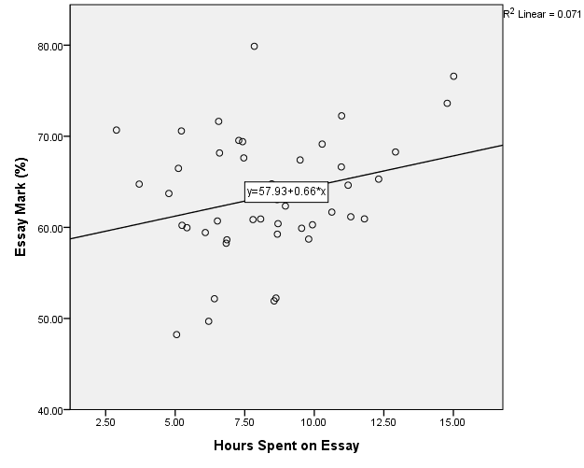

The scatterplot shows that there is a weak positive relationship

// KS test Analyze -> de -> explore -> plot, Normal~~check

Normality TEST:

$H_{0}$:Normality can be assumed.

$H_{1}$:Normality cannot be assumed.

|  |  |  |  |  |  |  |
| --- | --- | --- | --- | --- | --- | --- |
| **Tests of Normality** | | | | | | |
|  | Kolmogorov-Smirnova | | | Shapiro-Wilk | | |
| Statistic | df | Sig. | Statistic | df | Sig. |
| Hours Spent on Essay | .091 | 45 | .200* | .981 | 45 | .662 |
| Essay Mark (%) | .110 | 45 | .200* | .977 | 45 | .518 |
| *. This is a lower bound of the true significance. | | | | | | |
| a. Lilliefors Significance Correction | | | | | | |

For Essay Mark(K-S Test)

D(45) = 0.110, sig = 0.200 ( > 0.05)

This test is not significant

Assept $H_{0}$

Conclusion : It’s a normal distribution

For Hours(K-S Test)

D(45) = 0.977, sig = 0.200 ( > 0.05)

This test is not significant

Assept $H_{0}$

Conclusion : It’s a normal distribution

**//**

**Analyze -> Correlate -> Bi~ -> options 확인**

Pearson , be) normality test

Be positive relationship , one-tailed check

//

Pearson’s Correlation Test

|  |  |  |  |
| --- | --- | --- | --- |
| **Correlations** | | | |
|  | | Essay Mark (%) | Hours Spent on Essay |
| Essay Mark (%) | Pearson Correlation | 1 | .267* |
| Sig. (1-tailed) |  | .038 |
| N | 45 | 45 |
| Hours Spent on Essay | Pearson Correlation | .267* | 1 |
| Sig. (1-tailed) | .038 |  |
| N | 45 | 45 |
| *. Correlation is significant at the 0.05 level (1-tailed). | | | |

Pearson Correlation == R value

$H_{0}$:r = 0

$H_{1}$:r > 0 // be positive relationship

The Correlation is r(45) = 0.267, sig = 0.038( < 0.05)

This test is significant.

Reject ${ H}_{0}$

Conclustion : There is a positive relationship.

1. Degree Test // Analyze -> Correlate -> B~ -> Kendall , Spear,one tail

|  |  |  |  |  |
| --- | --- | --- | --- | --- |
| **Correlations** | | | | |
|  | | | Hours Spent on Essay | Grade |
| Kendall's tau_b | Hours Spent on Essay | Correlation Coefficient | 1.000 | -.158 |
| Sig. (1-tailed) | . | .089 |
| N | 45 | 45 |
| Grade | Correlation Coefficient | -.158 | 1.000 |
| Sig. (1-tailed) | .089 | . |
| N | 45 | 45 |
| Spearman's rho | Hours Spent on Essay | Correlation Coefficient | 1.000 | -.193 |
| Sig. (1-tailed) | . | .102 |
| N | 45 | 45 |
| Grade | Correlation Coefficient | -.193 | 1.000 |
| Sig. (1-tailed) | .102 | . |
| N | 45 | 45 |

Kendall’s Tau Correlation Test:

$$H_{0}:τ=0$$

$$H_{1}:τ=0$$

The Correlation is $τ$ (45) = -0.158, sig = 0.089 (> 0.05)

This test is non-significant

Accept $H_{0}$

Conclusion : There is no relationship

**Important**: You may need to draw a scatterplot to support your answer

**Part B: Partial Correlation Test**

**// All thing have relationship**

**// partial co~ = 한쪽을 제거해서 real relationship에 간섭하지 못 하게함.**

* A partial correlation provides an index of whether two variables are linearly related (hours and score) if the effects of a third control variable (say IQ) are removed from their relationship.
* A partial correlation is a type of Pearson correlation coefficient that can range in value from -1 to +1.
* A significant positive partial correlation implies that as the values on one variable increase, the values on a second variable also tend to increase, while holding constant the values of the control variable(s).

A professor was interested in whether there was a positive relationship between the time spent doing an essay and the mark received when considering the IQ of each student.

1. Write the null and alternative hypothesis for this test?
$$H_{0}:When controlling for IQ, there is no relationship between Hours and Score$$

$$H_{1}:When controlling for IQ, there is a positive relationship between Hours and Score$$

2. Perform the partial correlation test and interpret the SPSS output.

// Analyze -> co~ -> Partial, 항목 잘 지정(IQ relate 제거)

|  |  |  |  |  |
| --- | --- | --- | --- | --- |
| **Correlations** | | | | |
| Control Variables | | | Essay Mark (%) | Hours Spent on Essay |
| IQ | Essay Mark (%) | Correlation | 1.000 | .247 |
| Significance (1-tailed) | . | .053 |
| df | 0 | 42 |
| Hours Spent on Essay | Correlation | .247 | 1.000 |
| Significance (1-tailed) | .053 | . |
| df | 42 | 0 |

Partial Correlation Test: // r- value

The Correlation is $r$ (42) = 0.247, sig = 0.053 (> 0.05)

This test is non-significant

Accept $H_{0}$

Conclusion : The time spent doing an essay is unrelated to the mark received when controlling for the student’s IQ

**Part C:**

From the Smoking_Survey file, identify variables with the following relationships (use scatterplot and coefficient of determination value to support your answer):

//scatterplot, box plot 스케일데이터 4개 한꺼번에 넣고 함.

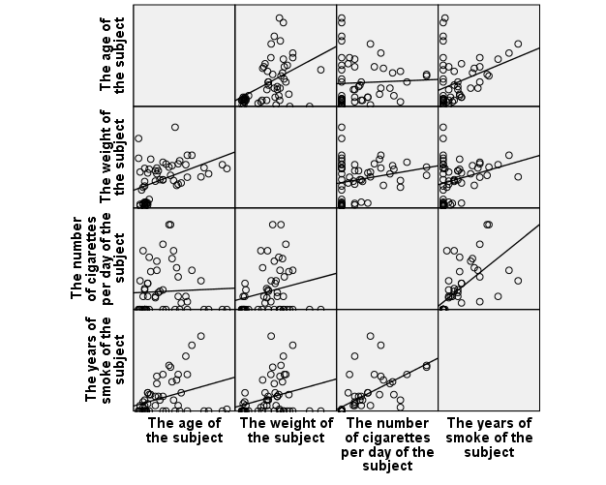

1. Strongest positive relationship:

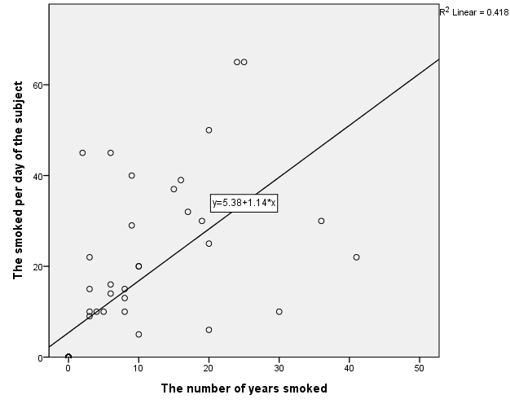

There is a positive moderate relationship, $r^{2}=0.418$

1. Weakest positive relationship:

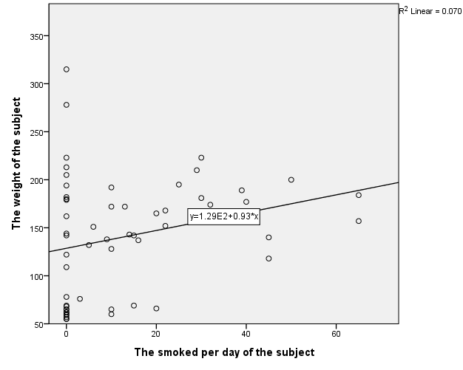  
There is a positive weak relationship, $r^{2}=0.070$

1. No relationship:

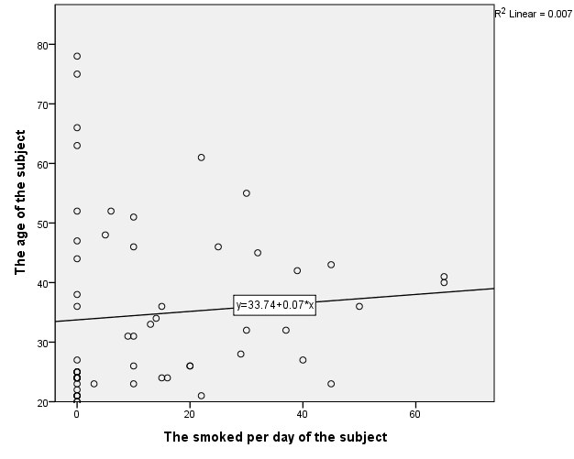

There is a no relationship, $r^{2}=0.007$