**SPSS Practical 6:**

**Part A:**

The following data were randomly selected from a sales record, where $P$ denote age, in years, and $Q$ denote sales price, in hundreds of dollars.

|  |  |  |  |  |  |  |  |  |  |  |
| --- | --- | --- | --- | --- | --- | --- | --- | --- | --- | --- |
| Item Number | 1 | 2 | 3 | 4 | 5 | 6 | 7 | 8 | 9 | 10 |
| $$P$$ | 6 | 6 | 6 | 4 | 2 | 5 | 4 | 5 | 1 | 2 |
| $$Q$$ | 125 | 115 | 130 | 160 | 219 | 150 | 190 | 163 | 260 | 260 |

**Answer the following questions:**

**// P = Age , Q = scales**

1. Use a graph to determine if there is any possible linear relationship between $P$& $Q$.

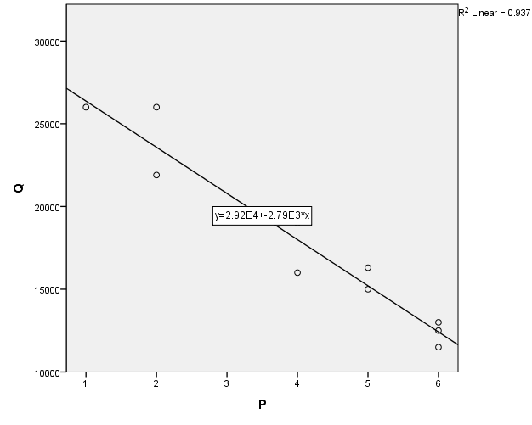

There is a strong negative relationship between Age and Scales

1. *Run* a Pearson’s test to verify your answer in Part (a).

|  |  |  |  |
| --- | --- | --- | --- |
| **Correlations** | | | |
|  | | P | Q |
| P | Pearson Correlation | 1 | -.968** |
| Sig. (1-tailed) |  | .000 |
| N | 10 | 10 |
| Q | Pearson Correlation | -.968** | 1 |
| Sig. (1-tailed) | .000 |  |
| N | 10 | 10 |
| **. Correlation is significant at the 0.01 level (1-tailed). | | | |

|  |
| --- |
| : r = 0 $H_{1}$ : r < 0  The Correlation is r(10) = -0.968, sig = 0.000(< 0.05)  This test is significant  Reject $H_{0}$ Conclustion : There is a negative relationship |

1. Compute the covariance between $P$ and $Q$.

|  |  |  |  |
| --- | --- | --- | --- |
| **Correlations** | | | |
|  | | P | Q |
| P | Pearson Correlation | 1 | -.968** |
| Sig. (1-tailed) |  | .000 |
| Sum of Squares and Cross-products | 30.900 | -86220.000 |
| Covariance | 3.433 | -9580.000 |
| N | 10 | 10 |
| Q | Pearson Correlation | -.968** | 1 |
| Sig. (1-tailed) | .000 |  |
| Sum of Squares and Cross-products | -86220.000 | 256816000.000 |
| Covariance | -9580.000 | 28535111.111 |
| N | 10 | 10 |
| **. Correlation is significant at the 0.01 level (1-tailed). | | | |

Cov(P,Q) **= -9580**

1. Determine the regression equation for the data.

// Analyze -> regression -> linear

|  |  |  |  |  |  |  |
| --- | --- | --- | --- | --- | --- | --- |
| **Coefficientsa** | | | | | | |
| Model | | Unstandardized Coefficients | | Standardized Coefficients | t | Sig. |
| B | Std. Error | Beta |
| 1 | (Constant) | 29160.194 | 1143.290 |  | 25.506 | .000 |
| P | -2790.291 | 256.289 | -.968 | -10.887 | .000 |
| a. Dependent Variable: Q | | | | | | |

Sales = 29160.194-2790.291(Age)

// Y = b0 + b1X + error

// Age(P) 에 있는 값이 기울기

// error는 b0에 포함

1. Compute and interpret the coefficient of determination, $r^{2}$.

// regression 구한 것에 model summagry

|  |  |  |  |  |
| --- | --- | --- | --- | --- |
| **Model Summary** | | | | |
| Model | R | R Square | Adjusted R Square | Std. Error of the Estimate |
| 1 | .968a | .937 | .929 | 1424.653 |
| 1. Predictors: (Constant), P | | | | |
| // R 제곱 값이 나와있기 때문에 방향은 모름(positive or negative) | | | | |

$r^{2}$ = 0.937, it’s a strong relationship

1. Find the predicted sales price when $age=7$.

Sales = 29160.194 – 2790.291(7) = 9628.157

1. Find the predicted age when the sales price is $15,000.

15000 = 29160.194-2790.291(Age)

Age = 5.047

Age $≈$ 5

**Part B:**

By using the R Program, compute the following questions: (same dataset as Part A).

1. Graph the data in a scatterplot to determine any possible linear relationship

> plot(x$P,x$Q)

> abline(lm(x$Q~x$P),col="red")

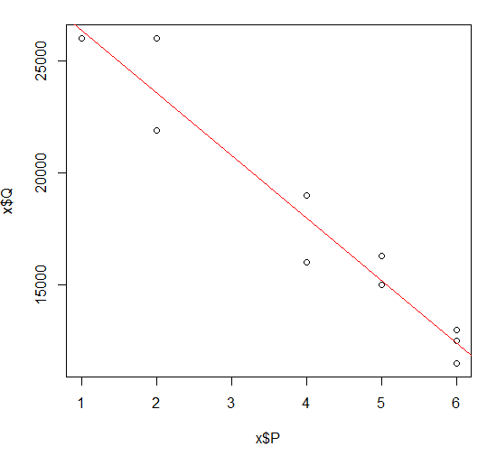

There is a negative relationship between P and Q

1. Compute covariance and Pearson’s correlation coefficient.

> cov(x$P, x$Q)

[1] -9580

Covariance = -9580

> cor(x$P, x$Q)

[1] -0.9678716

Pearson’s Correlation = -0.9678716

1. Determine the regression equation for the data.

> lm(formula = x$Q ~ x$P)

Call:

lm(formula = x$Q ~ x$P)

Coefficients:

(Intercept) x$P

29160 -2790

Q = 29160-2790P

1. Compute and interpret the coefficient of determination, 

> summary(lm(x$Q~x$P))

Call:

lm(formula = x$Q ~ x$P)

Residuals:

Min 1Q Median 3Q Max

-1999.03 -781.31 -63.59 896.12 2420.39

Coefficients:

Estimate Std. Error t value Pr(>|t|)

(Intercept) 29160.2 1143.3 25.51 5.98e-09 ***

x$P -2790.3 256.3 -10.89 4.48e-06 ***

---

Signif. codes: 0 ‘***’ 0.001 ‘**’ 0.01 ‘*’ 0.05 ‘.’ 0.1 ‘ ’ 1

Residual standard error: 1425 on 8 degrees of freedom

Multiple R-squared: 0.9368, Adjusted R-squared: 0.9289

F-statistic: 118.5 on 1 and 8 DF, p-value: 4.484e-06

$r^{2}$ = 0.9368

1. Perform Pearson, Spearman and Kendall test.

> cor.test(x$P,x$Q) Pearson

Pearson's product-moment correlation

data: x$P and x$Q

t = -10.887, df = 8, p-value = 4.484e-06

alternative hypothesis: true correlation is not equal to 0

95 percent confidence interval:

-0.9926062 -0.8659576

sample estimates:

cor

-0.9678716

> cor.test(x$P,x$Q,method="spearman") Spearman

Spearman's rank correlation rho

data: x$P and x$Q

S = 321.32, p-value = 3.149e-05

alternative hypothesis: true rho is not equal to 0

sample estimates:

rho

-0.9473695

Warning message:

In cor.test.default(x$P, x$Q, method = "spearman") :

Cannot compute exact p-value with ties

> cor.test(x$P,x$Q,method="kendall") Kendall

Kendall's rank correlation tau

data: x$P and x$Q

z = -3.3216, p-value = 0.0008951

alternative hypothesis: true tau is not equal to 0

sample estimates:

tau

-0.8690482

Warning message:

In cor.test.default(x$P, x$Q, method = "kendall") :

Cannot compute exact p-value with ties