E-Commerce Sales Analysis Observation
Data Cleaning, Analysis & Visualization with Excel

Overview:
Analysed E-commerce sales data using Excel by cleaning and organizing datasets, performing sales and profit analysis, and creating interactive dashboards. Utilized Pivot Tables, charts, slicers, and data visualization techniques to identify key trends, top-performing products, and business insights for data-driven decision-making.
Skills: Data Cleaning, Excel Functions, Pivot Tables, Data Visualization, Dashboard Creation, Sales Analysis.
Workflow:
Available Tables in the dataset:
  - Customer_Dim
  - Product_Dim
  - Store_Dim
  - Store_Dim
Data Cleaning:
Customer_Dim:
- Formatted the dataset into table and changed gave name of the table as Customer_Details
- Using the Flash fill option corrected the customer id properly

Before Correcting the Customer ID:

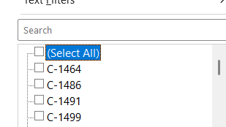

- Using the TRIM(PROPER([@Name])) function corrected the name of customers
- Corrected the Country name by flash fill
- There are no duplicates available in table
- Missing values were identified in the loyalty_level column and imputed using the mode, replacing all blank entries with "Platinum"
INDEX([Loyalty_Level],MODE(MATCH([Loyalty_Level],[Loyalty_Level],0)))
- Created new column as Age group to categorize the customers by using the formula
IF([@Age]<=30,"Adult",IF([@Age]<=50,"Mid-Adult","Senior"))
Product_Dim:
- Using the Flash fill option corrected the Product ID
Before correcting the Product ID:
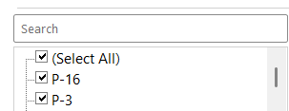

- Missing values in the Cost column were imputed using the formula below
IF(ISBLANK([@Cost]),AVERAGEIFS([Cost],[Category],[@Category],[Sub_Category],[@[Sub_Category]]),[@Cost])
- Reduced the decimal points based the existing values
(Another way : We can use the Power query to take the average by segregating category and subcategory and manually fill the average values in the blanks values)
- Filled the stock missing values by using below formula,
IF(ISBLANK([@Stock]),AVERAGEIFS([Stock],[Category],[@Category],[Sub_Category],[@[Sub_Category]]),[@Stock])

Store Dim:
- There are no such instances to change everything was fine in that table

Sales_Fact:
- Formatted the date and discount column
- And found the product category, subcategory
- In the Product dim table, we have first column as lookup values. Since the Primary condition becomes true, used the VLOOKUP to get the Category, Subcategory
- Category:
VLOOKUP([@[Product_ID]],Product_details[[#All],[Product_ID]:[Sub_Category]],3,0)
- Subcategory:
VLOOKUP([@[Product_ID]],Product_details[[#All],[Product_ID]:[Sub_Category]],4,0)
- Missing Values were found in the Columns Quantity, Unit price, Discount and Total amount
- Using the below functions, filled every blank cell based on the available data
Quantity =[@[Total_Amount]]/([@[Unit_Price]]*(1-[@Discount]))

For Unit_Price used Xlookup to get the Unitprice the Product dimension
Unit price
=IF(ISBLANK([@[Unit_Price]]),XLOOKUP([@[Product_ID]],Product_details[Product_ID],Product_details[Cost],"Not Found"),[@[Unit_Price]])

Or we can use the below function, if the required values are available,

Unit price=[@[Total_Amount]]/([@[Quantity]]*(1-[@Discount]))

Discount =(1-[@[Total_Amount]]/([@Quantity]*[@[Unit_Price]]))

Total Amount =[@Quantity]*[@[Unit_Price]]*(1-[@Discount])

- Additionally Extracted the Age Group, Gender and Loyalty_level from the Customer_dimension using the VLOOKUP with CustomerID

Age group=VLOOKUP([@[Customer_ID]],Customer_Details[#All],4,0)
Gender=VLOOKUP([@[Customer_ID]],Customer_Details[#All],5,0)
loyalty Level=VLOOKUP([@[Customer_ID]],Customer_Details[#All],9,0)

- Extracted the Region from the Store_Dim using the formula,
Region =XLOOKUP([@[Store_ID]],Table2[Store_ID],Table2[Region],"Region not found")
- Extracted the Year from the Order date for analysis purpose
YEAR([@[Order_Date]])
Pivot Tables and Charts:
Inserted the pivot table and charts from the Sales facts
Pivot Tables | Chart Type
Yearly sales analysis | Combo Chart
Payment type vs Sales | Pie-Doughnut Chart
Regionwise Avg.Revenue | Clustered Bar Chart
Sales based on Gender and Age group | Clustered Column Chart
Category wise Avg. Revenue | Pie Chart
Year vs Gender Sales | Clustered Column Chart

- Rearranged the Charts in another Sheet named as Sales_Dashboard
- Inserted slicers by selecting any graphs -> Insert->Slicers-> Select the column which needs to be filtered

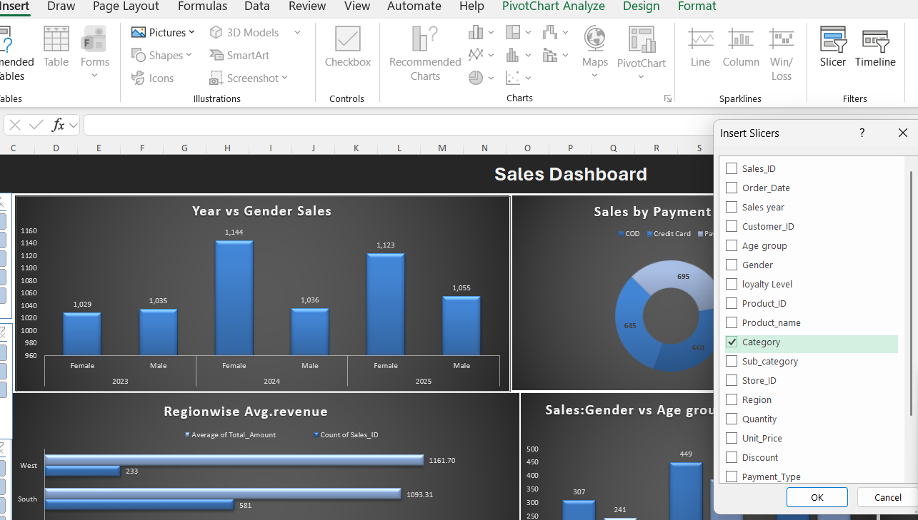

- To reflect the filter in all the charts, we need to give connections between pivots through Report Connections option

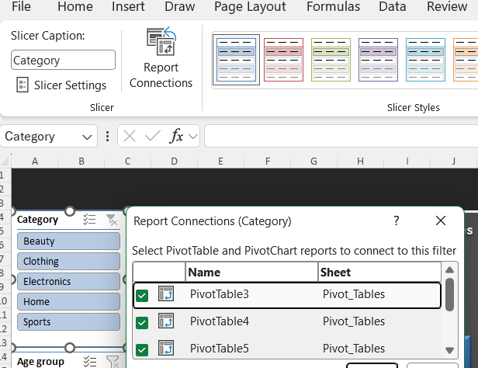

- In similar way, added two slicers as Age Group and Loyalty Level and reported Connections between all the pivot tables
Tool Pak Analysis:
Derived ToolPak Analysis by pivot table with Order date and Sales count , Avg of Total amount
Selected the Sales and Total amount ,clicked the Data analysis in the Data Ribbon
