WEEK 3 TASK REPORT
Unsupervised Learning and Clustering Analysis

Dataset: UCI Wine Dataset (accessed through Scikit-learn)
Algorithm: K-Means Clustering + PCA Visualization
Tools: Python, Pandas, NumPy, Scikit-learn, Matplotlib

Prepared as a comprehensive Week 3 internship/task submission

1. Executive Summary
This report demonstrates an unsupervised learning workflow for discovering natural groups in a publicly available dataset. The UCI Wine dataset contains chemical measurements of wines derived from three cultivars. The analysis deliberately ignores the known cultivar label during clustering so that the model discovers structure from the numerical features alone.
The dataset contains 178 observations and 13 numerical attributes. The workflow includes data inspection, preprocessing, standardization, K-Means clustering, selection of the number of clusters using the elbow method and silhouette analysis, dimensionality reduction with Principal Component Analysis (PCA), and cluster profiling.
For the final model, K = 3 was selected because it provides a compact and interpretable segmentation and corresponds to the strongest silhouette result among the tested values. The final silhouette score is approximately 0.285. The resulting clusters can be interpreted as groups of wines with different chemical profiles, which is useful for exploratory market segmentation, quality analysis, product positioning, and further research.

2. Dataset Description
The UCI Wine dataset is a well-known public dataset originally used for pattern recognition research. It contains chemical analysis results for wines from three cultivars grown in the same region of Italy. The dataset is available through the UCI Machine Learning Repository and is distributed directly through Scikit-learn's datasets module.
The dataset used in this analysis has 178 rows and 13 numerical features. Although the original dataset contains a target class representing cultivar, that target is not used to train the clustering model. It is retained only as contextual information in the dataset and excluded from the unsupervised learning input.
Feature | Meaning | Data Type
alcohol | Alcohol concentration | Numerical
malic_acid | Malic acid concentration | Numerical
ash | Ash content | Numerical
alcalinity_of_ash | Alkalinity of ash | Numerical
magnesium | Magnesium content | Numerical
total_phenols | Total phenols | Numerical
flavanoids | Flavanoid content | Numerical
nonflavanoid_phenols | Non-flavanoid phenols | Numerical
proanthocyanins | Proanthocyanin content | Numerical
color_intensity | Color intensity | Numerical
hue | Hue | Numerical
od280/od315_of_diluted_wines | Optical density ratio | Numerical
proline | Proline concentration | Numerical

3. Methodology

3.1 Overall Workflow
The analysis follows a standard unsupervised learning pipeline: dataset selection → data inspection → preprocessing → feature standardization → candidate K evaluation → K-Means model fitting → cluster visualization → cluster profiling → interpretation.
This approach is appropriate because clustering is exploratory: there is no dependent variable that the algorithm must predict. Instead, the objective is to maximize similarity within a cluster while maintaining separation between different clusters.

3.2 Data Inspection and Preprocessing
The features are continuous numerical measurements. K-Means is distance-based, so features with larger numerical scales can dominate the Euclidean distance calculation. To prevent this, StandardScaler was applied. Each feature was transformed to approximately zero mean and unit variance.
from sklearn.preprocessing import StandardScaler
features = wine.feature_names
X = df[features]
scaler = StandardScaler()
X_scaled = scaler.fit_transform(X)

3.3 Why K-Means?
K-Means was selected because it is simple, computationally efficient, and widely used for exploratory segmentation. It assigns each observation to the nearest centroid and repeatedly updates the centroids until the within-cluster variation is minimized. It is particularly suitable here because the dataset consists of continuous numerical measurements.
A limitation is that K-Means requires the number of clusters to be specified in advance and works best when clusters are reasonably compact and separated in the chosen feature space. Therefore, the number of clusters was not chosen arbitrarily; multiple values of K were evaluated using quantitative diagnostics.

3.4 Choosing the Number of Clusters
Two complementary techniques were used. First, the elbow method examines how inertia decreases as K increases. A useful K is often near the point where additional clusters provide diminishing improvement. Second, the silhouette score measures how similar an observation is to its own cluster compared with other clusters. Higher values generally indicate better separation.
from sklearn.cluster import KMeans
from sklearn.metrics import silhouette_score
for k in range(2, 11):
model = KMeans(n_clusters=k, random_state=42, n_init=10)
labels = model.fit_predict(X_scaled)
inertia = model.inertia_
score = silhouette_score(X_scaled, labels)
print(k, inertia, score)
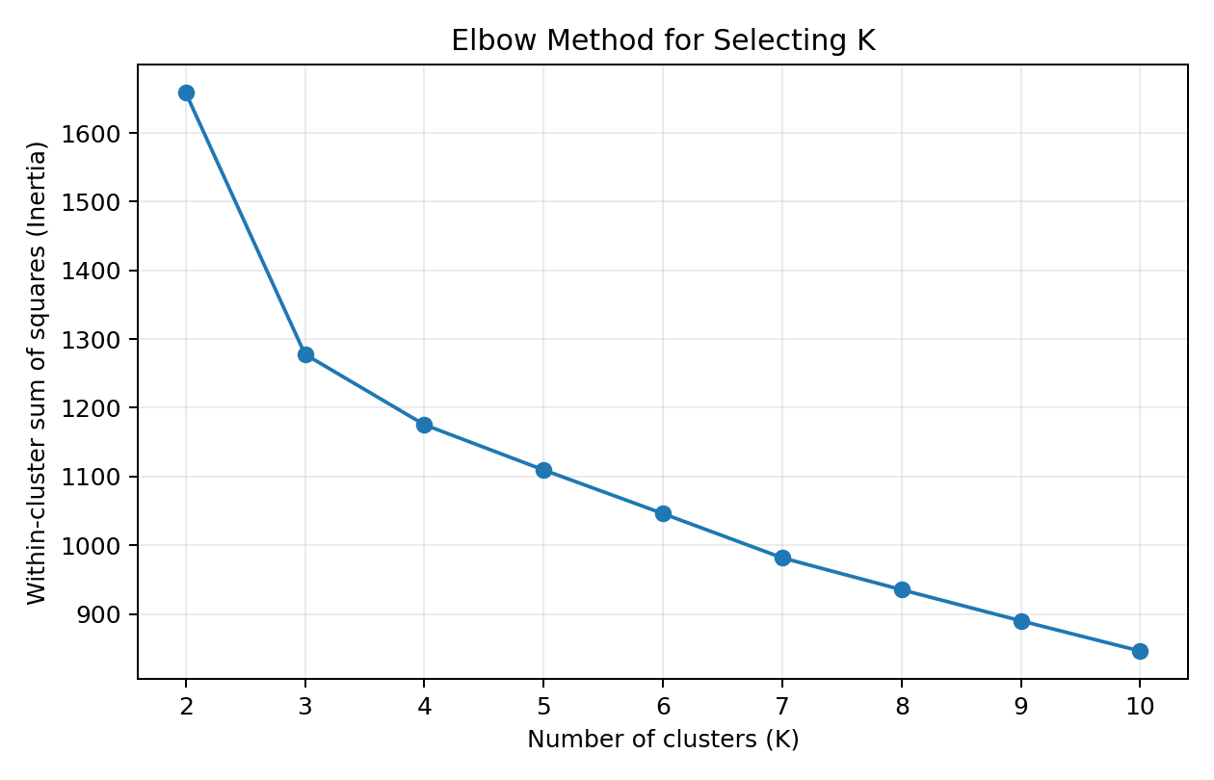
Figure 1. Elbow method used to examine candidate cluster counts.
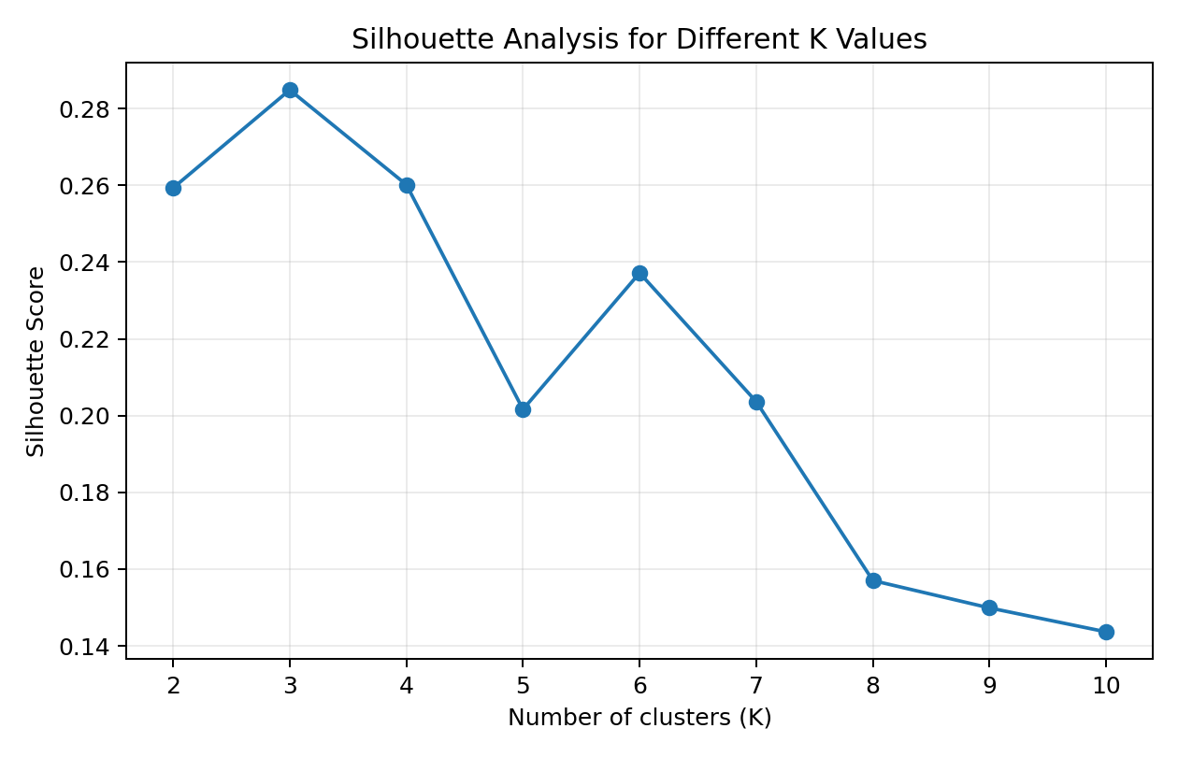
Figure 2. Silhouette scores for candidate values of K.
Based on the combined evidence, K = 3 was used for the final model. The final model achieved a silhouette score of 0.285. The value of K should still be treated as a modeling decision rather than an absolute truth, because clustering results depend on feature selection, scaling, distance metric, and algorithm assumptions.

4. Final K-Means Model
kmeans = KMeans(
n_clusters=3,
random_state=42,
n_init=10
)
labels = kmeans.fit_predict(X_scaled)
The random_state parameter was fixed at 42 to make the experiment reproducible. n_init=10 instructs Scikit-learn to run the K-Means initialization multiple times and retain a strong solution, reducing sensitivity to an unfavorable starting configuration.

5. Cluster Visualization Using PCA
The original dataset has 13 dimensions, so a direct plot of all features is not possible. Principal Component Analysis (PCA) was used only for visualization. PCA transforms correlated variables into a smaller set of orthogonal components that retain as much variance as possible. Importantly, PCA is not being used to define the final clusters; K-Means is fitted on the standardized original features.
from sklearn.decomposition import PCA
pca = PCA(n_components=2, random_state=42)
X_pca = pca.fit_transform(X_scaled)
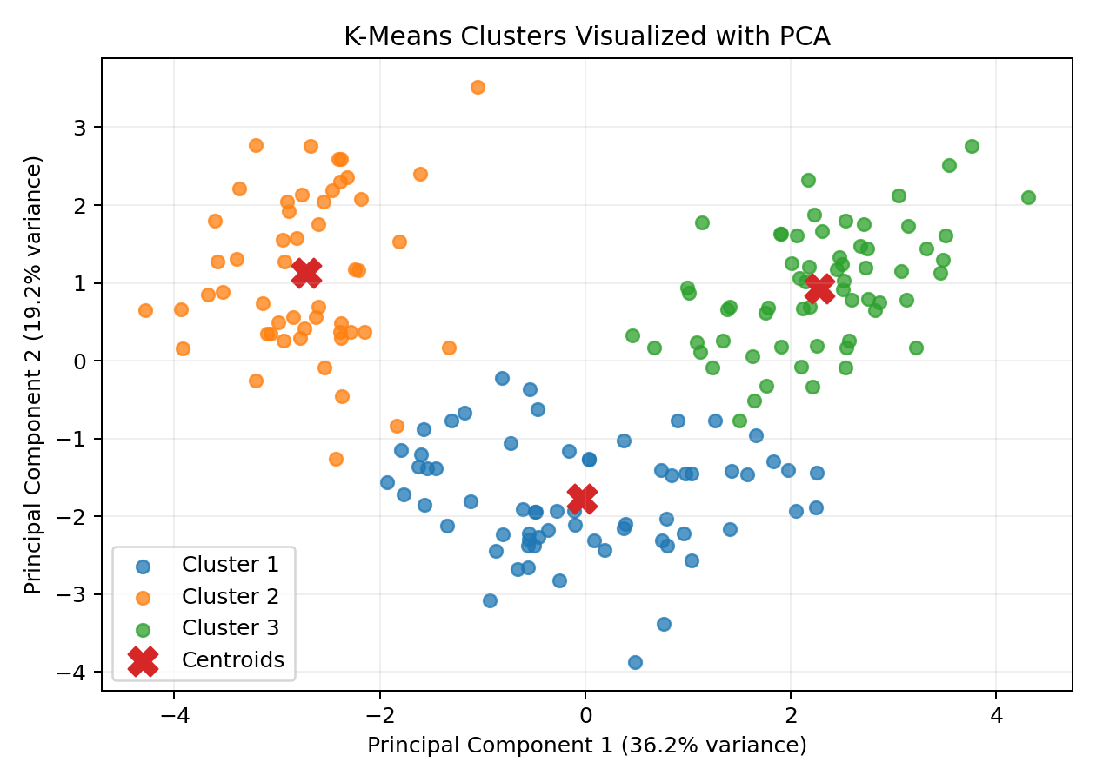
Figure 3. Final K-Means clusters projected into two PCA dimensions. PC1 explains 36.2% and PC2 explains 19.2% of standardized-feature variance.

6. Cluster Results
The final clustering divides the observations into three groups. The cluster numbering is arbitrary: Cluster 1 does not inherently mean better, larger, or more important than Cluster 2 or Cluster 3. The numbers simply identify the groups produced by the algorithm.
Cluster | Number of samples | Share of dataset
Cluster 1 | 65 | 36.5%
Cluster 2 | 51 | 28.7%
Cluster 3 | 62 | 34.8%
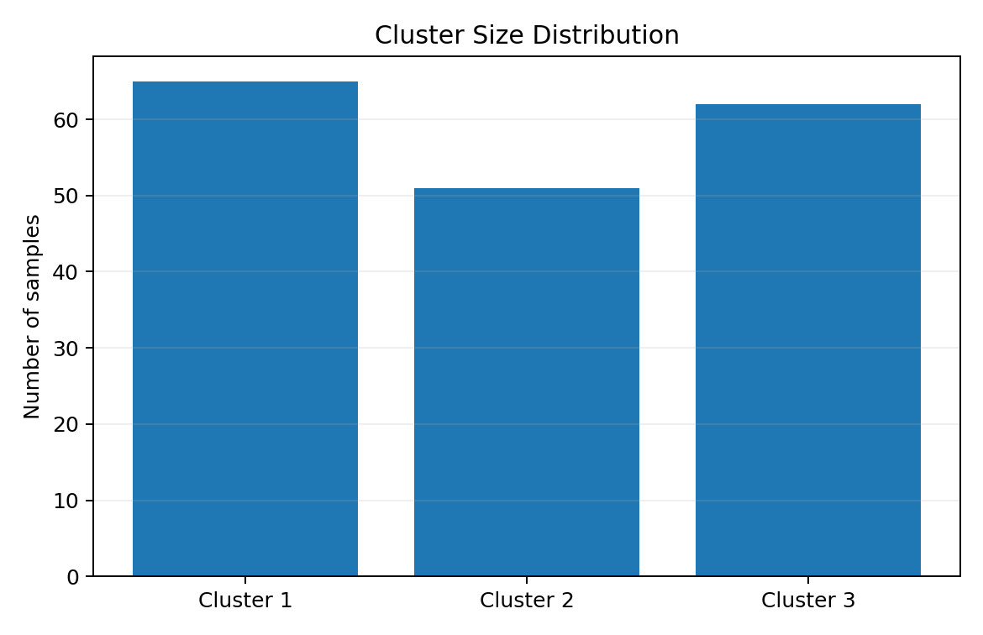
Figure 4. Number of observations assigned to each cluster.

7. Cluster Characteristics
Cluster profiling is essential because the cluster ID itself has no business meaning. The following table shows the mean value of each original feature within each cluster. These means help identify which chemical measurements distinguish the groups.
Cluster | alcohol | malic acid | ash | alcalinity of ash | magnesium | total phenols | flavanoids | nonflavanoid phenols | proanthocyanins | color intensity | hue | od280/od315 of diluted wines | proline
Cluster 1 | 12.25 | 1.9 | 2.23 | 20.06 | 92.74 | 2.25 | 2.05 | 0.36 | 1.62 | 2.97 | 1.06 | 2.8 | 510.17
Cluster 2 | 13.13 | 3.31 | 2.42 | 21.24 | 98.67 | 1.68 | 0.82 | 0.45 | 1.15 | 7.23 | 0.69 | 1.7 | 619.06
Cluster 3 | 13.68 | 2.0 | 2.47 | 17.46 | 107.97 | 2.85 | 3.0 | 0.29 | 1.92 | 5.45 | 1.07 | 3.16 | 1100.23

7.1 Standardized Cluster Profile
Because raw feature scales differ, standardized means are useful for interpretation. A positive value means that the cluster's mean is above the overall standardized mean for that feature, while a negative value means it is below the overall mean.
Cluster | alcohol | malic acid | ash | alcalinity of ash | magnesium | total phenols | flavanoids | nonflavanoid phenols | proanthocyanins | color intensity | hue | od280/od315 of diluted wines | proline
Cluster 1 | -0.93 | -0.39 | -0.49 | 0.17 | -0.49 | -0.08 | 0.02 | -0.03 | 0.06 | -0.90 | 0.46 | 0.27 | -0.75
Cluster 2 | 0.16 | 0.87 | 0.19 | 0.52 | -0.08 | -0.98 | -1.22 | 0.73 | -0.78 | 0.94 | -1.16 | -1.29 | -0.41
Cluster 3 | 0.84 | -0.30 | 0.36 | -0.61 | 0.58 | 0.89 | 0.98 | -0.56 | 0.58 | 0.17 | 0.47 | 0.78 | 1.13

7.2 Interpretation of Individual Clusters
Cluster 1 contains 65 observations (36.5% of the dataset). The strongest distinguishing variables include alcohol (higher, standardized mean 0.93), color intensity (higher, standardized mean 0.90), proline (higher, standardized mean 0.75), ash (higher, standardized mean 0.49). This indicates that the group has a distinctive multivariate chemical profile rather than being defined by a single measurement.
Cluster 2 contains 51 observations (28.7% of the dataset). The strongest distinguishing variables include od280/od315 of diluted wines (higher, standardized mean 1.29), flavanoids (higher, standardized mean 1.22), hue (higher, standardized mean 1.16), total phenols (higher, standardized mean 0.98). This indicates that the group has a distinctive multivariate chemical profile rather than being defined by a single measurement.
Cluster 3 contains 62 observations (34.8% of the dataset). The strongest distinguishing variables include proline (higher, standardized mean 1.13), flavanoids (higher, standardized mean 0.98), total phenols (higher, standardized mean 0.89), alcohol (higher, standardized mean 0.84). This indicates that the group has a distinctive multivariate chemical profile rather than being defined by a single measurement.

8. Business and Research Implications
Although the dataset is a scientific wine dataset rather than a customer database, the clustering workflow illustrates a general segmentation strategy. In a commercial setting, the same approach can group customers, products, stores, machines, or transactions based on multiple measured characteristics.
- Product segmentation: Wine producers or analysts could use chemical profiles to identify groups of products with similar measurable characteristics.
- Quality and process analysis: Clusters can help researchers investigate whether different production conditions or chemical profiles correspond to distinct product groups.
- Market positioning: If sensory scores, prices, or customer preferences were added in a separate business dataset, clusters could support differentiated product positioning.
- Research hypothesis generation: Unsupervised clusters can reveal patterns that motivate further statistical testing or laboratory investigation.
- Anomaly screening: Observations that are unusually distant from cluster centroids may warrant additional inspection, although K-Means itself is not a dedicated anomaly detector.

9. Evaluation of the Approach
The analysis satisfies the key requirements of an unsupervised clustering task: a public dataset was selected, numerical features were preprocessed, a clustering algorithm was applied, the number of clusters was investigated quantitatively, clusters were visualized, and cluster characteristics were interpreted.
The final silhouette score of 0.285 provides a quantitative indication of cluster separation. However, a single metric should not be treated as proof that the discovered groups are objectively real. Different scaling methods, feature subsets, algorithms, or distance measures could produce different partitions.

10. Limitations and Possible Improvements
- K-Means assumes that the selected distance representation is meaningful and that clusters are reasonably compact.
- The choice of K is not unique; elbow and silhouette diagnostics provide evidence but do not guarantee a single correct answer.
- PCA visualization reduces 13 dimensions to 2, so some separation visible in the plot may not represent the full feature space.
- The target labels are not used in training, so this is genuinely an unsupervised analysis; external labels could be used later only for validation.
- Future work could compare K-Means with hierarchical clustering, DBSCAN, Gaussian mixture models, or alternative distance metrics.
- A more extensive study could include repeated runs, stability analysis, feature selection, outlier analysis, and domain-expert validation.

11. Complete Reproducible Python Code
import pandas as pd
import matplotlib.pyplot as plt
from sklearn.datasets import load_wine
from sklearn.preprocessing import StandardScaler
from sklearn.cluster import KMeans
from sklearn.decomposition import PCA
from sklearn.metrics import silhouette_score
# Load public Wine dataset
wine = load_wine(as_frame=True)
df = wine.frame.copy()
# Select numerical features only
X = df[wine.feature_names]
# Standardize
scaler = StandardScaler()
X_scaled = scaler.fit_transform(X)
# Test different values of K
for k in range(2, 11):
model = KMeans(n_clusters=k, random_state=42, n_init=10)
labels = model.fit_predict(X_scaled)
print(
"K =", k,
"Inertia =", round(model.inertia_, 2),
"Silhouette =", round(silhouette_score(X_scaled, labels), 3)
)
# Final K-Means model
kmeans = KMeans(n_clusters=3, random_state=42, n_init=10)
labels = kmeans.fit_predict(X_scaled)
df["cluster"] = labels
# Silhouette score
score = silhouette_score(X_scaled, labels)
print("Final silhouette score:", score)
# PCA visualization
pca = PCA(n_components=2, random_state=42)
X_pca = pca.fit_transform(X_scaled)
for c in range(3):
idx = labels == c
plt.scatter(X_pca[idx, 0], X_pca[idx, 1], label=f"Cluster {c+1}")
plt.xlabel("PC1")
plt.ylabel("PC2")
plt.title("K-Means Clusters")
plt.legend()
plt.show()
# Cluster profile
print(df.groupby("cluster")[wine.feature_names].mean())

12. Conclusion
This project demonstrates how unsupervised learning can uncover structure in data without using class labels as training targets. The UCI Wine dataset was standardized and analyzed using K-Means clustering. The elbow method and silhouette analysis were used to evaluate candidate cluster counts, and PCA provided a two-dimensional visualization of the resulting groups.
The final three-cluster solution produced a silhouette score of 0.285 and revealed groups with different chemical profiles. The main lesson is that clustering is not simply about assigning labels: meaningful analysis requires careful preprocessing, model selection, visual validation, quantitative evaluation, and domain-oriented interpretation.

13. References
- Scikit-learn documentation — Clustering, KMeans, StandardScaler, PCA, and silhouette_score.
- Dua, D. and Graff, C. (2019). UCI Machine Learning Repository, Wine dataset.
- MacQueen, J. (1967). Some Methods for Classification and Analysis of Multivariate Observations. Proceedings of the Fifth Berkeley Symposium on Mathematical Statistics and Probability.
- Rousseeuw, P. J. (1987). Silhouettes: A graphical aid to the interpretation and validation of cluster analysis. Journal of Computational and Applied Mathematics, 20, 53–65.

Appendix A: Key Experimental Settings
Setting | Value
Dataset | UCI Wine dataset via Scikit-learn
Observations | 178
Input features | 13
Scaling | StandardScaler
Algorithm | K-Means
Candidate K values | 2 to 10
Final K | 3
random_state | 42
n_init | 10
Visualization | PCA with 2 components
Evaluation metric | Silhouette score = 0.285

