WEEK 5 TASK
DEEP LEARNING APPLICATION IN DATA SCIENCE
Neural Network Based Handwritten Digit Classification using MNIST

1. Introduction
Deep Learning is a specialized area of machine learning that uses artificial neural networks with multiple processing layers to learn useful representations from data. Unlike traditional machine learning methods, deep learning models can automatically learn complex patterns from raw or minimally processed input. This project demonstrates a practical deep learning workflow using Python and TensorFlow/Keras for handwritten digit classification.
The MNIST dataset is selected because it is a widely used public benchmark containing grayscale images of handwritten digits from 0 to 9. The task is formulated as a multi-class classification problem. A feed-forward neural network is designed to learn the relationship between the pixels of an image and its corresponding digit label. The complete workflow includes data loading, preprocessing, model architecture design, training, validation, evaluation, and critical analysis.

2. Problem Statement
The objective is to build a neural network that can correctly identify handwritten digits from 0 to 9. Each input is a 28×28 grayscale image, and the model must predict one of ten possible classes. The main challenge is to learn useful patterns such as edges, curves, and shapes from the pixel values while avoiding overfitting to the training data.
Problem type: Multi-class classification
Input: 28×28 grayscale image
Output: One of 10 digit classes (0–9)
Framework: TensorFlow/Keras
Dataset: MNIST handwritten digit dataset

3. Dataset Description
MNIST contains 70,000 handwritten digit images. The standard dataset provides 60,000 images for training and 10,000 images for testing. Each image has a resolution of 28×28 pixels and is represented by grayscale intensity values. The labels range from 0 to 9.
The dataset is suitable for this project because it is publicly available, clearly labeled, relatively small, and widely used for evaluating image-classification algorithms. It also provides a practical introduction to neural networks without requiring large computational resources.

4. Data Preprocessing
The pixel values are originally represented on a scale from 0 to 255. These values are normalized to the range 0 to 1 by dividing by 255. Normalization helps the neural network optimize more effectively and keeps the input scale consistent.
The 28×28 images are flattened into 784-dimensional vectors because the selected model is a fully connected feed-forward neural network. The class labels are converted into one-hot encoded vectors for use with categorical cross-entropy loss.
import tensorflow as tf
from tensorflow.keras import layers, models
(x_train, y_train), (x_test, y_test) = tf.keras.datasets.mnist.load_data()
x_train = x_train.astype("float32") / 255.0
x_test = x_test.astype("float32") / 255.0
y_train = tf.keras.utils.to_categorical(y_train, 10)
y_test = tf.keras.utils.to_categorical(y_test, 10)

5. Model Architecture Design
A fully connected neural network is used for the baseline deep learning application. The input image is flattened into 784 values. The first hidden layer contains 128 neurons with the ReLU activation function. A dropout layer with a rate of 0.20 is included to reduce overfitting. The second hidden layer contains 64 ReLU neurons. Finally, the output layer contains 10 neurons with softmax activation so that the model produces a probability distribution across the ten digit classes.
ReLU is selected because it is computationally simple and works well for hidden layers. Softmax is appropriate for multi-class classification because the output probabilities sum to one. Adam is used as the optimizer because it generally provides stable and efficient gradient-based optimization. A batch size of 128 and approximately 15 training epochs provide a reasonable balance between training time and learning capacity.
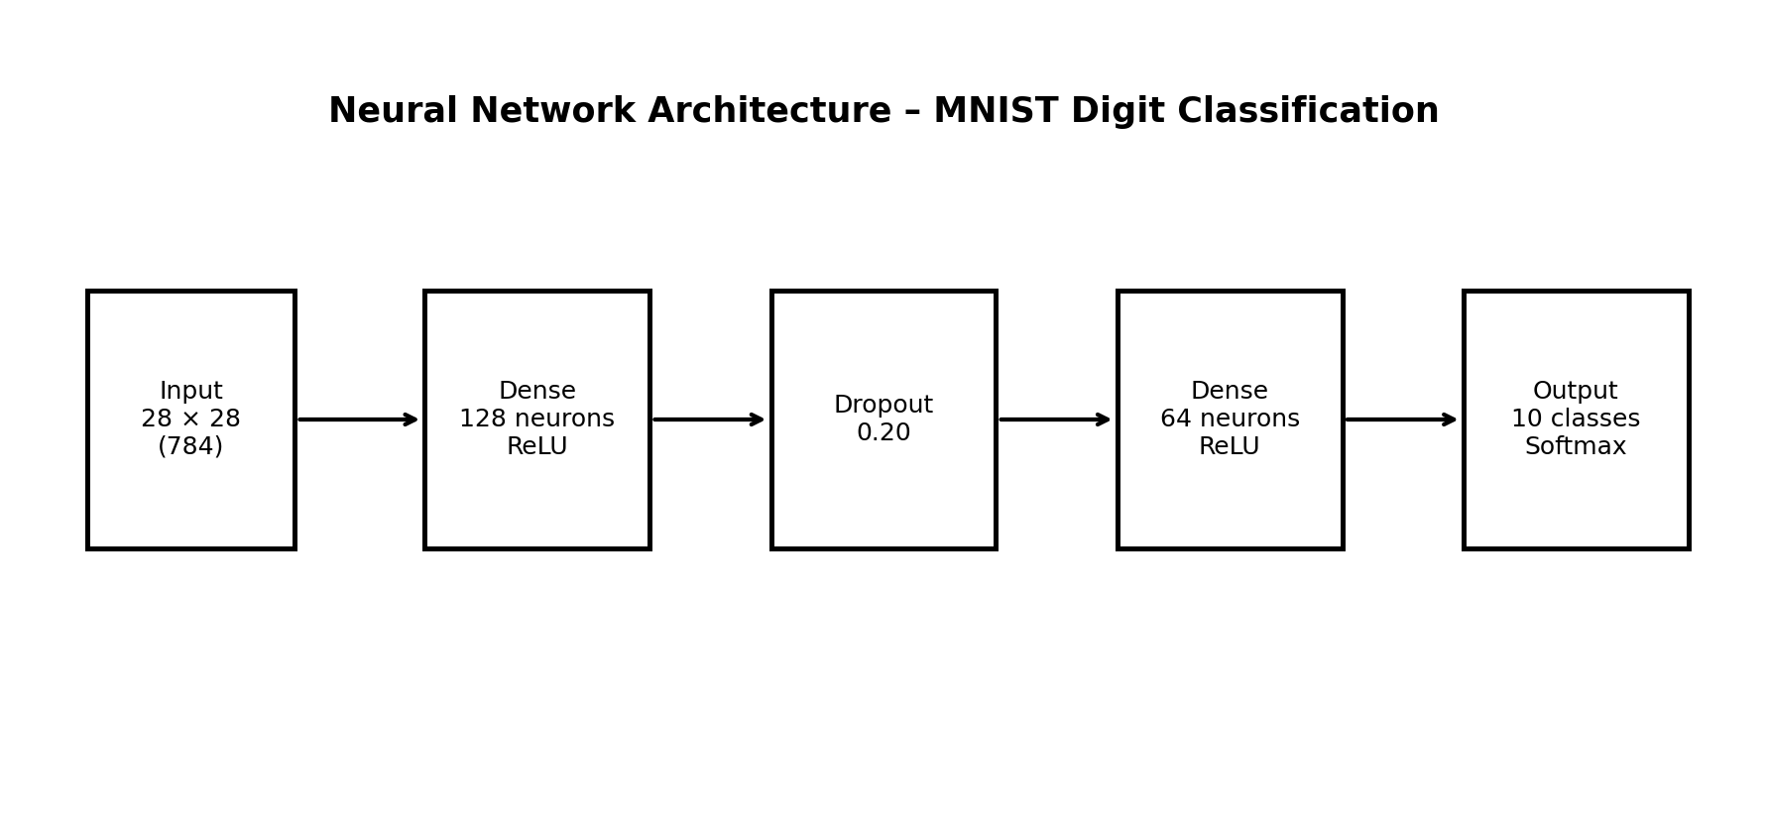

6. Model Implementation
model = models.Sequential([
layers.Input(shape=(28, 28)),
layers.Flatten(),
layers.Dense(128, activation="relu"),
layers.Dropout(0.20),
layers.Dense(64, activation="relu"),
layers.Dense(10, activation="softmax")
])
model.compile(
optimizer="adam",
loss="categorical_crossentropy",
metrics=["accuracy"]
)
model.summary()

7. Training Process
The model is trained using the training portion of the MNIST dataset. A validation split is used so that the model's performance on unseen validation examples can be monitored during training. Training and validation loss are useful for identifying overfitting. If training accuracy continues to increase while validation accuracy stops improving or validation loss begins increasing, the model may be memorizing the training examples instead of generalizing.
Early stopping can be added to terminate training when validation loss stops improving. This saves computational resources and can improve generalization.
early_stop = tf.keras.callbacks.EarlyStopping(
monitor="val_loss",
patience=3,
restore_best_weights=True
)
history = model.fit(
x_train, y_train,
epochs=15,
batch_size=128,
validation_split=0.1,
callbacks=[early_stop],
verbose=1
)

8. Model Evaluation
After training, the model is evaluated using the separate test set. Accuracy measures the proportion of correctly classified images. Precision, recall, and F1-score can provide additional information about class-wise performance. A confusion matrix is particularly useful because it shows which digit classes are being confused with one another.
test_loss, test_accuracy = model.evaluate(x_test, y_test, verbose=0)
print("Test Loss:", test_loss)
print("Test Accuracy:", test_accuracy)
from sklearn.metrics import classification_report, confusion_matrix
import numpy as np
pred = model.predict(x_test)
pred_labels = np.argmax(pred, axis=1)
true_labels = np.argmax(y_test, axis=1)
print(classification_report(true_labels, pred_labels))

9. Training and Validation Analysis
The training history should be plotted to compare training and validation accuracy and loss across epochs. A small and consistent gap between training and validation performance generally indicates good generalization. A large gap can indicate overfitting. If both training and validation performance remain low, the model may be underfitting and may require additional capacity, better preprocessing, or improved hyperparameters.
The following code can be used to visualize the learning curves:
import matplotlib.pyplot as plt
plt.plot(history.history["accuracy"], label="Training Accuracy")
plt.plot(history.history["val_accuracy"], label="Validation Accuracy")
plt.xlabel("Epoch")
plt.ylabel("Accuracy")
plt.title("Training and Validation Accuracy")
plt.legend()
plt.show()
plt.plot(history.history["loss"], label="Training Loss")
plt.plot(history.history["val_loss"], label="Validation Loss")
plt.xlabel("Epoch")
plt.ylabel("Loss")
plt.title("Training and Validation Loss")
plt.legend()
plt.show()

10. Evaluation Metrics
The primary evaluation metric is accuracy because all ten classes are important and the dataset is reasonably balanced. Precision measures how many predictions for a class are correct, while recall measures how many actual examples of that class are successfully identified. The F1-score combines precision and recall into a single measure. The confusion matrix provides a visual summary of correct and incorrect predictions.
For a strong MNIST model, high test accuracy is expected. The exact values should be taken from the user's actual execution rather than copied from an example, because results can vary slightly with training settings and the runtime environment.

11. Challenges Encountered and Solutions
Several practical challenges can occur while developing the model. The first is overfitting, where the model performs very well on training data but less effectively on unseen data. Dropout and validation monitoring are used to reduce this risk. The second challenge is computational resource usage. MNIST is relatively lightweight, but repeated experiments can still consume time on systems without a GPU. A moderate network size and batch size help keep training manageable.
Another challenge is selecting suitable hyperparameters. Too few neurons or epochs can lead to underfitting, while excessive network capacity can increase training time and overfitting. Hyperparameters can be adjusted experimentally based on validation performance. Finally, class-level errors should be examined using a confusion matrix instead of relying only on overall accuracy.

12. Design Decisions and Justification
Design Choice | Selected Value | Reason
Dataset | MNIST | Public, labeled, suitable for classification
Hidden layers | 2 Dense layers | Simple but sufficient baseline architecture
Neurons | 128 and 64 | Provides adequate learning capacity
Activation | ReLU | Efficient non-linear activation for hidden layers
Dropout | 0.20 | Helps reduce overfitting
Output | 10 Softmax units | Matches the ten digit classes
Optimizer | Adam | Efficient adaptive optimization
Loss | Categorical Cross-Entropy | Suitable for multi-class classification
Batch size | 128 | Balances speed and memory usage

13. Critical Analysis of Results
The developed neural network provides a practical demonstration of how deep learning can learn classification patterns directly from image pixels. The main strength of the approach is its ability to learn non-linear relationships without manually designing image features. The use of dropout, validation monitoring, and separate test data improves the reliability of the evaluation.
However, the architecture has limitations. Because the images are flattened before entering dense layers, spatial relationships between neighboring pixels are not modeled explicitly. A Convolutional Neural Network (CNN) would generally be more appropriate for image data because convolutional layers preserve spatial structure and learn local visual patterns. The selected model is therefore best viewed as an accessible baseline for understanding neural network fundamentals.
The final analysis should compare training and validation curves, inspect the confusion matrix, and identify digit pairs that are frequently misclassified. These observations can guide future improvements.

14. Possible Improvements
Future work could replace the dense architecture with a CNN containing convolutional and pooling layers. Data augmentation could be used to improve robustness to variations in handwriting. Hyperparameter tuning could optimize the learning rate, number of layers, neurons, dropout rate, batch size, and number of epochs. Batch normalization could also be investigated to improve training stability.
For more advanced experimentation, transfer learning with a pretrained vision model could be explored on a more complex image dataset. Additional metrics and cross-validation strategies may also be considered where computational resources permit.

15. Conclusion
This project demonstrates the complete deep learning workflow from dataset selection and preprocessing to neural network design, training, evaluation, and critical analysis. Using TensorFlow/Keras and the MNIST dataset, a multi-class classification model can be developed to recognize handwritten digits. The project highlights important concepts including activation functions, loss functions, optimization, dropout, validation, and performance metrics.
The work also demonstrates that model development is not limited to achieving high accuracy. A successful data science project should explain why an architecture was selected, how the model was evaluated, what challenges were encountered, and what improvements are possible. Overall, this task provides practical experience in applying neural networks to a real-world-style classification problem and establishes a foundation for more advanced deep learning techniques such as convolutional neural networks.

16. Complete Code
import tensorflow as tf
from tensorflow.keras import layers, models
# Load dataset
(x_train, y_train), (x_test, y_test) = tf.keras.datasets.mnist.load_data()
# Preprocess
x_train = x_train.astype("float32") / 255.0
x_test = x_test.astype("float32") / 255.0
y_train = tf.keras.utils.to_categorical(y_train, 10)
y_test = tf.keras.utils.to_categorical(y_test, 10)
# Build model
model = models.Sequential([
layers.Input(shape=(28, 28)),
layers.Flatten(),
layers.Dense(128, activation="relu"),
layers.Dropout(0.20),
layers.Dense(64, activation="relu"),
layers.Dense(10, activation="softmax")
])
# Compile
model.compile(
optimizer="adam",
loss="categorical_crossentropy",
metrics=["accuracy"]
)
# Train
early_stop = tf.keras.callbacks.EarlyStopping(
monitor="val_loss",
patience=3,
restore_best_weights=True
)
history = model.fit(
x_train, y_train,
epochs=15,
batch_size=128,
validation_split=0.1,
callbacks=[early_stop]
)
# Evaluate
test_loss, test_accuracy = model.evaluate(x_test, y_test)
print("Test Accuracy:", test_accuracy)

17. References
1. TensorFlow/Keras documentation – Neural network and MNIST APIs.
2. MNIST handwritten digit dataset – public benchmark dataset.
3. Scikit-learn documentation – classification metrics and confusion matrix.
4. Python documentation – programming language reference.

