+

EC5401 TRANSMISSION LINES AND WAVEGUIDES

**SMART BLIND STICK WITH ARDUINO**

## MINI PROJECT REPORT

***Submitted by***

|  |  |
| --- | --- |
| **POOJASREE M** | **2022504006** |
| **VAISHNAVI M** | **2022504519** |
| **PAVITHRA M** | **2022504537** |
| **PARKAVI M** | **2022504548** |

***In partial fulfilment for the award of the degrees of***

**BACHELOR OF ENGINEERING**

**IN**

**ELECTRONICS AND COMMUNICATION ENGINEERING**



# DEPARTMENT OF ELECTRONICS ENGINEERING MADRAS INSTITUTE OF TECHNOLOGY ANNA UNIVERSITY : CHENNAI – 600 004

**MAY 2024**

Certified that this project report **“SMART BLIND STICK WITH ARDUINO”** is the bonafide work of

|  |  |
| --- | --- |
| **POOJASREE M** | **2022504506** |
| **VAISHNAVI M** | **2022504519** |
| **PAVITHRA M** | **2022504537** |
| **PARKAVI M** | **2022504548** |

who carried out the project under my supervision.

**SIGNATURE**

**Dr.S.Piramasubramanian**

Associate Professor

Department of Electronics Engineering Madras Institute of Technology

Anna University Chennai 04

With profound gratitude and due regards, I sincerely acknowledge with thanks the opportunity provided to us by our respectful, Dean **Dr.K.RAVICHANDRAN**, Madras Institute of Technology, Anna University for providing a good environment and facilities.

I thank our respectful Head of the Department, **Dr.P.INDHUMATHI**, Professor , Madras Institute of Technology, Anna University for her encouragement during the project work.

I sincerely express my gratitude to our faculty incharge **Dr.S.PIRAMASUBRAMANIAN**, Associate Professor, Department of Electronics Engineering for being an inspiration to us and for valuable guidance throughout the course of this project.

**Place : Chennai Date : 31/05/2024**

|  |
| --- |
|  |
|  |

* 1. **INTRODUCTION:**

# CHAPTER 1

Smart Blind Stick is an interactive device which mainly aims at helping the blind to navigate easily and in a safer manner. In a normal day to day situation a blind person waves the blind stick ahead of them in order to check for any objects or obstacles. The smart stick helps them in this by detecting if any obstacle is blocking the path being taken by the subject. The device detects the obstacle with the help of a camera attached to the front of the stick. On detection of the obstacle, it is identified and appropriate instructions are provided to the user. Ultrasonic sensors are used for proximity detection of the obstacle. The stick vibrates on approaching an obstacle. This adds to the safety of the blind person. The appropriate instructions to the blind person is given over Bluetooth earphones. Thus using the various technology, the stick provides a safer and a better navigation experience for the visually challenged.

The blind person is expected to move the stick in front of him to ensure no obstacle is in his way. When the stick comes in contact with an obstacle, it is an indication for the blind person that he needs to change the path he was moving in..

## PROJECT AIM :

The aim of this project is to give blind person better understanding of the path he is moving in .

## CHAPTER 2

**DESCRIPTION OF THE COMPONENTS**

The list of components are

* + - Ultrasonic sensor
    - Led
    - Arduino UNO
    - Battery
    - Buzzer

## ULTRASONIC SENSOR:

An ultrasonic sensor works similar as of sonar. It can measure distance of object by sending sound waves. Sound waves are send at a specific frequency at a specific direction and listen for sound wave to come back. time taken by sound wave to come back helps us to determine distance of object.

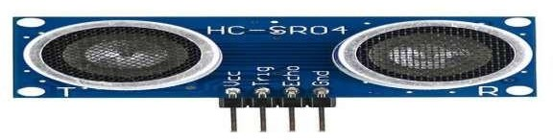

**Figure 2.1 Ultrasonic sensor**

## LED:

A light-emitting diode (LED) is a semiconductor device that emits light when an electric current flows through it. When current passes through an LED, the electrons recombine with holes emitting light in the process.Led allow the current to flow

in reverse direction. Light-emitting diodes are heavily doped p-n junctions. Based on the semiconductor material used and the amount of doping, an LED will emit coloured light at a particular spectral wavelength when forward biased. An LED is encapsulated with a transparent cover so that emitted light can come out.

. 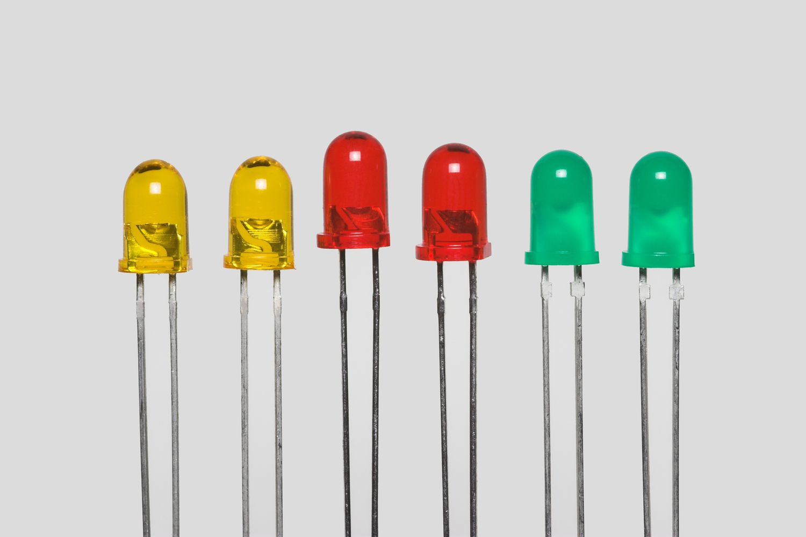

**Figure 2.2 LED**

## ARDUINO BOARD:

The Arduino is an open source electronics platform based on easy to use hardware and software. The open source Arduino software makes iteasy to write code and upload it to the board. It runs on Windows, Mac OS X and Linux. The environment is written in java and based on processing and other open source software. This software can be used with any Arduino board. The Arduino software IDE contains a text editor for writing code, a message area, a text console, a toolbar with buttons for common function. It connects to Arduino and Genuino hardware t+o upload programs and communicate with them. Program written using Arduino software are called sketches.

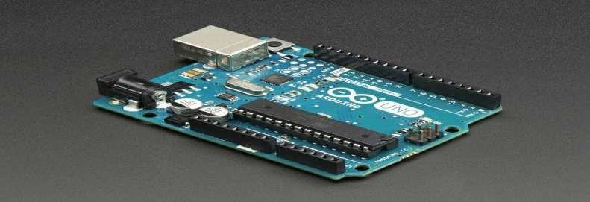

**Figure 2.3 Arduino Board**

## BATTERY:

Batteries are made up of three basic components: an **anode**, a **cathode**, and an **electrolyte**. A **separator** is often used to prevent the anode and cathode from touching, if the electrolyte is not sufficient. In order to store these components, batteries usually have some kind of **casing**.

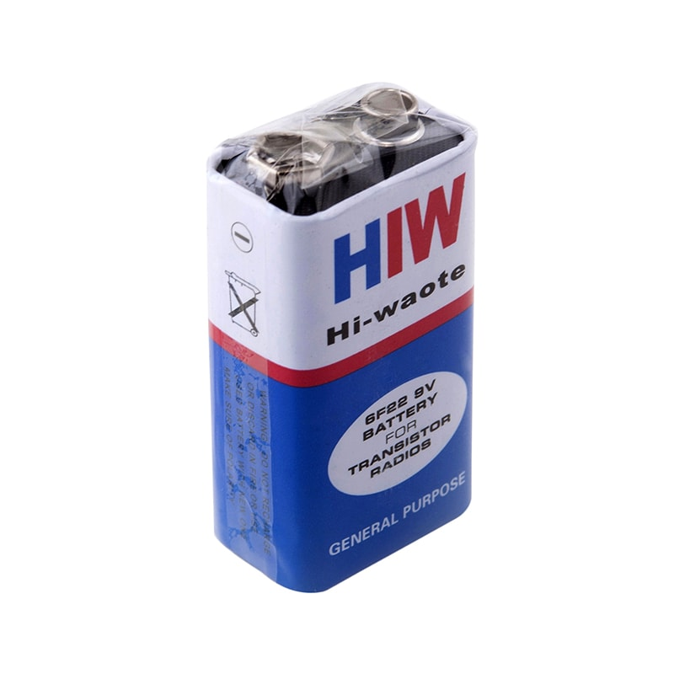

**Figure 2.4 Battery**

* 1. **BUZZER:**

Buzzer is an electrical device that is used to get a buzzing or beeping sound when a potential difference is created or voltage is applied. It has different applications in offices, schools, quiz competitions, sports, and games. By building a [**circuit**](https://collegedunia.com/exams/circuit-diagram-definition-components-types-example-physics-articleid-888) and making a buzzer, we will get an idea of how the circuit and [**potential difference**](https://collegedunia.com/exams/difference-between-emf-and-voltage-definition-and-solved-examples-physics-articleid-2662) in it will result in the functioning of the buzzer device

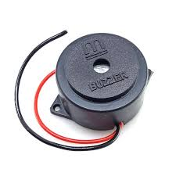

fig2.5 Buzzer

**CHAPTER 3**

CODE

// defines pins numbers

const int trigPin = 9;

const int echoPin = 10;

const int buzzer = 11;

const int ledPin = 13;

// defines variables

long duration;

int distance;

int safetyDistance;

void setup() {

pinMode(trigPin, OUTPUT); // Sets the trigPin as an Output

pinMode(echoPin, INPUT); // Sets the echoPin as an Input

pinMode(buzzer, OUTPUT);

pinMode(ledPin, OUTPUT);

Serial.begin(9600); // Starts the serial communication

}

void loop() {

// Clears the trigPin

digitalWrite(trigPin, LOW);

delayMicroseconds(2);

// Sets the trigPin on HIGH state for 10 micro seconds

digitalWrite(trigPin, HIGH);

delayMicroseconds(10);

digitalWrite(trigPin, LOW);

// Reads the echoPin, returns the sound wave travel time in microseconds

duration = pulseIn(echoPin, HIGH);

// Calculating the distance

distance= duration*0.034/2;

safetyDistance = distance;

if (safetyDistance <= 5){

digitalWrite(buzzer, HIGH);

digitalWrite(ledPin, HIGH);

}

else{

digitalWrite(buzzer, LOW);

digitalWrite(ledPin, LOW);

}

// Prints the distance on the Serial Monitor

Serial.print("Distance: ");

Serial.println(distance);

}

**CHAPTER 4**

CIRCUIT DIAGRAM

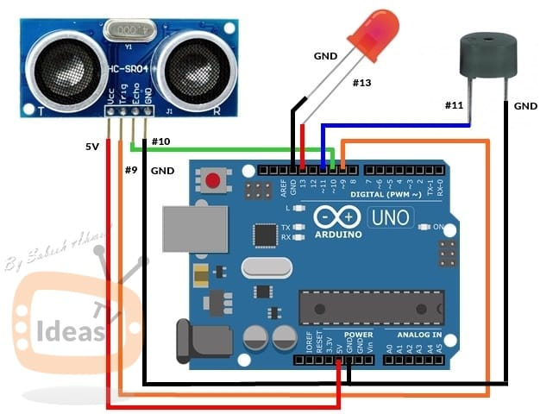

**CHAPTER 5**

**Explanation**

1. *Setup Phase*:

- Serial communication is initialized for debugging.

- Pin modes are set for the ultrasonic sensor, vibration motor, and buzzer.

2. *Loop Phase*:

- The ultrasonic sensor sends out a pulse and listens for the echo.

- The duration of the echo is measured and converted into distance.

- If the measured distance is below a certain threshold (e.g., 50 cm), the vibration motor and buzzer are activated to alert the user of an obstacle.

- If the distance is greater than the threshold, the alerts are deactivated.

Working Principle

1. *Obstacle Detection*:

- *Ultrasonic Sensor*: The ultrasonic sensor emits ultrasonic waves. When these waves hit an obstacle, they bounce back to the sensor.

- *Distance Measurement*: The Arduino calculates the time it takes for the waves to return and converts this time into a distance measurement.

2. *Feedback Mechanism*:

- *Vibration Motor*: If the measured distance to an obstacle is less than a predetermined threshold (e.g., 50 cm), the Arduino activates the vibration motor to alert the user.

- *Buzzer*: Simultaneously, the Arduino activates a buzzer to provide an auditory alert.

Summary

- *Sensor*: Ultrasonic sensor detects obstacles by measuring distance.

- *Processing*: Arduino processes the distance data.

- *Alert*: If an obstacle is close, Arduino triggers a vibration motor and a buzzer to alert the user.

This principle ensures that the user is warned about nearby obstacles through vibrations and sounds, enabling safer navigation.

**CHAPTER 6**

USES IN REAL LIFE

A smart blind stick equipped with sensors and feedback mechanisms has several real-life uses, significantly enhancing the mobility and safety of visually impaired individuals. Here are some key applications:

### Real-Life Uses

1. *Obstacle Detection and Avoidance*:

- *Indoor Navigation*: Helps users detect furniture, walls, and other obstacles within homes, offices, or public buildings.

- *Outdoor Navigation*: Assists in navigating sidewalks, parks, and other outdoor environments by detecting curbs, steps, and other potential hazards.

2. *Increased Independence*:

- *Public Transportation*: Enables users to navigate bus stops, train stations, and airports more independently.

- *Shopping and Errands*: Assists users in moving around stores, malls, and marketplaces, making it easier to run errands and shop independently.

The Internet of Things (IoT) has brought about numerous applications for the blind stick, enhancing its functionality and accessibility for visually impaired individuals. Some applications include:

1. *Obstacle Detection and Navigation:* Using sensors like ultrasonic or infrared, the blind stick can detect obstacles in the user's path and provide feedback through vibrations or auditory cues, helping them navigate safely.

2. *Indoor Navigation:* IoT-enabled blind sticks can utilize Wi-Fi or Bluetooth beacons installed indoors to provide navigation assistance in places like shopping malls, airports, or train stations.

3. *Environmental Monitoring:* Sensors on the blind stick can detect environmental factors such as temperature, humidity, and air quality, providing useful information to the user.

4. *GPS Integration:* By integrating GPS technology, blind sticks can provide outdoor navigation assistance, including route planning and destination guidance.

5. *Smartphone Integration:* Connecting the blind stick to a smartphone app enables additional features such as remote control, location sharing with family or caregivers, and integration with other accessibility tools.

6. *Emergency Assistance:* IoT-enabled blind sticks can include features such as automatic SOS alerts triggered by sudden falls or prolonged inactivity, providing peace of mind for both users and their loved ones.

7. *Object Recognition:* Advanced IoT models can incorporate artificial intelligence for real-time object recognition, helping users identify common objects, landmarks, or even faces.

These applications demonstrate the potential of IoT technology to significantly enhance the functionality and effectiveness of blind sticks, improving the independence and quality of life for visually impaired individuals.

**CHAPTER 7**

FUTURE ADVANCEMENTS

Future advancements in IoT-enabled blind sticks could include:

1. *Advanced Sensor Technology:* Integration of more advanced sensor technologies such as LiDAR (Light Detection and Ranging) for more precise obstacle detection and environmental mapping.

2. *Machine Learning and AI:* Continued advancements in machine learning and artificial intelligence could enable blind sticks to better understand and interpret their surroundings, providing more accurate and personalized assistance to users.

3. *Gesture Recognition:* Incorporation of gesture recognition technology could allow users to interact with the blind stick through gestures, making it more intuitive and easier to use.

4. *Haptic Feedback:* Further development of haptic feedback systems could provide more detailed and nuanced feedback to users, enhancing their spatial awareness and navigation abilities.

5. *Integration with Wearable Devices:* Integration with wearable devices such as smartwatches or head-mounted displays could provide users with additional information and feedback, enhancing the overall user experience.

6. *Cloud Connectivity:* Cloud connectivity could enable blind sticks to access and share data in real-time, allowing for more seamless integration with other IoT devices and services.

7. *Health Monitoring:* Integration of health monitoring sensors could enable blind sticks to monitor vital signs such as heart rate and blood pressure, providing users with valuable health information and alerts.

8. *Augmented Reality:* Incorporation of augmented reality technology could overlay digital information onto the user's surroundings, providing additional context and guidance.

These advancements have the potential to greatly improve the functionality, usability, and effectiveness of IoT-enabled blind sticks, further enhancing the independence and quality of life for visually impaired individuals.

**REFERNCES;**

<https://circuitdigest.com/microcontroller-projects/arduino-smart-blind-stick>

<https://youtu.be/_RpSaj9j-GY?si=3sfjVRoyBywZcPLN>

**THANKYOU**