MOTOR DRIVER

ELECTRONIC DESIGN LABORATORY

Submitted by

KESHIKA J M -2022504510

KARTHIGAA S -2022504511

PAVITHRA M -2022504537

PREMALATHA M -2022504543

PARKAVI M -2022504548

BACHELOR OF ENGINEERING

IN

ELECTRONICS AND COMMUNICATION

ENGINEERING



DEPARTMENT OF ELECTRONICS ENGINEERING

MADRAS INSTITUTE OF TECHNOLOGY

TABLE OF CONTENTS

S.NO TITLE PAGE NO

ACKNOWLEDGEMENT 1

ABSTRACT 2

CHAPTER -1 (3-4)

* 1. Introduction
  2. Project aim
  3. Project objective
  4. Limitation and description of project
  5. Purpose

CHAPTER -2 (5)

2.1 Hardware requirements

CHAPTER -3 (6-8)

3.1 Description of hardware components

CHAPTER -4 (9)

4.1 Circuit diagram

4.2 Working principle

CHAPTER -5 (10-12)

5.1 H-Bridge

5.1.1 H-Bridge motor forward circuit

5.1.2 H-Bridge motor backward circuit

CHAPTER -6 (13-14)

6.1 Applications

6.2 Advantages and disadvantages

6.3 Roles in future

6.4 Integrated efficiency

CHAPTER -7 (15)

7.1 Conclusion

CHAPTER -8 (16)

8.1 References

LIST OF IMAGES

SNO NAME PAGE NO

1. BJT -BC327 6

2. MOSFET-IRF540N 7

3. BJT-BC548 8

4. CIRCUIT DIAGRAM OF MOTOR DRIVER 9

5. H-BRIDGE 10

6. H-BRIDGE FORWARD CIRCUIT 11

7. H-BRIDGE BACKWARD CIRCUIT 12

**ACKNOWLEDGEMENT:**

We are thankful to our Dean, Dr. J. Prakash, Madras Institute of Technology, Anna University and Head of the Department Dr. P. Hindumathi, Electronics Engineering Department, for providing us with good facilities and opportunities to explore.

We would like to express our sincere gratitude to Dr.A.Divya for their invaluable support, guidance, and contributions throughout the completion of this report. Their insights, and feedback, and encouragement have been instrumental in shaping the outcomes presented herein.

We are also grateful to our parents and classmates who encouraged us to work on this project

**Place: Chennai**

**Date: 29.01.2024**

**ABSTRACT:**

This report explores the functionality, applications, and design considerations of motor shield drivers, crucial components in the realm of robotics and automation. It delves into the fundamental principles behind motor control and elucidates how motor shield drivers facilitate precise control over various types of motors, including DC motors, stepper motors, and servo motors. Moreover, the report discusses the diverse applications of motor shield drivers across industries, ranging from hobbyist projects to industrial automation. Additionally, it addresses key considerations in such as power requirements, communication protocols, and compatibility with microcontrollers. Through comprehensive analysis and examples, this report offers valuable insights into the role and significance of motor shield drivers in contemporary engineering and technology landscapes.

Furthermore, the report evaluates the performance metrics of motor shield drivers, including speed control, torque output, and energy efficiency, highlighting their impact on overall system performance. By examining emerging trends and advancements in motor control technology, this report provides a forward-looking perspective on the future evolution and integration of motor shield drivers in next-generation robotic systems and automated machinery. Through comprehensive research and analysis, this report serves as a valuable resource for engineers, researchers, and enthusiasts seeking to leverage the full potential of motor shield drivers in their projects and applications.

**CHAPTER -1**

* 1. **INTRODUCTION**

Motor drivers are a vital part of any robotics or automation

project. They provide the power needed to control motors and

other components within an application.

They are essentially responsible for providing the voltage, current

directionality and protection necessary to efficiently operate

your robotic parts or devices.

Motor drivers are basically current amplifiers that amplifies the low

input current and provides enough current to drive the motor.

* 1. **PROJECT AIM**

The aim of the project is to design and construct a motor driver which rotate in forward and backward direction.

* 1. **PROJECT OBJECTIVE**

The objective of the project is to implement a low cost, reliable,

Motor driver which is operated with the help of switch.

**LIMITATIONS AND DESCRIPTION OF THE PROJECT**

DC motors are vital components used in a wide range of applications, from household devices to industrial machinery. Their ability to provide precise speed control and high starting torque makes them versatile and valuable in various industries.

A major disadvantage is the limited lifetime due to friction wear of the brushes. These also limit the speed of DC motors. The so-called brush fire, which occurs between the brushes and the commutator, also limits the applications of DC motors.

**Purpose:**

Shield motor drivers are essential components in robotics, automation, and DIY projects where motorized motion is required. They ensure smooth operation and prevent damage to motors and other electronic components by regulating power delivery. By offering features like PWM for speed control and H-bridge configurations for bidirectional movement, shield motor drivers enhance the versatility of motor-driven applications.

Their compact form factor and ease of integration make them popular choices for hobbyists, educators, and professionals seeking reliable motor control solutions. In conclusion, shield motor drivers play a crucial role in empowering creators to bring their motorized projects to life while ensuring efficient and safe operation.

**CHAPTER -2**

2.**1 HARDWARE REQUIREMENTS**

* DC motor - 1
* MOSFET transistors IRF540N - 4
* Diodes - 4
* NPN bipolar transistors (BJT) BC548 - 2
* PNP bipolar transistors (BJT) BC327 - 2
* 2.2k ohm resistors - 4
* 10K ohm resistors - 4
* SPST Switch - 1
* Some jumper wires
* Breadboard

**CHAPTER -3**

**3.1 DESCRIPTION OF HARDWARE COMPONENTS**

**DC MOTOR**

A DC motor is defined as a class of electrical motors that convertdc current electrical energy into mechanical energy. From theabove definition, we can conclude that any electric motor that is operated using direct current or DC is called a DC motor.

**BJT - BC327**

BJT-BC327

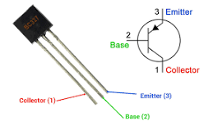

The PNP transistor is a type of transistor in which one n-type material is doped with two p-type materials. It is a device that is controlled by the current. Both the emitter and collector currents were controlled by the small amount of base current.

BC327 is a general-purpose PNP transistor that can be used for switching and amplification purposes in electronic circuits. It can be used as a switch to drive loads up to 800mA, including high power relays, high power transistors, high power LEDs, ICs, etc.

**DIODES**

A diode is a two-terminal electronic component that conducts electricity primarily in one direction. It has high resistance on one end and low resistance on the other end. Semiconductors like silicon and germanium are used to make the most of the diodes. Even though they transmit current in a single direction, the way with which they transmit differs.

**MOSFET - IRF540N**

MOSFET -IRF540N

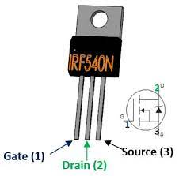

DEFINITION: MOSFET stands for metal-oxide-semiconductor field-effect transistor. It is a field-effect transistor with a MOS structure. Typically, the MOSFET is a three-terminal device with gate (G), drain (D) and source (S) terminals.

IRF540N is an N-Channel MOSFET transistor. This MOSFET can drive loads up to 23A and can support peak current up to 110A. It also has a threshold voltage of 4V, which means it can easily be driven by low voltages like 5V.

**BJT - BC548**

BJT -BC548

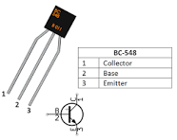

A negative-positive-negative transistor, called an NPN transistor, is a specific type of bipolar junction transistor containing a P-type semiconductor sandwiched between two N-type semiconductors.

BC548 is a NPN transistor and is used for amplifying and switching purposes in electrical circuits. Like every other NPN transistor, it consists of three pins: the collector, base, and emitter.

**CHAPTER -4**

**4.1 CIRCUIT DIAGRAM**

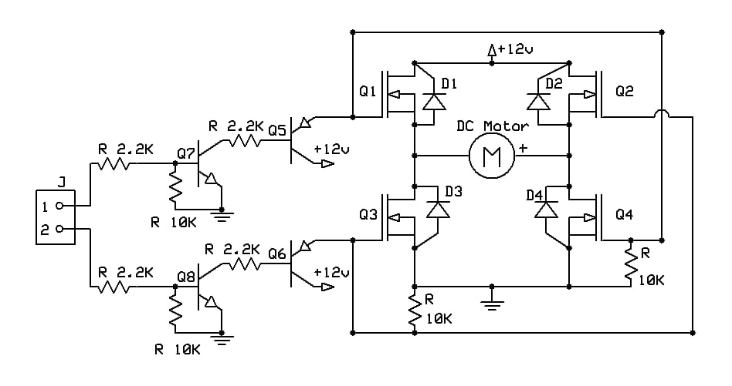

**4.2 WORKING PRINCIPLE**

This circuit is designed to run a motor from the same power source as your microcontroller. Setting I/O pin 1 high makes the motor spin in one direction, and setting pin 2 high makes it spin in the other. Setting both pins low stops the motor, so speed control can be achieved through a PWM signal to a pin. I should also mention that setting both pins high at the same time shorts your battery, and should be avoided.

**CHAPTER -5**

5.1 **H-BRIDGE**

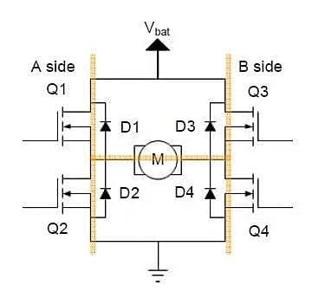

The yellow line segment represents the ‘H-Bridge’

5.1.**1 H-BRIDGE MOTOR FORWARD CIRCUIT**

**H-Bridge motor forward circuit**

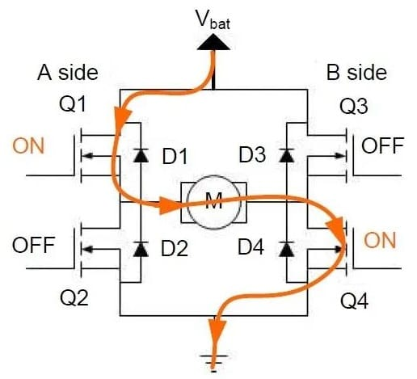

Usually, the H-bridge is used to drive inductive loads, here we drive a DC motor.

**STEPS INVOLVED:**

->Turn on Q1 and Q4.

->Turn off Q2 and Q3.

At this point, assuming the motor is forward, the current passes through Q1, M, Q4 in turn, as marked in the diagram using the orange line segment.

5.1.2 **H-BRIDGE MOTOR BACKWARD CIRCUIT**

H-Bridge motor backward circuit

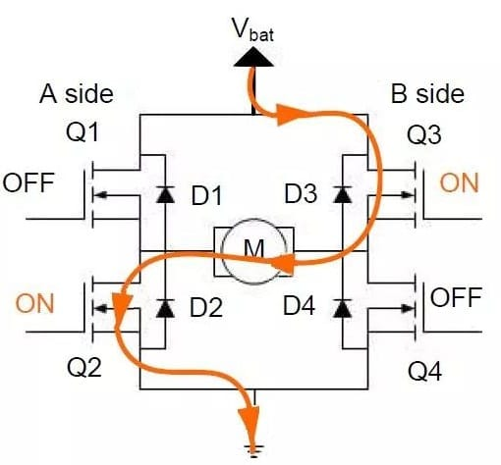

This time the state of the four switching components are as follows.

**STEPS INVOLVED:**

->Turning off Q1 and Q4.

->Turning on Q2 and Q3.

At this point the motor reverses (opposite to the case described earlier), which current passes through Q2, M, and Q3 in turn, as marked in the diagram using orange line segment.

Thus, as the SPST switch is turned on, the motor runs in the forward/backward direction based on the inputs given.

**CHAPTER -6**

6.1 **APPLICATIONS**

* In building a robot or other microcontrolled gadget, you will need to drive DC motors forwards and backwards
* Elevators
* Steel mills
* Rolling mills
* Locomotives
* Excavators

**6.2 ADVANTAGES AND DISADVANTAGES**

**6.2.1 ADVANTAGES**

* Simpler installation and maintenance.
* High startup power and torque.
* Fast response times to starting, stopping, and acceleration.
* Availability in several standard voltages.
  + 1. **DISADVANTAGES**
* Clogging at the speed less than 300 rpm
* High starting torque can damage reducers

**Role in Future:**

In the future, shield motor drivers could be integrated into advanced autonomous vehicles, enabling precise control and efficient power management for electric propulsion systems. These motor drivers might feature AI algorithms for real-time decision-making, allowing vehicles to adapt to changing road conditions and traffic patterns seamlessly. Moreover, they could be crucial components in futuristic robotics, powering agile and dexterous machines capable of performing complex tasks in various industries, from healthcare to manufacturing. Additionally, in space exploration, shield motor drivers could be vital for maneuvering spacecraft and robotic explorers across distant planets and celestial bodies, facilitating scientific discoveries and expanding our understanding of the universe.

**Integrated efficiency :**

Shield motor drivers boost efficiency in:

1. Vehicles: Enhance energy management.

2. Robotics: Improve motion control.

3. Home Automation: Power smart devices.

4. Industrial Machinery: Ensure smooth operation.

5. Agricultural Equipment: Optimize processes.

6. Medical Devices: Enable precise movement.

7. Aerospace and Defense: Ensure reliability.

Integration meets diverse industry needs efficiently.

**CHAPTER -7**

**7.1 CONCLUSION**

To sum up, our mini project on DC motor driver showcased a reliable and responsive system for motor control. The integration of H-bridge technology allowed seamless bidirectional movement.

CHAPTER -8

8.1 REFERENCES

## <https://robocraze.com/blogs/post/what-is-motor-driver#header-2>

* <https://www.utmel.com/blog/categories/motors/h-bridge-working-circuits-and-applications>
* <https://www.instructables.com/Easy-DC-Motor-Controller/>