Remote Monitoring of Solar Panel Parameters for Efficient Power Generation

**Pavithra M**  
Department of Electronics Engineering  
Madras Institute of Technology, Anna University  
Chennai, India **Parkavi M**  
Department of Electronics Engineering  
Madras Institute of Technology, Anna University  
Chennai, India

***Abstract*—Solar photovoltaic (PV) systems are crucial for sustainable energy, but their output is easily affected by soiling, weather, and other environmental factors. This paper proposes an IoT-enabled smart monitoring solution for solar panels, employing an ESP32 microcontroller to collect real-time data on light intensity, voltage, temperature, and humidity. The system includes an automated dust cleaning mechanism triggered by reduced efficiency, and presents live data through the Blynk app. Field results show improved yield, reduced manual maintenance, and increased operational awareness. The approach demonstrates a scalable, cost-effective solution for remote solar PV management.**

***Keywords— solar PV monitoring; IoT; ESP32; automated cleaning; Blynk; voltage sensing; LDR; DHT11.***

1. INTRODUCTION

The urgent need for sustainable and renewable energy sources has intensified global interest in solar photovoltaic (PV) technology. Solar PV systems are not only crucial for reducing carbon footprints but also offer decentralized power solutions in both urban and remote environments. Despite their many advantages, PV systems face a persistent challenge: the deterioration of performance due to environmental and operational factors. One of the most significant contributors to efficiency loss is the accumulation of dust, bird droppings, and other particulate matter on the panel surface. Studies show that even a thin layer of dust can cause a 15–35% decrease in power output, especially in regions with high particulate pollution or infrequent rain.

The impact of these losses is compounded in large-scale solar farms or remote standalone installations where manual inspection and maintenance are costly, labor-intensive, and sometimes impractical. Traditional mitigation strategies—such as scheduled manual cleaning and basic performance checks—often fail to address unexpected soiling events or transient environmental impacts that can occur between maintenance cycles.

Advancements in Internet of Things (IoT) technology, embedded sensors, and wireless communication have opened new possibilities for overcoming these challenges. IoT-enabled solutions make it feasible to continuously monitor multiple environmental and operational parameters, triggering targeted maintenance actions based on real-time data rather than fixed schedules. This approach minimizes energy loss, prolongs equipment life, and reduces operational expenses.

In this context, our work presents an intelligent, automated, and remotely accessible solar panel management system. The proposed design integrates low-cost, reliable sensors with modern microcontrollers and real-time cloud connectivity. Beyond basic monitoring, an innovative feedback-driven cleaning mechanism is deployed to mitigate performance drops promptly and autonomously. By providing actionable insights and remote actuation capability, this system empowers users to optimize solar power yield while minimizing manual intervention, and demonstrates a scalable model adaptable to various deployment scales and environments.

II. SYSTEM DESIGN AND COMPONENTS

**A. System Architecture Overview**

The core objective of the system design is to ensure reliable, continuous monitoring and timely maintenance of solar panels with minimal human effort. The system architecture is modular, supporting scalability (single panels to arrays) and straightforward component replacement or upgrades. It consists of three interlinked subsystems: sensing and data acquisition, processing and actuation, and user interaction (remote visualization and control).

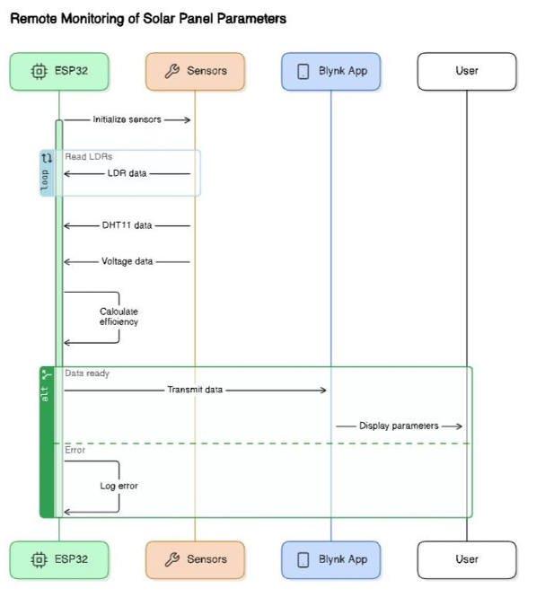

**B. Sensing and Data Acquisition Subsystem**

Light Detection (LDR Array):

Four Light Dependent Resistors (LDRs) are strategically placed on the panel’s corners to provide spatial detection of light variations. This setup not only identifies general soiling but can localize severe dust spots or shadows, improving cleaning precision. The LDRs are multiplexed to optimize the number of analog input lines required and to allow synchronized sampling.

Temperature and Humidity Sensing (DHT11):

The DHT11 sensor measures ambient temperature and relative humidity, parameters that have a direct influence on the efficiency of PV cells and the likelihood of soiling. These readings are used both for performance diagnostics and to inform weather-related cleaning logic (e.g., suppressing cleaning cycles during rain or very high humidity events).

Voltage Measurement (Voltage Divider):

Real-time assessment of panel output voltage acts as the primary performance metric. A resistive voltage divider brings the PV output down to safe levels suitable for the ESP32’s built-in analog-to-digital converter (ADC). Since voltage directly correlates with yield, sudden drops are a robust indicator of soiling or other operational issues.

**C. Processing and Control**

ESP32 Microcontroller:

Acting as the central processing unit, the ESP32 is responsible for acquiring sensor data, executing threshold comparison algorithms, managing network connections (WiFi), and actuating the cleaning servo. It is chosen for its dual-core performance, extensive I/O, and built-in wireless connectivity, all of which facilitate real-time data handling and multi-tasking. The program is structured for high reliability, using non-blocking sensor reads and event-driven actuation routines.

Automated Cleaning Mechanism:

When the system detects a notable drop in either the average LDR reading or panel voltage (e.g., below 80% of the clean baseline after adaptive filtering), the ESP32 triggers a micro servo to actuate a cleaning arm or vibration module. This prompt, feedback-driven intervention typically restores output metrics without manual intervention. The system logs each cleaning event, creating a maintenance history.

**D. Communication and User Interface**

Wireless Data Transmission:

The ESP32 sends all collected data and event logs to the Blynk cloud platform via WiFi. This enables low-latency, remote visualization and control over the user’s smartphone or web dashboard.

Blynk Dashboard:

The Blynk interface provides intuitive widgets—real-time graphs, historical logs, notification alerts, and manual override buttons for cleaning activation. Users can monitor trends, spot issues early, and initiate remote cleaning cycles as needed.

**E. Power Management**

Independent/Autonomous Powering:

The control electronics and servo are powered via the panel itself or an auxiliary regulated battery, ensuring that the system functions continuously even when main power output dips temporarily during maintenance or adverse weather.

**F. Data Logging and Analysis**

Continuous Logging:

All sensor readings and system actions are logged both locally and in the cloud for historical analysis. This supports long-term diagnostics, predictive maintenance scheduling, and system optimization.

Voltage Divider: Reduces the PV output voltage to a level compatible with the ESP32’s ADC, facilitating accurate monitoring of the panel’s electrical performance.

III. IMPLEMENTATION

**A. Hardware Integration**

The complete system hardware was built around the ESP32 microcontroller due to its integrated WiFi, dual-core processing capabilities, and versatile I/O options. The physical assembly consists of a robustly mounted sensor array, actuator mechanism, custom wiring, and a perfboard/PCB for circuit consolidation.

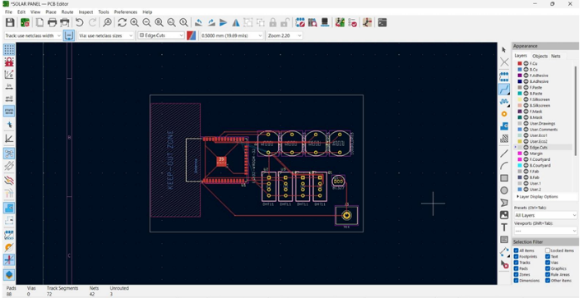

Figure 1

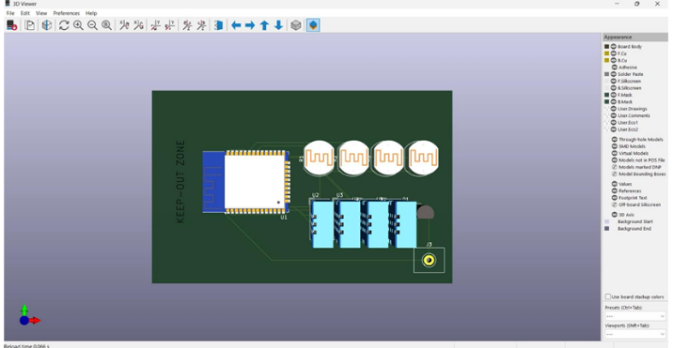

Figure 2

**1) Sensor Integration**

LDR Array: Four LDRs are individually positioned at the corners of the solar panel and multiplexed via analog switches. Multiplexing conserves GPIO pins and enables the ESP32 to sequentially gather spatial light intensity data. Each LDR’s output is filtered with a low-value resistor to suppress noise and enhance response time.

DHT11 Sensor: The temperature/humidity sensor is positioned away from direct sunlight and insulated from panel heat using a small shield, ensuring readings reflect ambient—not surface—environmental conditions. It connects to a digital pin, with short wiring to minimize signal loss.

Voltage Divider: Two precision resistors scale down the solar panel’s output voltage (typically 6–18V) to below 3.3V, protecting the ESP32 ADC. High-voltage traces are kept short and isolated from logic signals for safety.

**2) Cleaning Actuator Assembly**

An SG90 micro servo motor is affixed parallel to the panel frame, actuating a lightweight cleaning arm or vibration element. The arm is built from a non-scratch plastic strip or foam for gentle contact. The servo is powered directly from a 5V regulated rail, while control is via a dedicated digital pin. The mechanical linkage is designed for minimal friction and tested for continuous actuation cycles (>200 cycles without mechanical failure).

**3) Power Supply and Safety**

The ESP32 and actuator system draw regulated 5V either from the PV panel (through a buck converter) or a supplemental battery. Proper reverse-polarity and overcurrent protection is included using diodes and fuses. All connections use insulated crimped terminals; water-sensitive parts are conformally coated or boxed for outdoor resilience.

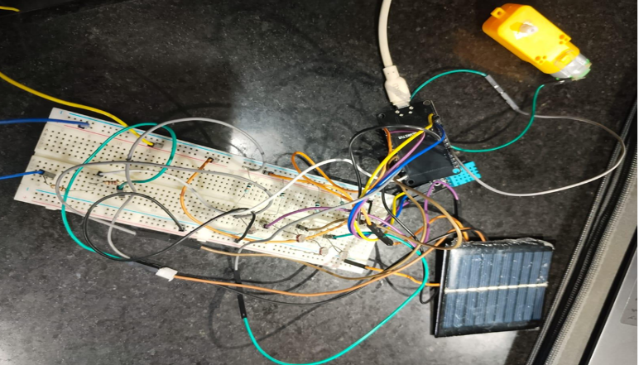

Figure 3

**B. Firmware Development**

The ESP32 is programmed using Arduino IDE and open-source libraries (WiFi.h, BlynkSimpleEsp32.h, DHT.h, ESP32Servo.h). The firmware is structured for modularity and reliability.

**1) Initialization and Connectivity**

At boot, the ESP32 attempts to connect to a predefined WiFi network and initialize the Blynk cloud session. If either fails, the board enters a safe “retry” state until connectivity is restored, with status indicated via onboard LED blinking.

**2) Sensor Polling and Data Acquisition**

LDRs: The four LDRs are polled via analogRead in rapid sequence, their values normalized to baseline “clean” readings.

Environmental Parameters: DHT11 values are sampled with built-in debouncing and error checking (checksum validation).

Voltage Sensing: The scaled analog input is sampled and converted to true panel voltage using calibration constants.

All raw data is timestamped using the system clock for precise event log correlation.

**3) Data Analysis and Cleaning Logic**

The core process evaluates each metric in the following steps:

Calculate the average LDR, compare to stored clean reference.

If the panel voltage or LDR index falls below a preset threshold (typically 80% of clean baseline) and humidity is not extreme (to avoid cleaning during rain), trigger a servo actuation cycle.

After cleaning, update the clean reference if restored voltage is stable.

If a manual cleaning request is received via the Blynk dashboard, execute the cleaning cycle regardless of sensor inputs.

All cleaning actions and status changes are logged for later analysis.

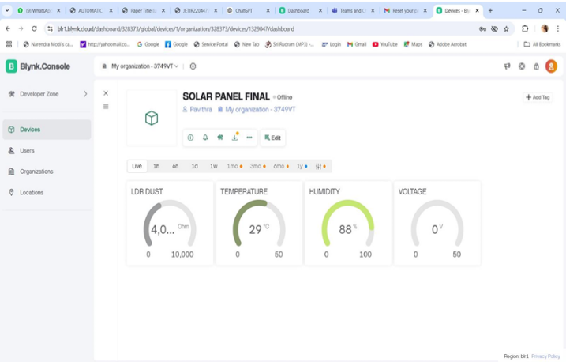

Figure 4

**4) Data Transmission to Blynk Cloud**

After each measurement cycle:

Sensor values and event status (e.g., “Cleaned”, “No action”, “Error: Sensor read fail”) are packaged and sent to the Blynk cloud via a secure MQTT channel.

Blynk widgets display live graphs, historical logs, and real-time notification alerts (push notification and/or email) for soiling or hardware events.

Users may access the dashboard via smartphone (iOS/Android) or desktop web, and securely trigger manual overrides.

**5) Reliability and Power Optimization**

All sensor and actuator routines are non-blocking to maintain real-time responsiveness.

The ESP32 deep-sleep feature is implemented for non-critical night hours to conserve power, with auto-wake on sunrise or user command.

Watchdog timers and error-checking routines ensure system recovers automatically from transient faults.

**C. Prototype Assembly and Field Deployment**

The fully integrated system was mounted to the frame of a 10W test panel. Field wiring is routed through weatherproof conduit. The assembly survived multiple weeks of outdoor exposure, including rain and high humidity, demonstrating durability, reliable wireless connectivity, and robust cleaning operation under varied environmental conditions.

IV LIMITATIONS AND FUTURE WORK

**A. Limitations**

LDR Detection: Can give false positives in heavy shading or cloud cover; future versions will use improved algorithms.

•DHT11 Sensor: Sufficient for trends but lacks high accuracy.

•Current Sensing: Only voltage is monitored; for deeper diagnostics, current measurement is needed.

•Mechanical Robustness: Further testing is needed in harsher environments.

**B. Future Enhancements**

•Upgrade to more precise sensors (DHT22/SHT3x) and add current sensing.

•Apply machine learning for better soiling/cloud discrimination.

•Enable mesh networking for multi-panel scalability.

•Integrate weather APIs for adaptive scheduling.

•Miniaturize hardware with a custom PCB.

V CONCLUSION

An affordable, automated IoT system for solar panel monitoring and cleaning was developed and validated. Using an ESP32 with modular sensors and cloud connectivity, the system detects performance drops, triggers cleaning only when necessary, and keeps users informed via a remote dashboard. Field results show higher energy yield, less manual effort, and improved maintenance tracking. With further enhancements in sensing and scalability, this approach is well-suited for widespread residential and commercial solar deployments.

##### References

1. Manisha Kharat and B. N. Chaudhari, “Integrating IoT with Solar Energy: A Review of Monitoring Systems for Enhanced Performance,” *Int. J. Research Publication and Reviews*, vol. 6, no. 1, pp. 4874–4877, Jan. 2025.
2. “Monitoring Photovoltaic Panels Using the ESP32 Microcontroller via low‑power Bluetooth Communication,” (authors not listed), presented as a conference/preprint, esp. describing ESP32, current sensor plus voltage divider, Bluetooth + LCD + smartphone real‑time display. Published approx. 3.2 years ago (~2022)
3. H. J. El‑Khozondar et al., “A smart energy monitoring system using ESP32,” *ScienceDirect*, 2024 (year) — an IoT energy‑monitoring design retrieving and transmitting real‑time panel parameters.
4. Zafar Permana Muqorrobin et al., “Off‑grid Solar System Monitoring Based on ESP‑32 and Handy‑Talkie Communication,” *VUBETA*, vol. 1, no. 2, pp. 26–37, Nov. 2024.
5. Isha M. Shirbhate and Sunita S. Barve, “Solar panel monitoring and energy prediction for smart solar system,” *Internat. J. Adv. Appl. Sci. (IJAA S)*, vol. 8, no. 2, pp. 136–142, June 2019
6. [6] Dipali E. Bhatkar, “A Study of IoT Based Real‑Time Monitoring Multiple Solar Power Remote Monitoring,” *Emerging Trends in Electrical Engineering*, vol. 3, no. 1, pp. 1–5, Jun. 30 2025
7. Batıkan Erdem Demir, “A New Low‑Cost Internet of Things‑Based Monitoring System Design for Stand‑Alone Solar Photovoltaic Plant and Power Estimation,” *Appl. Sci.*, vol. 13, no. 24, Art. 13072, Dec. 2023
8. Srimanya S. and Adhiselvam A., “Solar Power Monitoring and Management Using IoT,” *Int. J. Innovative Research in Electrical, Electronics, Instrumentation and Control Engineering*, vol. 13, no. 4, pp. 37–44, Apr. 2025
9. Ashwini Anjikar et al., “IoT‑Based Solar Power Monitoring and Optimization System for Industrial Applications,” *Int. Res. J. Modernization in Eng. Tech. & Sci.*, vol. 7, no. 4, pp. 1–10, Apr. 2025