JavaScript Test 1

Parker Wallace

20161994

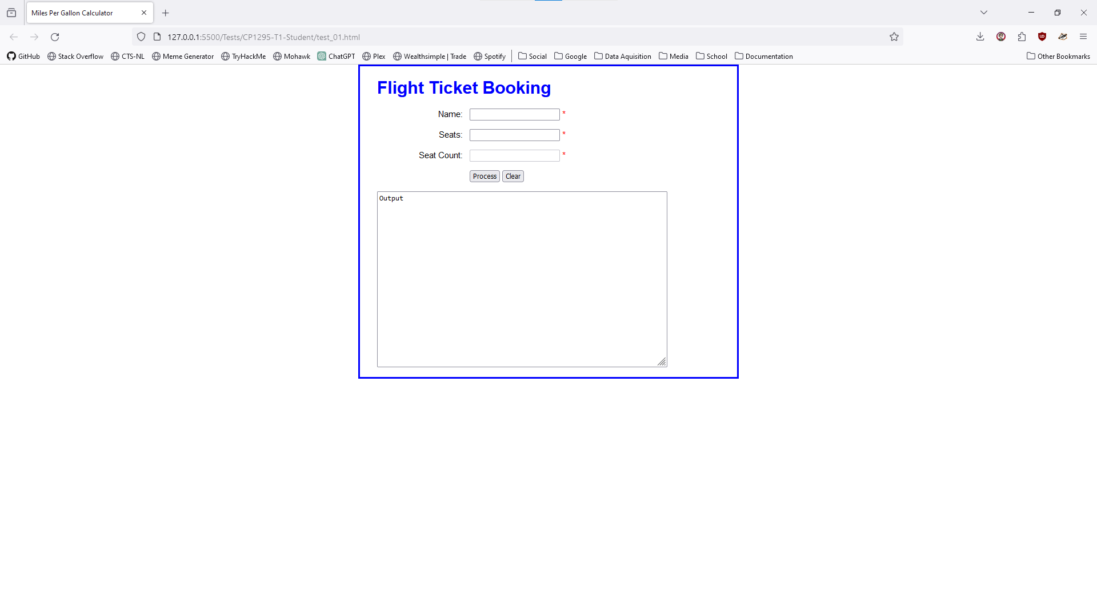

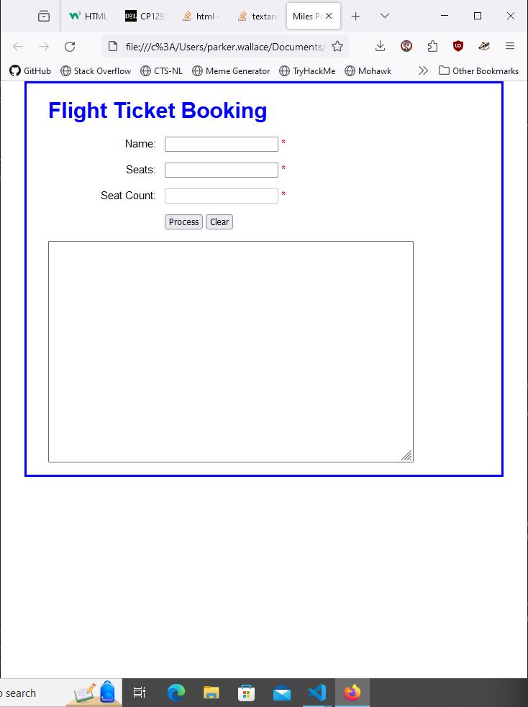

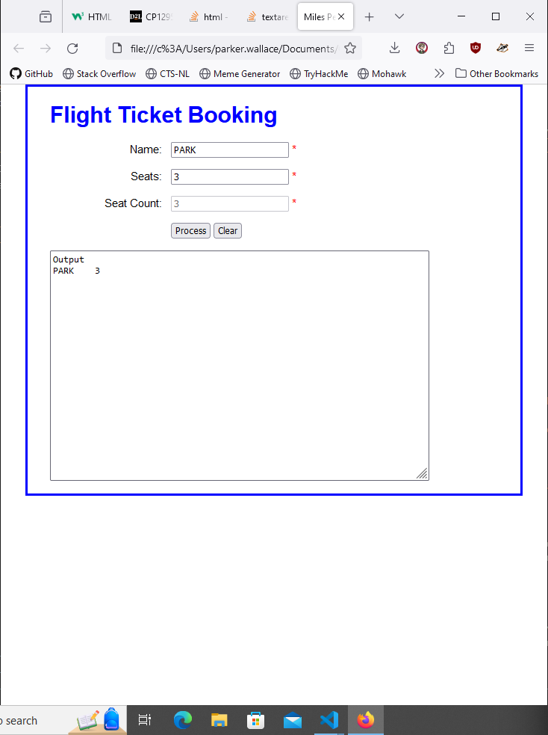

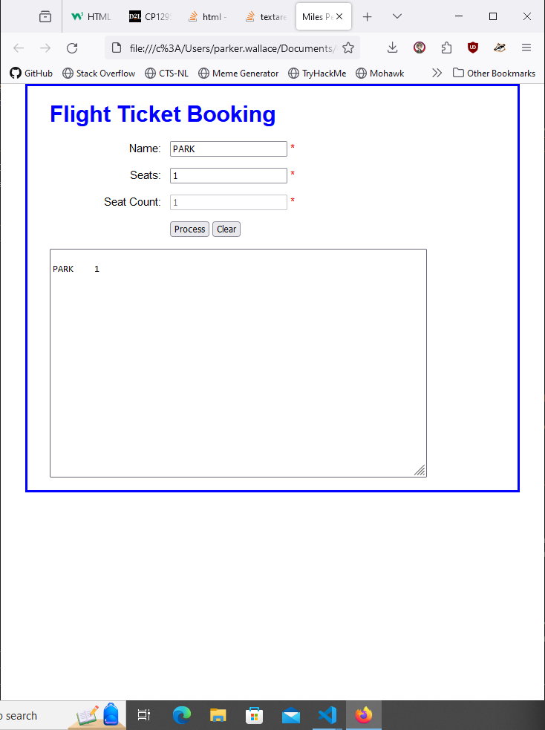

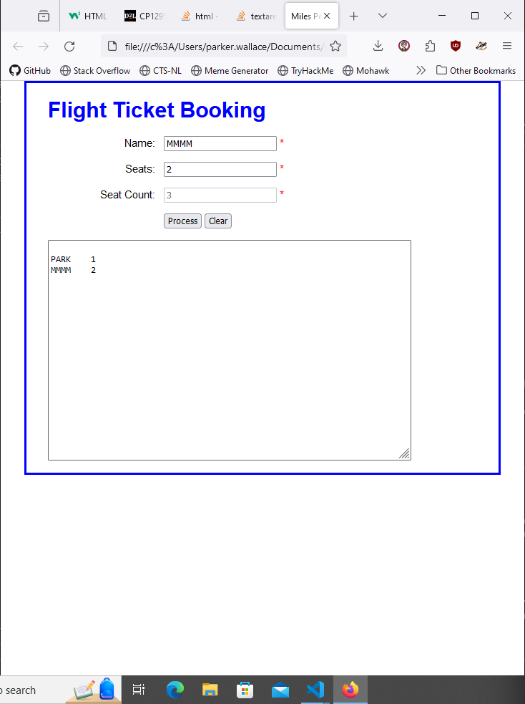

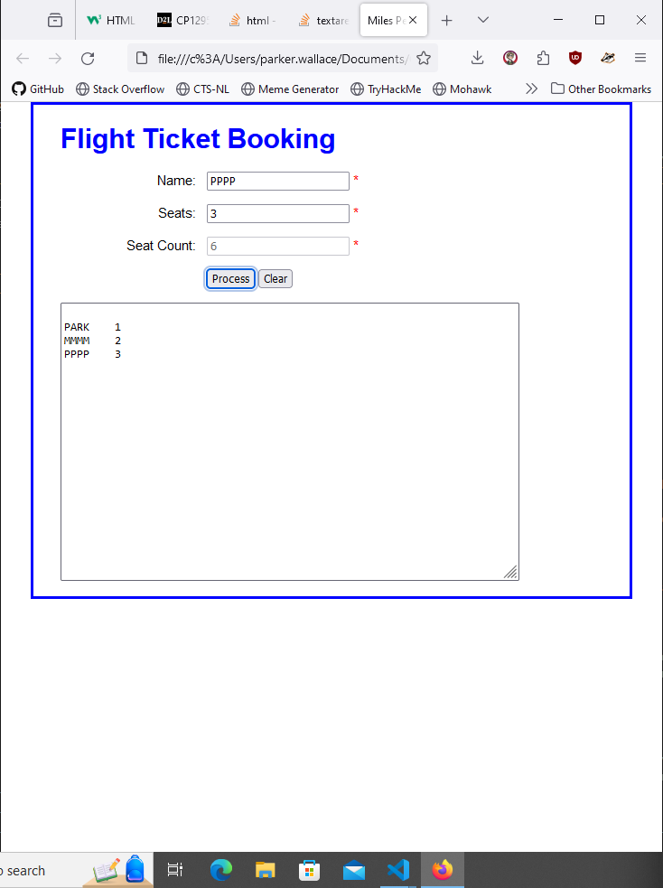

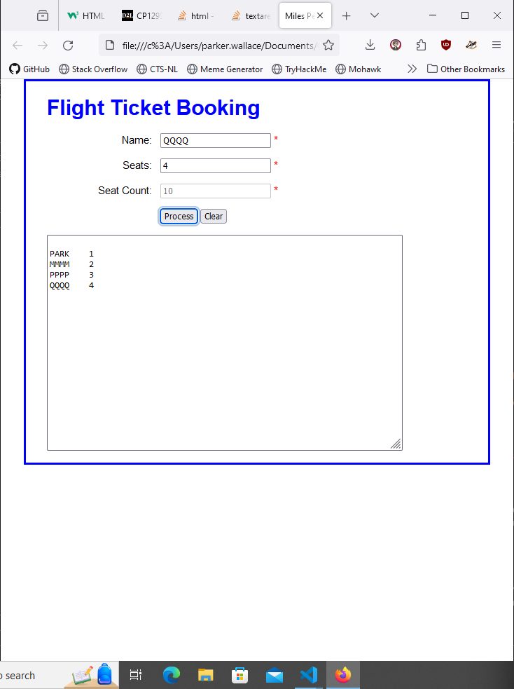

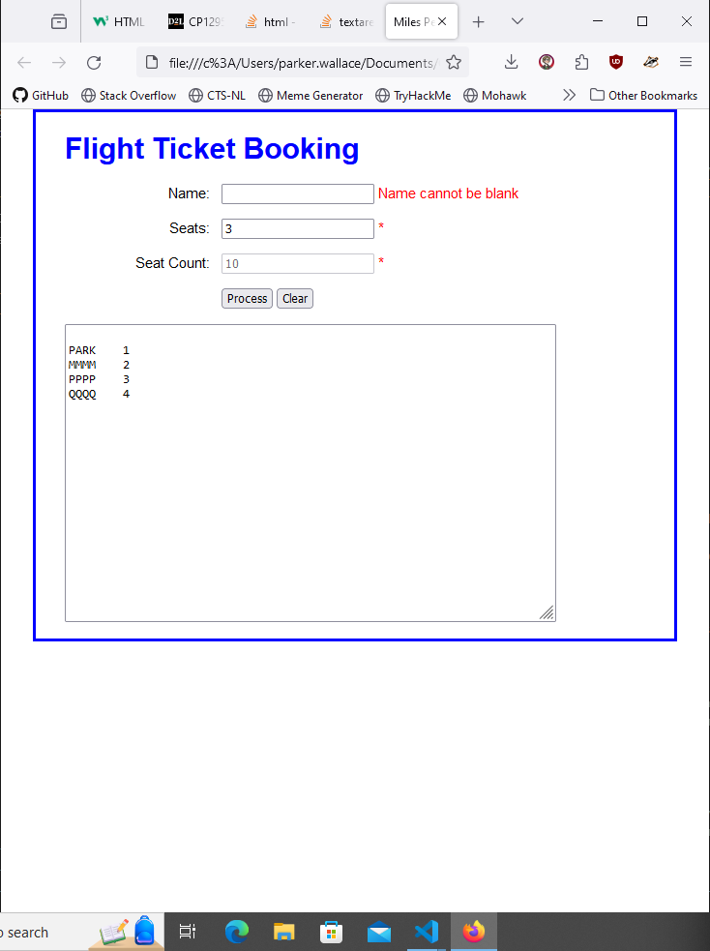

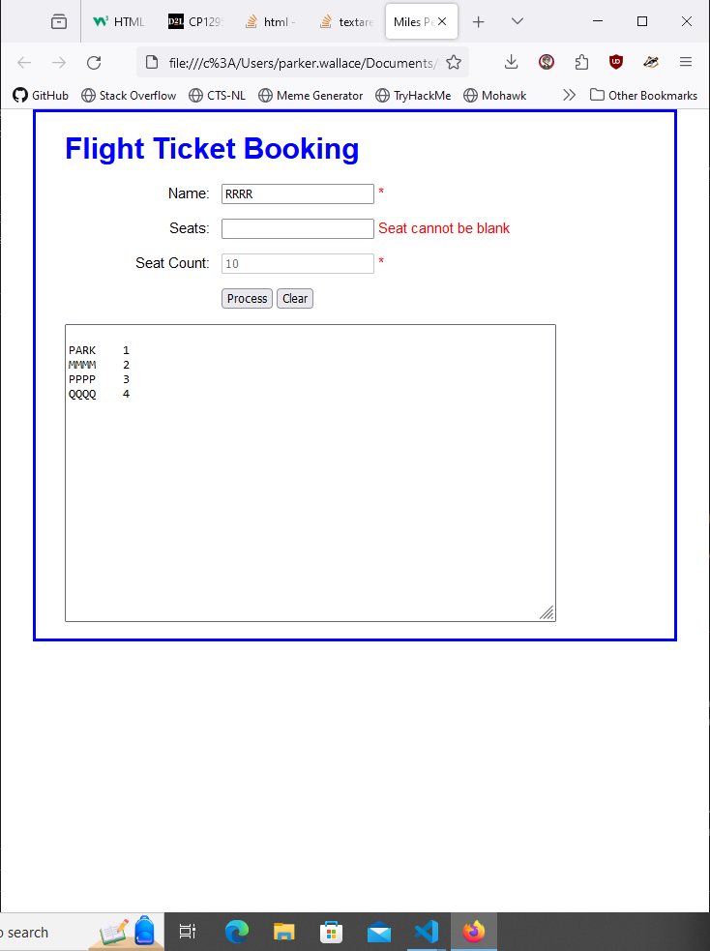

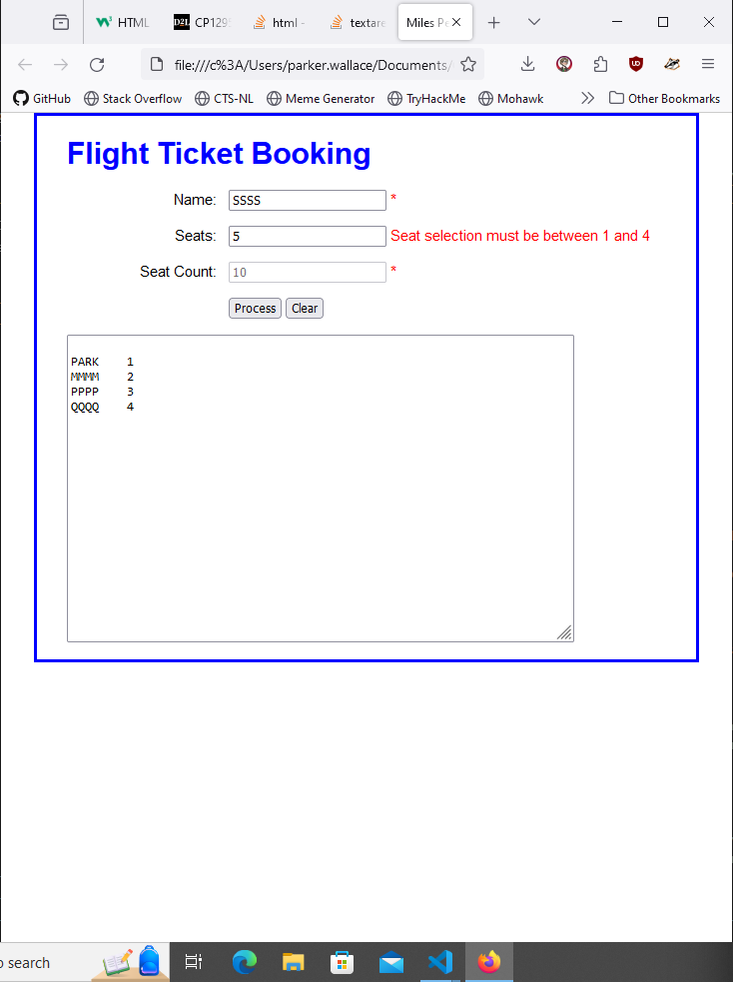

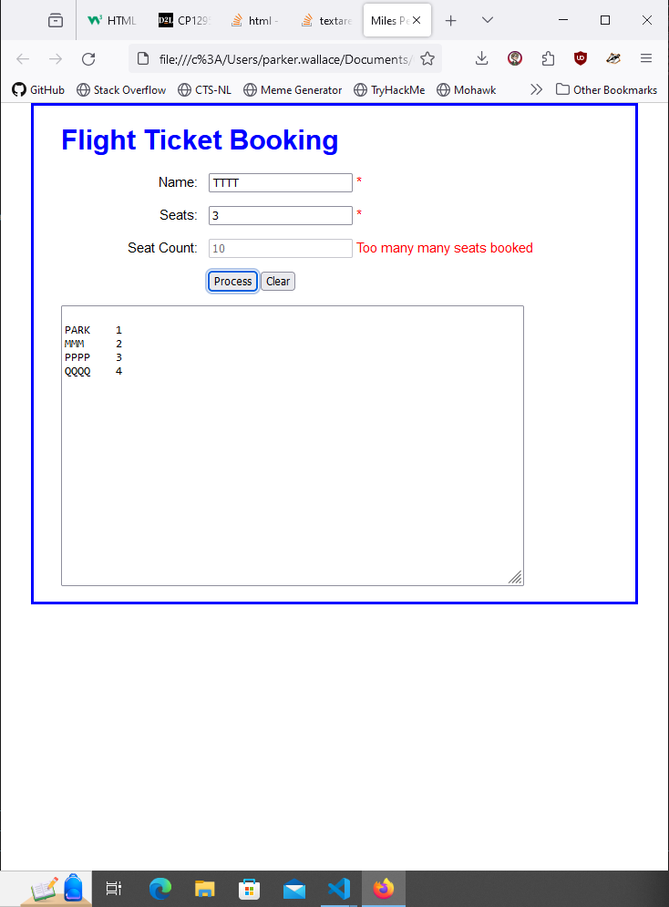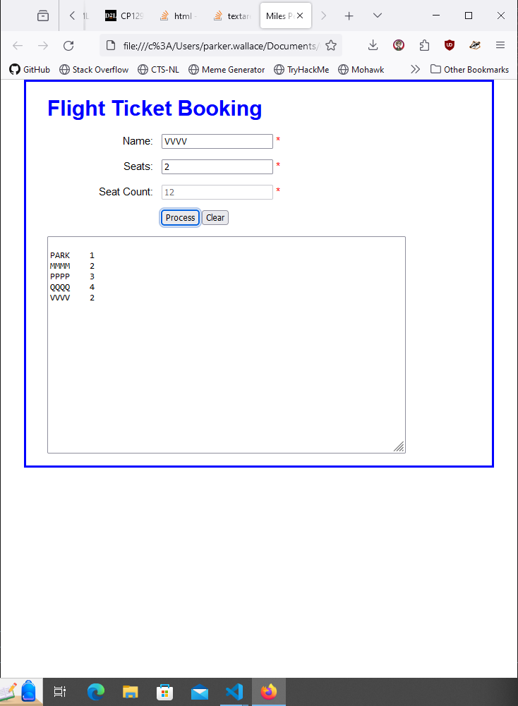

"use strict";

const $ = selector => {return document.querySelector(selector)}

// CP1295 Advanced JavaScript CP1295

// window.alert("Script is running");

document.addEventListener('DOMContentLoaded', ()=> {

$("#process_ticket_id").addEventListener("click", formValidation)

$("#clear_fields_id").addEventListener('click', ()=>{

console.log("clear")

document.querySelectorAll("div > .clear_list").forEach(e => e.value = "")

document.querySelectorAll("span").forEach(e => e.textContent = "")

$("#output_ta_id").textContent = ""

} )

})

function formValidation () {

document.querySelectorAll("span").forEach(e => e.textContent = "*")

if ($("#name_id").value == "") {

console.log("blank")

$("#name_feedback_id").textContent = "Name cannot be blank"

}

else if ($("#seats_id").value == "") {

console.log("blank")

$("#seats_feedback_id").textContent = "Seat cannot be blank"

}

else if (isNaN($("#seats_id").value)) {

$("#seats_id").value = ""

$("#seats_feedback_id").textContent = "Seat must be numeric"

}

else if (parseInt($("#seats_id").value) > 4 | parseInt($("#seats_id").value) < 1) {

$("#seats_id").value = ""

$("#seats_feedback_id").textContent = "Seat selection must be between 1 and 4"

}

else if (parseInt($("#seat_count_id").value) + parseInt($("#seats_id").value) > 12) {

console.log("blank")

$("#seat_count_feedback_id").textContent = "Too many many seats booked"

}

else {

if (isNaN(parseInt($("#seat_count_id").value))) {

$("#seat_count_id").value = 0 + parseInt($("#seats_id").value)

$("#output_ta_id").textContent += "\n" + $("#name_id").value + '\t' + $("#seats_id").value

console.log("first")

}

else {

console.log("second")

$("#seat_count_id").value = (parseInt($("#seat_count_id").value)) + parseInt($("#seats_id").value)

$("#output_ta_id").textContent += '\n' + $("#name_id").value + '\t' + $("#seats_id").value}

}

}