M5 – Problem 1
Estimating Housing Prices with a Support Vector Machine
Name: Parker
Course: AI – Module 5 Assignment (Problem 1)

What this program does
For this problem I built a Support Vector Machine and used it as a regressor (SVR) to predict Boston house prices from 13 features like crime rate, number of rooms, tax rate, and so on. After training it I checked how good the predictions were using mean squared error and explained variance. Then, like the assignment asked, I turned it into a yes/no classification problem by splitting the prices at 25.00, which let me make a confusion matrix and a classification report to see how well it separates cheaper houses from more expensive ones.

Implementation
First I imported everything I needed – numpy, the dataset and preprocessing tools from sklearn, the SVR model, the shuffle function, the metrics (confusion matrix, classification report, mean squared error, explained variance), and matplotlib for the plot.
Then I loaded the housing data and shuffled it with random_state=7. Shuffling matters because if the data has any kind of order to it, the train/test split could end up biased. Using a fixed random_state just means I get the same result every time I run it, which made it easier to check my work.
Next I split it 80/20. With 506 samples that comes out to 404 for training and 102 for testing. I just took the first 80% for training and the rest for testing after the shuffle.
For the model I used SVR with a linear kernel (that part was required). I left C at 1.0 and epsilon at 0.1. The way I understand it, C controls how much the model gets penalized for errors, and epsilon is basically a margin around the prediction where small errors don't count. Then I trained it with .fit() on the training data.
After training, I ran the model on the test set to get the predicted prices. To see how it did I printed the mean squared error and the explained variance score.
Then came the binarizing part. I used sklearn's Binarizer with a threshold of 25.00, so any price of 25 or above becomes a 1 and anything below becomes a 0. I did this to both the predicted prices and the actual prices so I could compare them. One thing I want to point out: the assignment says to use the actual values “in the training data,” but for a confusion matrix the predicted labels and actual labels have to be the same length and be the same houses, so I used the actual test prices instead. Otherwise the two lists wouldn't line up and it wouldn't work.
With the two label lists I made the confusion matrix, plotted it in grayscale (and saved it as an image), and finally printed the classification report.

Results
Here's what I got when I ran it (it's the same every time because of the fixed random_state):
#### Support Vector Regressor performance ####
Mean squared error = 15.38
Explained variance score = 0.82

#### Confusion matrix ####
[[69 10]
[ 4 19]]

#### Classification report ####
precision recall f1-score support

Class-0 (< 25.00) 0.95 0.87 0.91 79
Class-1 (>= 25.00) 0.66 0.83 0.73 23

accuracy 0.86 102
macro avg 0.80 0.85 0.82 102
weighted avg 0.88 0.86 0.87 102
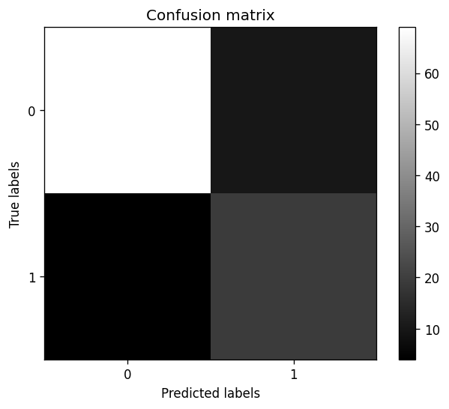

What the results mean
The explained variance came out to 0.82, which means the model explains about 82% of the variation in the house prices. For a plain linear model I thought that was pretty good. The mean squared error was 15.38.
For the confusion matrix, out of the 102 test houses it got 69 of the cheaper houses right and 19 of the more expensive ones right. It messed up 10 times by labeling a cheaper house as expensive, and 4 times by missing an expensive house and calling it cheap. Overall accuracy was 86%. It's really good at spotting the affordable houses (0.95 precision on Class-0) and decent at catching the expensive ones. The weakest spot is that it sometimes over-guesses “expensive” (0.66 precision on Class-1).

How to run it
Just run: python M5_Problem1_SVM_Housing.py
You'll need numpy, scikit-learn, and matplotlib installed (pip install numpy scikit-learn matplotlib).
Quick note on the data: the assignment uses datasets.load_boston(), but that function got removed in newer versions of scikit-learn. So in my code I try load_boston() first, and if it's not there it automatically loads the same data from the BostonHousing.csv file I included. That way it runs no matter which version of scikit-learn you have and still gives the numbers above.

