Title Page
Executive Summary (Check)
PDD
TRD
Project Schedule
Status Reports
User Manual

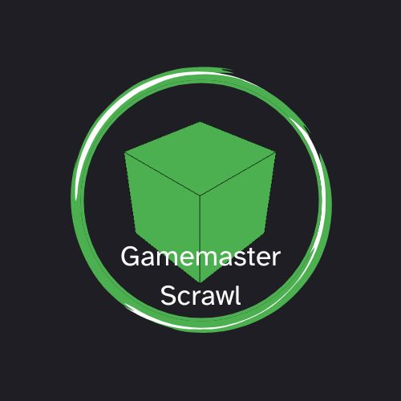
Table of Contents

Executive Summary ------------------------------------------------- 3
Project Definition Document ------------------------------------------------ 4
Technical Requirement Document ----------------------------------------- 6


GamemasterScrawl: An Overview

GamemasterScrawl is a web browser-based virtual tabletop mapping tool designed to give Gamemasters and their players a shared, accurate, live view of the battlefield in a 3-D Space

- Opportunity: Table-Top Role-Playing Games (TTRPGs) typically use a map system. However, most TTRPG systems allow for movement in all 3 dimensions. Sadly, most TTRPG map software only supports 2 dimensions. This can lead to confusion and disagreements at the table, as use of the third dimension can easily be overlooked in the heat of the moment in combat.
- Solution: GamemasterScrawl will be a TTRPG map system that is built with a 3D approach. It will be a browser-based application that supports live updates to multiple users simultaneously. It will also be hosted on a single client’s device, which reduces server overhead on the business side. This will feature 3D space for all the maps, both in creation and interaction. This allows for players and the Gamemaster to view the battlefield from many more angles than a 2D map could provide, increasing the possibility for the creative ideas that TTRPGs are best known for. In addition, a user management system will be included, as well as an entity (called token) management system.
- Competitive Advantage: Currently, there is only one other competitor in the 3D TTRPG Map system space, Sigil VTT from Wizards of the Coast, and that competitor is scheduled to be sunset in October of 2026. As such, there is a gap opening up in the market that GamemasterScrawl can fill. In addition, the only other competitor is specific to a TTRPG system, Dungeons and Dragons, whereas GamemasterScrawl is designed to be TTRPG system-agnostic, which allows it to appeal to a much more broad demographic compared to Sigil VTT.

GamemasterScrawl aims to fill this emerging gap in the market by delivering a simple, out-of-the-box solution for a TTRPG group to users to manage maps in a 3-Dimensional Space

Project Definition Document (PDD)
Why am I doing this? | Purpose
Table-Top Role-playing Games (TTRPGs) allow for a group of friends to meet up and have a fun time imagining and role-playing various characters and interactions in a large variety of scenarios. One way to keep order in this controlled chaos is to have a well-maintained and accurate central map for interacting with the fictional world. Several solutions for managing this map are high-quality, but are designed with a purely 2-dimensional vision. However, many TTRPG systems allow for movement in a 3-D space. Representing 3-D movement in these solutions is difficult, due to the 2-D top-down view of the map these software solutions provide. As such, it can lead to infighting and make these scenarios much more clunky and undesirable. Thus, the purpose of this project is to fill this niche: Making a TTRPG-system agnostic program that focuses on movement in a 3-D space. This will allow both the players and the Gamemaster to quickly and efficiently deal with these scenarios and adjust the game accordingly, without the need for undoing events or other mishaps due to a lack of the third dimension.
What goal(s) does this project support, what  problems are solved, what needs are met? | Goals & Objectives
- Develop a Browser-based 3-D virtual tabletop system
- Support any TTRPG system, not just Dungeons and Dragons
- Provide intuitive ways to interact with and edit the 3-D space
- Enhance player/Gamemaster immersion and spatial awareness
How does this project fit with other solutions  that available? | Scope, Project Context, Project Dependencies
This product will be a standalone solution to this problem. I plan on no integrations with similar products or other products in the space, with the exception of importing of some assets (Images/textures) for use in the 3-D space.
This product will:
- Use browser-based Clients 3-D environment, And item manipulation in this environment
- Allow map Creation
- Utilize modern Browser Technology
This product will not:
- Implement AI Features on launch

What is the expected benefit from this project? | Expected Benefits, Business Case, Value, Success Criteria
- Streamlined TTRPG Gameplay
- Enhanced Player and Gamemaster immersion
- All parties’ spatial awareness has been improved
What am I going to do? | Scope
- Develop/Utilize a lightweight 3-D rendering system for browsers
- Allow basic user management for Gamemasters
- Implement Real-Time synchronization between all clients via Sockets
- Create a system for 3-D map Creation
- Use the above system for 3-D space manipulation
Who is affected by this and who must be involved? | Stakeholders
- Gamemasters
- Players
- The Computer Science Department

How will we know when I am done and whether the project was successful? | Success Criteria
- The program supports 3-D manipulation of a space
- Users can create custom maps
- Updates to all clients in a reasonable speed (>200ms)
- Works on all major browsers (Chromium, Gecko, Safari)
- Minimal crashing during use
- User Management/Permissions are fully functional
- Data is correctly saved between uses
- Data is managed securely
Completed by: | Parker Hoffman
Date: | 1/24/2026
Project Title / ID Number | GamemasterScrawl/5
Approved by: | Dr. Cheri A. Coder

