GamemasterScrawl
User’s Guide
A guide to simplifying TTRPG Map Management
Parker Hoffman
4-22-2026

Table of Contents:
1. User management (2)
1.1: User Login (3)

2. Map Creation (4)
2.1: Creating a Room (5)
2.2: Editing a room (6)
3. Token Management (7)
4. Map Manipulation (9)
4.1: Selecting a room to be used (9)
4.2: Adding Tokens to the Map (10)
4.3: Token Selection (10)
4.4: Interacting with the map (11)
4.4.1: Rotating the camera (11)
4.4.2: Move the camera position (11)
4.4.3: Moving a token (11)
1: User Management
In order to allow other users to sign in, accounts for all non-host users must be created. To do that, the host must first click the button labeled ‘User Management’ in the top left corner of the home screen. See the image below to see what your screen might look like:
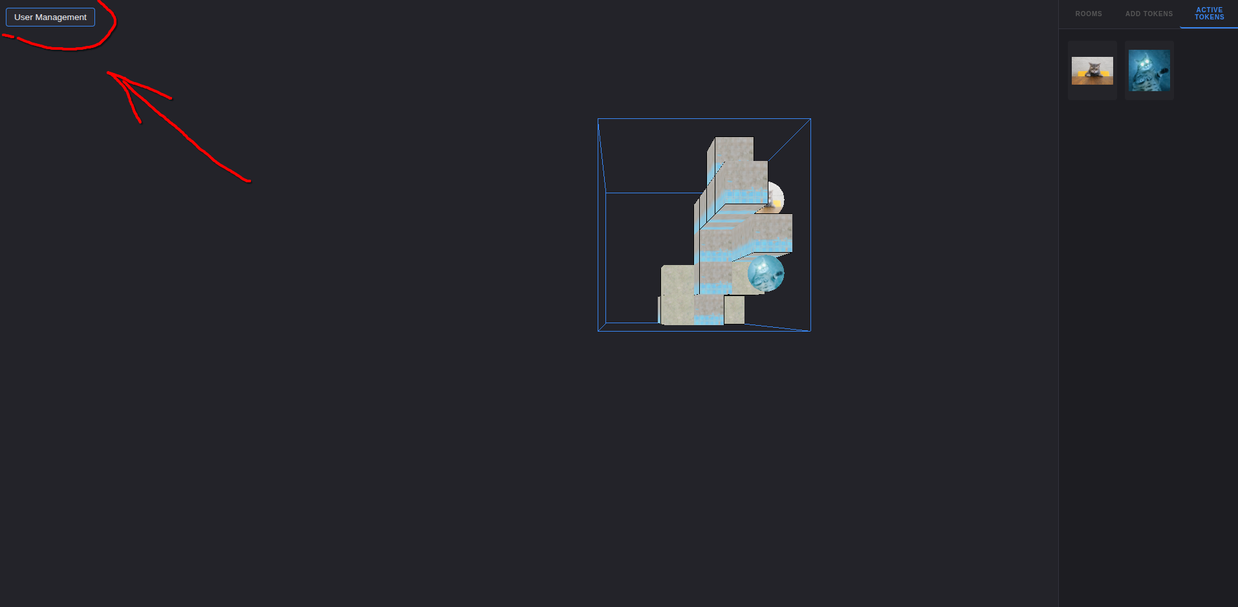
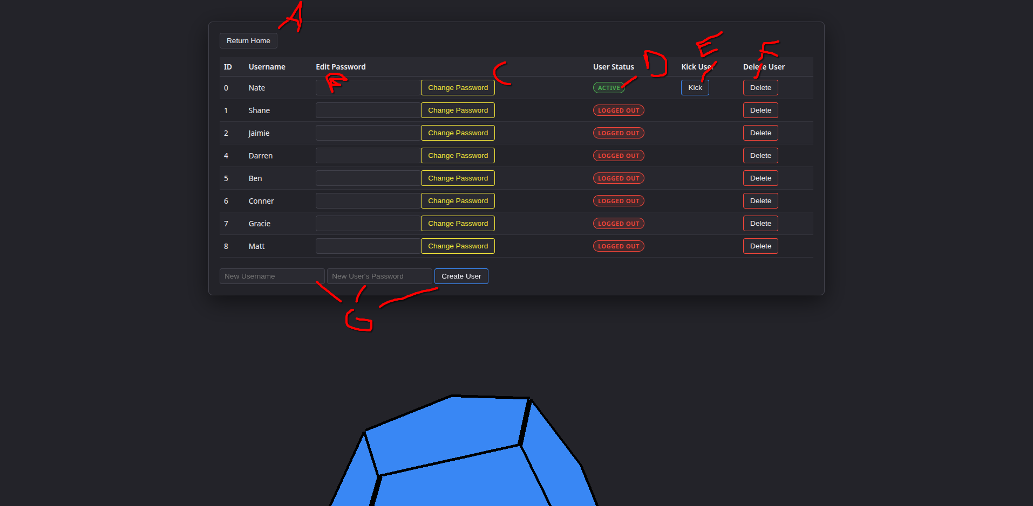
You will then see this screen.
A. This button will return the user to the home screen
B. : this is where you can input a different password for the use this row represents. See C for where to submit it. Case is important!
C. This button will submit and change the password for the user permanently. Be careful!
D. This will indicate if a user is currently logged in under this account
E. This button will only appear if a user is signed in under this account. Upon clicking of this button, it will log that user out and send them back to the log in screen
F. Upon clicking this button, this account will be deleted. Be careful: This cannot be undone!
G. This is where you create a new user. Text must be entered into the first field, this is the username fro the user. This cannot be changed after submission. The second field is the password for this account. The third is how you submit and create the new accounts

1.1: User Login
If the user is not the host, they will see the following screen:

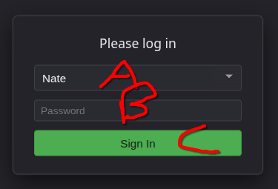
A: This is a dropdown. The user can choose the name of the account they want to log in under
B. This is the input for the password. As the user, enter in the correct password for the user selected
C. Click this to attempt to log in as the selected user with the given password, If the password is not correct, you will be notified. Otherwise, you will be sent to the home screen.

2. Map Creation

In order to have a map to deal with, the map must first be created. As the host, open the home screen. First, as the host, in the pane on the right, select the ‘Rooms’ tab. Then, click the ‘Map Editor’ button.
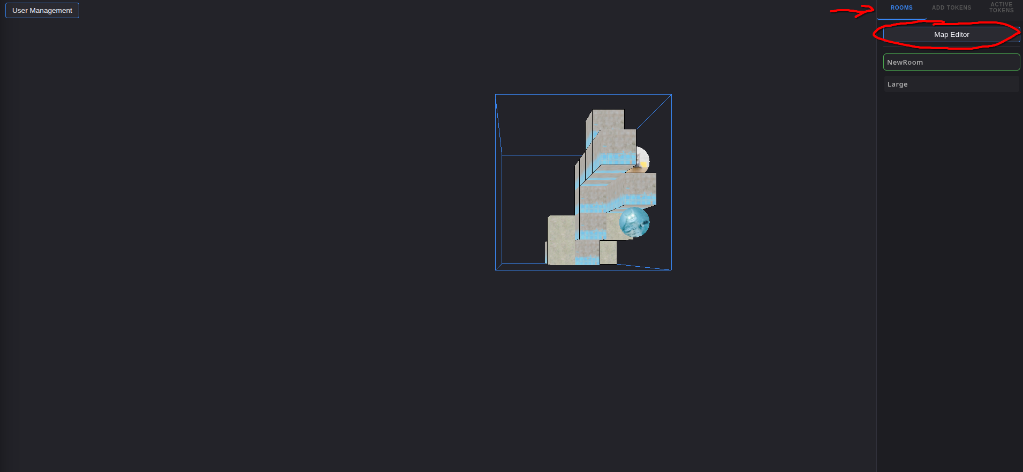
To select a room to edit it, in the pane on the right, choose the ‘Rooms’ tab. Then, choose the ‘map’ the room has been assigned, or you can find it under the ‘All Rooms’ section. Clikc on the room you want to edit, and will appear in the editing pane

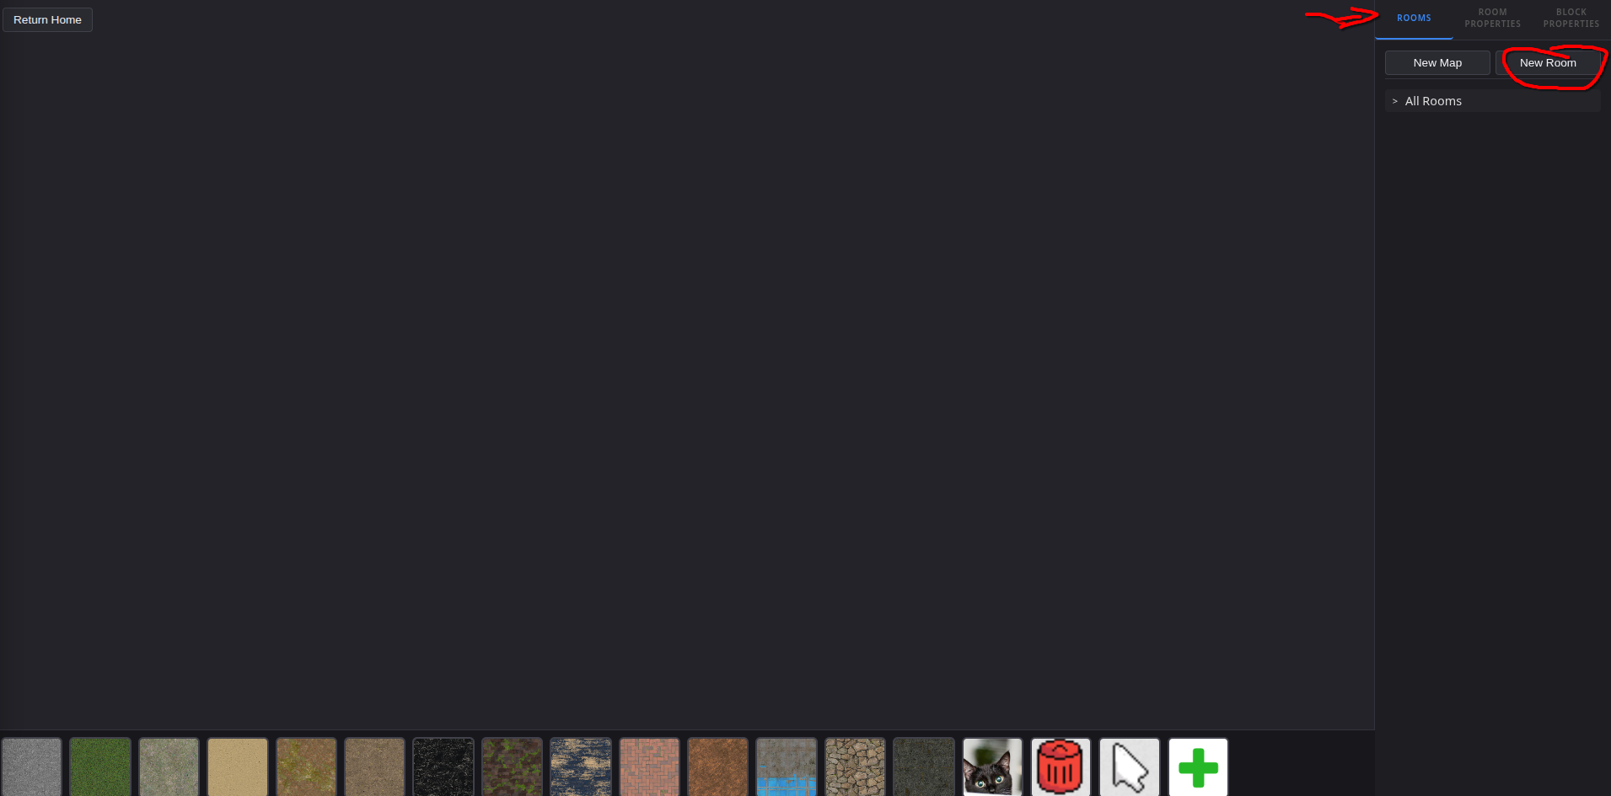
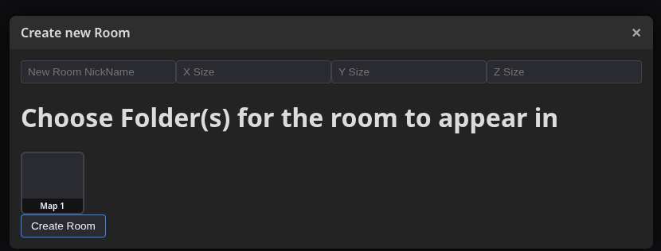
2.1: Creating a Room
To create a new room, have the host open the map management screen. Then, in the right sidebar, select the ‘Rooms’ tab, and click the ‘new Room’ button
A new window will now be popped open for creating a fresh map. It contains a nickname for the room, the dimensions for the room, and optional selectors for what ‘maps’ (or folders’ to store the map in.
Click the ‘Create Room’ button after inputting the nickname and dimensions to create the room. It will be auto-selected
2.2: Editing a map
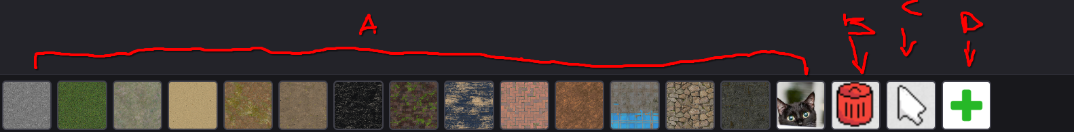
After selecting a room, it will appear in the main pane. In the bottom of the screen, there is the following toolbar:
A. These are all the blocks that can be added. Just click a block to select it, and then click on the map to add a block with that texture there
B. This is the ‘delete block’ option. Click to select it, and then when clicking on a block on the map, it will delete it.
C. This is the ‘select block’ option. It allows selection of a specific block for editing other properties
D. This button allows you to upload any image to use as a texture for a block. Clicking it will open file explorer for file selection.

The map will automatically save any changes made to it.

3. Token Management

As the host, on the home screen, select the ‘Add Tokens’ Tab in the right sidebar. Then, clikc the ‘Token Editor’ button to navigate to the Token Management screen.

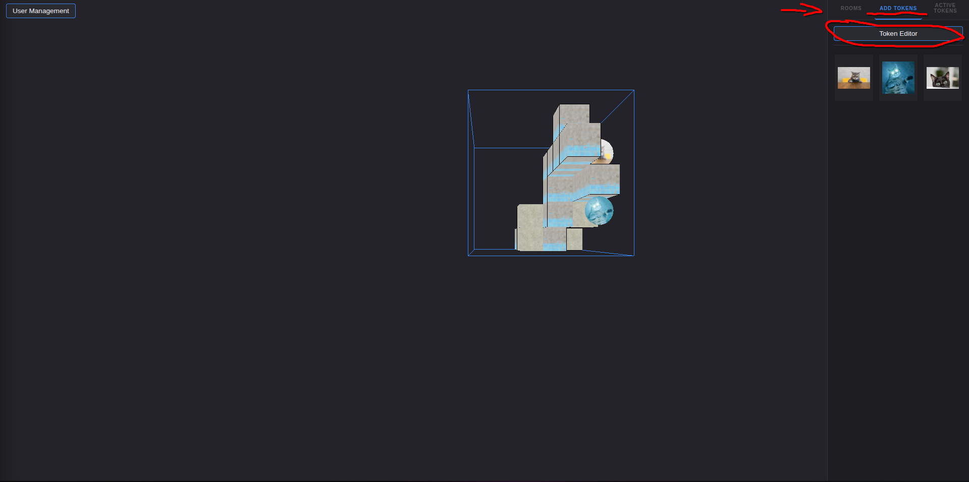
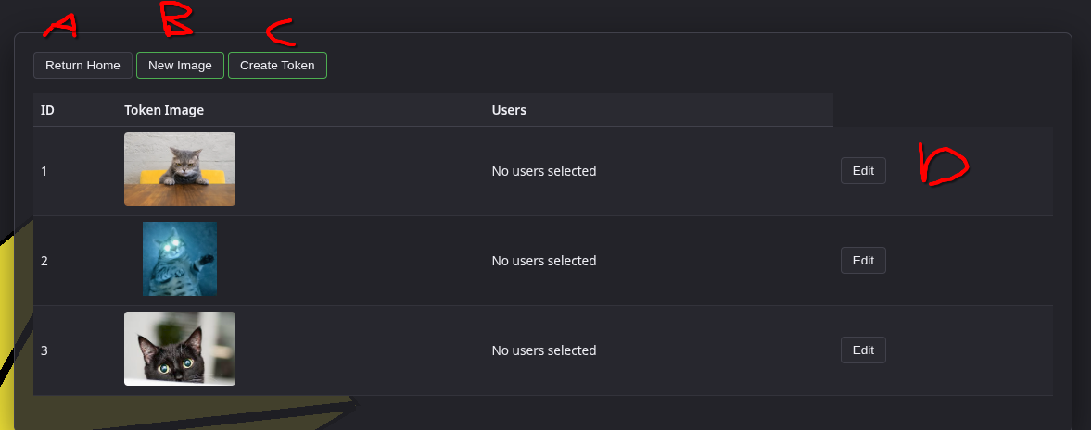
Once on this screen, you will see the following:
A. This button will take the user back to the Home screen
B. This button will allow the user to upload a new image that can be used for tokens. Clicking it will open a File Explorer window for file selection
C. Clicking this button will open a dialog to create a fresh token. The dialog is the next diagram
D. Clicking this button allows for editing of the existing token in this row. It opens the dialog in the next diagram

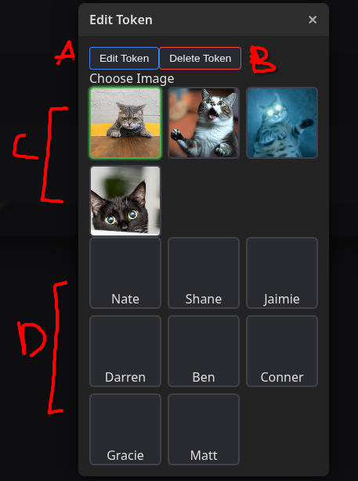
A. This is the button that saves changes to the token. If you are instead creating a token, it saves and creates the new token.
B. This button will only show up if you are editing a token. On click, it deletes the token. This cannot be undone
C. This is the image for the token. Only 1 image can be selected. The only options are images you have previously uploaded
D. This is a list of users who can move this token. It reads from the user list set up from section 1. The host is always included for any token.

4. Map Manipulation
4.1: Selecting a room to be used
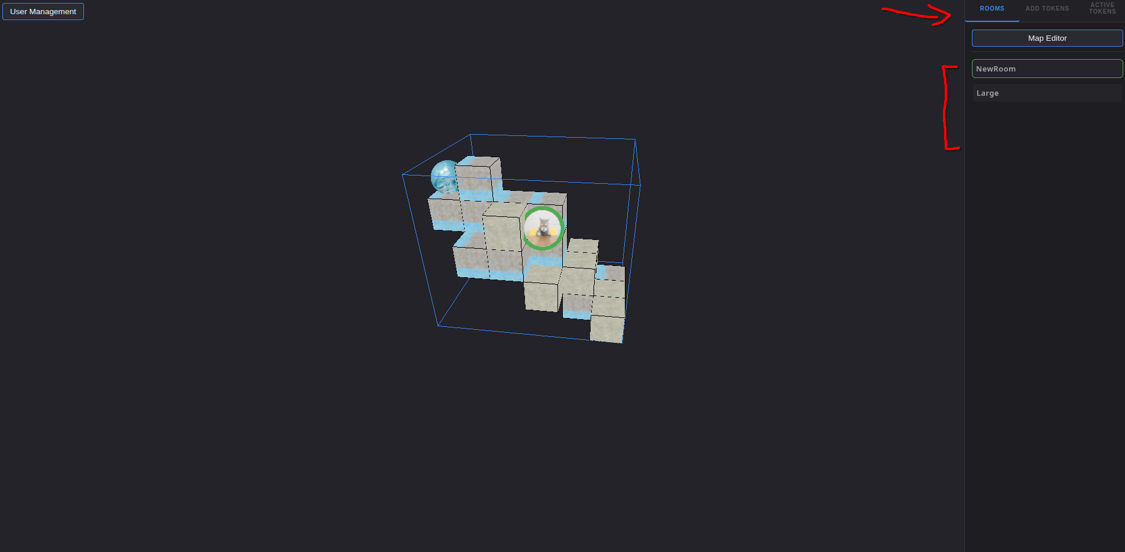
In order to change the selected room, the host needs to open the ‘Rooms’ tab in the right panel of the Home screen. The host just needs to click on the name of the room they have already created from the list of rooms (see Section 2). After clicking, the room will be loaded on every logged-in user’s instance

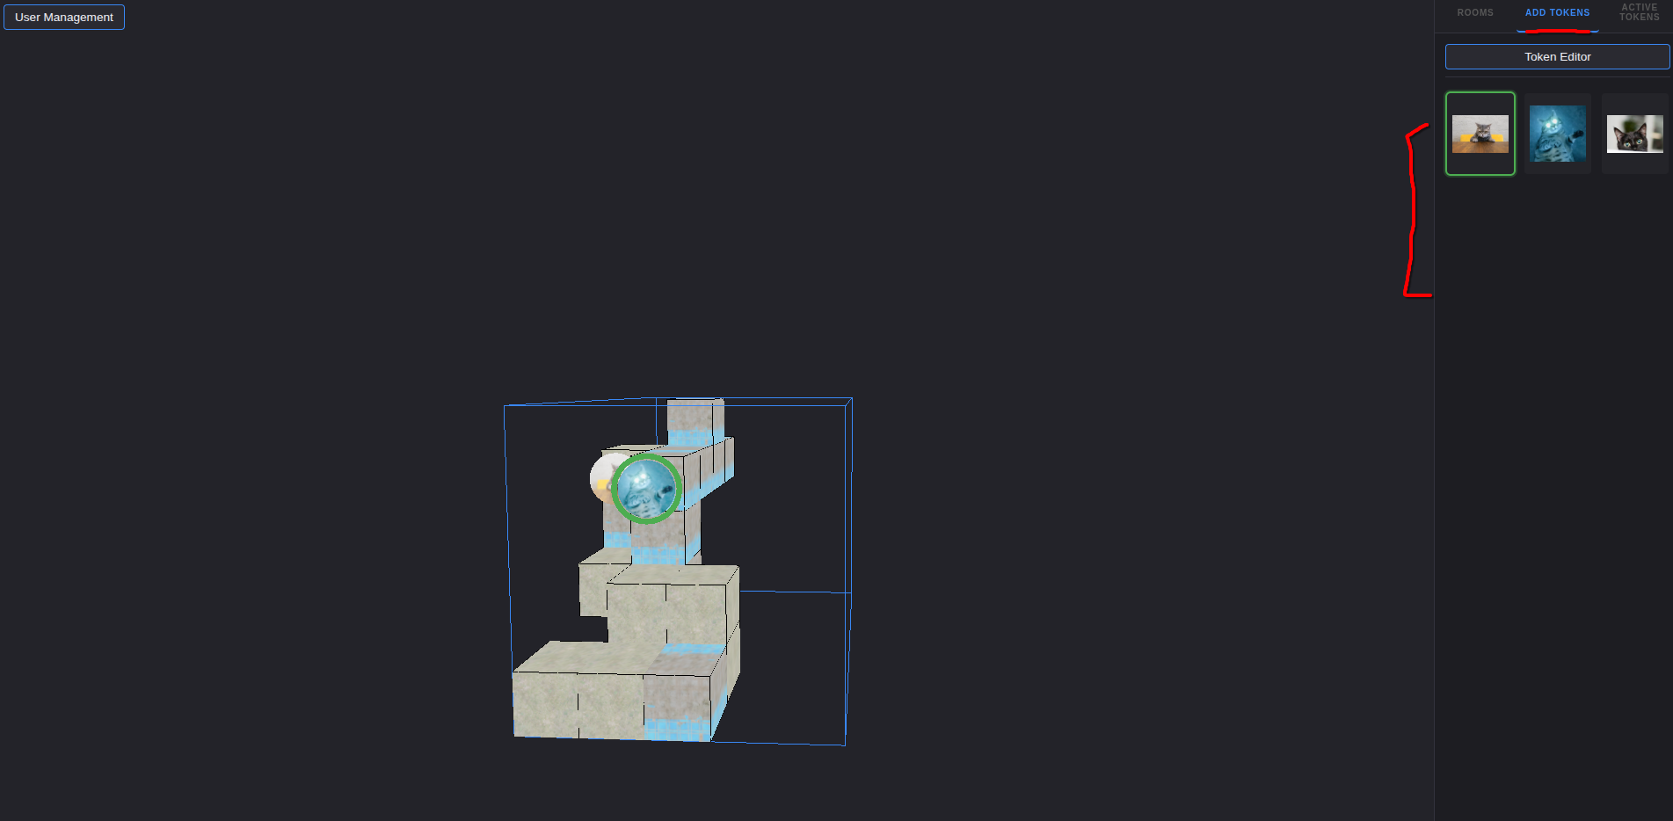
4.2 Adding tokens to the map
The Host needs to select the ‘Add Tokens’ tab from the sidebar on the right. Then, they need to click on the token they created (see Section 3). The, they just need to click on the map where they want a new token instance to be placed.
4.3: Token Selection
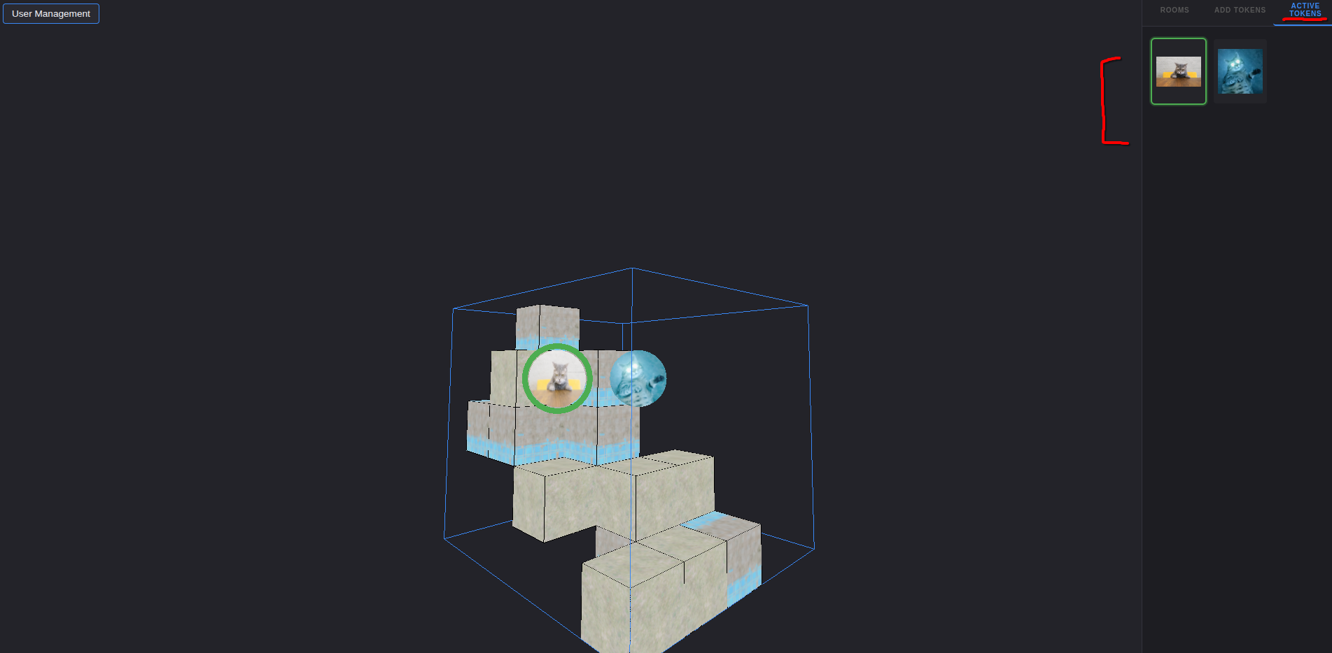
In order to move a token around the map, any user needs to navigate to the ‘Active Token tab in the right pane. The user then needs to click the token they want to move. The token will get a green halo on the map.
4.4: Interacting with the map
The map has the following functions:
4.4.1: Rotating the camera
To rotate the camera, hold down the scroll wheel on the mouse. As the user moves their mouse around with this button pressed, the camera will rotate around the map. Upon release, the camera will maintain this angle.
4.4.2: Move the camera position
To move the camera’s position, the user need to hold right click down and move the mouse. This will slide the camera around the 3D space. After releasing right click, the camera will remain in tht position.
4.4.3: Moving a token
To change the position of a token, the user needs to left click and drag the token to the square they want. On release, the token will be moved to that position. It will move the selected token to the point of release. To select a token, see Section 4.3

