European service-hub expansion
  - Meridian Parts | Board decision paper | 27 September 2026

Recommendation: advance a gated investment case
Advance Czechia + Spain as the leading case, with €225,000 capex and 5 FTE. It ranks first among feasible portfolios on base annual incremental contribution (€198,099) and remains positive in policy low volume (€64,619) and joint return/FX stress (€32,180). Simple base payback is 1.14 years. Stage commitments through evidence and service gates; the arithmetic does not prove demand or a causal hub effect.
Strongest alternative by base-case ranking: POL + ESP, €186,329 annual increment, €240,000 capex, 6 FTE, low €58,562, stress €29,264. Change the decision if validated volumes or avoidable savings fail to clear low/stress hurdles, or quotes exceed the €450,000/seven-FTE envelope.

2025 diagnosis
Synthetic revision-resolved records show 1,254 eligible 2025 shipments and 77,436 units. Gross sales €4,464,622 less credits/refunds €80,831 yields net sales €4,383,792. Net COGS is €2,246,919, fulfillment €106,862, leaving contribution €2,030,010 (46.3% of net sales). Booked revenue is shipment-based sales less credits. Cash differs with settlement timing and working capital; contribution additionally deducts product and fulfillment costs. Cash receipts are absent, so cash conversion is not measurable here.
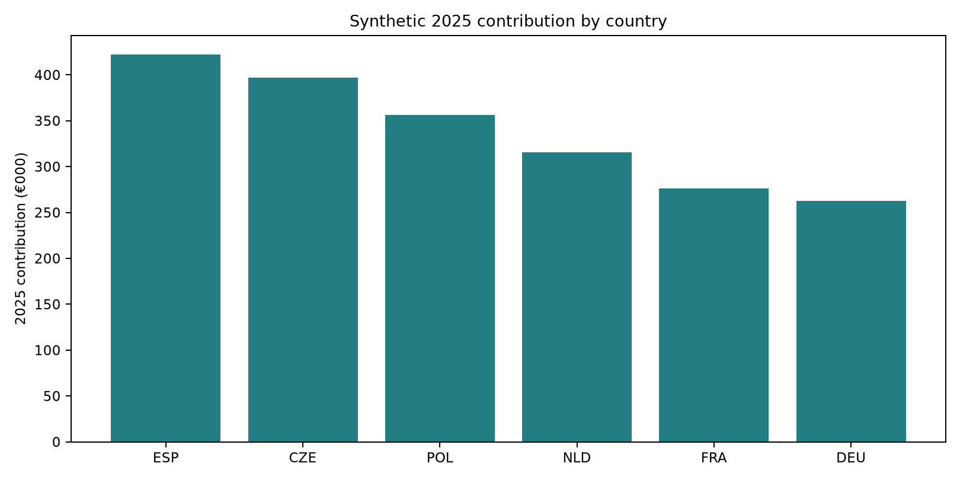
Figure 1. Contribution by country from synthetic 2025 records.
Czechia and Spain lead the modeled pair result because the supplied per-unit savings, units and fixed costs combine favorably under policy arithmetic. The option file does not independently evidence avoidable costs or service improvement. Validate savings against shipment-lane invoices and a central-hub comparator.

Options and scenarios
Portfolio | Capex | FTE | Low/year | Base/year | High/year | Stress/year | Payback
CZE + ESP | €225,000 | 5 | €64,619 | €198,099 | €331,580 | €32,180 | 1.14y
POL + ESP | €240,000 | 6 | €58,562 | €186,329 | €314,096 | €29,264 | 1.29y
POL + CZE | €205,000 | 5 | €56,856 | €178,995 | €301,134 | €-78,570 | 1.15y
NLD + ESP | €270,000 | 6 | €43,994 | €166,931 | €289,869 | €107,630 | 1.62y
NLD + CZE | €235,000 | 5 | €42,289 | €159,598 | €276,907 | €-203 | 1.47y
NLD + POL | €250,000 | 6 | €36,232 | €147,828 | €259,423 | €-3,119 | 1.69y
FRA + ESP | €340,000 | 7 | €13,687 | €129,849 | €246,012 | €73,105 | 2.62y
FRA + CZE | €305,000 | 6 | €11,981 | €122,516 | €233,050 | €-34,729 | 2.49y
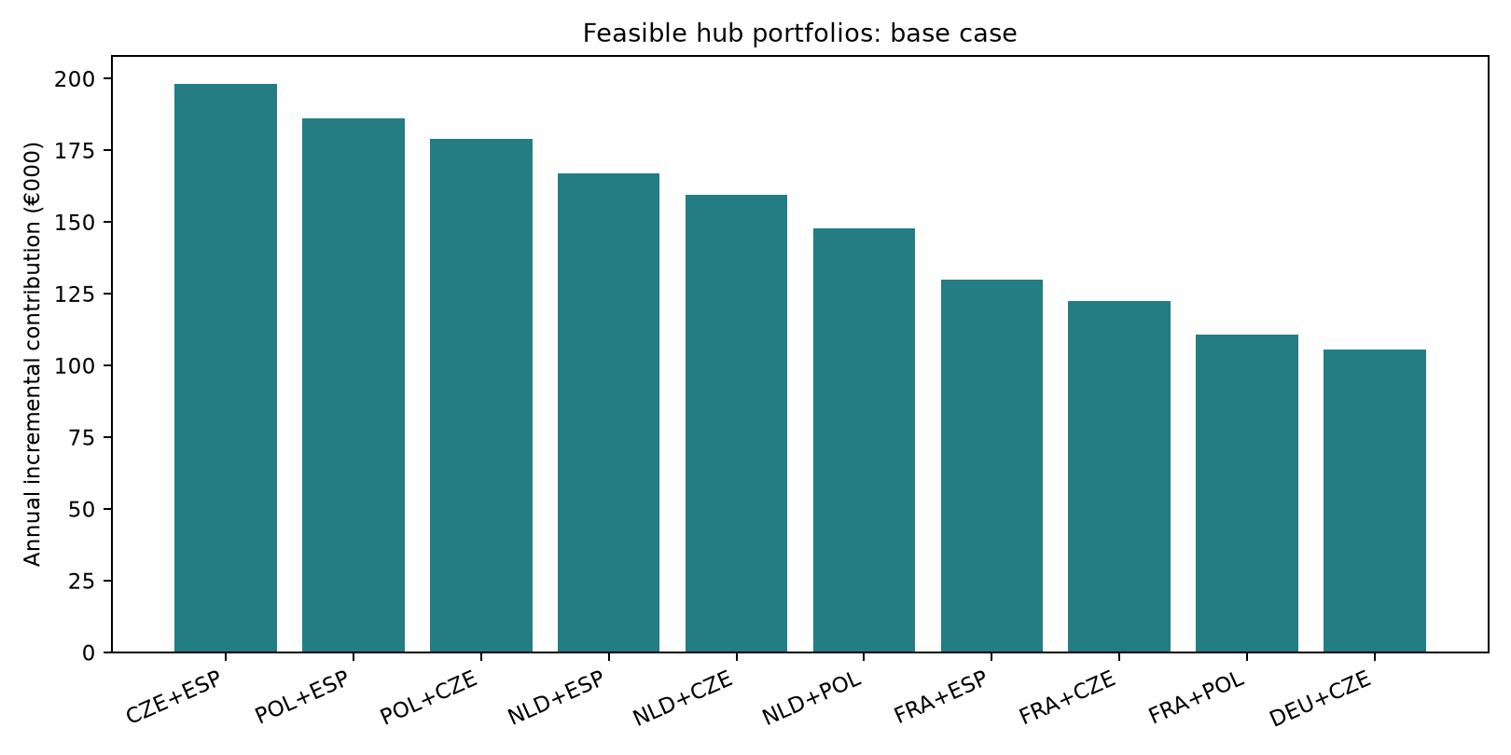
Figure 2. Top feasible alternatives, ranked by base annual contribution. Feasibility: at most two hubs, ≤€450k capex and ≤7 FTE.
Low/base/high uplifts are 10/25/40%. Annual increment = baseline contribution × uplift + baseline units × (1 + uplift) × savings/unit − annual fixed cost. Stress uses 25% volume, a refund shock of 3% gross with no cost recovery, and 10% depreciation against net sales for PLN/CZK markets. Stress has no assigned likelihood. Capex is a year-zero outlay, excluded from annual contribution. Simple payback is capex divided by positive base increment, without discounting.

Market context
Archived World Bank population grew 2.22% in Spain and 2.18% in Czechia from 2022 to 2024, while Poland declined 0.71%. In 2024 current-US-dollar GDP per capita ranged from $25,104 in Poland to $67,465 in Netherlands. These are broad scale/economic context, not replacement-assembly demand evidence; GDP per capita is neither PPP nor constant-price real income. Full years and missingness are preserved in workbook; historical values may have revisions.

90-day implementation, owners and gates

Days 0–30 | validate baseline
CFO + Commercial Operations reconcile order, invoice/credit, lane-cost and return records; sample carrier invoices. Gate 1: ≥98% record/cost linkage, cutoff and FX reviewed, Finance signs baseline. Dependency: operational-system access.

Days 31–60 | prove location case
COO + Regional Service, with Finance, HR and Procurement: verify catchment, addressable units, avoidable costs, local labor/carrier/lease quotes; design a reversible 3PL or central-stock pilot. Gate 2: rerun low/stress positive and remain within capex/FTE.

Days 61–90 | stage, commit or stop
CEO/Board sponsor + CFO stage release after demand evidence, exit clauses, named service owner, SLA and inventory controls. Gate 3: approve pilot/fit-out only if downside economics and service plan pass; otherwise defer with a dated review.
Weekly KPI plan: OTIF vs central baseline, median order-to-delivery hours, expedite/fulfillment EUR per order, return rate and restock recovery, fill rate, eligible units, contribution after recurring hub costs, capex committed/forecast, FTE staffed. Owners: Regional Service (service), Supply Chain (inventory/delivery), Commercial Ops (units), Finance (economics), HR (staffing). Risks: synthetic assumptions may not transfer, capex/fixed costs may inflate, local stock may become obsolete, refund credits may precede recovery, realized FX may diverge, and ramp may delay savings.

Method, source and limitations
Highest numeric order revision replaces the whole earlier row; exact repeats collapse. Include shipped, non-test orders with 2025 shipment date, including free shipments. Resolve return revisions, include received through 2026-01-31 inclusive, and attach only to eligible order IDs. Unlinked returns are quarantined. Gross and summed refund use the original sale-month ECB arithmetic mean in local units per EUR (EUR=1); per-order components round half-up to cents. Latest effective unit cost applies; only restocked units recover COGS. Empty country-months are zeros, and margin is null for zero net sales.
Quality: 1,328 raw order rows, 13 exact duplicate rows, 1,297 IDs after revision resolution, 1,254 eligible orders; 264 return rows, 241 attached return IDs and 1 quarantined/unlinked. All 72 country-month records reconcile to country totals. Detailed anomaly counts and handling are in metrics.json and workbook.
Client orders, returns, costs and hub choices are entirely synthetic. Public evidence is a frozen source-room capture of official ECB historical rates and official World Bank API responses. WB archive lastupdated 2026-07-13 and captured 2026-09-27; historical revisions may be included. ECB reference rates are not realized transaction FX. No live account, interviews, geocoded demand, local quotes or causal savings study was accessed. Missing values are not imputed. Scenario model is simple and undiscounted; excludes ramp, tax, working capital, salvage and complete cash flows. Evidence URLs, retrieval times, hashes, units and labels are in evidence/source-register.csv; raw sources are under evidence/raw/.

