Predicted HLA class I epitopes of the SARS-CoV-2 proteome

**Authors:**

Katie M. Campbell1, Gabriela M. Steiner2, Daniel K. Wells2, Antoni Ribas1,2,4,5, Anusha Kalbasi*3,4,5

**Affiliations:**

1Department of Medicine, Division of Hematology-Oncology, University of California, Los Angeles (UCLA), Los Angeles, CA, 90095, USA

2Parker Institute for Cancer Immunotherapy, San Francisco, CA, 94129, USA

3Department of Radiation Oncology, UCLA, CA, 90095, USA

4Department Surgery, Division of Surgical Oncology, University of California, Los Angeles, Los Angeles, CA, USA

5Jonsson Comprehensive Cancer Center, Los Angeles, CA, USA

To whom correspondence should be addressed:

Katie Campbell, Ph.D., Department of Medicine, Division of Hematology-Oncology, 9-666 Factor Building, 700 Tiverton Avenue, Los Angelels, CA 90095. Email: [KatieCampbell@mednet.ucla.edu](mailto:KatieCampbell@mednet.ucla.edu).

Anusha Kalbasi, M. D., Department of Radiation Oncology, Jonsson Comprehensive Cancer Center (JCCC), UCLA; B-262 Factor Building, 700 Tiverton Avenue, Los Angeles, CA 90095. Phone: (310) 267-4831; Email: anushakalbasi@mednet.ucla.edu.

# 

# Abstract

Elucidating antiviral cytotoxic CD8+ T lymphocyte (CTL) responses to SARS-CoV-2 may shed light on the heterogeneity of clinical outcomes and inform vaccine or therapeutic approaches. To facilitate the evaluation of antiviral CTL responses to SARS-CoV-2, we generated a publicly accessible database of epitopes predicted to bind any class I HLA protein across the entire SARS-CoV-2 proteome. While a subset of epitopes from early betacoronaviruses, such as SARS-CoV (SARS), have been validated experimentally, validation systems are often biased toward specific HLA haplotypes (notably HLA-A*02:01). To enable evaluation of epitopes across individuals with a variety of HLA haplotypes, we computed the predicted binding affinities between nine-mer peptides derived from the annotated SARS-CoV-2 peptidome across 9,360 MHC Class I HLA-A, -B, and -C alleles. There were 6,748 unique combinations of peptides and HLA alleles (pMHCs) with a predicted binding affinity of less than 500nM, including 1,103 unique peptides and 1,022 HLA alleles. These peptides were derived from all 11 proteins spanning the SARS-CoV-2 peptidome, including peptides that have previously been validated experimentally. We also show evidence that these epitopes may be relevant in other HLA contexts. This complete dataset is available through a public Google Cloud bucket (gs://pici-covid19-data-resources/mhci/peptide_predictions).

# 

# Introduction

In a subset of patients, SARS-CoV-2 can result in COVID-19, which can be a deadly disease with hallmarks of acute respiratory distress syndrome (ARDS)(*1*). Other patients harboring SARS-CoV-2 can have minimal or no symptoms. While clinical factors such as older age and underlying medical conditions have been reported as potential risk factors for more severe disease(*2*), the heterogeneity of clinical response to this viral agent is otherwise poorly understood.

Cytotoxic CD8+ T lymphocyte (CTL) responses are crucial for initial viral clearance and development oof immunologic memory(*3*). CTL responses are a plausible contributor to immunopathology following viral infection(*4*). Excessive CTL responses may contribute to ARDS and less effective responses may allow progression of viral pathology.

The heterogeneity in CTL responses to SARS-CoV-2 may in part be related to the capacity to recognize the viral antigens in the context of class I major histocompatibility complex (MHC) proteins. Indeed, genetic susceptibilities to viral infection have been tied to human leukocyte antigen (HLA) haplotypes(*5*). Furthermore, differences in functional antigen-specific CTL responses in symptomatic and asymptomatic patients is critical to identifying and understanding the biology of at-risk populations.

As a resource to explore antigen and HLA specific CTL responses, we used a computational approach widely used in understanding neoantigen-specific CTL responses in patients with cancer. With this approach, we predicted all potential peptides that bind any class I HLA protein across the entire SARS-CoV-2 proteome.

# Methods

## SARS-CoV-2 data acquisition and protein annotation

The protein fasta containing 1,075 protein sequences, spanning 166 genotypes for SARS-CoV-2 were accessed using the NCBI Virus resource (<https://www.ncbi.nlm.nih.gov/labs/virus/vssi/>) on March 15, 2020 (**Supplementary Table 1**). Of the 1,075 accession identifiers for proteins, there were 144 unique amino acid sequences. These were further reduced to 22 groups by overlapping amino acid sequences (i.e. some accessions were regions within annotated proteins). Using the named annotation of these accession identifiers, these 22 groups of accession identifiers were annotated by the 11 named proteins in the SARS-CoV-2 proteome; 8 accession identifiers were labeled ‘UNKNOWN’ because they were not annotated with protein names.

## Peptide-MHC binding prediction

MHC binding predictions were performed on 9-mer peptides derived from the protein fasta, across 9,360 haplotypes of class I HLA-A, -B, and -C, (**Supplementary Table 2**) using the pvacbind tool from pVACtools(*6*) and nine prediction algorithms (MHCflurry, MHCnuggetsI, NNalign, NetMHC, PickPocket, SMM, SMMPMBEC, SMMalign, NetMHC). The following parameters were used:

|  |  |
| --- | --- |
| -b (BINDING_THRESHOLD) | 500 |
| -m, --top-score-metric | median |
| --net-chop-method | cterm |
| --netmhc-stab | TRUE |

These jobs were executed on the Google Cloud Platform using Terra and the griffithlab/pvactools Docker container. The binding affinities for each prediction were summarized by their Median Score.

## Assignment of peptides to proteins

Peptides were assigned to proteins based upon the protein annotation described above. Peptides per amino acid (Peptides/AA) were calculated by taking the total number of high-binding (<500nM) peptides associated with the protein accession divided by the length of the protein. These numbers were aggregated by the average Peptides/AA per protein.

## Data Availability Statement

The results of this study are available in a public Google bucket through the following link: <https://console.cloud.google.com/storage/browser/pici-covid19-data-resources>.

The folder “gs://pici-covid19-data-resources/mhci/peptide_predictions” in this bucket contains all of the Supplementary Tables corresponding to this document and the unfiltered peptide binding predictions (all_epitopes.tsv results from pvacbind). See either the **Supplementary Note** or the README in the Google bucket for further details.

# Results

We deployed peptide binding predictions across 9-mer peptides derived from 1,075 protein sequences spanning 166 SARS-CoV-2 genotypes for 9,360 class I HLA alleles (2,987 HLA-A; 3,707 HLA-B; 2,666 HLA-C). Peptide binding predictions were filtered to those with a high-binding affinity (<500nM) to identify putative class I HLA antigens (**Figure 1A**). There were 6,748 unique combinations of peptides and HLA alleles (pMHCs) with a predicted binding affinity of less than 500nM (**Supplementary Table 3**), including 1,103 unique peptides and 1,022 HLA alleles (295 HLA-A, 614 HLA-B, and 113 HLA-C).

In order to better understand the class I antigenic profile of the SARS-CoV-2 proteome, we focused on pMHCs with a binding affinity of less than 500nM (n=6,748). Of the 1,103 unique peptides comprising these pMHCs, there were between 1 and 55 (median 3) alleles that could bind each peptide (**Figure 1B**), indicating that multiple HLA types could present the same antigens. Antigens were annotated by their corresponding protein (**Methods**) to identify which viral proteins may be responsible for class I recognition. There were between 12 and 684 (median 31) high-binding peptides observed in each of the 11 viral proteins (Orf1ab, Surface/Spike Glycoprotein, Orf3a, Envelope (Orf4; E), Membrane Glycoprotein, Orf6, Orf7a, Orf7b, Orf8, Nucleocapsid (Orf9), and Orf10; **Figure 1C**, **Supplementary Figure 1**). These predicted peptides were distributed throughout each protein (**Figure 1D**). Orf1ab was the largest protein and had the highest number of peptides (n=684), followed by the Surface/Spike Glycoprotein (n=109) and the Nucleocapsid (Orf9; n=60). When normalized by amino acid length, the largest proteins had the lowest density of peptides.

We were additionally interested in the diversity and number of the HLA alleles that could bind each predicted SARS-CoV-2 peptide. HLA alleles were annotated by their gene and structural superfamily (**Supplementary Table 4**)(*7*). In addition, we specifically highlighted the HLA-A*02 allele group, due to the prevalence of this allele in the population and its level of study in model systems. There were more peptides with predicted high binding affinities for HLA-A (n=438 unique peptides) and -B (n=552) alleles, compared to -C (n=243) (**Supplementary Figure 3**). HLA alleles within superfamilies tended to bind similar numbers of peptides (left bar plot, **Figure 2, Supplementary Figure 3**) and the same sets of peptides (heatmap clusters, **Figure 2**). However, overall, a diverse set of HLA alleles are predicted to bind antigens spanning the viral proteome (**Figure 2**).

Due to the partial homology between SARS-CoV-2 with SARS-CoV, we evaluated whether any experimentally validated epitopes from SARS-CoV were identified in our study (**Supplementary Table 5**). Using the Immune Epitope Database (IEDB) (*8*), we enumerated 30 HLA class I 9-mer epitopes that were validated by T cell assays (cytokine release assays, tetramer staining, and/or cytotoxicity assays) in clinical samples (including those derived from recovered SARS-CoV patients and normal donors) and humanized mouse models (e.g. HLA-A*0201 transgenic mice). Of these 30 epitopes, 12 were also seen in our filtered results (**Table 1**), including epitopes corresponding to the HLA-A*02 (n=20), HLA-A*11 (n=1), and HLA-B*40 (n=1) allele groups. Of note, 6 out of the 12 epitopes were also predicted as high-binding antigens across other allele groups.

Grifoni, et al. recently used the homology between the SARS-CoV and SARS-CoV-2 proteomes and the existing annotated epitopes of SARS-CoV from the IEDB (*8*) to infer T cell epitopes derived from SARS-CoV-2(*9*). Our prediction identified 10 of the 25 dominant class 1 HLA 9-mer epitopes from that study. In addition, our study reports 1,088 additional predicted peptides that may serve as a resource for experimental validation.

# Discussion

Our study was designed to evaluate the predicted MHC Class I epitope landscape with respect to the SARS-CoV-2 viral proteome. We aimed to establish a resource for the scientific community, and have made all of these results, filtered and unfiltered, publicly available. This work complements and builds upon recent studies that inferred the epitope landscape of SARS-CoV-2 based on its partial homology with SARS-CoV, for which there is an existing annotated epitope landscape(*9, 10*).

Our analysis was restricted to pMHC complexes with predicted binding affinities of less than 500nM. Subsequent analysis did not treat the predicted binding affinities as a continuous variable (i.e. predicted values of 5nM and 400nM were treated similarly in the remaining analysis). The pMHC binding affinities presented here are computationally defined. In the absence of experimental vaildation, we did not try to further delineate the association between HLA diversity and the predicted binding affinity. Furthermore, utilizing a threshold of 500nM may result in underestimating the number of alleles associated with the predicted antigenic peptides. Thus, this analysis could be expanded to consider pMHCs with binding affinities slightly greater than 500nM.

We also compared our filtered results to experimental efforts to validate viral epitopes of the homologous virus SARS-CoV over the last two decades. Our prediction successfully identified 12 of 30 previously validated HLA class I 9-mer peptides across the SARS-CoV viral peptidome. Moreover, we predict that there are additional HLA types that may successfully bind and present these antigens.

This dataset and analysis has limitations. Our search was restricted to perfectly matched amino acid sequences, and there may be peptides associated with SARS-CoV-2 that have mismatches, compared to SARS-CoV. In addition, we did not further assess peptide sequences in pMHCs with affinities greater than 500nM and refined searches will be necessary to completely assess the homology between the SARS-CoV and SARS-CoV-2 epitomes. Lastly, the HLA binding prediction algorithms used in this study are trained based on antigen binding affinities available in the IEDB; thus, our results are biased toward previously studied epitopes and HLA haplotypes.

With the ongoing SARS-CoV-2 pandemic, there are efforts to collect blood and tissue samples from asymptomatic, symptomatic and convalescent patients. This database of predicted HLA class I binding peptides may serve as a guide to identify and monitor phenotypic, functional and kinetic responses of putative SARS-CoV-2 specific CD8+ T cells across patients with a broad range of HLA haplotypes.

# Acknowledgments

The computational resources for this study were provided by the Parker Institute for Cancer Immunotherapy. KMC is supported by the UCLA Tumor Immunology Training Grant (NIH T32CA009120) and the Cancer Research Institute (CRI) Irvington Postdoctoral Fellowship Program. AK is supported by the UCLA CTSI KL2 Award (NCATS TR001882) and Sarcoma Alliance for Research Through Collaboration Career Enhancement Program.

# Declaration of Interests

KMC is a shareholder in Geneoscopy LLC. DKW is a founder, equity holder and receives consulting fees from Immunai.

# Figures

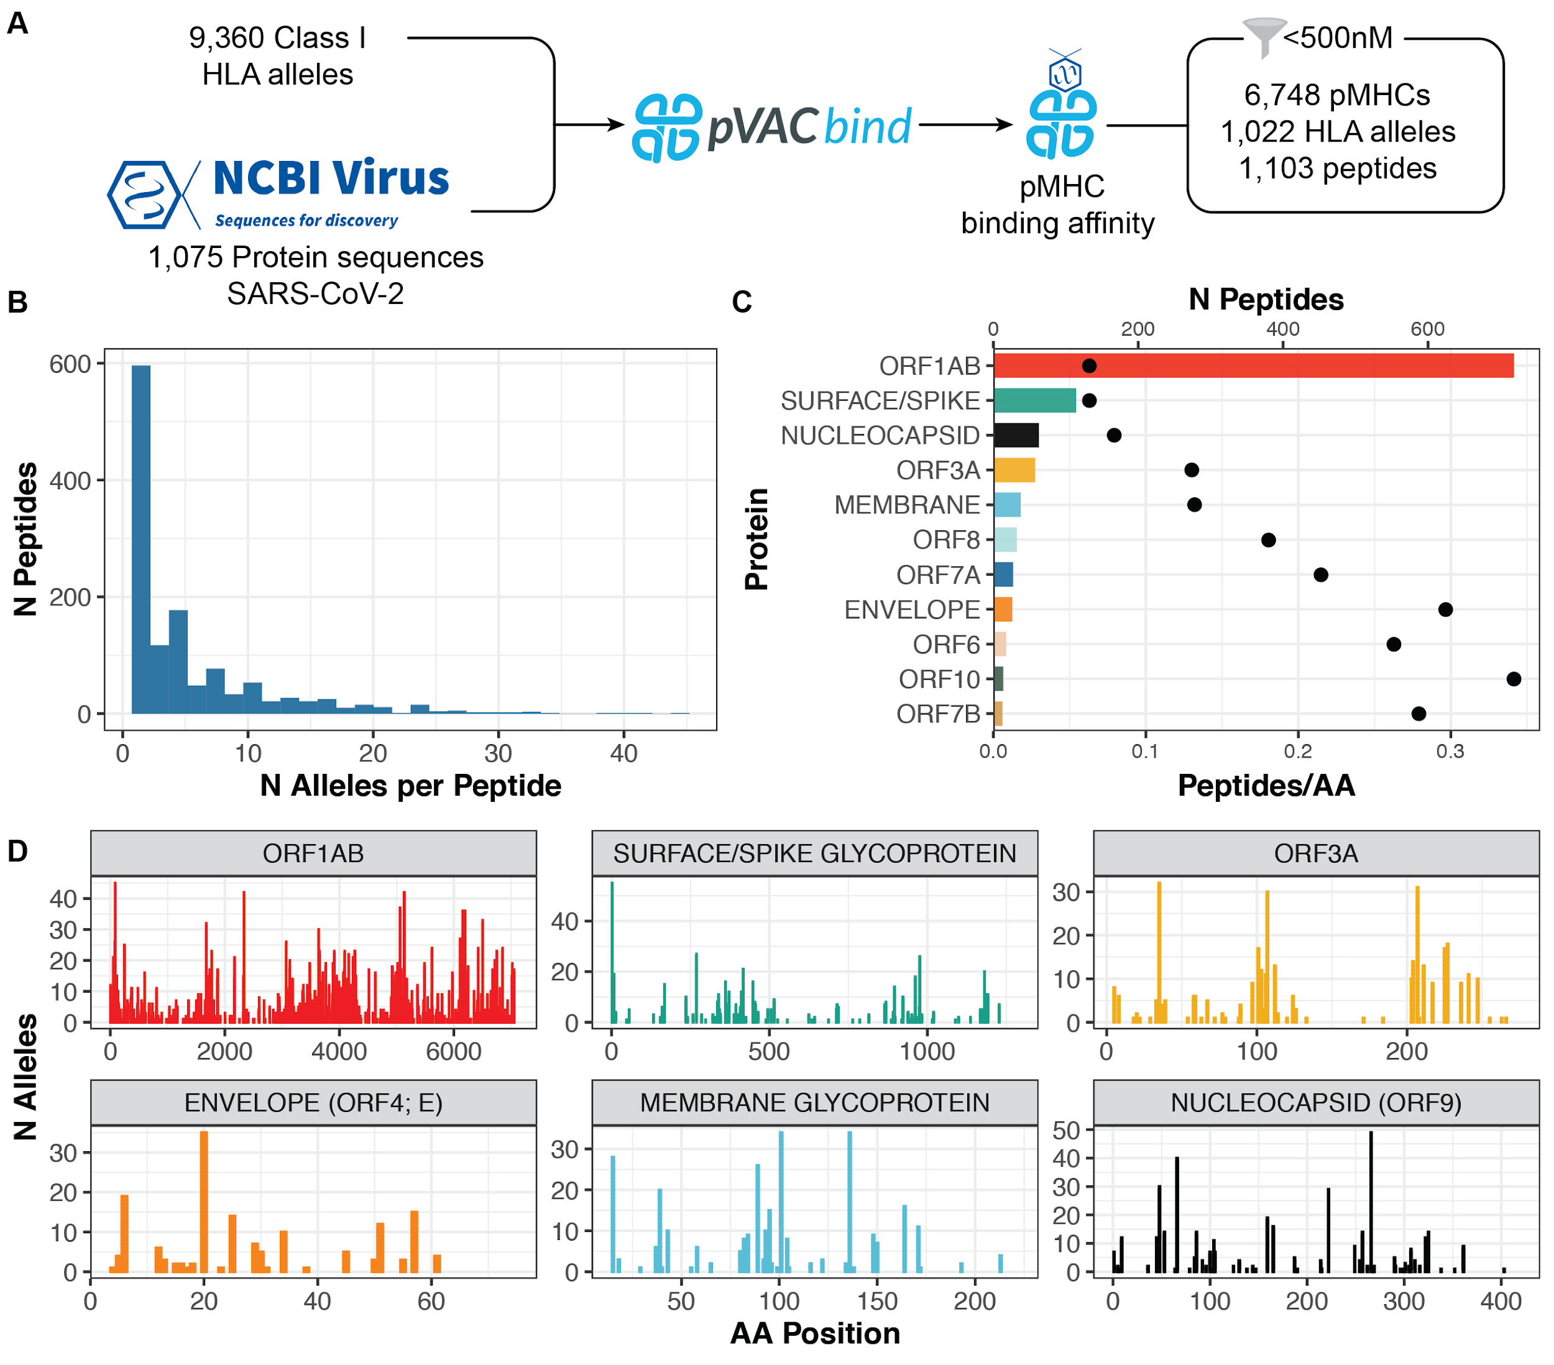

### Figure 1. Peptide binding predictions for SARS-CoV-2

A. Overview of the analysis strategy used in this study. Nine-mer peptides derived from the proteins were used, and binding predictions were generated using nine different prediction algorithms (See Methods). B. Peptide-MHC complexes (pMHCs) were filtered to those with binding affinities of less than 500nM. This histogram shows the distribution of the number of pMHCs (x-axis) corresponding to each peptide. C. Number of peptides (bars; top x-axis) derived from each protein (y-axis). The number of peptides was normalized to the length of the protein, and is indicated by a single point (poinst; bottom x-axis). D. Bar charts showing the number of alleles (y-axis) that have a high-binding peptide at the corresponding protein position (x-axis) for six viral proteins. Due to differences in amino acid sequences across annotated proteins, there are 43 peptides not shown. See **Supplementary Figure 1** for remaining proteins.

# 

### Figure 2. SARS-CoV-2 Class I epitome

This figure displays all combinations (pMHCs; n=6,493) across peptides (x-axis) properly assigned to protein annotations (bottom color bar) with a binding affinity to HLA alleles (y-axis) of less than 500nM. The heatmap shows the binding affinity (fill color, nM), and pairs without high-binding epitopes are black. The bar charts show the number of peptides corresponding to each peptide (top) or the number of peptides corresponding to each allele (side left). Each allele is annotated (side color bars) by its gene (HLA-A, -B, -C), whether it is part of the A02 allele group, and superfamily (if available).

# Tables

### Table 1. Previously validated SARS-CoV peptides.

|  |  |  |  |
| --- | --- | --- | --- |
| **HLA Allele (Validated)** | **Peptide (Validated)** | **Reference** | **Predicted HLA Alleles** |
| **Nucleocapsid** | | | |
| A*02:01 | ALNTPKDHI | (*11*) | HLA-A\***02**:11 |
| A*02:01 | GMSRIGMEV | (*11, 12*) | HLA-A\***02**:03, A\***02**:50 |
| A*11:01 | KTFPPTEPK | (*13*) | HLA-A*03:10, 03:42, 03:44, 03:54, 03:73, 03:76, **11**:01, 30:31, 74:13 |
| A*02:01 | [L]LLLDRLNQL | (*11, 12, 14*) | HLA-A\***02**:02, **02**:03, **02**:11, **02**:13, **02**:132, **02**:141, **02**:150, **02**:16, **02**:173, **02**:181, **02**:19, **02**:196, **02**:205, **02**:214, **02**:228, **02**:238, **02**:25, **02**:262, **02**:70, **02**:71, **02**:73, **02**:85, **02**:95 |
| HLA-B*08:22, 08:38, 08:41, 08:56 |
| HLA-C*03:71 |
| A*02:01 | LQLPQGTTL | (*15*) | HLA-A\***02**:06, **02**:14 |
| HLA-B*15:01, 15:03, 15:103, 15:113, 15:127, 15:132, 15:179, 15:62, 15:69, 15:75, 15:98, 39:23, 39:49, 40:07, 40:12, 40:13, 40:21, 40:46, 48:15, 48:21 |
| B*40:01 | MEVTPSGTW[L] | (*16, 17*) | HLA-B*13:26, **40**:47, 44:101, 44:104, 44:17, 44:43, 44:48, 44:63, 44:71, 44:81, 44:91 |
| **Surface/Spike Glycoprotein** | | | |
| A*02:01 | FIAGLIAIV | (*18*) | HLA-A\***02**:03, **02**:131, **02**:150, **02**:170, **02**:179, **02**:187, **02**:196, **02**:205, **02**:214, **02**:228, **02**:238, **02**:248, **02**:257, **02**:50, **02**:69, **02**:71, **02**:85, **02**:95 |
| A*02:01 | KLPDDFMGCV | (*14, 19*) | HLA-A\***02**:50 |
| A*02:01 | NLNESLIDL | (*20*) | HLA-A\***02**:02, **02**:131, **02**:141, **02**:155, **02**:16, **02**:186, **02**:19, **02**:209, **02**:22, **02**:69, **02**:90 |
| A*02:01 | RLNEVAKNL | (*21*) | HLA-A\***02**:03, A\***02**:11, 02:128, 02:171, 02:196, 02:230, **02**:238, **02**:253, **02**:258, **02**:99 |
| HLA-B*27:20 |
| A*02:01 | VLNDILSRL | (*20, 22*) | HLA-A\***02**:03, **02**:11, **02**:13, **02**:132, **02**:148, **02**:151, **02**:171, **02**:186, **02**:19, **02**:196, **02**:209, **02**:22, **02**:230, **02**:238, **02**:253, **02**:258, **02**:52, **02**:70, **02**:71, **02**:73, **02**:85, **02**:99 |
| HLA-C*05:04, 05:23, 05:33 |
| **Orf1ab** | | | |
| A*02:01 | VLAWLYAAV | (*23*) | HLA-A*02:11, 02:148, 02:22, 02:230, 02:253, 02:258 |

Allele groups highlighted in **bold** under “Predicted HLA Alleles” indicates that the allele group matches the validated HLA Allele group (Column 1).

Supplementary Appendix

Predicted MHC Class I presentation of the SARS-CoV-2 peptidome

**Authors:**

Katie M. Campbell1, Gabriela M. Steiner2, Daniel K. Wells2, Antoni Ribas1,2,4,5, Anusha Kalbasi*3,4,5

**Affiliations:**

1Department of Medicine, Division of Hematology-Oncology, University of California, Los Angeles (UCLA), Los Angeles, CA, 90095, USA

2Parker Institute for Cancer Immunotherapy, San Francisco, CA, 94129, USA

3Department of Radiation Oncology, UCLA, CA, 90095, USA

4Department Surgery, Division of Surgical Oncology, University of California, Los Angeles, Los Angeles, CA, USA

5Jonsson Comprehensive Cancer Center, Los Angeles, CA, USA

# 

# Supplementary Note

The results of this study are available in a public Google bucket through the following link: <https://console.cloud.google.com/storage/browser/pici-covid19-data-resources>.

The folder “gs://pici-covid19-data-resources/mhci/peptide_predictions” in this bucket contains all of the Supplementary Tables corresponding to this document and the unfiltered peptide binding predictions (all_epitopes.tsv results from pvacbind). The details regarding these files are available in this document, as well as the README in the Google bucket.

Files can be accessed using either the command line gsutil tool (<https://cloud.google.com/storage/docs/gsutil>) or the Google Cloud Console.

## Files

All of the Supplementary Tables associated are available as tab-delimited ‘.tsv’ files:

* gs://pici-covid19-data-resources/mhci/peptide_predictions/SupplementaryTable1_ProteinSequences.tsv
* gs://pici-covid19-data-resources/mhci/peptide_predictions/SupplementaryTable2_HLATypes.tsv
* gs://pici-covid19-data-resources/mhci/peptide_predictions/SupplementaryTable3_FilteredAntigenBindingPredictions.tsv
* gs://pici-covid19-data-resources/mhci/peptide_predictions/SupplementaryTable4_HLASuperfamilies.tsv
* gs://pici-covid19-data-resources/mhci/peptide_predictions/SupplementaryTable5_PreviouslyIdentifiedSARS-CoVEpitopes.tsv
* gs://pici-covid19-data-resources/mhci/peptide_predictions/SupplementaryTable6_AlleleFileMapping.tsv

## Unfiltered file names

Each unfiltered file (*.all_epitopes.tsv) contains the unfiltered results from pvacbind, executed across 10 HLA alleles (there are 9,360 of these files). Each file name indicates the list of 10 alleles included in the associated TSV (With asterisks [*] and colons [:] replaced by underscores [ _ ]) and an underscore [ _ ] between each allele.

For example, the file:

HLA-A_01_01_HLA-A_01_02_HLA-A_01_03_HLA-A_01_04_HLA-A_01_06_HLA-A_01_07_HLA-A_01_08_HLA-A_01_09_HLA-A_01_10_HLA-A_01_100.all_epitopes.tsv

Contains the 10 alleles:

HLA-A*01:01, HLA-A*01:02, HLA-A*01:03, HLA-A*01:04, HLA-A*01:06, HLA-A*01:07, HLA-A*01:08, HLA-A*01:09, HLA-A*01:10, and HLA-A*01:100

**Supplementary Table 6** (SupplementaryTable6_AlleleFileMapping.tsv) directly maps HLA alleles to the corresponding file name.

## 

# Supplementary Figures

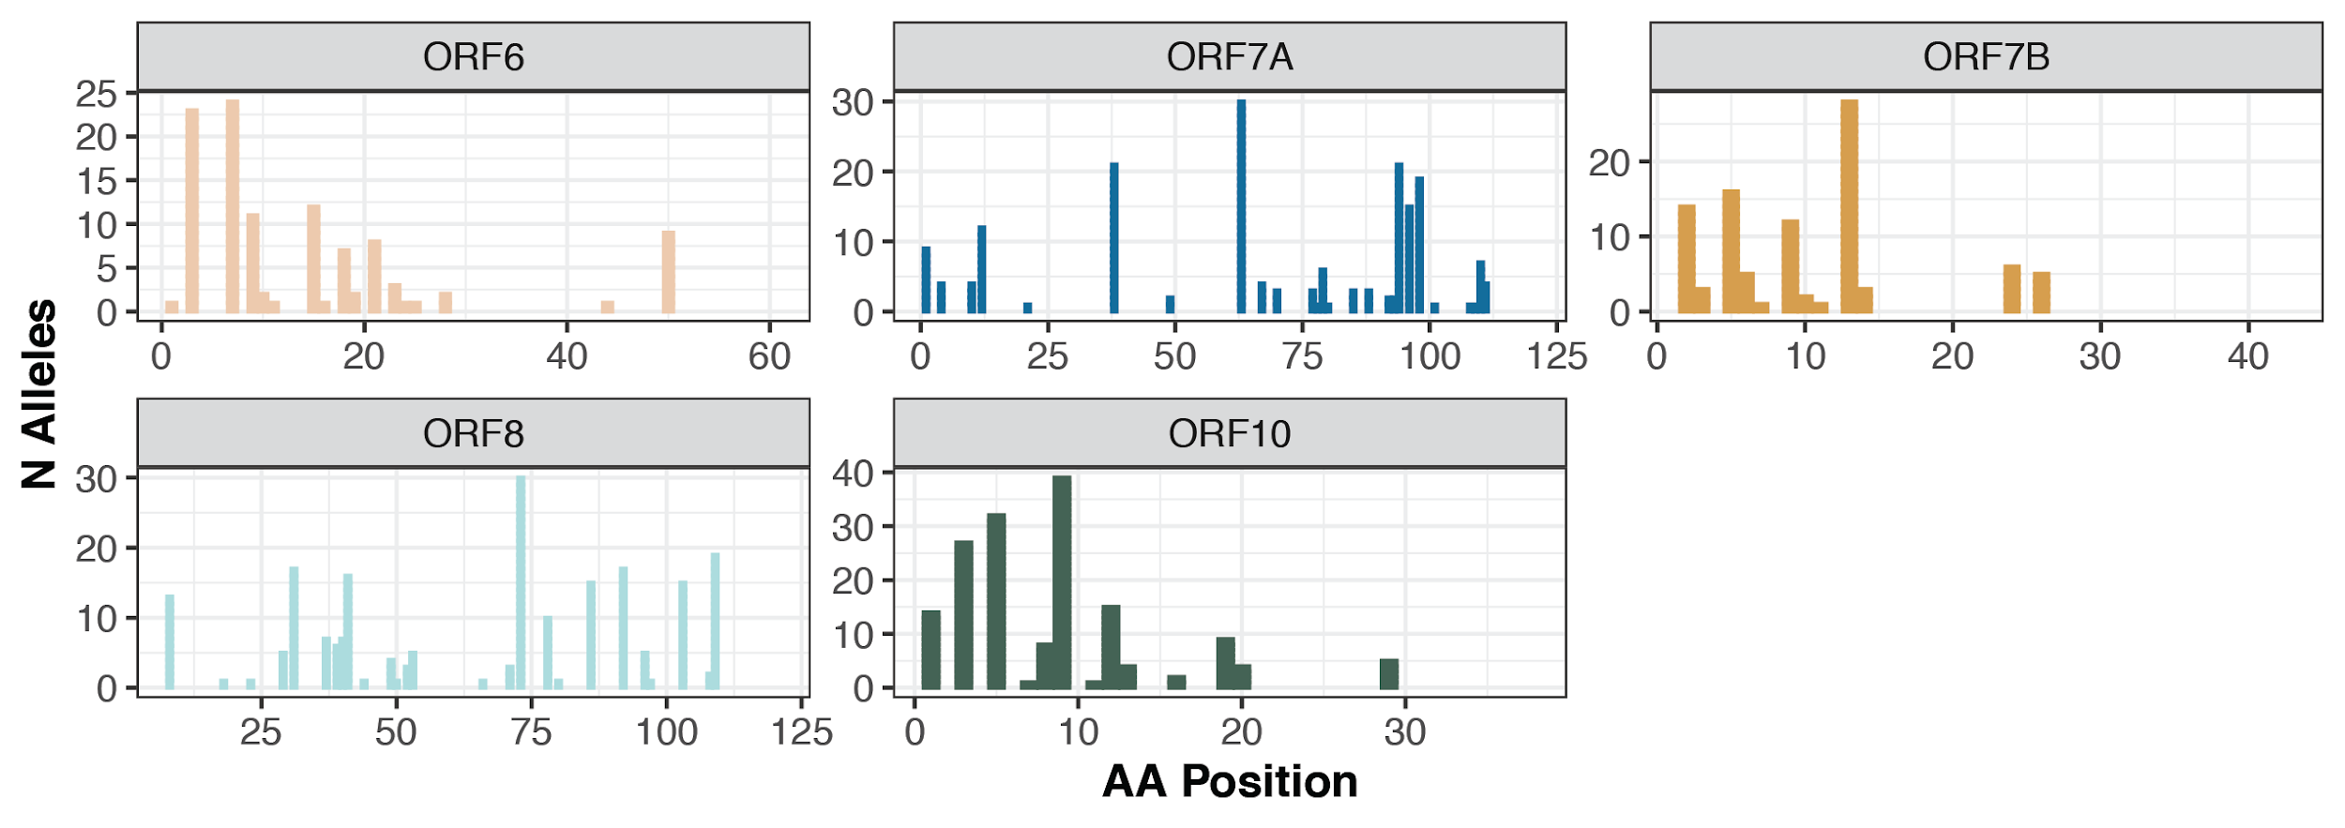

### Supplementary Figure 1. Number of alleles with high-binding peptides across viral proteins.

Bar charts showing the number of alleles (y-axis) that have a high-binding peptide at the corresponding protein position (x-axis) for five viral proteins. Corresponds to Figure 1D. Due to differences in amino acid sequences across annotated proteins, there are 5 peptides not shown.

# 

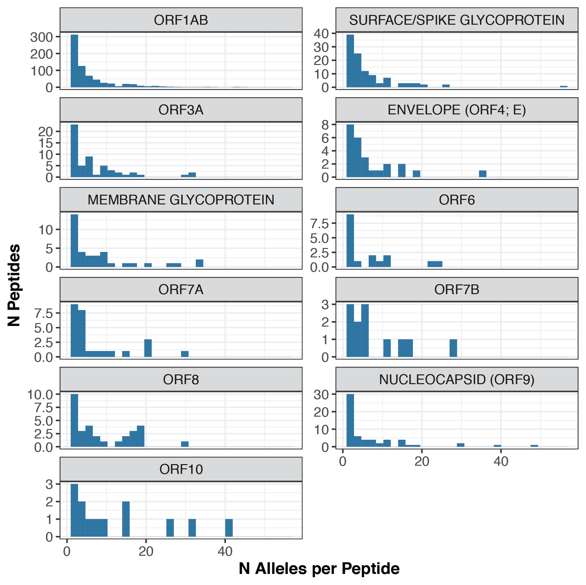

### Supplementary Figure 2. Number of pMHCs per peptide across proteins

The histogram in Figure 1B was broken up to display the distribution of pMHCs per peptide across each protein. Of note, there are no peptides corresponding to more than one protein annotation, and peptides corresponding to the annotated “Unknown” proteins (see **Methods**) are not included (n=34).

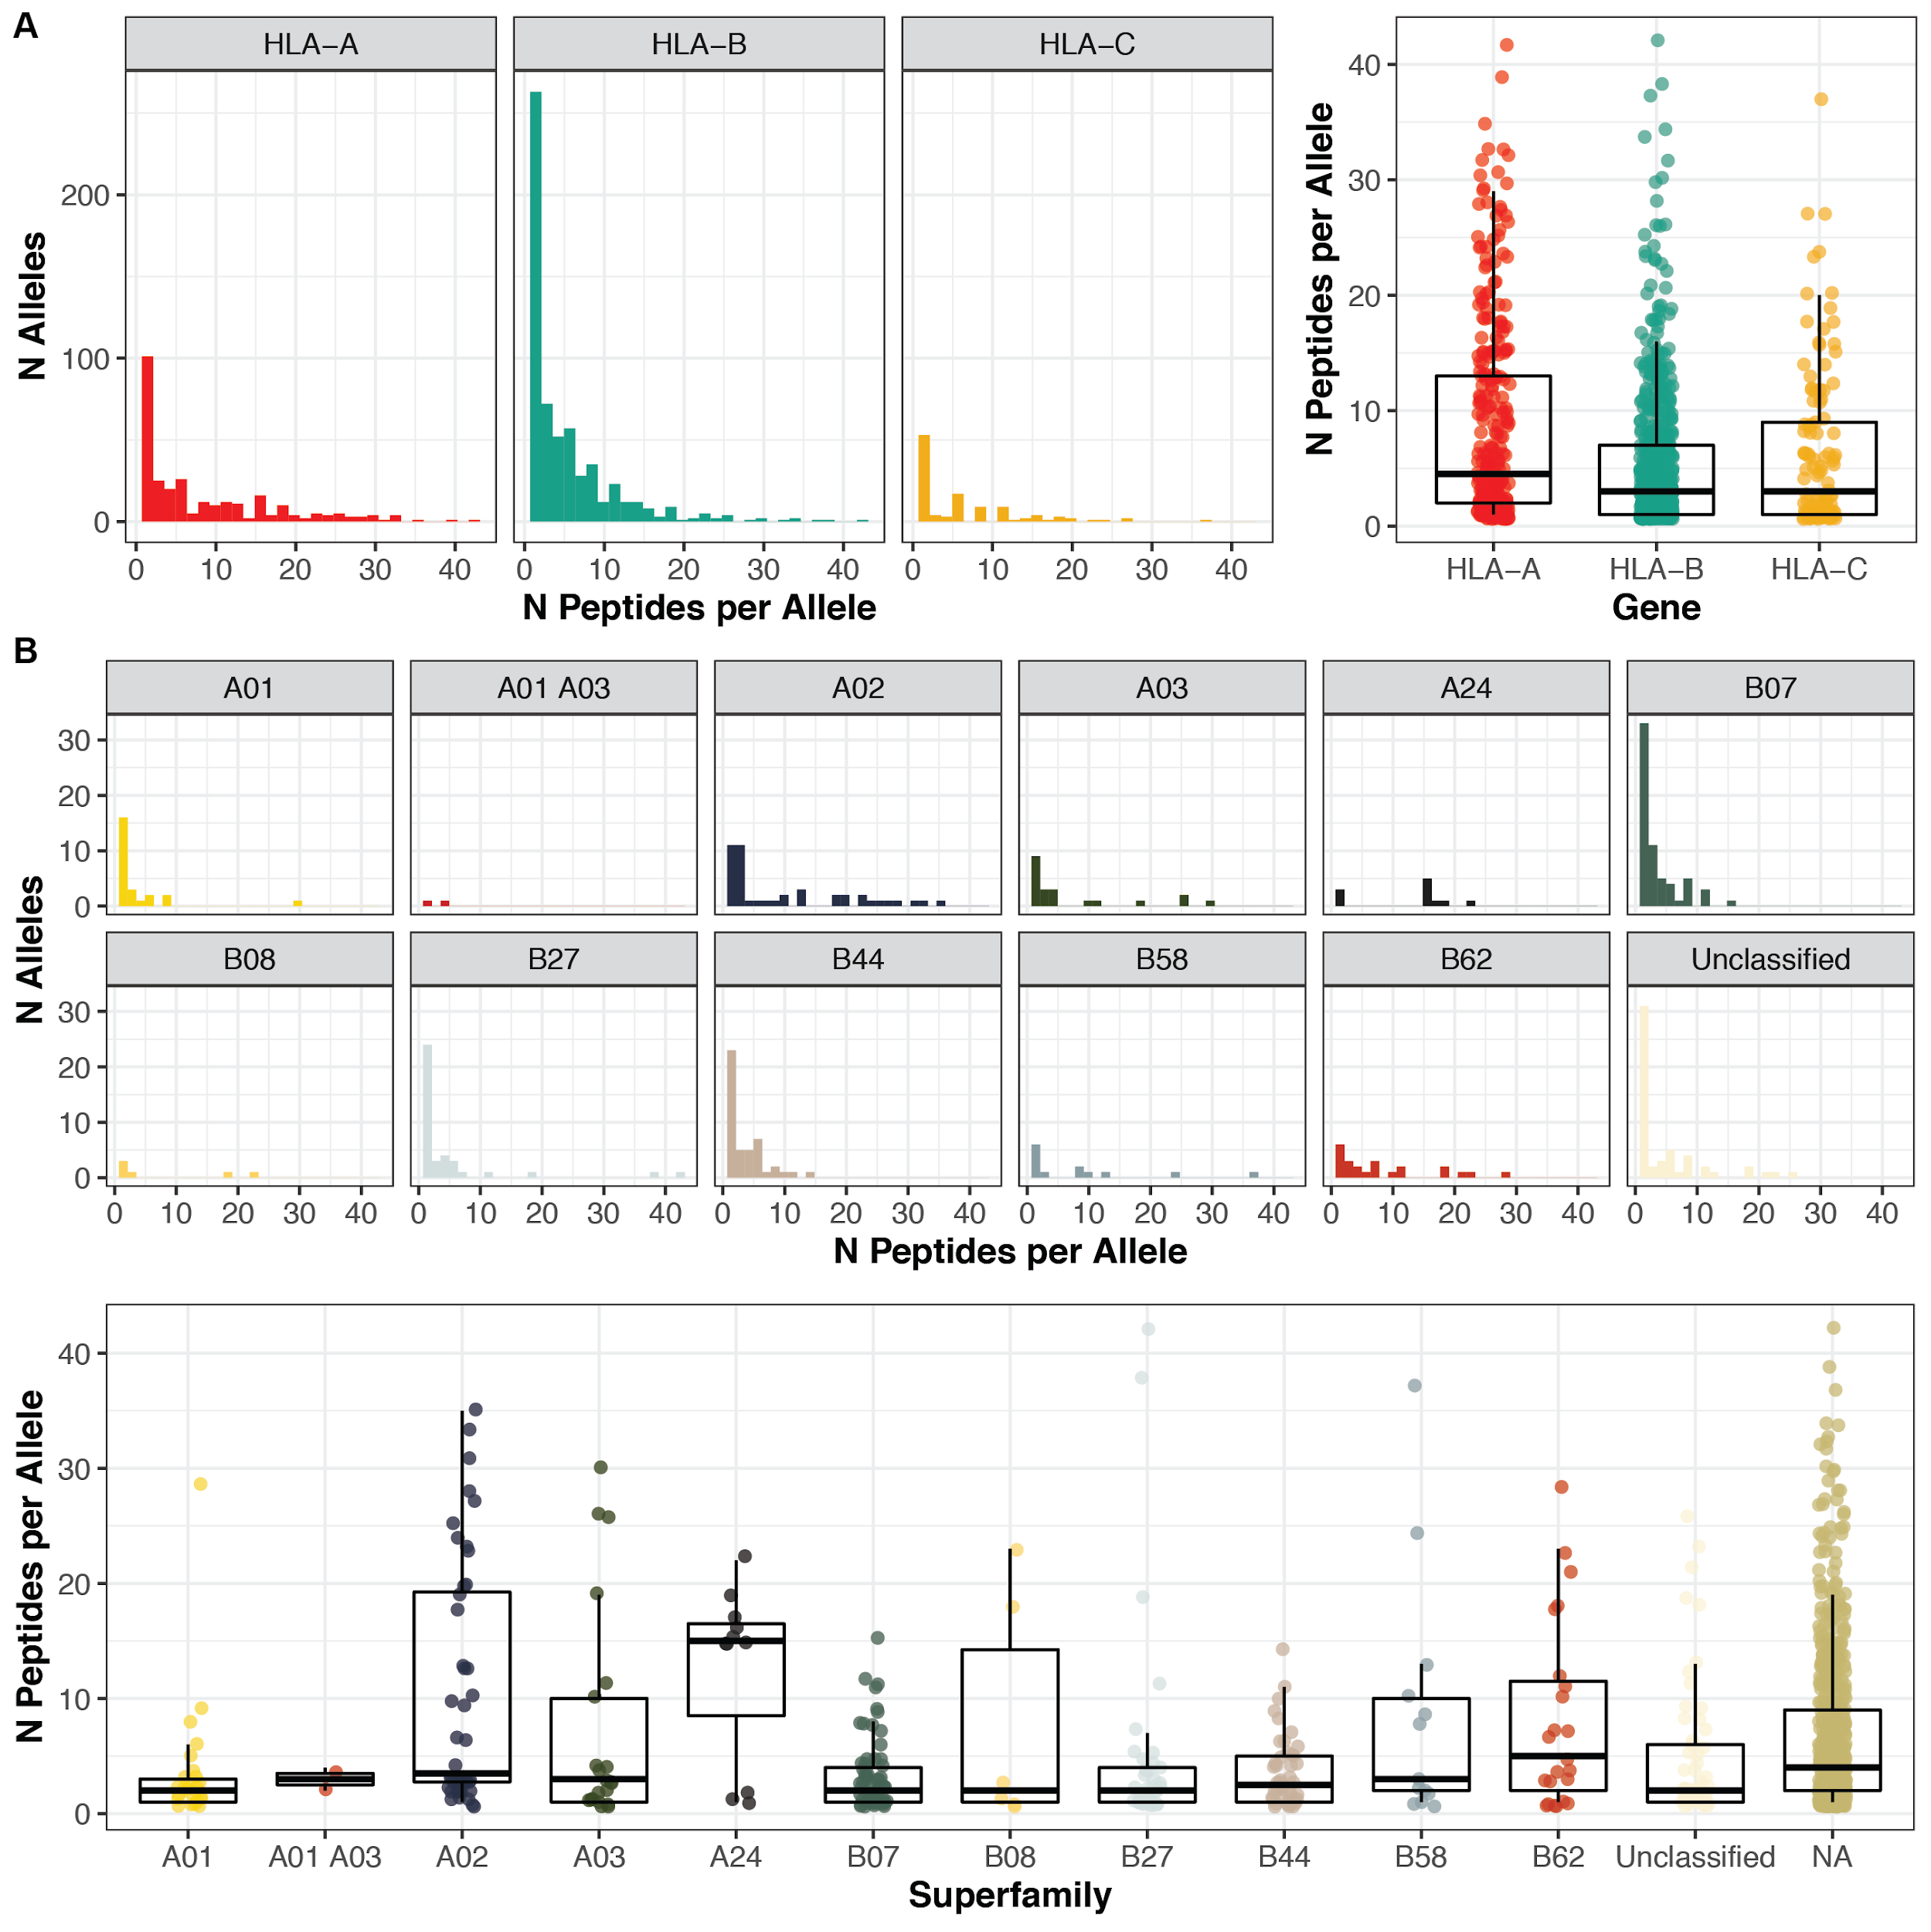

### Supplementary Figure 3. Distribution of the number of pMHCs per allele

A. These histograms (left) show the distributions of the number of pMHCs (x-axis) corresponding to each HLA allele, across the three HLA genes. The corresponding boxplots (right) show the distribution of the number of pMHCs (y-axis) per allele. B. Histograms (top) and boxplots (bottom), describing the number of peptides

# Supplementary Tables

### Supplementary Table 1. Protein sequences

This table summarizes the 1,075 annotated SARS-CoV-2 proteins used in this study. The ‘Accession’ column in this table maps to the ‘Mutation’ Column in the pvacbind results (**Supplementary Table 3**).

### Supplementary Table 2. HLA types

This table includes all 9,360 HLA types used as inputs to pvacbind evaluated in this study.

### Supplementary Table 3. Filtered antigen binding predictions

The filtered.tsv results from pvacbind were merged across all HLA alleles.

### Supplementary Table 4. HLA superfamilies

This table includes the annotation of the HLA superfamilies from Sidney, et al.

### Supplementary Table 5. Previously identified SARS-CoV epitopes

These epitopes from SARS-CoV were assembled from manual literature review.

### Supplementary Table 6. Allele File Mapping

This file contains the mapping between HLA alleles and their corresponding file that contains the unfiltered antigen binding predictions (See **Supplementary Note** for further details).

**REFERENCES**

1. X. Yang *et al.*, Clinical course and outcomes of critically ill patients with SARS-CoV-2 pneumonia in Wuhan, China: a single-centered, retrospective, observational study. *Lancet Respir Med*, (2020).

2. D. Wang *et al.*, Clinical Characteristics of 138 Hospitalized Patients With 2019 Novel Coronavirus-Infected Pneumonia in Wuhan, China. *Jama*, (2020).

3. E. J. Wherry, R. Ahmed, Memory CD8 T-cell differentiation during viral infection. *Journal of virology* **78**, 5535-5545 (2004).

4. R. Channappanavar, S. Perlman, Pathogenic human coronavirus infections: causes and consequences of cytokine storm and immunopathology. *Semin Immunopathol* **39**, 529-539 (2017).

5. A. V. Hill, Immunogenetics and genomics. *Lancet* **357**, 2037-2041 (2001).

6. J. Hundal *et al.*, pVACtools: A Computational Toolkit to Identify and Visualize Cancer Neoantigens. *Cancer immunology research* **8**, 409-420 (2020).

7. J. Sidney, B. Peters, N. Frahm, C. Brander, A. Sette, HLA class I supertypes: a revised and updated classification. *BMC Immunol* **9**, 1 (2008).

8. R. Vita *et al.*, The Immune Epitope Database (IEDB): 2018 update. *Nucleic Acids Res* **47**, D339-d343 (2019).

9. A. Grifoni *et al.*, A Sequence Homology and Bioinformatic Approach Can Predict Candidate Targets for Immune Responses to SARS-CoV-2. *Cell Host Microbe*, (2020).

10. S. F. Ahmed, A. A. Quadeer, M. R. McKay, Preliminary Identification of Potential Vaccine Targets for the COVID-19 Coronavirus (SARS-CoV-2) Based on SARS-CoV Immunological Studies. *Viruses* **12**, (2020).

11. Y. P. Tsao *et al.*, HLA-A*0201 T-cell epitopes in severe acute respiratory syndrome (SARS) coronavirus nucleocapsid and spike proteins. *Biochem Biophys Res Commun* **344**, 63-71 (2006).

12. S. Ohno *et al.*, Synthetic peptides coupled to the surface of liposomes effectively induce SARS coronavirus-specific cytotoxic T lymphocytes and viral clearance in HLA-A*0201 transgenic mice. *Vaccine* **27**, 3912-3920 (2009).

13. C. Sylvester-Hvid *et al.*, SARS CTL vaccine candidates; HLA supertype-, genome-wide scanning and biochemical validation. *Tissue Antigens* **63**, 395-400 (2004).

14. M. Zhou *et al.*, Screening and identification of severe acute respiratory syndrome-associated coronavirus-specific CTL epitopes. *Journal of immunology (Baltimore, Md. : 1950)* **177**, 2138-2145 (2006).

15. Y. K. Cheung, S. C. Cheng, F. W. Sin, K. T. Chan, Y. Xie, Induction of T-cell response by a DNA vaccine encoding a novel HLA-A*0201 severe acute respiratory syndrome coronavirus epitope. *Vaccine* **25**, 6070-6077 (2007).

16. L. Rivino *et al.*, Defining CD8+ T cell determinants during human viral infection in populations of Asian ethnicity. *Journal of immunology (Baltimore, Md. : 1950)* **191**, 4010-4019 (2013).

17. C. X. Chang *et al.*, Conditional ligands for Asian HLA variants facilitate the definition of CD8+ T-cell responses in acute and chronic viral diseases. *Eur J Immunol* **43**, 1109-1120 (2013).

18. Y. D. Wang *et al.*, T-cell epitopes in severe acute respiratory syndrome (SARS) coronavirus spike protein elicit a specific T-cell immune response in patients who recover from SARS. *Journal of virology* **78**, 5612-5618 (2004).

19. J. Liu *et al.*, The membrane protein of severe acute respiratory syndrome coronavirus acts as a dominant immunogen revealed by a clustering region of novel functionally and structurally defined cytotoxic T-lymphocyte epitopes. *J Infect Dis* **202**, 1171-1180 (2010).

20. Y. Lv, Z. Ruan, L. Wang, B. Ni, Y. Wu, Identification of a novel conserved HLA-A*0201-restricted epitope from the spike protein of SARS-CoV. *BMC Immunol* **10**, 61 (2009).

21. B. Wang *et al.*, Identification of an HLA-A*0201-restricted CD8+ T-cell epitope SSp-1 of SARS-CoV spike protein. *Blood* **104**, 200-206 (2004).

22. H. L. Oh *et al.*, Engineering T cells specific for a dominant severe acute respiratory syndrome coronavirus CD8 T cell epitope. *Journal of virology* **85**, 10464-10471 (2011).

23. S. Kohyama *et al.*, Efficient induction of cytotoxic T lymphocytes specific for severe acute respiratory syndrome (SARS)-associated coronavirus by immunization with surface-linked liposomal peptides derived from a non-structural polyprotein 1a. *Antiviral Res* **84**, 168-177 (2009).