Peg Solitaire — Sprint 3 Deliverable
Tables and extra criterion generated by AI like in sprint 1
Video Link:
https://umsystem.hosted.panopto.com/Panopto/Pages/Viewer.aspx?id=f76c4735-6fc4-49ce-b920-b424006b5a0f
Source code file name | Production Code or Test Code | # lines of code
AutoGame | Production | 77
Game | Production | 66
GameFactory | Production | 71
ManualGame | Production | 94
Board | Production | 224
CellState | Production | 10
DiamondBoard | Production | 66
EnglishBoard | Production | 75
HexagonBoard | Production | 85
Move | Production | 65
BoardPanel | Production | 296
GameStatusPanel | Production | 71
MainWindow | Production | 261
AutoGameTest | Test | 102
GameFactorytest | Test | 144
ManualGameTest | Test | 139
Diamondboardtest | Test | 106
Englishboardtest | Test | 120
HexagonBoardTest | Test | 105
Total |  | 2177

3. Production Code vs User Stories / Acceptance Criteria (3 points)
Summarize how each of the user story/acceptance criteria is implemented in your production code (class name and method name etc.)
User Story ID | AC ID | Acceptance Criterion Description
1 | 1.1 | Given the game is on the main screen, when the player views the Board Type panel, then they should see radio buttons for English, Hexagon, and Diamond board types.
 | 1.2 | Given the player selects a board type, when the selection is made, then a new game with that board type starts immediately with the default size for that type.
 | 1.3 | Given the board size spinner is visible, when the player changes the size value, then only odd numbers between 5 and 25 are accepted (the spinner steps by 2).
 | 1.4 | Given the player changes the board size, when they click New Game, then the board redraws at the new size with the center hole empty.
2 | 2.1 | Given the game is on the main screen, when the player clicks the Autoplay button, then an automated game begins on the currently selected board type and size.
 | 2.2 | Given an automated game is running, when the player clicks New Game, then the autoplay stops and a new manual game begins.
3 | 3.1 | Given the player has selected a board type and size, when they click New Game, then the board resets to its initial state with all holes filled except the center.
 | 3.2 | Given a new game starts, when the board is displayed, then the peg count and rating in the status bar update to reflect the new starting state.
4 | 4.1 | Given the manual game is in progress, when the player clicks a peg, then the peg is highlighted in gold and all valid destination holes are shown with a green ring.
 | 4.2 | Given a peg is selected, when the player clicks a valid destination hole, then the peg moves, the jumped peg is removed, and the peg count decrements by one.
 | 4.3 | Given a peg is selected, when the player clicks an invalid cell or empty area, then the selection is cleared with no change to the board state.
 | 4.4 | Given a peg is selected, when the player clicks a different peg, then the selection transfers to the newly clicked peg.
5 | 5.1 | Given the manual game is in progress, when no valid moves remain, then a Game Over dialog appears showing pegs remaining and the player's rating.
 | 5.2 | Given the manual game is in progress, when only one peg remains, then the game ends and the player receives an Outstanding rating.
 | 5.3 | Given the game is over, when the player dismisses the dialog, then they can start a new game using the New Game button.
6 | 6.1 | Given an automated game is running, when the Autoplay timer fires, then the computer selects a random valid move and applies it, updating the board and status bar.
 | 6.2 | Given an automated game is running, when each move is applied, then the board animates step by step (one move per timer tick) rather than jumping to the end result.
 | 6.3 | Given an automated game is running, when no valid moves remain, then the autoplay timer stops automatically.
7 | 7.1 | Given an automated game has ended, when the game-over state is detected, then a dialog appears showing the number of pegs remaining and the rating achieved.
 | 7.2 | Given the automated game has ended, when the player dismisses the dialog, then the New Game and Autoplay buttons are re-enabled.
8 | 8.1 | Given a manual game is in progress, when the player clicks Randomize, then the board state changes to a new valid mid-game position by applying a series of random valid moves.
 | 8.2 | Given the board has been randomized, when the board is displayed, then it is in a consistent valid state with no pegs outside valid cells and the correct peg count shown.
 | 8.3 | Given a manual game is in progress, when the player clicks Randomize, then the move history is not affected — randomization moves are not counted as player moves.
 | 8.4 | Given an automated game is running, when the player views the sidebar, then the Randomize button is disabled (randomize only applies to manual games).

User Story ID | AC ID | Class Name(s) | Method Name(s) | Status (complete or not) | Notes (optional)
1 | 1.1 | EnglishBoard, HexagonBoard, DiamondBoard, MainWindow | BoardPanel.setGame(), GameFactory.createBoard() | Complete
 | 1.2 | MainWindow | getSelectedBoardType(), onBoardTypeChanged() | Complete | Auto-starts new game on type change
 | 1.3 | MainWindow | getSelectedSize(), JSpinner (step=2, odd only) | Complete | Spinner enforces odd values
 | 1.4 | MainWindow, GameFactory | startNewManualGame(), GameFactory.create() | Complete
2 | 2.1 | MainWindow, GameFactory | startAutoplay(), GameFactory.create() | Complete
 | 2.2 | MainWindow | startNewManualGame(), stopAutoplay() | Complete | Timer stopped on New Game
3 | 3.1 | EnglishBoard, HexagonBoard, DiamondBoard | initBoard(), setCell(), recountPegs() | Complete
 | 3.2 | MainWindow, GameStatusPanel | startNewManualGame(), GameStatusPanel.refresh() | Complete
4 | 4.1 | BoardPanel | handleClick(), select() | Complete | Gold highlight + green rings
 | 4.2 | BoardPanel, ManualGame | handleClick(), ManualGame.makeMove() | Complete
 | 4.3 | BoardPanel | handleClick(), clearSelection() | Complete
 | 4.4 | BoardPanel | handleClick(), select() | Complete | Re-selects new peg
5 | 5.1 | MainWindow, Board | showGameOverDialog(), Board.isGameOver() | Complete
 | 5.2 | Board | isGameOver(), getRating() | Complete | Outstanding for 1 peg
 | 5.3 | MainWindow | showGameOverDialog(), startNewManualGame() | Complete
6 | 6.1 | AutoGame, MainWindow | AutoGame.makeMove(), Timer actionPerformed | Complete
 | 6.2 | MainWindow | startAutoplay() — Timer at 400ms intervals | Complete | Step-by-step animation
 | 6.3 | MainWindow | Timer actionPerformed, stopAutoplay() | Complete
7 | 7.1 | MainWindow | showGameOverDialog(), Game.getRating() | Complete
 | 7.2 | MainWindow | stopAutoplay(), btnAutoplay.setEnabled() | Complete
8 | 8.1 | ManualGame | randomize(int minMoves, int maxMoves) | Complete | Applies 5-15 random valid moves
 | 8.2 | Board | recountPegs(), getValidMoves() | Complete | Board remains consistent
 | 8.3 | ManualGame | randomize() — does not add to moveHistory | Complete
 | 8.4 | MainWindow | startAutoplay(), btnRandomize.setEnabled(false) | Complete

4. Tests vs User Stories / Acceptance Criteria (2 points)
Summarize how each of the user story/acceptance criteria is tested by your test code (class name and method name) or manually performed tests.
4.1 Automated tests directly corresponding to acceptance criteria

User Story ID | AC ID | Class Name(s) of the Test Code | Method Name(s) of the Test Code | Status (Pass/Fail/In Progress)
1 | 1.1 | — | Manual test only (UI radio buttons visible) | —
 | 1.2 | GameFactoryTest | create_englishManual_returnsManualGame, create_hexagonManual_returnsManualGame, create_diamondManual_returnsManualGame | Pass
 | 1.3 | — | Manual test only (spinner step behaviour) | —
 | 1.4 | GameFactoryTest | customSize_englishBoard_hasCorrectSizeAndCenterEmpty, customSize_hexagonBoard_hasCorrectSizeAndCenterEmpty, customSize_diamondBoard_hasCorrectSizeAndCenterEmpty, customSize_newGame_isNotOver | Pass
2 | 2.1 | GameFactoryTest | create_englishAutoplay_returnsAutoGame, create_hexagonAutoplay_returnsAutoGame, create_diamondAutoplay_returnsAutoGame | Pass
 | 2.2 | — | Manual test only (UI timer/button interaction) | —
3 | 3.1 | EnglishBoardTest, HexagonBoardTest, DiamondBoardTest | centerCell_isEmptyAtStart, initialPegCount_is32 / is36 / is40, playableCells_arePegAtStart | Pass
 | 3.2 | GameFactoryTest | newGame_hasCorrectInitialPegCount_english, newGame_hasCorrectInitialPegCount_hexagon, newGame_hasCorrectInitialPegCount_diamond, newGame_isNotOver | Pass
4 | 4.1 | — | Manual test only (UI highlight and green ring rendering) | —
 | 4.2 | ManualGameTest | makeMove_validMove_updatesBoardState, makeMove_validMove_decrementsPegCount, makeMove_validMove_returnsTrue | Pass
 | 4.3 | ManualGameTest | makeMove_invalidMove_returnsFalse, makeMove_invalidMove_doesNotChangePegCount, makeMove_nullMove_returnsFalse | Pass
 | 4.4 | — | Manual test only (UI click re-selection behaviour) | —
5 | 5.1 | ManualGameTest | isOver_trueWhenNoMovesRemain | Pass
 | 5.2 | ManualGameTest | getRating_outstanding_whenOnePegLeft | Pass
 | 5.3 | GameFactoryTest | newGame_afterGameOver_boardIsFullyReset | Pass
6 | 6.1 | AutoGameTest | makeMove_appliesALegalMove, makeMove_returnsTrueWhenMovesAvailable, makeMove_decrementsPegCount | Pass
 | 6.2 | — | Manual test only (UI animation timing) | —
 | 6.3 | AutoGameTest | makeMove_returnsFalseWhenGameOver, runToEnd_terminates, runToEnd_doesNothingIfAlreadyOver | Pass
7 | 7.1 | GameFactoryTest | autoGame_afterRunToEnd_ratingIsValid, autoGame_afterRunToEnd_pegCountMatchesRating | Pass
 | 7.2 | — | Manual test only (UI button re-enable) | —
8 | 8.1 | ManualGameTest | randomize_reducesPegCount, randomize_doesNotCorruptBoard | Pass
 | 8.2 | ManualGameTest | randomize_producesValidBoardState | Pass
 | 8.3 | ManualGameTest | randomize_doesNotAddToMoveHistory | Pass
 | 8.4 | — | Manual test only (UI button disabled during autoplay) | —

4.2 Manual tests directly corresponding to acceptance criteria
The following acceptance criteria involve UI-only behaviour that cannot be verified by automated unit tests.

User Story ID | Acceptance Criterion ID | Test Case Input | Test Oracle (Expected Output) | Notes
1 | 1.1 | Program Started | Player sees buttons and board
 | 1.3 | Press size up/down | All numbers are odd | This specification was added by me to ensure the boards can be centered
2 | 2.2 | Auto started, new game pressed | Player sees new board and auto stops
4 | 4.1 | Peg selected | Player can see highlights | Feature suggested by AI, thought it was good, added to story 4
 | 4.4 | Peg selected, new peg clicked | Player sees new peg highlighted with no changes
6 | 6.2 | Auto selected | Player sees changes as step-by-step
7 | 7.2 | Auto finishes | Player closes pop-up, program continues | Pop-up feature suggested and added by AI
8 | 8.4 | Auto selected | Player sees randomize is grayed-out

5. (3 points)
5.1 Describe how the class hierarchy in your design deals with the common and different
requirements of the Manual Game and the Automated Game.

The manual and automated game states are modeled in a hierarchy that has a common abstract class “Game” and two subclasses “ManualGame” and “AutoGame”. The design itself is made to keep the most basic things in common for the two subclasses. The most important of these commonalities is the board itself being passed through in the abstract “Game” class to be used by either, without needing to know the type or size of the board. Both of them also share important methods to get board info like whether the game is over, how many pegs are left, what valid moves there are, and current rating (unneeded for sprint 3 but AI added without asking and I saw no issue with keeping it). Having the hierarchical system also simplifies the code by having the constructors for both be unified (to an extent) to remove redundancies by doing the same things for both manual or auto games. All of this also simplifies the job of displaying the game as changes to board state won’t need to depend on what mode you’re in, allowing for shared display code.

The important difference between manual and auto is that of the “makeMove()” method. Both subclasses have an override of the method to make it useful for their own use cases. Manual will take the input move (a struct/class containing the origin and destination) and test its validity, then make the valid move on the board. Automatic will ignore any input move rather, when called, it will check for a valid move, take any one of the valid moves, and make the move on the board from there. The manual and automatic subclasses also have their own methods that are unique to them and their needs. Manual has a “randomize()” method that will make a random set of moves to randomize the board (as requested by user story 8). Automatic has a “runToEnd()” method that loops the “makeMove()” method creating the entire functionality of the automatic mode playing itself by continuing to make moves until none are possible.

Overall, the hierarchical structure is much better than what I had originally with a main “Game” class in sprint 2. It allowed for simpler implementation and the ability to have the two different modes in the first place. It allowed common constructors, methods, and display logic without redundant code. It also allowed for the separate implementations to coexist without having a strange back-and-forth in the same file/class (i.e. no juggling whether you can randomize or if the game plays itself in one big class)
5.2 Demonstrate how you use LLM (ChatGPT or other) to analyze how well your code adheres to the design principles discussed in class - modularity, cohesion, coupling, and encapsulation – using the definitions provided in class.
To start off with the use of AI for this sprint, I knew I needed to refactor my code. The code used in sprint 2 was, frankly, a mess and would not work for this. To this end, I had the AI give me an outline, step-by-step process, and file structure to move forward with. Modularity was a big emphasis when it came to refactoring, the new file structure/outline had built in separation for each big component (i.e. display, board, game function). With the modularity also came cohesion as the AI provided outline, and mentoring during development, ensure separation of function between classes. Coupling wasn’t specifically planned for but rather emerged during other processes, for instance the AI suggested keeping the board and game classes completely separate. This made changes to board and game state not have a ripple effect on each other that hurt the functionality of the other. Encapsulation is practically inherit to java but to specify what the AI had pertaining to it, made observations in how things like default board type and size should be public to be viewed, and used, by other classes. While, things like the origin and destination of a move should be private to be viewed by get methods.

The AI was a kind of watchdog for keeping good design and assisted heavily in simplifying code. Firstly the AI made good comments for anything I gave it, particularly when making the unit tests. Secondly when I first gave AI my original sprint 2 code to work off of it made a beautiful collection of refactorized versions of my past classes. Specifically it used the English, Game, and PinArray logic to great use for making the new Game, GameFactory, and model (board) classes. Lastly, the AI refined the overall design of the UI, no longer did I have to close the window to render the next one and it gave some much needed visual improvements to all the buttons and pins. One gripe I had was when making the hexagon code, the suggestions it kept giving did not make hexagons requiring a lot of reprompting (shown in screenshots).
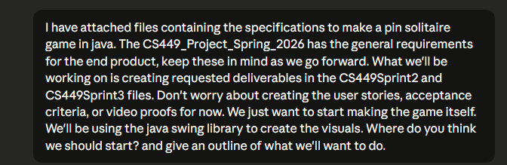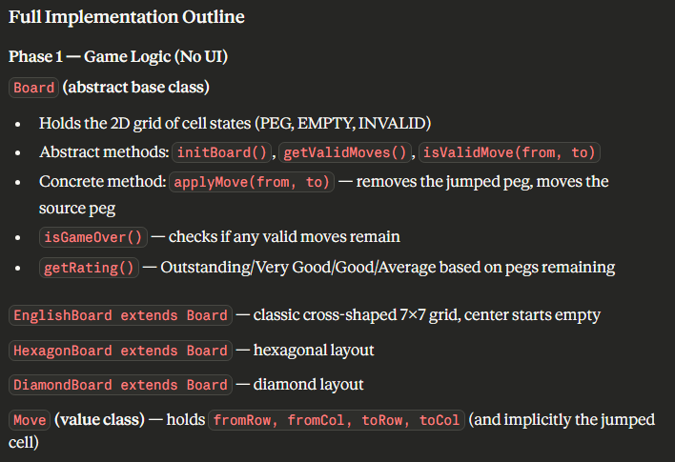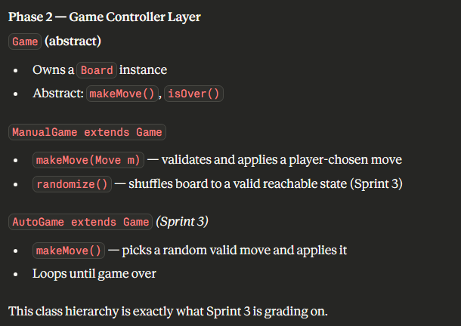
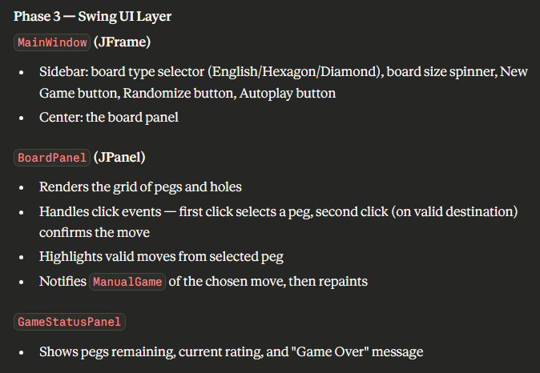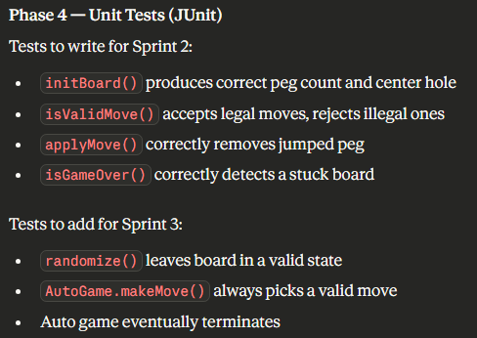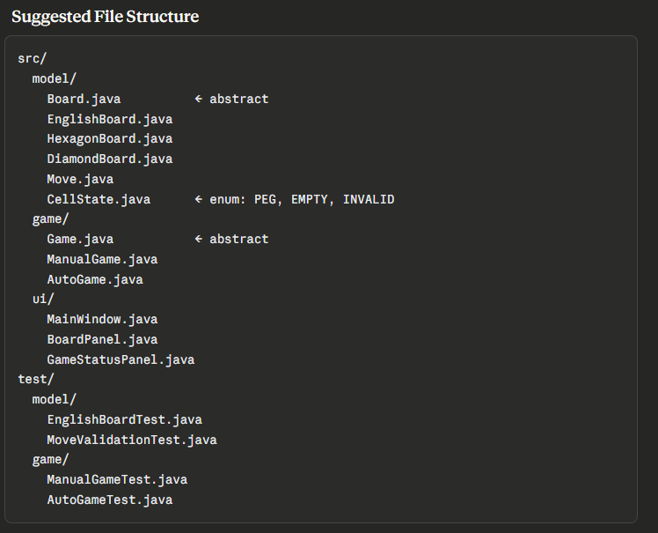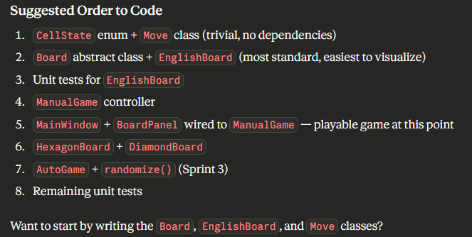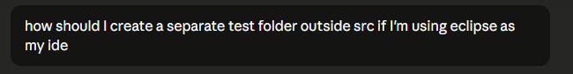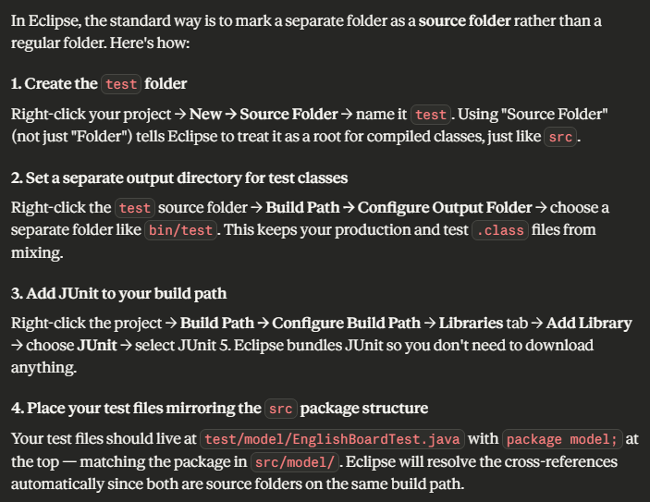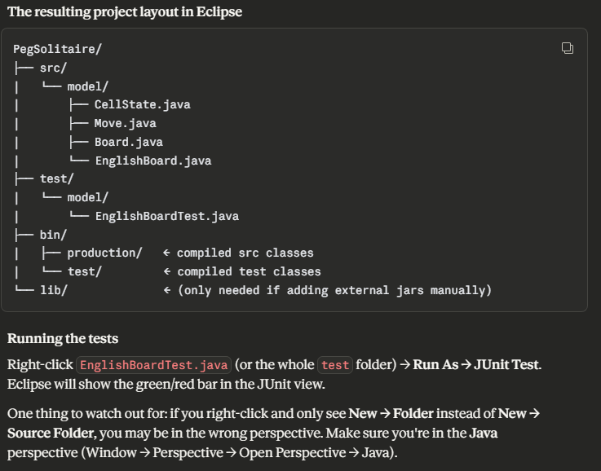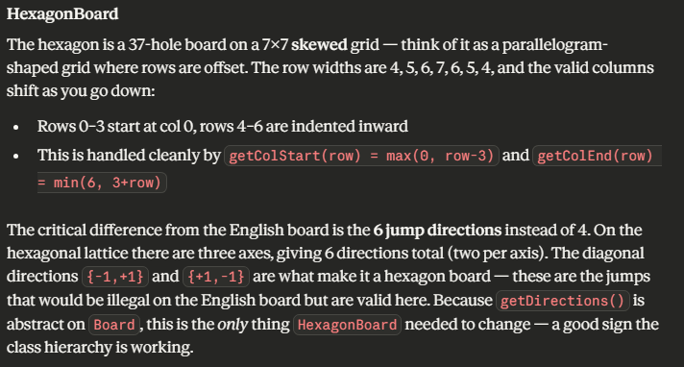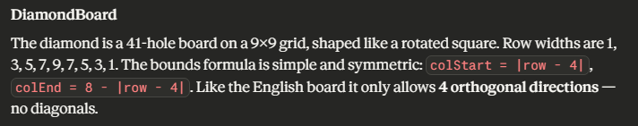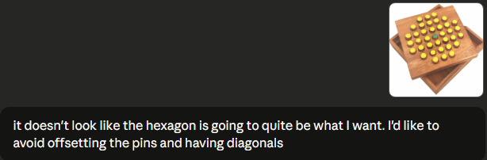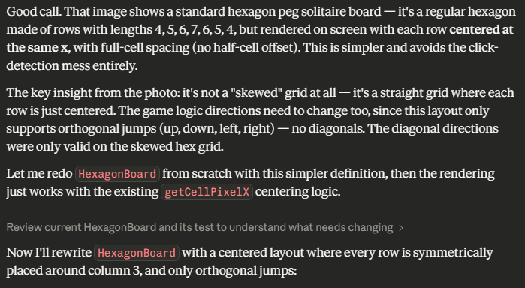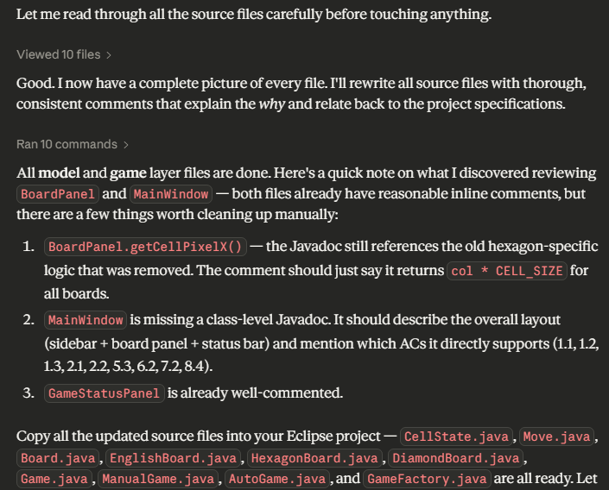

Only screenshots pertaining to AI changes to ensure design adherence included

