PARKING BUILDING MANAGEMENT SYSTEM
  - Business Process & Data Model Specification
Project Document — Format Proposal
Ho Chi Minh City, July 2026

Document status: DRAFT — FORMAT REVIEW ONLY
This revision defines the proposed structure and presentation. Detailed PBMS content and SVG diagrams are included as review evidence.

Document status: DRAFT — FORMAT REVIEW ONLY This revision defines the proposed structure and presentation. Detailed PBMS content and SVG diagrams will be populated only after format approval.

Table of Contents
- 0. Document Control
- 1. Document Overview
- 2. Business Processes (Swimlanes)
- 3. Data Model (ERD)
- 4. Business Rules
- 5. State Charts
- 6. Traceability, Gaps and Review

0. Document Control

0.1 Document Information
Field | Value
Document | PBMS Business Process & Data Model Specification
File | SWP391_PBMS_PROJECT_DOCUMENT.md
Structure version | 0.1
Related SRS | ../PBMS_SRS_Document.md, version 1.4 - REVIEW
Content status | Pending format approval
Primary sources | Current PBMS web/API codebase and approved SRS baseline
Intended output | Markdown document with linked SVG diagrams

0.2 Revision History
Version | Date | Status | Description
0.1 | 2026-07-20 | DRAFT | Reformat proposal focused on swimlanes, ERD, business rules and state charts.
0.2 | 2026-07-20 | DRAFT | Applied CR-GEN-003 scope decisions to the proposed content map.

0.3 Document Conventions
- PBMS identifies synchronous application processing.
- System identifies non-human scheduled workers.
- Human lanes use explicit roles: Guest, Driver, Staff, Manager and Admin.
- Requirement and rule IDs remain in English for traceability.
- Every diagram is maintained as source text and exported to SVG.
- PARTIAL, GAP, DEPRECATED and REVIEW are displayed explicitly where applicable.
- Backend-only code without an exposed end-to-end product flow is not treated as a current feature.

1. Document Overview

1.1 Purpose
Provide one concise review document for PBMS business behavior, data relationships, governing rules and lifecycle states.

1.2 Scope
In scope | Out of scope
Business processes and actor responsibilities | Package/namespace diagrams
Logical ERD and key integrity constraints | Detailed class specifications
Active business rules and decision tables | Method-by-method code design
State transitions and side effects | SQL/query catalogue
Cross-model traceability and known gaps | Screen-by-screen prototype specification
Current frontend-accessible product behavior and approved remediation targets | Refund, Monthly Subscription, user Notification, incident file upload, automatic API retry, Shift Report, and shift handover

1.3 Future Scope Register
Future ID | Capability | Current treatment | Activation condition
FUT-SHIFT-001 | Shift Report and shift handover | Excluded from current processes, ERDs, business rules, state charts and acceptance scope. Existing backend code is a future implementation artefact only. | Separate approved change request plus completed frontend, authorization and end-to-end verification.
FUT-NOTIF-001 | User Notification | Excluded from current processes, active ERDs, business rules and acceptance scope. Retained backend code must be non-exposed and non-running. | Separate approved change request plus a delivery/read contract and end-to-end verification.

2. Business Processes (Swimlanes)

2.0 Process Index
Process ID | Process group | Primary actors | Planned diagram level
BP-00 | PBMS end-to-end landscape | All actors, PBMS, System | Overview
BP-01 | Registration and authentication | Guest, Driver, PBMS | Direct-JWT overview + recovery remediation
BP-02 | Structure, pricing, configuration and RBAC | Manager, Admin, PBMS, System | Overview + Admin role-permission mapping
BP-03 | Booking and deposit | Driver, PBMS, VNPay, System | Overview + map selection
BP-04 | Gate check-in and allocation | Staff, PBMS, OCR | Overview
BP-05 | Session query and extension | Driver, Staff, PBMS | Overview
BP-06 | Checkout and payment | Staff, PBMS, VNPay | Overview; no refund path
BP-07 | Text-only incidents and exceptional operations | Driver, Staff, Manager, Admin, PBMS | Overview + all active Driver categories
BP-08 | Monitoring, revenue and audit | Staff, Manager, Admin, PBMS | Overview

Figure 1 — BP-00 End-to-End Landscape
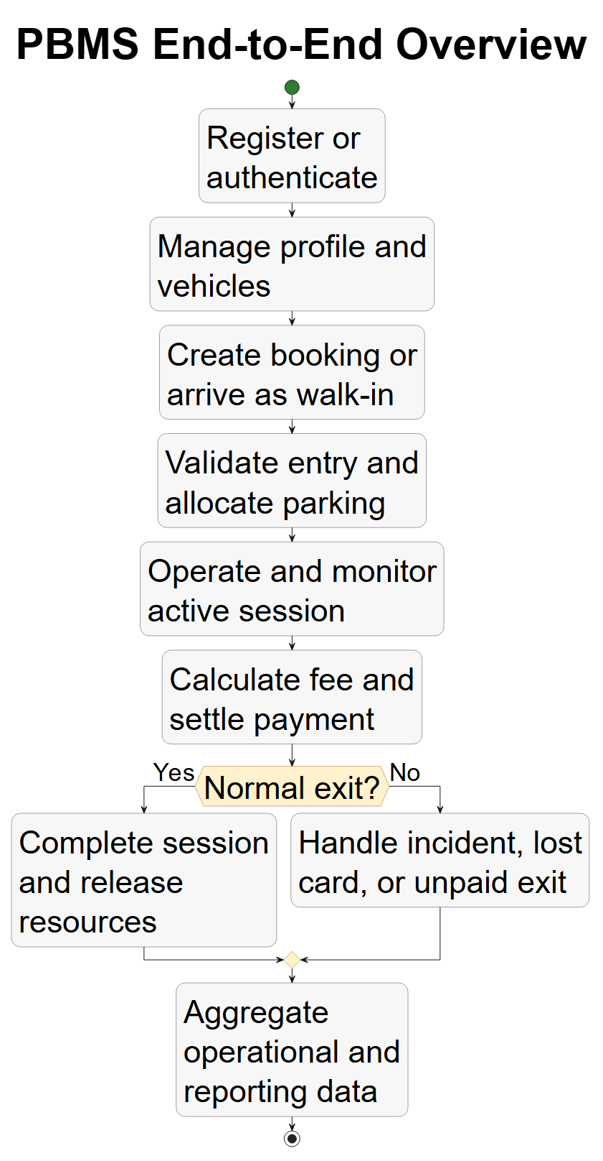

Figure 2 — BP-01 Guest and Driver Journey
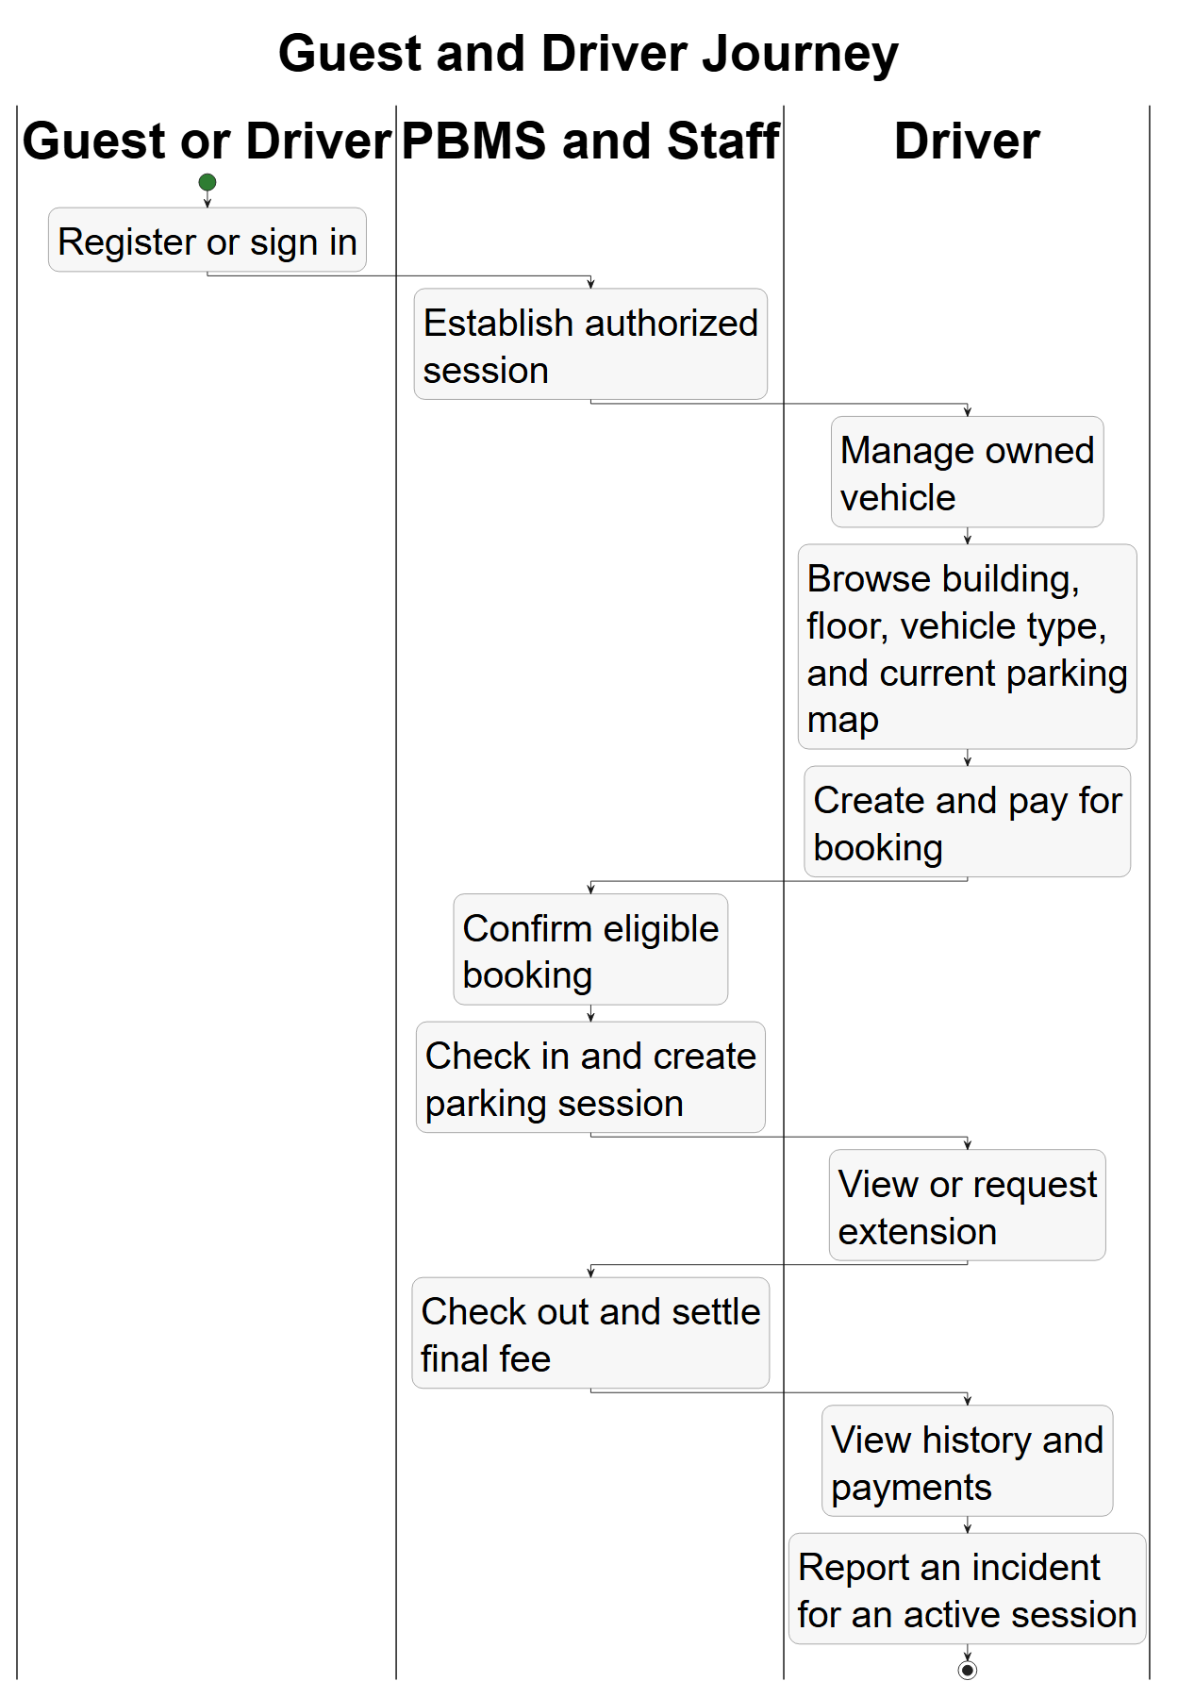

Figure 3 — BP-02 Staff Gate Operations
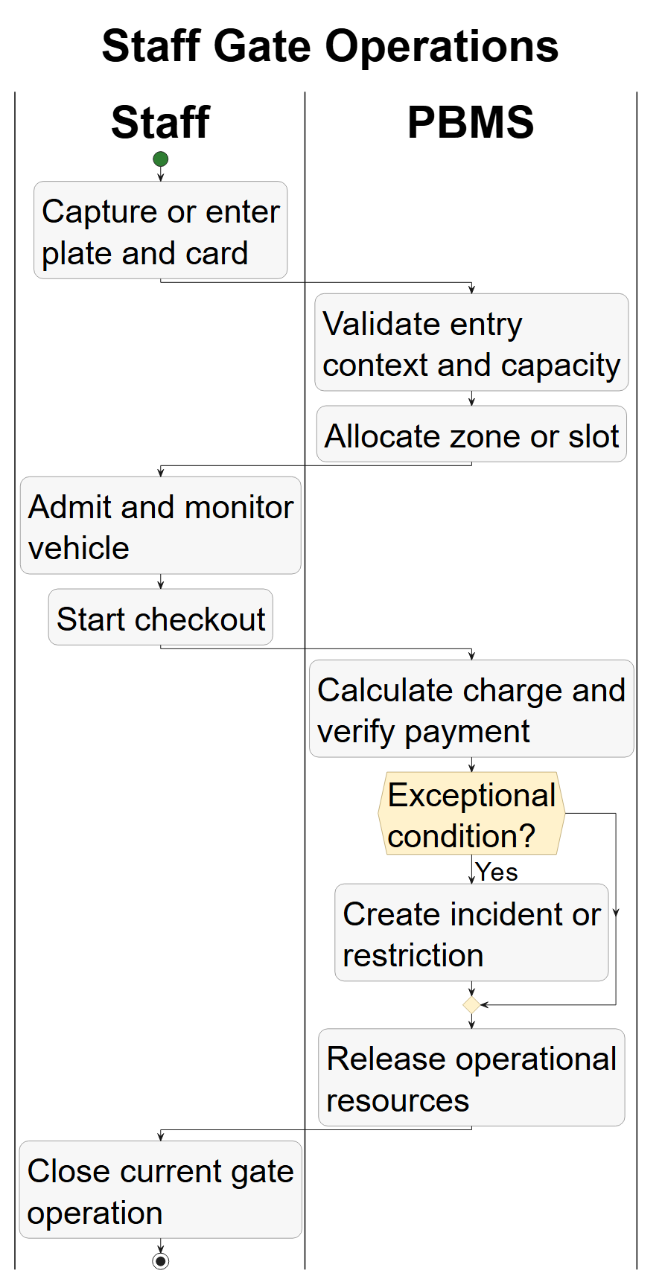

Figure 4 — BP-03 Management and Background Control
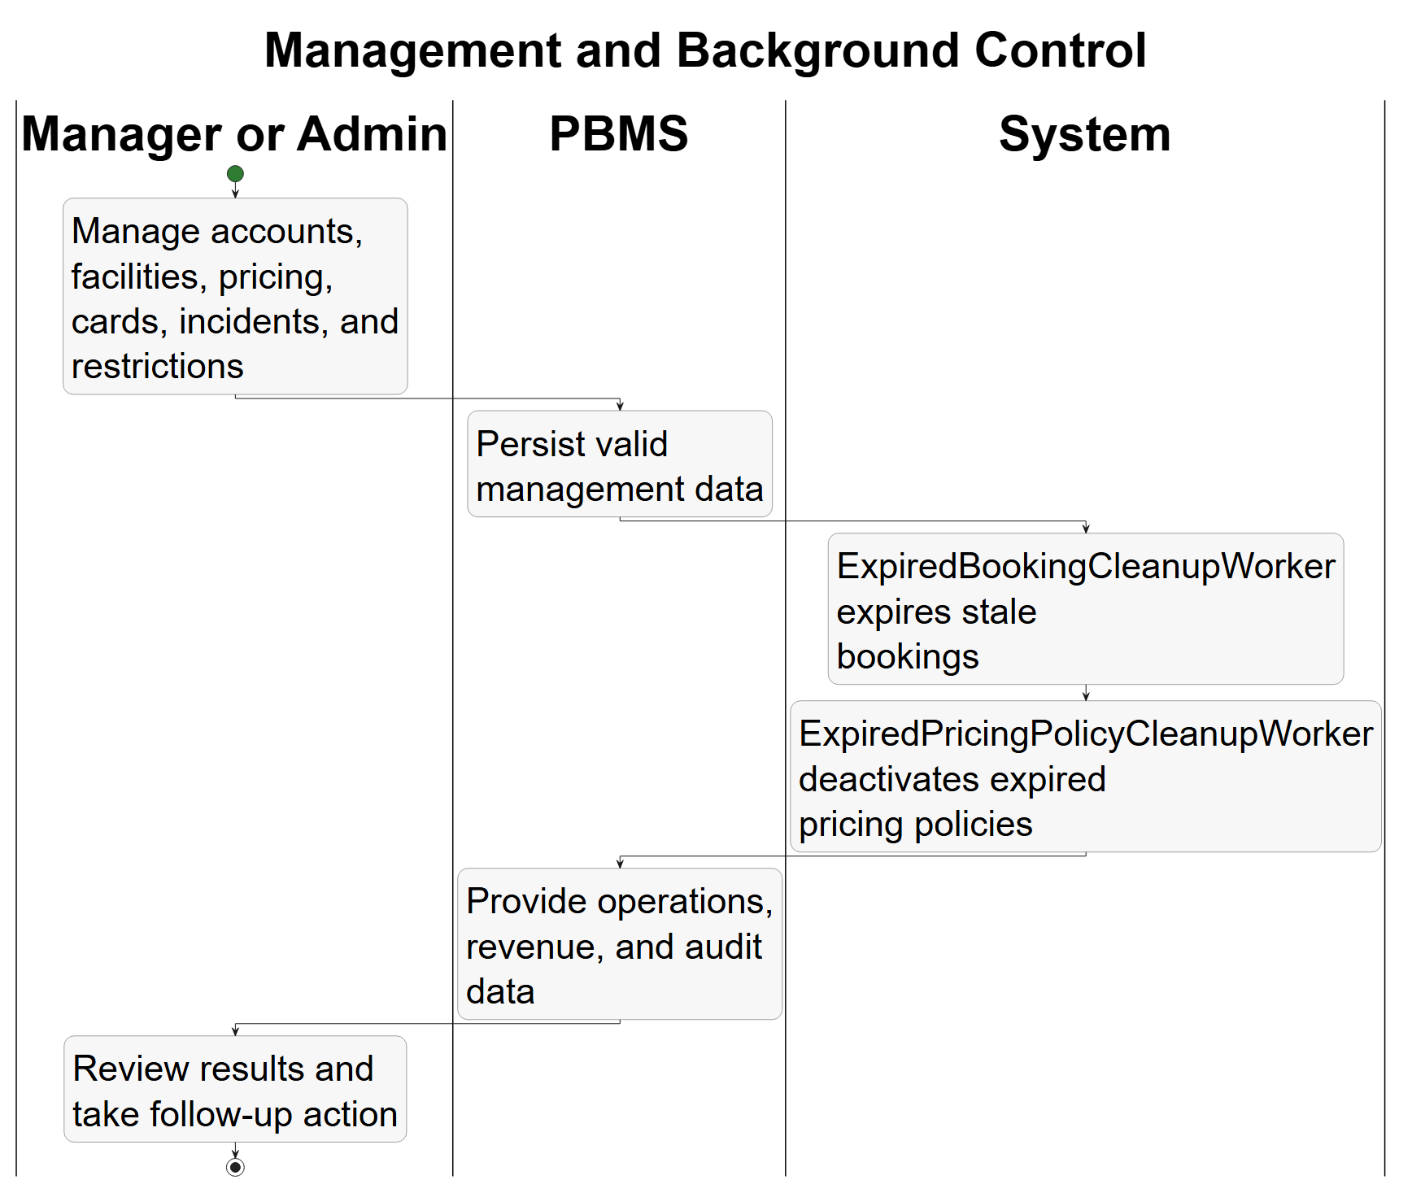

Figure 5 — BP-04 Registration and Authentication
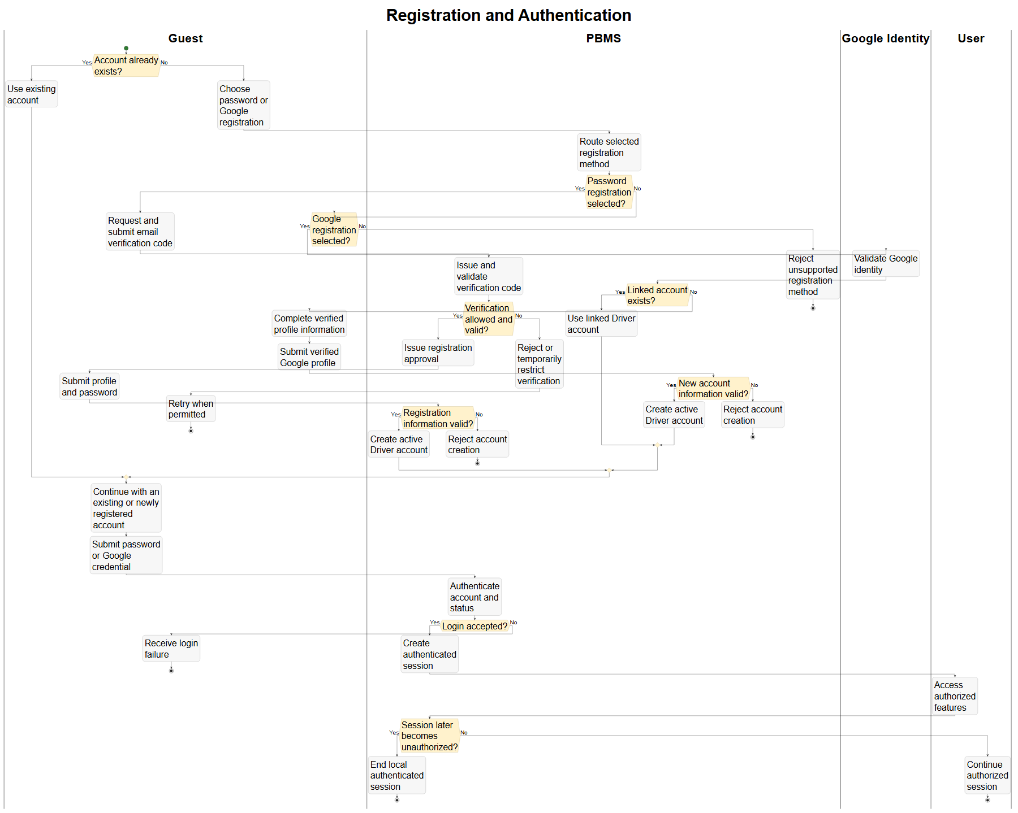

Figure 6 — BP-05 Password Recovery
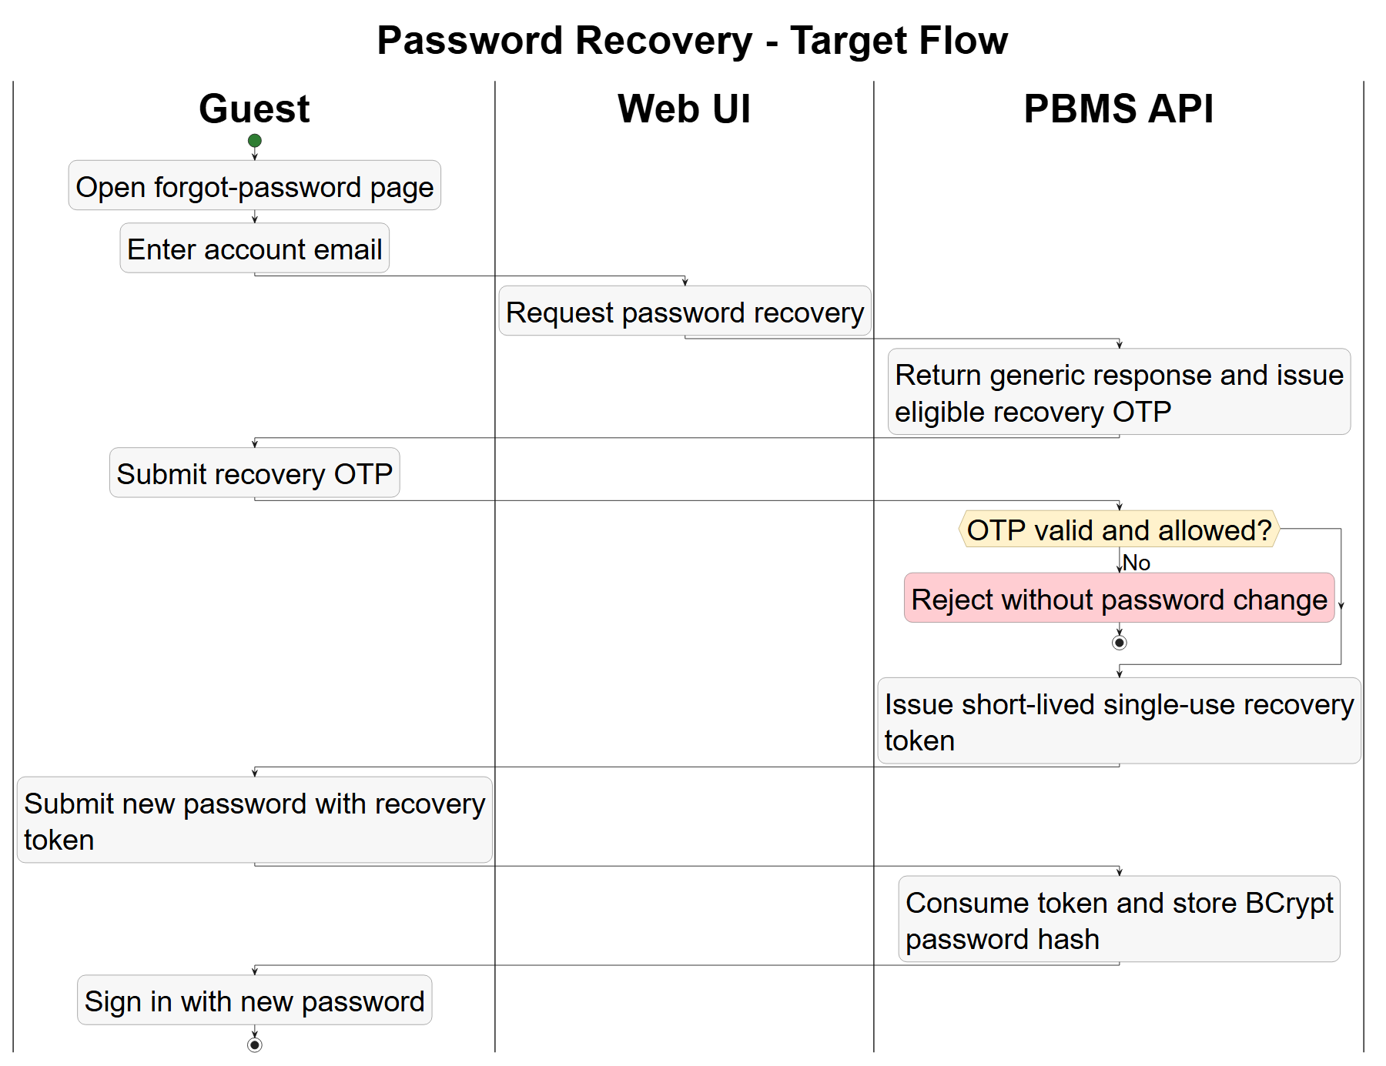

Figure 7 — BP-06 Management Overview
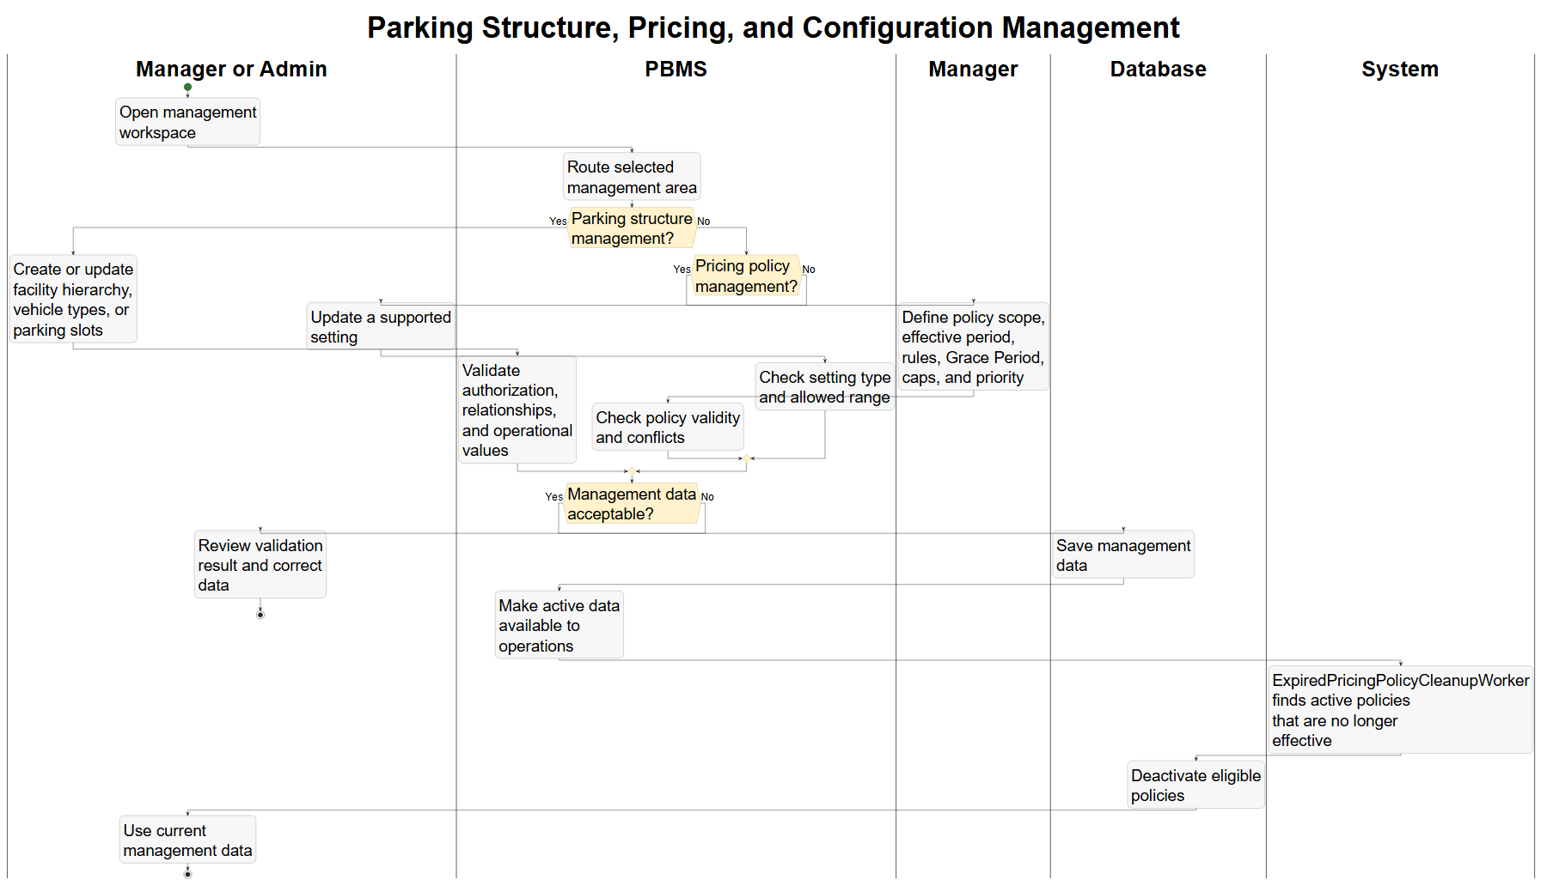

Figure 8 — BP-07 Booking Overview
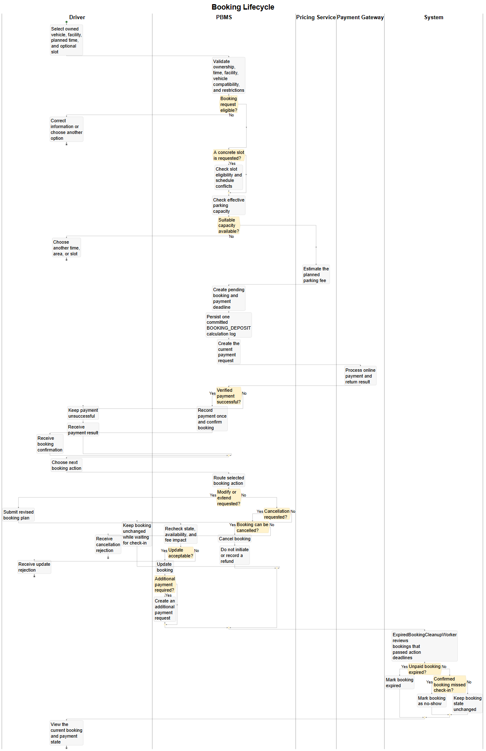

Figure 9 — BP-08 Driver Map Selection
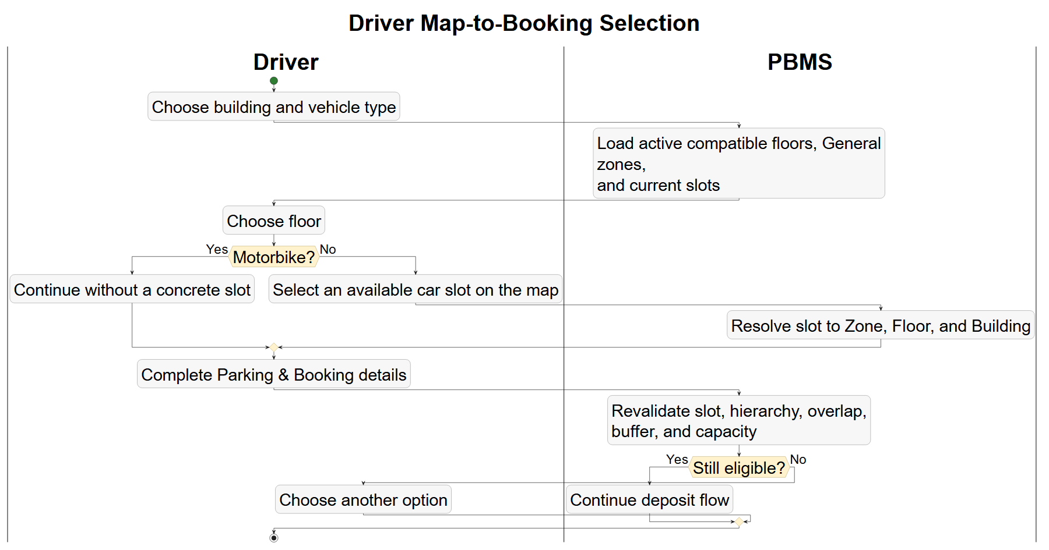

Figure 10 — BP-09 Gate Check-in and Allocation
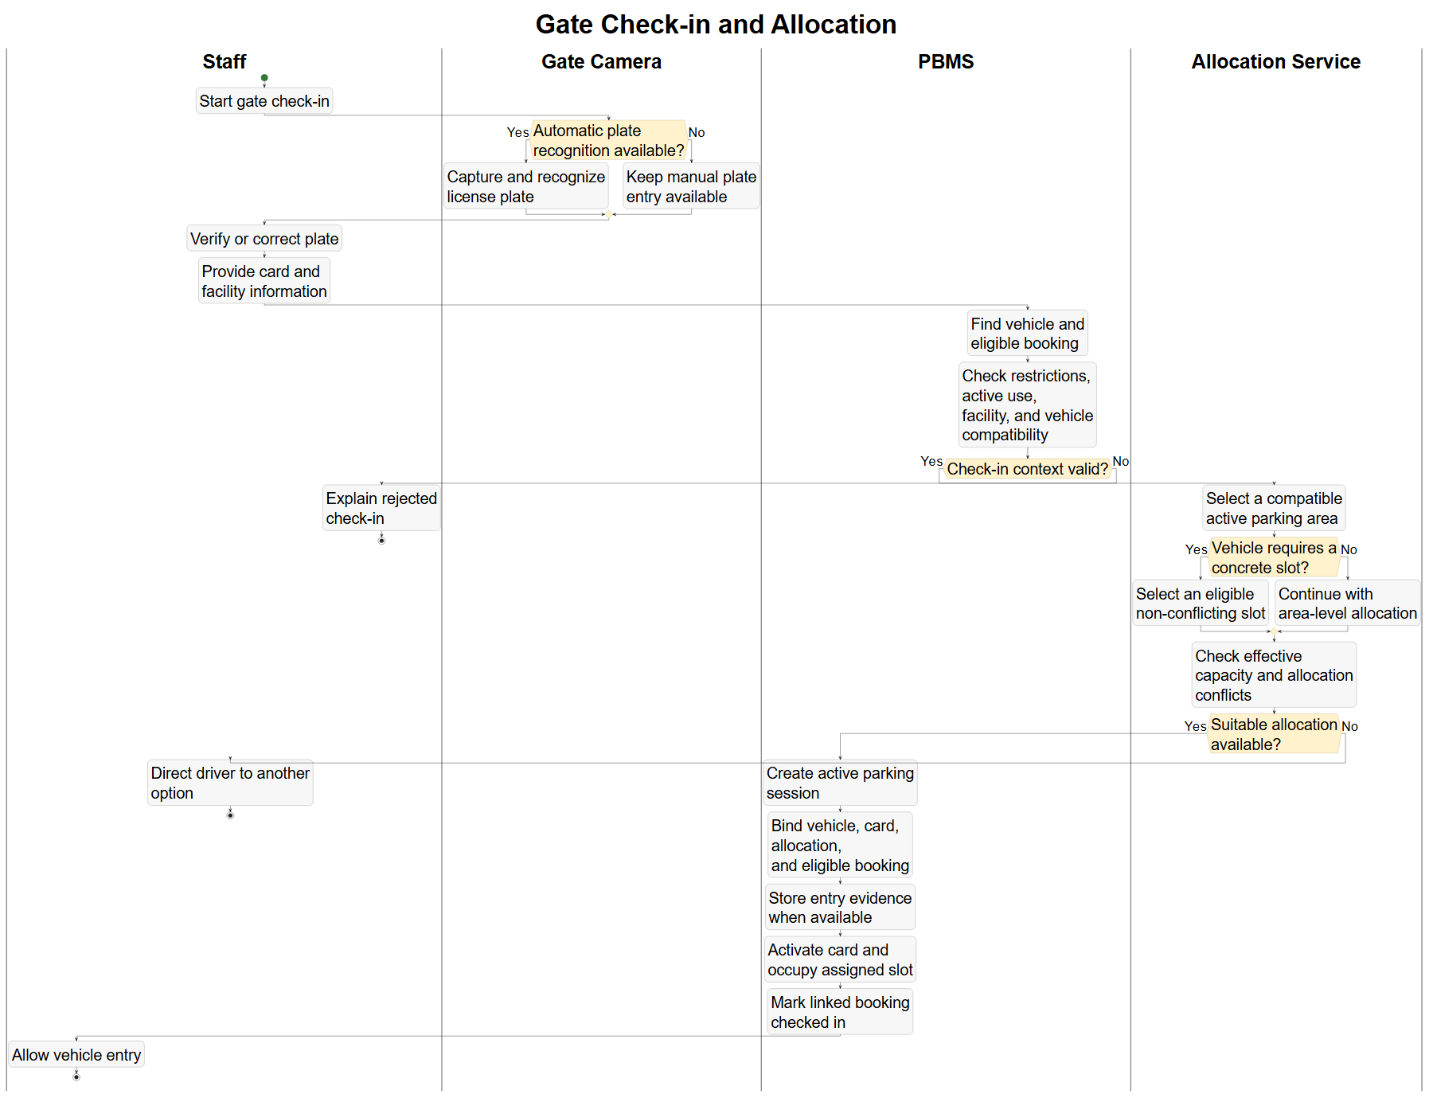

Figure 11 — BP-10 Session Query and Extension
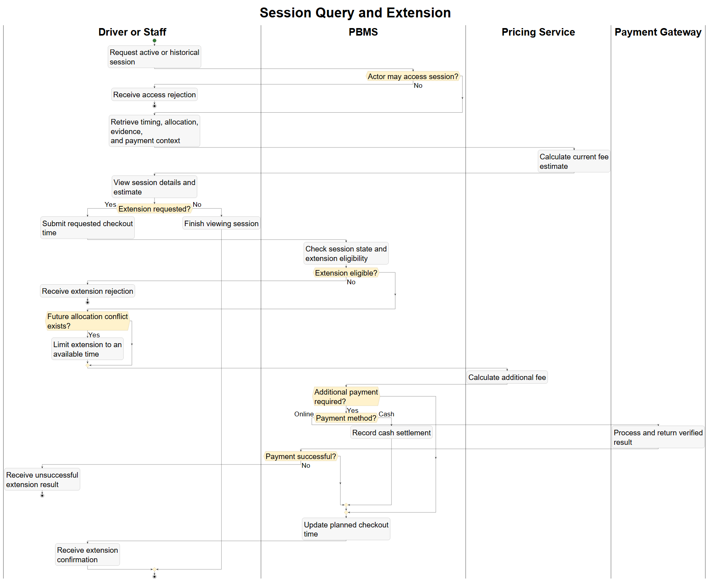

Figure 12 — BP-11 Standard Checkout
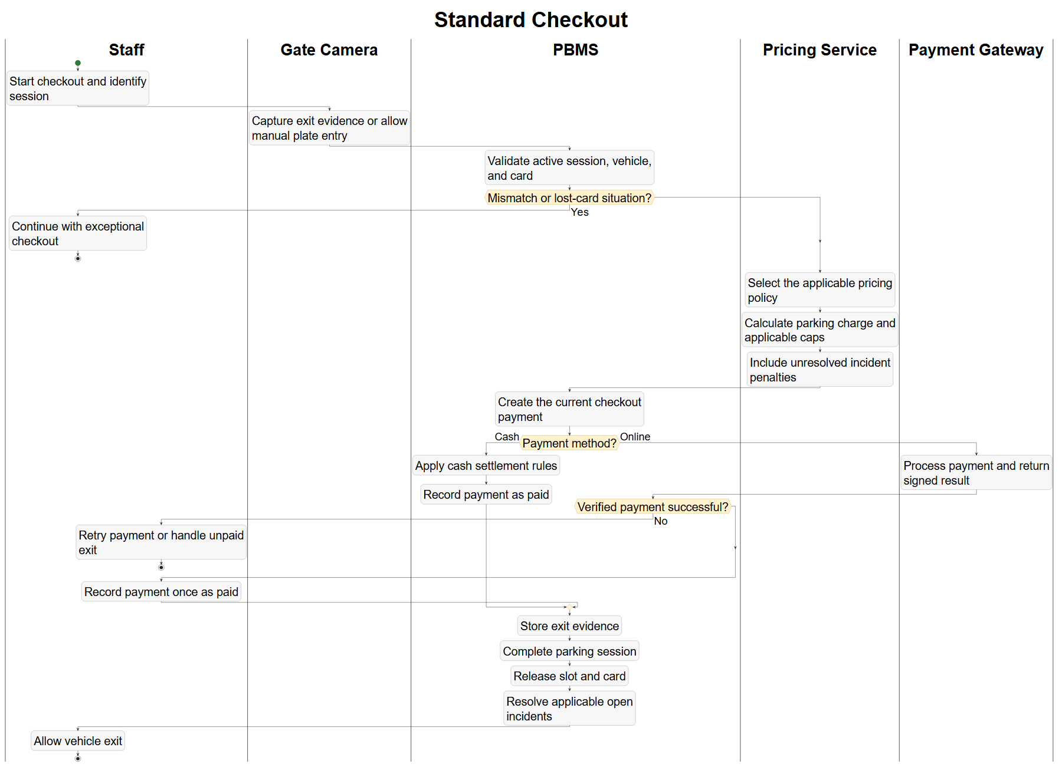

Figure 13 — BP-12 Exceptional Operations
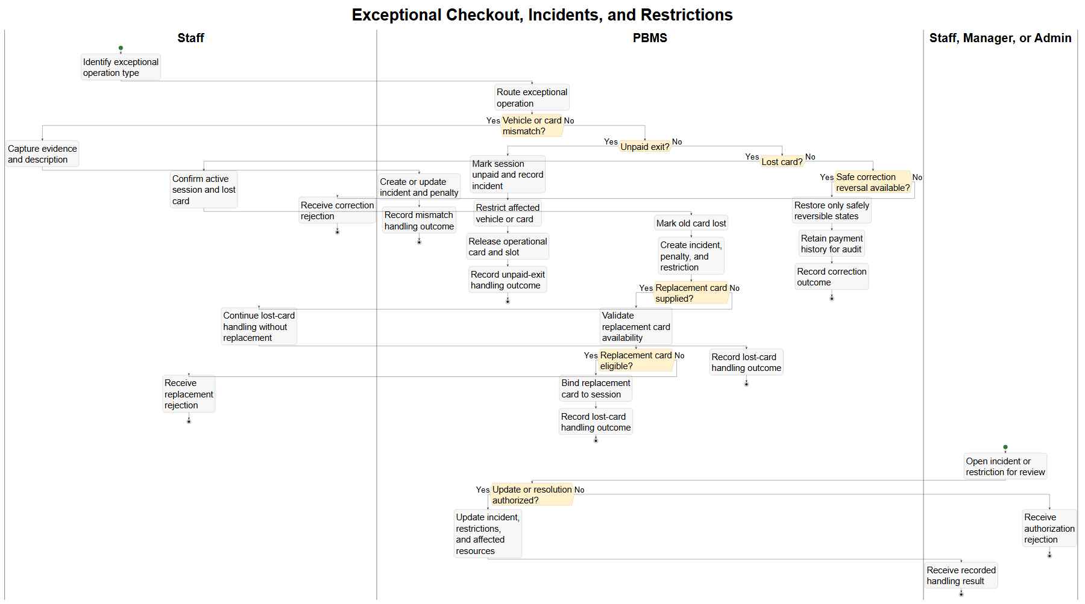

Figure 14 — BP-13 Driver Incident Reporting
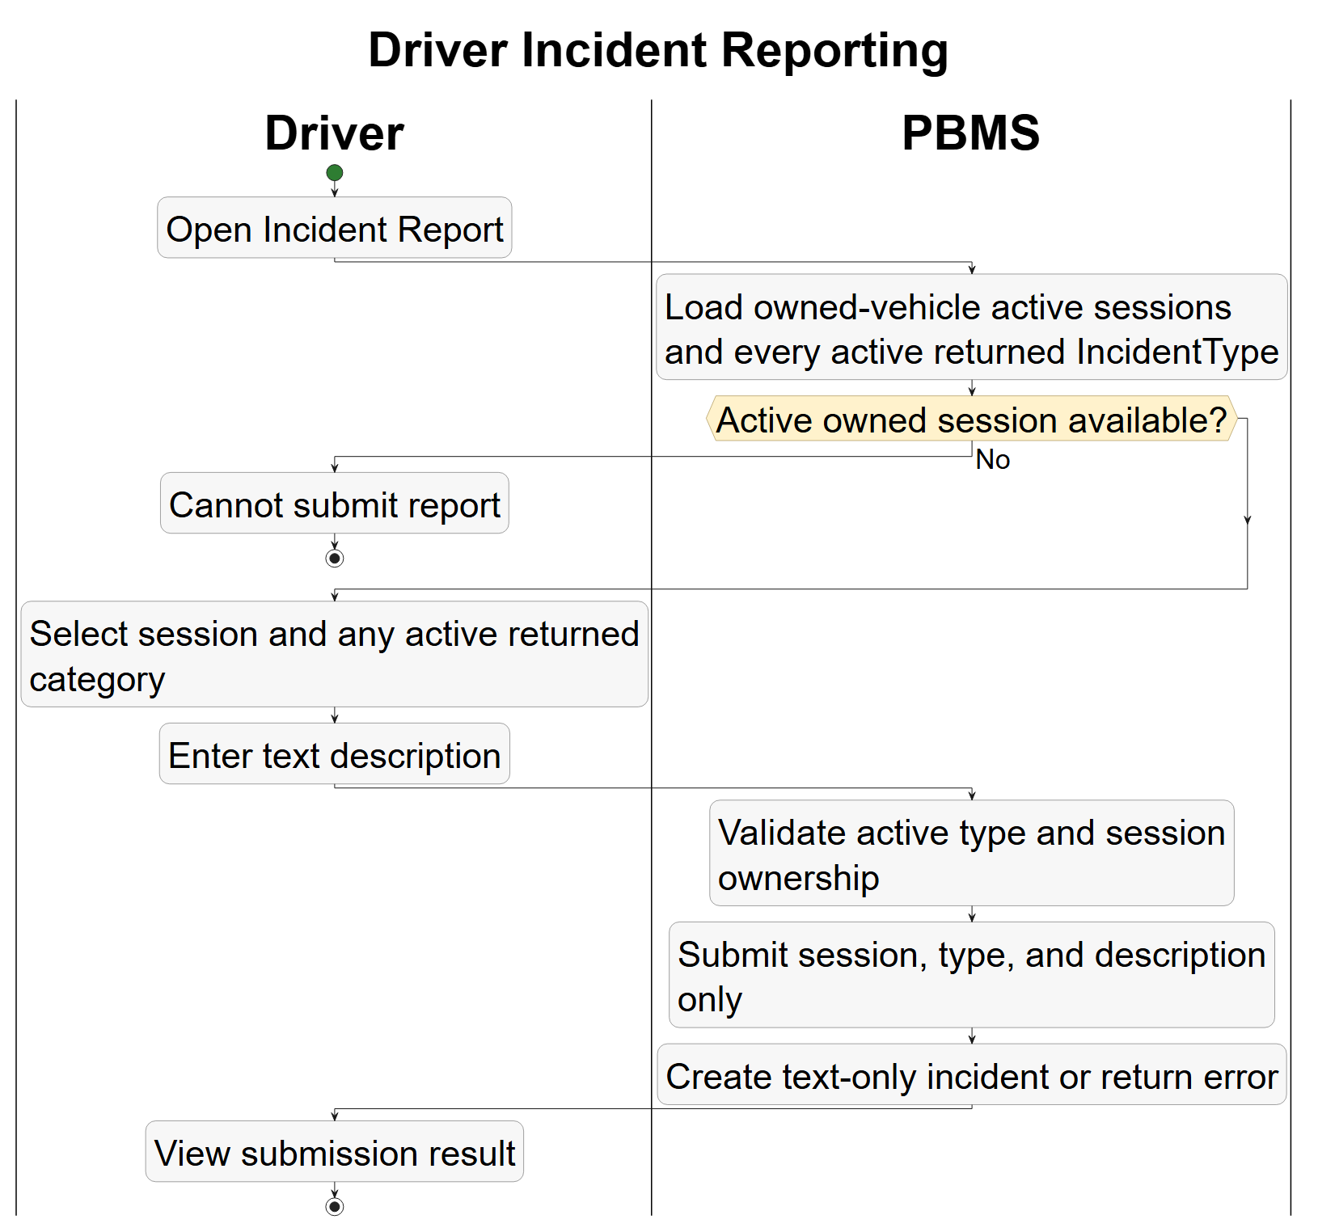

Figure 15 — BP-14 Monitoring, Revenue and Audit
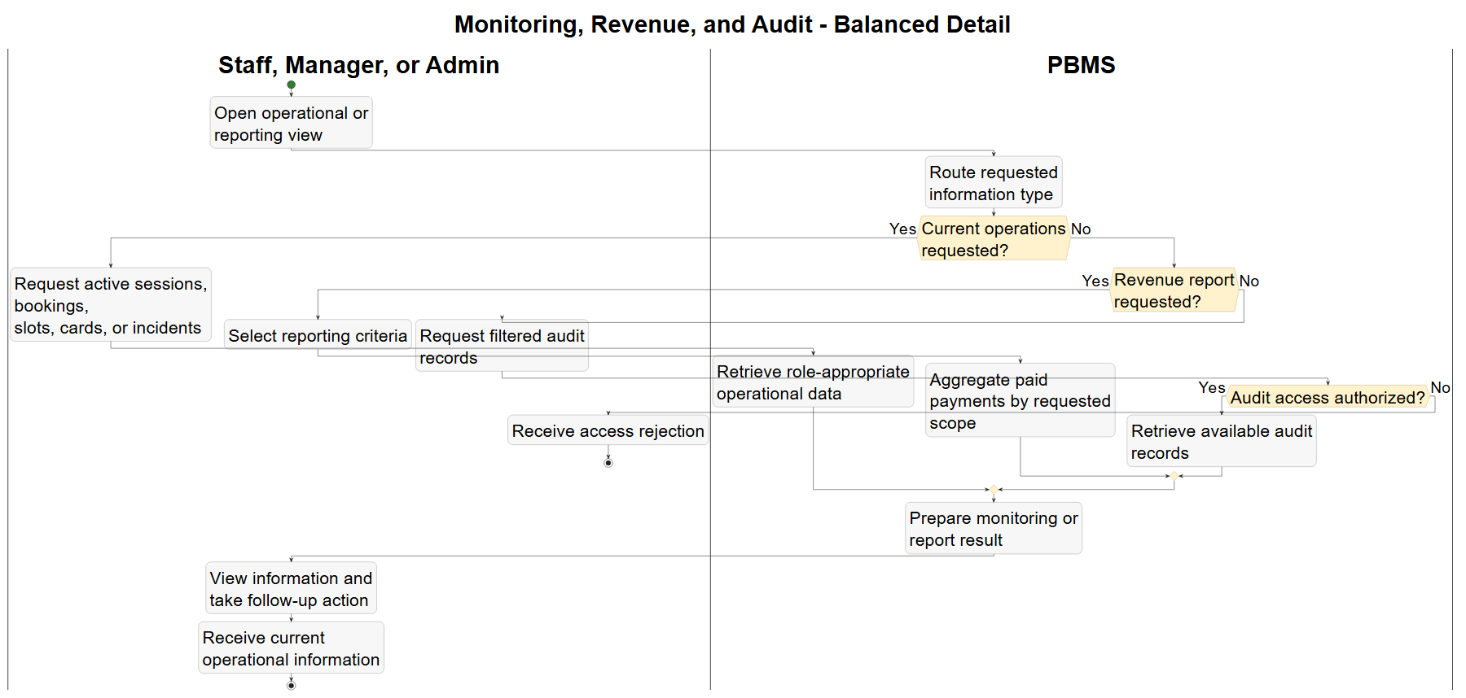
2.2 Planned Process Sections
The final content will follow the index order:
- End-to-End Landscape.
- Registration and Authentication.
- Structure, Pricing, Configuration and Role-Permission Management.
- Booking Lifecycle.
- Gate Check-in and Allocation.
- Session Query and Extension.
- Standard Checkout.
- Exceptional Checkout and Incidents.
- Monitoring, Revenue and Audit.
Complex processes may use x.0 for the consolidated swimlane and x.1, x.2 for smaller reviewable subflows.

3. Data Model (ERD)

3.0 ERD Index
ERD ID | Model scope | Planned content
ERD-00 | Active model overview | Cross-domain relationships without attributes
ERD-01 | Identity and access control | Role, Permission, RolePermission, Account, AuditLog
ERD-02 | Infrastructure and vehicle classification | Building, Floor, Zone, ParkingSlot, VehicleType, Vehicle, Account
ERD-03 | Booking and parking operations | Booking, ParkingSession, Vehicle, Building, Card, Zone, ParkingSlot, Account
ERD-04 | Incident management and blacklist | IncidentType, PenaltyConfig, Incident, Blacklist, Vehicle, Card
ERD-05 | Pricing engine, payment and calculation log | PricingPolicy graph, Payment and PricingCalculationLog

Figure 16 — ERD-00 Active Model Overview
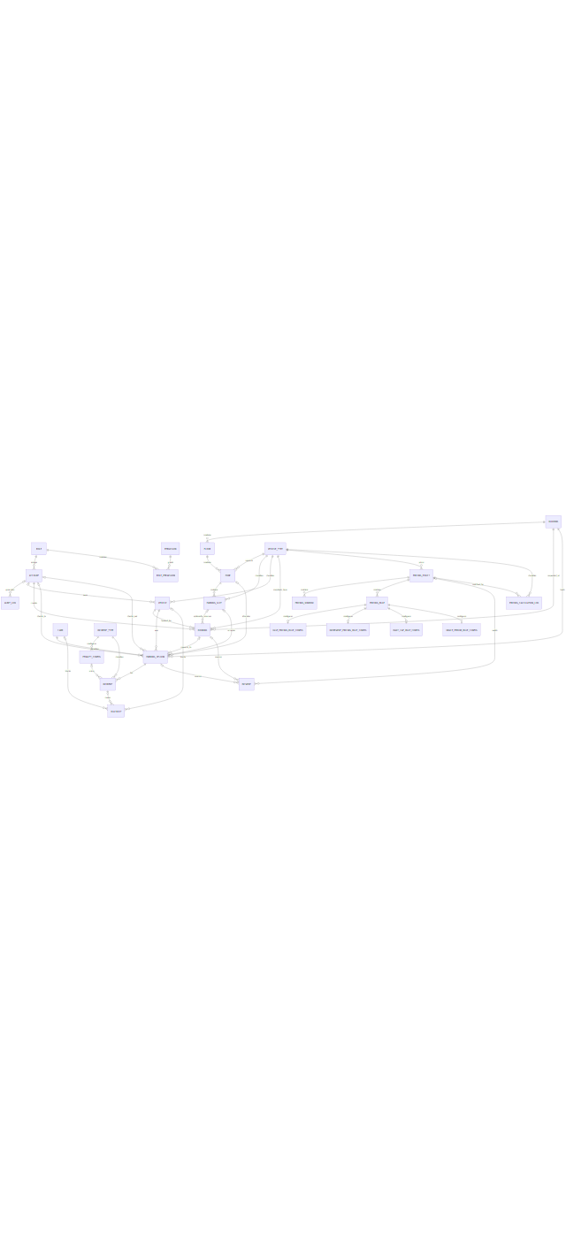

Figure 17 — ERD-01 Identity and Access Control
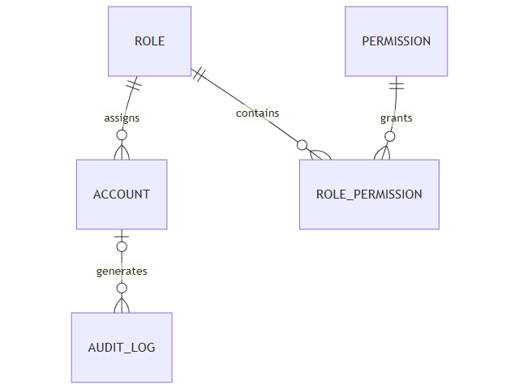

Figure 18 — ERD-02 Infrastructure and Vehicle Classification
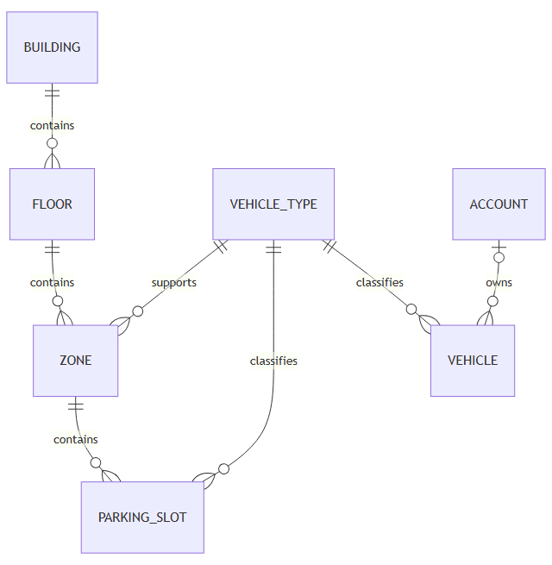

Figure 19 — ERD-03 Booking and Parking Operations
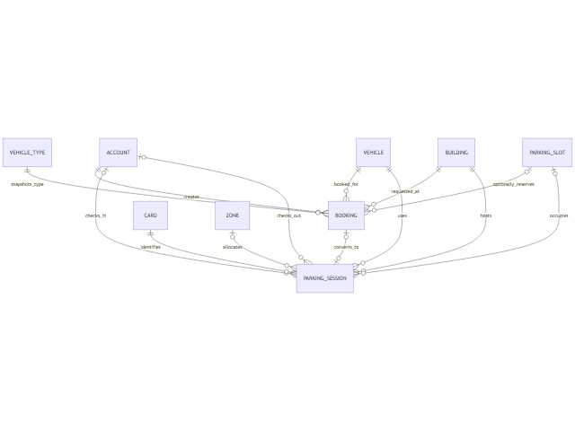

Figure 20 — ERD-04 Incident Management and Blacklist
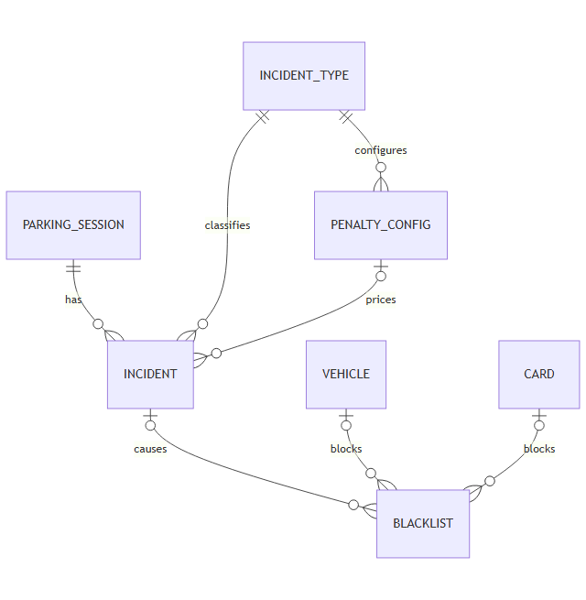

Figure 21 — ERD-05 Pricing Engine, Payment and Calculation Log
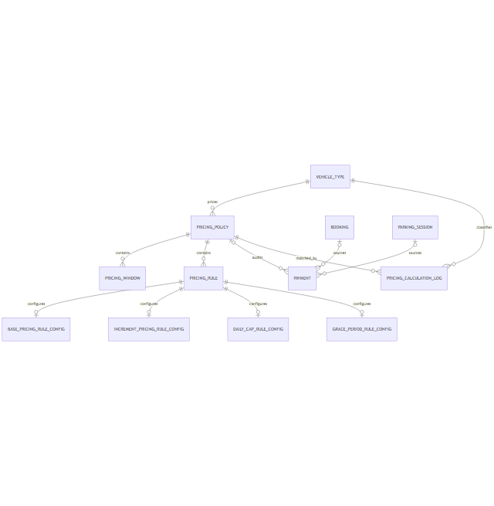

4. Business Rules
Rule ID | Business rule
BR-ACC-001 | Registration OTP has six digits and expires after five minutes.
BR-ACC-002 | OTP resend cooldown is sixty seconds.
BR-ACC-003 | Five failed OTP verifications cause a fifteen-minute lockout.
BR-ACC-004 | Registration verification token expires after ten minutes.
BR-ACC-005 | Password recovery OTP/token uses a distinct purpose, is short-lived and single-use, and does not reveal whether an email exists.
BR-BOOK-001 | Booking lead time is at least fifteen minutes.
BR-BOOK-002 | Booking duration is at least four hours.
BR-BOOK-003 | Booking payment deadline is fifteen minutes after creation.
BR-BOOK-004 | Confirmed booking check-in grace is thirty minutes after planned check-in.
BR-BOOK-005 | Only cars may select a concrete slot during booking.
BR-BOOK-006 | Default slot booking buffer is thirty minutes.
BR-BOOK-007 | Default near-term walk-in threshold is two hours.
BR-BOOK-008 | Zone booking limit is 1..100 percent and defaults to 80 percent.
BR-BOOK-009 | Effective capacity subtracts the ceiling of the vehicle-type buffer ratio.
BR-BOOK-010 | Booking deposit equals the estimate for the full planned interval.
BR-BOOK-011 | Booking cancellation changes Booking state without initiating or recording a refund.
BR-ALLOC-001 | A vehicle cannot have two active sessions.
BR-ALLOC-002 | A card cannot serve two active sessions.
BR-ALLOC-003 | A slot cannot serve overlapping active use.
BR-FEE-001 | Missing or false APPLY_SEGMENTED_PRICING selects non-segmented pricing.
BR-FEE-002 | Segmented candidates are ordered by Priority, EffectiveStart, then ID descending.
BR-FEE-003 | A partial increment applies only when its threshold percentage is reached.
BR-FEE-004 | Daily-cap boundaries use Vietnam calendar days (UTC+7).
BR-FEE-005 | Open or Processing incident penalties are included in current pricing.
BR-FEE-006 | Policy overlap validation compares policies of the same priority.
BR-FEE-007 | Excess duration up to and including the configured Grace Period does not create the next increment charge; chargeable excess begins after Grace Period.
BR-LOG-001 | Preview-only price calculation returns a breakdown without persisting PricingCalculationLog.
BR-LOG-002 | A persisted payable amount creates exactly one correlated PricingCalculationLog in the same successful operation.
BR-LOG-003 | Idempotent replay does not create a duplicate committed calculation log.
BR-PAY-001 | A newer payment invalidates older Pending payments for the same booking or parking session.
BR-PAY-002 | CASH settles synchronously; ONLINE_BANKING settles after verified VNPay processing.
BR-PAY-003 | Refund state transitions are removed from the current PBMS release and project.
BR-PAY-004 | Revenue includes only PAID payments.

5. State Charts

5.0 State Chart Index
State chart ID | Aggregate | Main states | SVG required
SC-BOOK-001 | Booking | Pending, Confirmed, Cancelled, Expired, CheckedIn, NoShow | Yes
SC-SESSION-001 | Parking Session and resources | Active, checkout outcomes and resource release | Yes
SC-SLOT-001 | Parking Slot | Available, Occupied, Reserved/Blocked, Maintenance | Yes
SC-CARD-001 | Card | Available, InUse, Lost and restored/replaced outcomes | Yes

Figure 22 — SC-BOOK-001 Booking Lifecycle
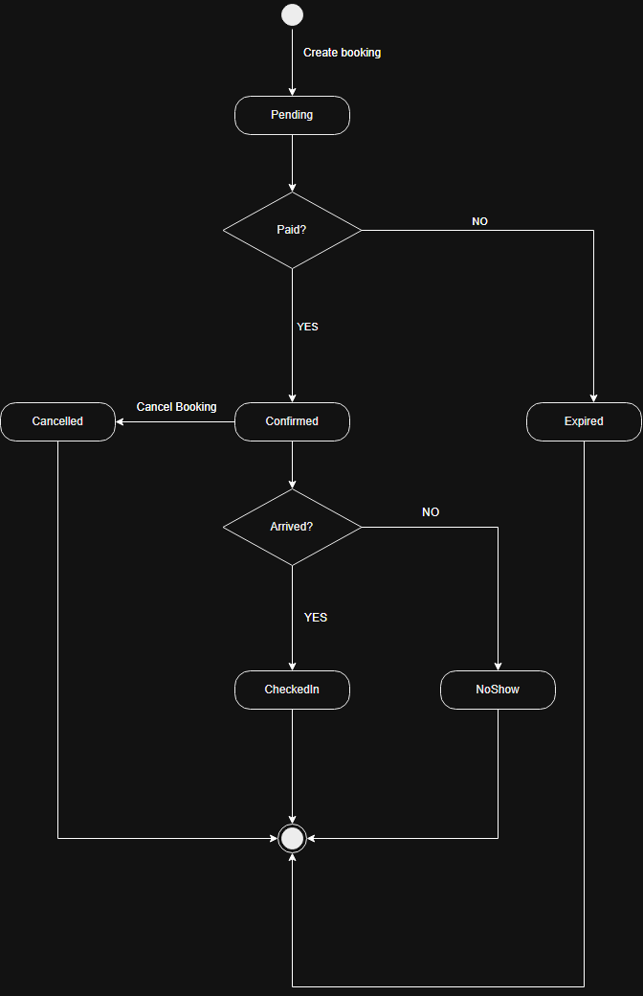

Figure 23 — SC-CARD-001 Card Lifecycle
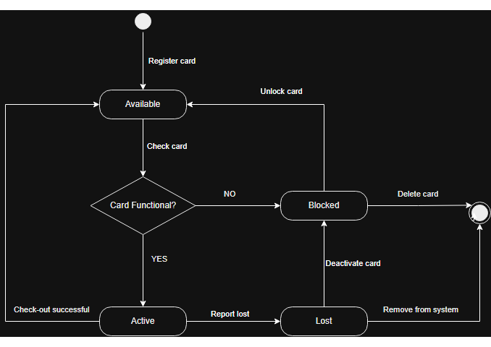

Figure 24 — SC-INC-001 Incident Lifecycle
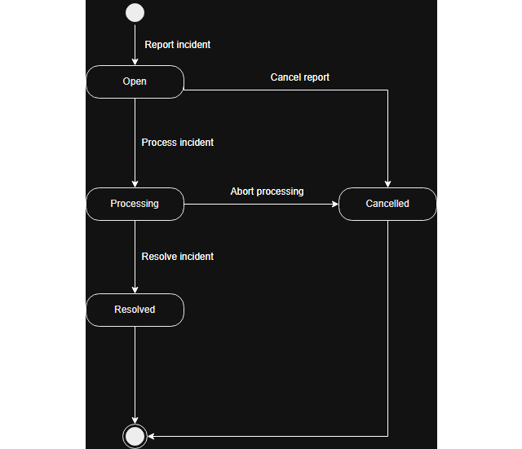

Figure 25 — SC-SESSION-001 Parking Session Lifecycle
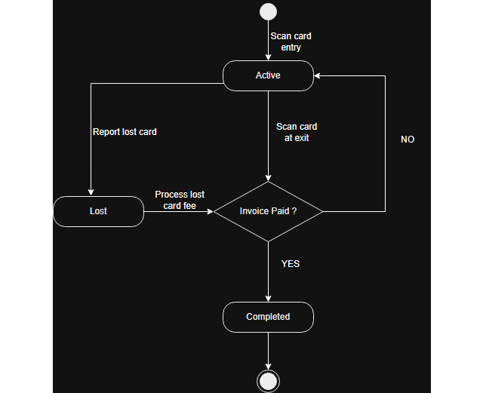

Figure 26 — SC-SLOT-001 Parking Slot Lifecycle
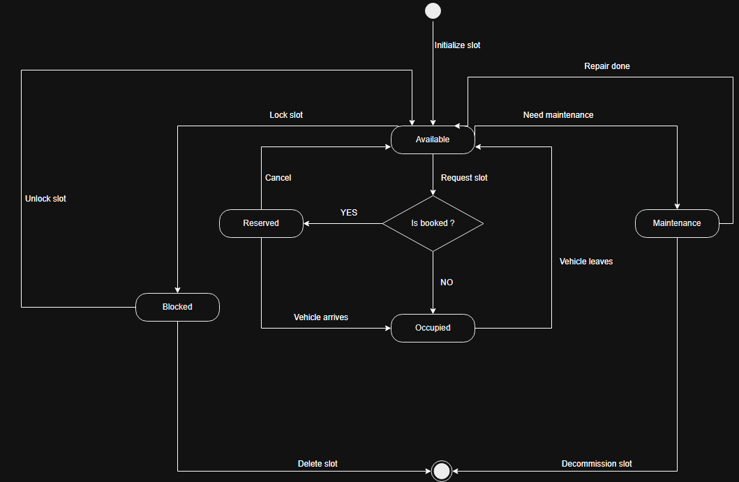

5.2 Transition Table Format
From state | Trigger | Guard / authorization | To state | Side effects
[State] | [Event] | [Condition and actor] | [State] | [Data/resource/payment effect]

Invalid or unsupported transitions must be listed once as a common rejection rule instead of repeated in every row.

6. Traceability, Gaps and Review

6.1 Cross-Model Traceability
Business process | ERD | Business rules | State chart | SRS requirements | SVG evidence
[BP-*] | [ERD-*] | [BR-*] | [SC-*] | [UC/FR/NFR IDs] | [Relative paths]

6.2 Open Questions and Known Gaps
ID | Question or gap | Affected models | Required decision
[OQ/RISK-*] | [Concise issue] | [BP/ERD/BR/SC IDs] | [Owner and expected resolution]

6.3 Final Review Checklist
- ☐ Format approved by the document owner.
- ☐ Every active process has a rendered swimlane SVG.
- ☐ Every active data domain appears in an ERD SVG.
- ☐ Every active business rule appears once in the catalogue.
- ☐ Every managed lifecycle has a state chart SVG and transition table.
- ☐ Process, entity, rule, state and SRS IDs are cross-traceable.
- ☐ Partial, gap, dormant and deprecated behavior is clearly labeled.
- ☐ Future-only backend artefacts are excluded from current-scope diagrams and rules.
- ☐ All SVG links resolve and render successfully.
- ☐ Product and Security owners review open decisions.
End of format proposal. Detailed content intentionally remains pending approval.

