**Site Name:**

This site will be called **Odomsweather.com**. As the name indicates, it will be a site dedicated to the weather for locations chosen by Brother Mike Odom.

**Site Purpose:**

As this is a test website page, additional website may be created for different customers based off of this test website. A customer may choose up to seven (7) weather locations for their personalized website. The purpose of this can be to plan vacations, see the weather for family and friends around the world or determine the best camping stop for the weekend.

**Target Audience and Scenarios:**

Target audiences would be individual wanting more than the typical Google Weather report. Instead of seeing just the temperature and weather emoji, the customer can see detailed information about not just the weather in a location they are interested in, but also check on crowd averages, fall foliage news, recommended packing guide based off the weather in a particular area. This website can be customized for multiple uses: planning vacations, weekend forecasts with links to local camping sports or attractions, accompanying detailed information about the weather where friends and family live.

**Site Map:**

This section describes the basic structure of the **OdomsWeather.com** website.

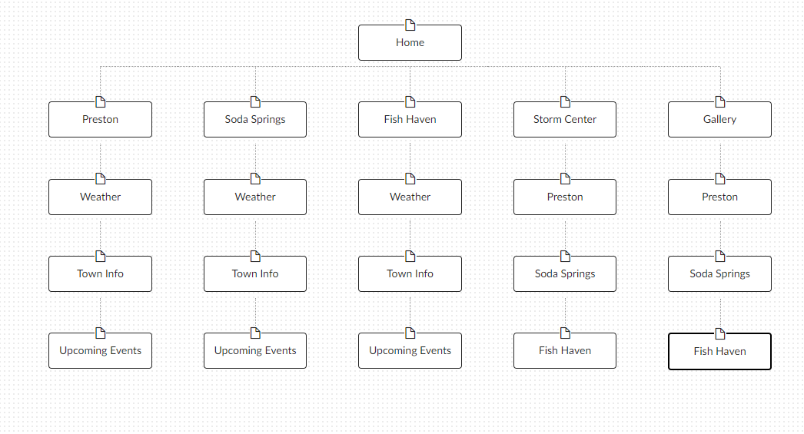

Figure 1 – OdomsWeather.com Site Map, demonstrating the structure of the site.

**Color Scheme:**

Describes the Background, text, links, accents(s), highlights, and logos of the **Odomsweather.com** site.

The proposed background will be rotating pictures of nature in the greens and browns. Wording in a cream with links in red to stand out. The Logo is under development.

**Typography:**

Describes the fonts, font sizes, styles, and line height used in the Odomsweather.com site.

The following table recommends the following color, size, and font used in each of the areas of the page template.

|  |  |  |
| --- | --- | --- |
| **Object/Item** | **Font** | **Size and Color** |
| **Default Paragraph Text** |  |  |
| **Heading Level 2 (h2)** |  |  |
| **Heading Level 3 (h3)** |  |  |
| **Navigation Anchor Selected** |  |  |
| **Navigation Anchor Unselected** |  |  |

**Wireframe Sketches**

This information will be discussed in further detail at a later date.