**Site Name:**

This site will be called **The Temple Inn & Suites**. As the name indicates, it will be a site dedicated to the a hotel chain which caters to hotel accommodations or Senior Missionary housing near temple locations for The Church of Jesus Christ of Latter-day Saints.

**Site Purpose:**

This site is meant to be a landing page for patrons to find information about the hotel chain and it’s accommodations and a site to request more information about long term housing for Sr. Missionaries.

**Target Audience and Scenarios:**

The first target audience would be temple patrons looking for a place to stay which they serve in the temple. The site provides information on the accommodations available. Available accommodations include childcare requests so parents may attend the temple, youth trip information, wedding and reception information and family search experts.

The second audience would be long-term rental of a condo style room for Sr. Missionaries who are serving their missions at the temple. The condo style rooms include a small kitchenette.

**Site Map:**

This section describes the basic structure of **The Temple Inn & Suites** website.

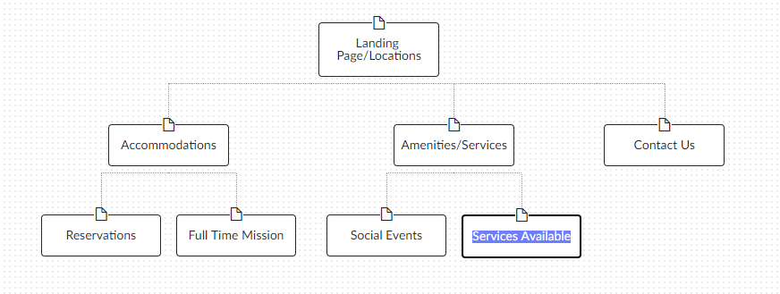

Figure 1 – The Temple Inn and Suites Site Map, demonstrating the structure of the site.

**Color Scheme:**

Describes the Background, text, links, accents(s), highlights, and logos of the **TempleInnAndSuites** site.

Primary colors for the website will be a variety of gold, cream and Hymn-book green:

Cornsilk (rgb(255,248,220) 

Dark Goldenrod rgb(184,134,11) 

Very dark desaturated cyan rgb(32,73,78) 

The proposed background will be rotating pictures of amenities within the hotel chain. Wording to go along with slide show. The Logo is under development.

**Typography:**

Describes the fonts, font sizes, styles, and line height used in the **TempleInnAndSuites** site.

Fonts used:

Old Standard 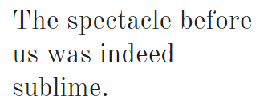

Cinzel 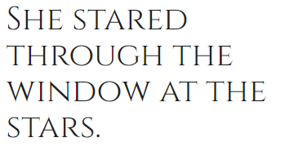

Cormorant Garamond 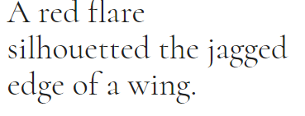

Satisfy 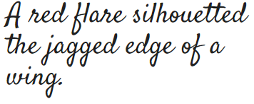

**Wireframe Sketches**

