Proximity

1. the site/company name, = The Church of Jesus Christ of Latter-Day Saints
2. the website address (URI), www.lds.org
3. a screenshot of the page in mobile view\*, and
4. a paragraph on why/how the design principle is exemplified on that page. – LDS.org groups related items together. Items across the top bar separate like topics, some leading to additional websites like LDS Newsroom and upcoming events page. Items are usually easily searchable and many similar items may show up in you search. There are external links to

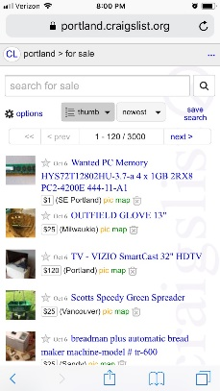

Repetition

1. the site/company name, = Craigslist
2. the website address (URI), www.portland.craigslist.com
3. a screenshot of the page in mobile view\*, and
4. a paragraph on why/how the design principle is exemplified on that page. – Craigslist is all about repetition. The searchable items are grouped into categories, then displayed in repetitive blocks that can be quickly viewed. No one product or listing will stand out by the picture alone as all are the same size. It’s up to the listing author to entice view through eye catching pictures or descriptions.



Alignment

1. the site/company name, = Weebly
2. the website address (URI), www.cubscoutpack842tigard.weebly.com
3. a screenshot of the page in mobile view\*, and
4. a paragraph on why/how the design principle is exemplified on that page. – Weebly sites come programed with automatic alignment. Each page can essentially match the next with a few variations. The fonts and layout are all similar from page to page so there is no re-evaluating the page to see where everything is.

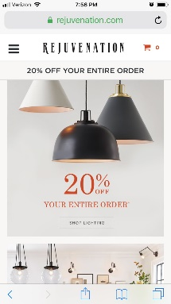

Contrast

1. the site/company name, = Rejuvenation
2. the website address (URI), www.rejuvenation.com
3. a screenshot of the page in mobile view\*, and
4. a paragraph on why/how the design principle is exemplified on that page. – The contrast on the site between the logo and the “cart” and “sale item price” makes the eye quickly travel to the sale items with a subconscious hint as to the shopping cart. The style of the pictures brings the focus to the product.

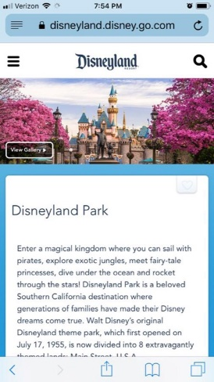Typography

1. the site/company name, = Disneyland
2. the website address (URI), www.disneyland.disney.go.com
3. a screenshot of the page in mobile view\*, and
4. a paragraph on why/how the design principle is exemplified on that page. – Disney is an icon in typography. They have a very distinct logo and it is featured very prominently on each page. The format and style of the body of the text is also district, but similar to every page. There is a consistency that brings a sense of trust.