__Home__

Logo 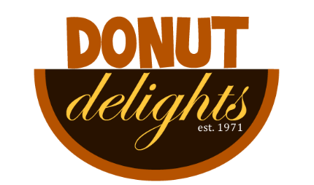

-need picture

-interior shop

-sampling of donut products

-animated gif

-embedded youtube video

-simple background image that fits theme

__Navigation__

-home

-about us

- contact

-location

-menu

__Color__

-brown

-orange

-blue

-black

-white

­__AboutUs__

Donut Delights was started in 1971 by Melvin Furballski, an immigrant baker from the far east coast of Poland. Known far and wide for his delicate pastries, Melvin fled his homeland in search of a better life for his family. In 1970 he landed in New York City and by chance he found an open seat on a bus heading west. When an unexpected mechanical failure forced a three day delay in Champaign, Illinois, Furballski saw the need for a donut shop, so he decided to stay and make a new life for himself in Urbana, Illinois. With only one hundred dollars to his name, he found an abandoned bread shop and within two days he had one of a kind donuts flying off the racks faster than he could bake them and things have never slowed down. Now you can find that same great donut recipe plus dozens more still being made with the same love and care as when Donut Delights first opened. A bakery fire in the mid-1980s destroyed many of the shop's records...but NOT THE RECIPES. While many people might have viewed the fire as an excuse to quit, Melvin instead used it as an opportunity to reconfigure the interior design, allowing him to add the coffee roastery section as well. So when you visit, be prepared for the inviting mix of aromas from fresh-roasted coffee beans and fresh-baked donuts: It's the closest thing to "Breakfast Heaven" anywhere in the C-U area!

__Contact__

Donut Delights

2112 Main Street Urbana , Illinois 61801

Insert a google map for location.

(217)-555- 1234

email: contact@donutdelights.com

__Menu__

-see directions for menu

__Additional__

-form to add customers emails to his coupon

-daily specials

-comment section

-form to send customers emails about events

-social media links: facebook, google+, Instagram

-fun donut and coffee facts

__Audience__

-potential customers

-appealing to draw users