Document Name:
Database Design Document

Project Name:
PARKnSHOP.com Online Mall

Group: 3

Author:
Zhang Xiang
STU_NUM:13121307
Kai Teng
STU_NUM:13121227
Kong Zhi
STU_NUM:13121271
Wen Qianru
STU_NUM:13121298

Date:07-10-2015

Version: 1.0
- Introduction
  - Objective
This document provides guidance for developers, designs the database overview corresponding the system, and helps developers to develop the PARKnSHOP’s relational database.
  - Background
- Software name：PARKnSHOP.com Online Mall
- Database name：PARKnSHOP
- Database management System ：MySQL 5.5
- Users using the system: the customers, stores and administrators of for PARKnSHOPsystem.
  - Decisions
Based on user demand for integrated, induction and abstract, forming an independent of the specific DBMS concept model, we use E-R diagram representation.

1.4 Terms
- PARKnSHOP: Online Shopping System which names PARKnSHOP.

- ER:entity-relational model.
- Customer : abstruct of customer in reality, user of PARKnSHOP who shopping through it.
- Store:abstruct of store in reality,user of PARKnSHOP who offering commdity to custom through it.
- Commodity:tradable goods.
- Admin:administrators of PARKnSHOP, in charge of the development and maintenance of system,who has the highest authority of database.

1.5 support software
- Supported operating system：Windows 2000/Windows NT/Windows XP/Windows Vista/Windows 7/
Windows 8/Windows 10
b. Development tools：MySQL 5.5 + DiagramDesigner

- Concept Design

2.1 The global ER model

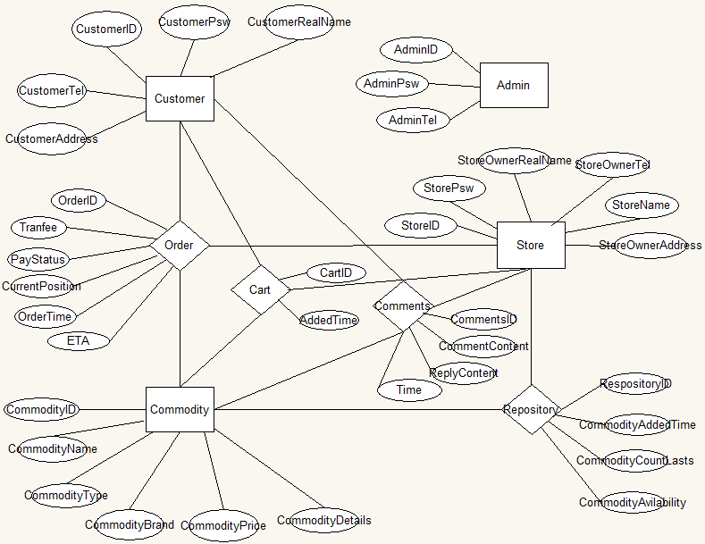

2.2 The local ER model

2.2.1 local ER model 1
Customer is one of the most important entity in the system,which contains imformation about basic personal imformation,and related login imformation.

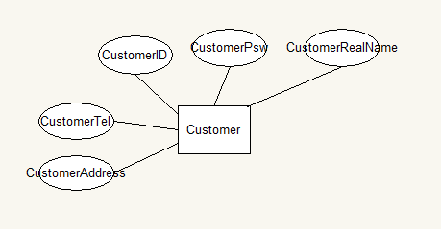

2.2.2 local ER model 2
Store is also important entity which corresponds to an login account,in fact,the concept maybe more close to the mixture of storeowner and store,while one owner just has one store.
In designing,basic imformation of store,login information and storeowner’s identity information together constitute the store in PARKnSHOP ’s concept model.
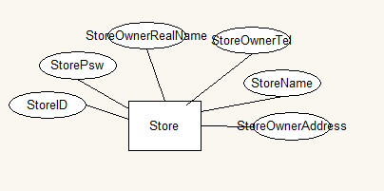

2.2.3 local ER model 3
Commodity repersents goods which bought by costomers and selling by stores.As a entity,it has attributes for their own,like ID,name,details,type,price and so on,which decribes the basic information of commodity itself.

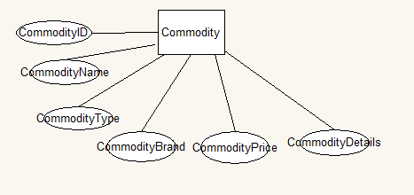

2.2.4 local ER model 4

Comparely,admin has less attribute than mentioned there entity,whose amount always less than other, while less interaction occurs on them.

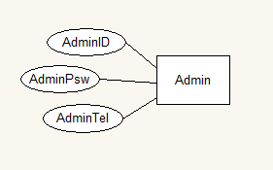

2.2.5 local ER model 5

Order was been designed as a relation between Customer ,store and Commdity. In natural language expression,it means someone buy something from somestore.

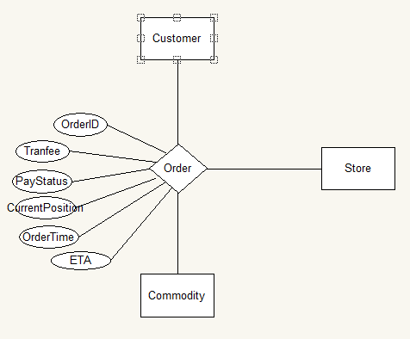

2.2.6 local ER model 6
Cart have the same point in concept with favorites of browsers.Customers can put what they interesting with into cart if they don not buy it immediate.So it is a relation between Customer,Store and Commodity like Order without abundant attributes.

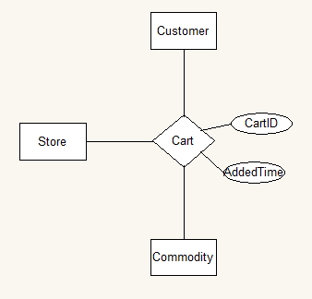

2.2.7 local ER model 7
Repository represents the relationship of sells.It has attributes for the context of transaction in E-commerce,like count of lasts,AddedTime,Avilablity and so on.

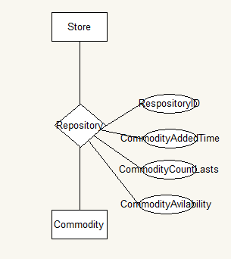

2.2.8 local ER model 8
Comments is also a important function of PARKnSHOP,which delivered by customer and replyed by store for a specific commodity.

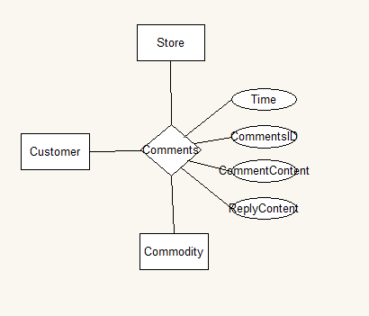

- Logic Design

3.1 Overview of relational tables
According to the design of ER up, we derive the relational table as shown below.
3.1.1 Customer Table
Field Name | Field Type | Constraints | Description
CustomerID | varchar(20) | not null | The CustormerID is 18 characters (ie. The ID number).
CustomerPsw | char(6) | not null | The password is 6 characters.
CustomerRealName | char(20) | null | For example：ZhangXiang
CustomerTel | varchar(20) | null | Such as:15091839924 .
CustomAddress | varchar(100) | null | Useful in mailing commodity.

3.1.2 Store Table
Field Name | Field Type | Constraints | Description
StoreID | varchar(20) | not null | Less than 18 characters.
StorePsw | char(6) | not null | Password is 6 characters.
StoreOwnerRealName | varchar(20) | not null | Nessceary for legality
StoreOwnerTel | varchar(20) | null | Such as:15091839924
StoreName | varchar(30) | null | It will display to customer.
StoreOwnerAddress | varchar(100) | null | Useful in posting.

3.1.3 Commodity Table
Field Name | Field Type | Constraints | Description
CommodityID | char(20) | not null | Must use 18 characters.
CommodityName | varchar(30) | not null | Very important for shows.
CommodityType | varchar(10) | null | A simple classification of goods.
CommodityDetails | varchar(250) | null | A link to a html page contains detail description.
CommodityBrand | varchar(20) | null | Brand not long.
CommodityPrice | int | not null, default 0 | Price of it.

3.1.4 admin Table
Field Name | Field Type | Constraints | Description
AdminID | varchar(20) | not null | Less than 18 characters.
AdminPsw | char(6) | not null | Password is 6 characters.
AdminTel | varchar(20) | not null | Such as:110

3.1.5 Order Table
Field Name | Field Type | Constraints | Description
OrderID | char(20) | not null | Must use 20 characters.
CustomerID | varchar(20) | not null,reference Customer.CustomerID | The CustormerID_id is 18 characters.
StoreID | varchar(20) | not null,reference Store.StoreID | Less than 18 characters.
CommodityID | char(20) | not null | Must use 20 characters.
TranFee | double | null | Transportation costs
PayStatus | booolean | not null | State of payment
CurrentPosition | varchar(50) | not null | The current position where the commodity is.
OrderTime | Datetime | not null | Automatic generation
ETA | Datetime | not null | The estimated date when the commodity arrive

3.1.6 Cart Table
Field Name | Field Type | Constraints | Description
CartID | char(20) | not null | Must use 20 characters.
CustomID | varchar(20) | not null,reference Customer.CustomerID | The CustormerID_id is 18 characters.
StoreID | varchar(20) | not null,reference Store.StoreID | Less than 18 characters.
CommodityID | char(20) | not null | Must use 20 characters.
AddedTime | Datetime | not null | Automatic generation

3.1.7 Repository Table
Field Name | Field Type | Constraints | Description
RepotitoryID | char(20) | not null | Must use 20 characters.
StoreID | varchar(20) | not null,reference Store.StoreID | Less than 18 characters.
CommodityID | char(20) | not null | Must use 20 characters.
CommodityAddedTime | DateTime | not null | Automatic generation
CommodityCountLasts | int | null | Inventory of Commodity
CommodityAvilabilty | boolean | null | Avilable is true

3.1.8 Comments Table
Field Name | Field Type | Constraints | Description
CommentsID | char(20) | not null | Must use 20 characters.
CustomerID | varchar(20) | not null,reference Customer.CustomerID | The CustormerID_id is 18 characters.
StoreID | varchar(20) | not null,reference Store.StoreID | Less than 18 characters.
CommodityID | char(20) | not null | Must use 20 characters.
CommentContent | varchar(200) | not null | It must have some thing.
ReplyContent | varchar(200) | null | It only have one reply.
Time | DateTime | not null | Automatic generation

- Physical Design
Generate in the relational tables of logical design into MySQL 5.5 database management system to go.

