Document Name:
Database Design Document

Project Name:
PARKnSHOP.com Online Mall
BY Group: 3

Prepared By:
DBA
WenJie (T) 13121297
WuQingxia 13121240
ZhaoXian 13121264

Date:07/12/2015

Modified By: WenJie (13121297)
Date:08/12/2015

Version: 1.0

- Introduction
  - Objective
This document provides guidance for developers, designs the database overview corresponding the system, and helps developers to develop the PARKnSHOP’s relational database.
  - Background
- Software name：PARKnSHOP
- Database name：PARKnSHOP_DB
- Database management System ：MySQL 5.5
- Users using the system: the customers, sellers and administrators of PARKnSHOP system.
  - Decisions
Based on user demand for integrated, induction and abstract, forming an independent of the specific DBMS concept model, we use E-R diagram representation.

1.4 Terms
- PARKnSHOP : Online Shopping System which names PARKnSHOP.

- ER: entity-relational model.
- Customer: abstruct of customer in reality, user of PARKnSHOP who shopping through it.
- Shop: abstruct of store in reality, user of PARKnSHOP who offering commdity to customer through it.
- Shopowner: abstruct of store’s owner in reality, operate the store.
- Product: tradable goods.
- Administrator: administrators of PARKnSHOP, in charge of the development and maintenance of system, who has the highest authority of database.
- Friendlist: friends of customers.
- Salehistory: the list of shopsells.

1.5 support software
a. Supported operating system：Windows 2000/Windows NT/Windows XP/Windows Vista/Windows 7
b. Development tools：MySQL 5.5 + PowerDesigner

- Concept Design

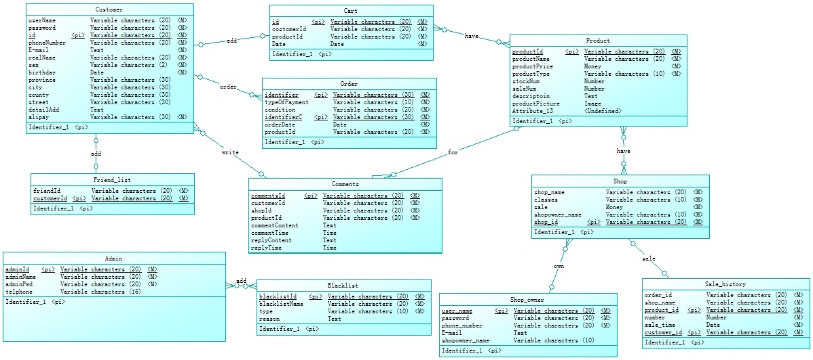
2.1 The global ER model

2.2 The local ER model

2.2.1 local ER model 1
Customer is one of the most important entity in the system, which contains information about basic personal information, and related login information.
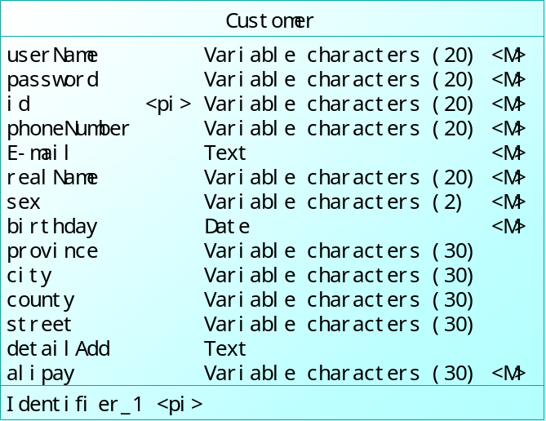

2.2.2 local ER model 2
Order was been designed as a relation between Customer, Shopowner and Product. In natural language expression, it means someone buy something from some shop.
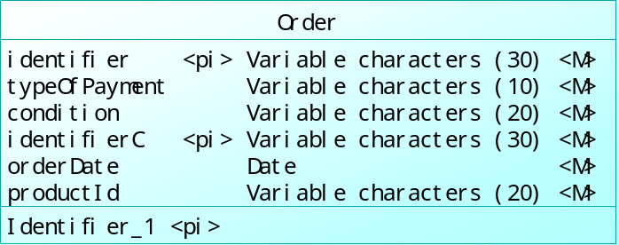

2.2.3 local ER model 3
Cart have the same point in concept with favorites of browsers. Customers can put what they interesting with into shopping cart if they do not buy it immediate. So it is a relation between Customer, Shopowner and Product like Order without abundant attributes.
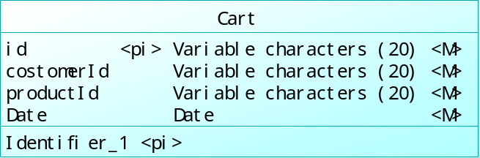

2.2.4 local ER model 4
Friendlist is also a important function of PARKnSHOP, which managed by customer to add some friends. They can share products to each other and take message to others.
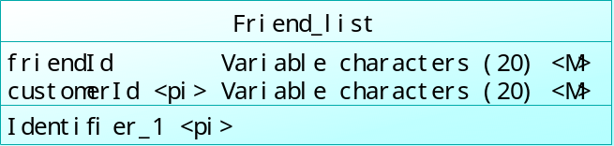

2.2.5 local ER model 5
product represents goods which bought by customers and selling by stores. As a entity, it has attributes for their own, like ID, name, brief introduction, details, type, price and so on, which describes the basic information of product itself.
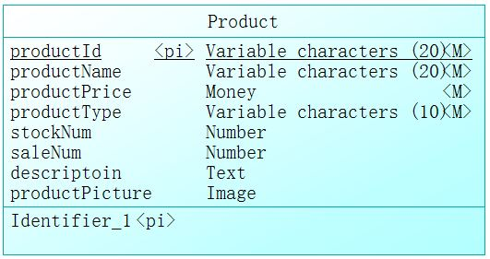

2.2.6 local ER model 6
Comments is also a important function，which delivered by customer and replayed by shop owner for a specific product.
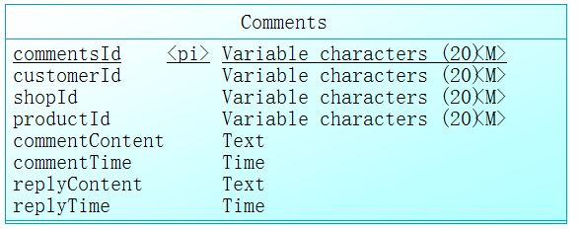

2.2.7 local ER model 7
Administrater has less attribute than mentioned there entity, whose amount always less than other, while less interaction occurs on them.
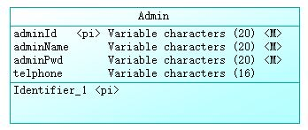

2.2.8 local ER model 8
Blacklist is mainly used by administrator to blacklist customers or shop owners for some reason，its attributes like the following show.
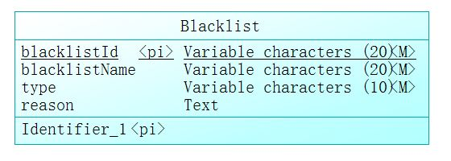

2.2.9 local ER model 9
Shop is also important entity which corresponds to an login account, in fact, the concept maybe more close to the mixture of shopowner and store.
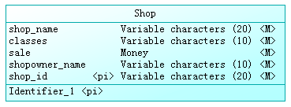

2.2.10 local ER model 10
Shopowner is also important entity which corresponds to an login account.
In designing, basic information of shopowner, login information.
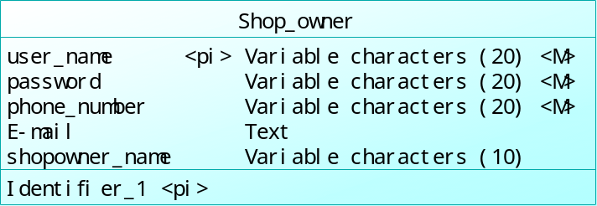

2.2.11 local ER model 11
Salehistory is also an important entity, through which customers can look through the sale history in every shop.
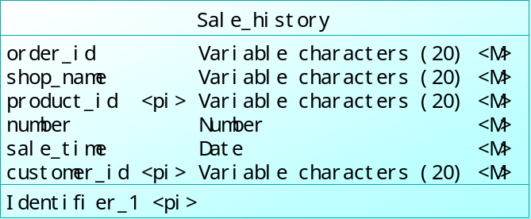
- Logic Design

3.1 Overview of relational tables
According to the design of E-R up, we derive the relational table as shown below.
Customer：
Field Name | Field Type | Constraints
userName | Variable characters(20) | not null
password | Variable characters(20) | not null
phoneNumber | Variable characters(20) | not null
E-mail | Text | not null
realName | Variable characters(20) | not null
sex | Variable characters(2) | not null
birthday | Date | not null
province | Variable characters(30)
city | Variable characters(30)
county | Variable characters(30)
street | Variable characters(30)
detailAdd | Text
alipay | Variable characters(30) | not null
id | Variable characters(20) | main key ，auto increment
Order:
Field Name | Field Type | Constraints
identifier | varchar(30) | main key、not null
typeOfPayment | varchar(10) | not null
condition | varchar(20) | not null
identifierC | varchar(30) | main key、not null
orderDate | Date | not null
productId | varchar(20) | not null
Cart:
Field Name | Field Type | Constraints
Id | varchar(20) | main key、not null
customerId | varchar(20) | not null，reference Customer.Id
productId | varchar(20) | not null，reference Product.id
Date | Date | Date
Friend_list:
Field Name | Field Type | Constraints
customerId | varchar(20) | main key、reference customer.id
friendId | varchar(20) | not null，reference customer.id
Product:
Field Name | Field Type | Constraints
productId | varchar(20) | main key、not null
productName | varchar(20) | not null
productPrice | Money | not null
productType | varchar(10) | not null
stockNum | number
saleNum | number
descriptoin | Text
productPicture | Image
Comment:
Field Name | Field Type | Constraints
commentId | varchar(20) | main key、not null
customerId | varchar(20) | not null
productId | varchar(20) | not null
shopId | Varchar(20) | not null
commentContent | Text
commentTime | Date
replyContent | Text
replyTime | Date
Administrater:
Field Name | Field Type | Constraints
adminId | varchar(20) | main key、not null
adminName | varchar(20) | not null
adminPwd | varchar(20) | not null
telphone | varchar(16) | not null
Black_list:
Field Name | Field Type | Constraints
blacklistId | Variable characters(20) | main key
blacklistName | Varchar(20) | not null
type | varchar(20) | not null
reason | Text
Shop:
Field Name | Field Type | Constraints
shop_name | Variable characters(20) | not null
classes | Variable characters(10) | not null
sale | Money | not null
shopowner_name | Variable characters(10) | not null
shop_id | Variable characters(20) | main key、not null
Shop_owner:
Field Name | Field Type | Constraints
user_name | Variable characters(20) | main key、not null
password | Variable characters(20) | not null
phone_number | Variable characters(20) | not null
E-mail | Text | not null
shopowner_name | Variable characters(10) | not null
Sale_history:
Field Name | Field Type | Constraints
shop_name | Variable characters(20) | main key、not null
order_id | Variable characters(20) | not null
product_id | Variable characters(20) | not null
number | Number | not null
sale_time | Date | not null
customer_id | Variable characters(20) | not null

4. Physical Design
Generate in the relational tables of logical design into MySQL 5.5 database management system to go.

