Same Model, Different Evaluation Population
  - A WILDS-inspired laboratory using Civil Comments toxicity data
Parminder Singh
2026-10-25
Table of contents

1. Laboratory Question
What happens to our conclusions when the model stays largely the same but the evaluation environment changes?

1.1 Why This Laboratory?
Performance on held-out observations from familiar conditions does not establish performance in every new population, institution, place, or time period. WILDS studies naturally occurring distribution shifts and motivates evaluating systems beyond a single average test score. This laboratory adopts that reasoning without attempting to reproduce the full benchmark (Koh et al., 2021).

1.2 Connect the Lab to WILDS
CivilComments-WILDS concerns binary toxicity prediction from comment text and includes identity-mention metadata. Its official evaluation emphasizes performance on identity-by-label groups. Here, the local dataset was prepared from Kaggle Jigsaw/Civil Comments records using processing scripts; its equivalence to the official release has not been independently verified. The actual source CSV is identified by checksum in the reproducibility section (Civil Comments Laboratory, 2026; Jigsaw, 2019; Koh et al., 2021; WILDS contributors, n.d.).
The experiment holds the predictive task, feature pipeline, fitted classifier, and decision threshold constant while changing the identity-mention composition of the evaluation population. This is a custom selection over real comments, not an official leaderboard reproduction and not a claim about a new hospital, platform, or calendar period. The comparison is observational, not a randomized treatment (Civil Comments Laboratory, 2026; Koh et al., 2021).

1.3 Learning Objectives
The goal is to assess what changes in the evidence when evaluation conditions change, not to optimize a benchmark score. The objectives are to distinguish ID from shifted evaluation, separate average performance from local failures, examine probability errors, diagnose before modifying a model, and make a judgment whose scope matches the evidence (Civil Comments Laboratory, 2026; Koh et al., 2021).

2. Inspect the Data

2.1 Prediction target, predictors, and metadata
The predictor is comment_text. The binary outcome is toxicity >= 0.5; its source annotation score lies between zero and one. A mean annotation score is not the same quantity as binary toxicity prevalence. The selected metadata fields are male, female, LGBTQ, Christian, Muslim, other religions, Black, and White. Identity annotations describe mentions in text, not the author’s demographic identity. IDs, article IDs, and identity metadata are used for auditing, grouping, and analysis—not as classifier inputs (Civil Comments Laboratory, 2026; Jigsaw, 2019; WILDS contributors, n.d.).
The source CSV contains 448,000 records. The preparation excluded 2 records with missing or whitespace-only text. The supplied split counts below precede these exclusions. Source: this laboratory’s saved inspection outputs (Civil Comments Laboratory, 2026).
split | n
train | 269038
test | 133782
val | 45180
source_row | id | split
235182 | 5971919 | train
245642 | 5353666 | test

2.2 Contamination checks and repeated text
The audit checks comment IDs, article IDs, and lowercase/whitespace-normalized text. No shared comment IDs or development-to-test article overlap were found in the completed run. Repeated text did occur within and across partitions. The cleaning rule excludes every occurrence of repeated normalized text among the four planned analysis partitions, rather than retaining an arbitrary first copy. This conservative rule changes the evaluated population; it does not establish that repeated comments are invalid, remove paraphrases, or establish independence (Civil Comments Laboratory, 2026).
partition | rows_before | rows_removed | rows_after
train | 160916 | 1759 | 159157
validation | 27270 | 288 | 26982
ID_test | 81234 | 874 | 80360
shifted_test | 52547 | 646 | 51901
The rule removes 3,567 records from the planned partitions. Retained record identifiers and excluded record identifiers are saved separately for audit. Source: original analysis outputs (Civil Comments Laboratory, 2026).

3. Define Two Evaluation Conditions

3.1 What distinguishes development from the shifted environment?
Development training and validation use comments in their supplied partitions for which none of the eight selected identity scores reaches 0.5. ID evaluation uses identity-mention-absent comments in the supplied test partition. Shifted evaluation uses comments in that same supplied test partition with at least one selected identity score at least 0.5. The broader source field identity_any is not substituted for this eight-field definition (Civil Comments Laboratory, 2026).
partition | n | toxic_n | toxicity_prevalence
train | 159157 | 12585 | 0.0791
validation | 26982 | 2083 | 0.0772
ID_test | 80360 | 6370 | 0.0793
shifted_test | 51901 | 8619 | 0.1661
The identity-present training and validation comments are deliberately excluded from development. This makes the population shift explicit, but it also limits conclusions: there is no identity-present ID population for a matched identity-specific degradation comparison. Both test populations retain their supplied article context, including shared test articles. These shared articles do not create development-to-test article overlap (Civil Comments Laboratory, 2026).

4. Hold the Modeling Strategy Steady
A single pipeline fits TF–IDF features and logistic regression using cleaned development training comments only. It uses word unigrams and bigrams, sublinear term frequency, minimum document frequency 3, and at most 50,000 features. Logistic regression uses C=1.0, the liblinear solver, a maximum of 1,000 iterations, no class weighting, and seed 42. Validation is diagnostic only: it selects neither hyperparameters nor the decision threshold. The fixed classification threshold is 0.5 in every population (Civil Comments Laboratory, 2026; Scikit-learn developers, n.d.-d, n.d.-a).
The completed run fits 159,157 training records and retains 50,000 text features. The solver reports [12] iterations. Source: saved model metadata (Civil Comments Laboratory, 2026).
This is the manageable baseline chosen for this laboratory. A separate course starter repository’s prescribed model has not been verified; consequently, the report does not claim to reproduce an unspecified starter model. The important experimental control is that the same fitted pipeline evaluates both test populations (Civil Comments Laboratory, 2026; Koh et al., 2021).

4.1 Metrics and uncertainty
Balanced accuracy is primary and averages toxic recall and non-toxic specificity. Secondary evidence includes accuracy, precision, recall, specificity, F1, ROC AUC, and average precision. Brier score and log loss summarize probability-prediction error; lower is better, and neither is a pure calibration statistic. Ten-bin ECE here is the bin-frequency-weighted absolute difference between mean predicted toxicity probability and observed toxicity prevalence, using equal-width probability bins (Civil Comments Laboratory, 2026; Scikit-learn developers, n.d.-b, n.d.-c).
Uncertainty for eight metrics uses 1,000 joint article-cluster bootstrap replicates over 20,861 distinct test articles. Each selected article contributes all its comments in both populations. Intervals are percentile intervals for shifted-minus-ID differences, conditional on one fitted model and the cleaned samples. They assume article-level resampling is appropriate, do not capture training variability or cross-article author dependence, and are not adjusted for multiple comparisons (Cameron, 2022; Civil Comments Laboratory, 2026).

5. Evaluate In-Distribution Performance
partition | n | toxicity_prevalence | accuracy | balanced_accuracy | recall | specificity | f1
validation | 26982 | 0.0772 | 0.9416 | 0.6391 | 0.2813 | 0.9968 | 0.4265
ID_test | 80360 | 0.0793 | 0.9389 | 0.6308 | 0.2647 | 0.9970 | 0.4072
ID accuracy is 93.89%, but toxic recall is only 26.47%. The model detects 1,686 toxic comments and misses 4,684. Thus high overall accuracy is not evidence of satisfactory toxic-comment detection even under familiar conditions. Source: original evaluation results (Civil Comments Laboratory, 2026).

6. Evaluate the Shifted Environment

6.1 How does predictive performance change?
The pipeline is not rebuilt, recalibrated, or tuned using the shifted test data. Change in the following table means shifted minus ID. Positive changes improve higher-is-better scores but worsen Brier score, log loss, and ECE (Civil Comments Laboratory, 2026; Scikit-learn developers, n.d.-b).
metric | ID | shifted | change_shifted_minus_ID | better_direction
accuracy | 0.9389 | 0.8528 | -0.0861 | higher
balanced_accuracy | 0.6308 | 0.5630 | -0.0679 | higher
precision | 0.8827 | 0.8932 | 0.0105 | higher
recall | 0.2647 | 0.1290 | -0.1357 | higher
specificity | 0.9970 | 0.9969 | -0.0000 | higher
f1 | 0.4072 | 0.2255 | -0.1818 | higher
roc_auc | 0.9186 | 0.8228 | -0.0958 | higher
average_precision | 0.6501 | 0.5642 | -0.0859 | higher
brier_score | 0.0464 | 0.1141 | 0.0677 | lower
log_loss | 0.1693 | 0.3755 | 0.2062 | lower
ece_10_bins | 0.0331 | 0.0741 | 0.0410 | lower
metric | change_shifted_minus_ID | ci_95_low | ci_95_high
accuracy | -0.0861 | -0.0916 | -0.0807
balanced_accuracy | -0.0679 | -0.0745 | -0.0611
precision | 0.0105 | -0.0117 | 0.0333
recall | -0.1357 | -0.1488 | -0.1222
specificity | -0.0000 | -0.0007 | 0.0006
f1 | -0.1818 | -0.1995 | -0.1638
brier_score | 0.0677 | 0.0635 | 0.0720
log_loss | 0.2062 | 0.1939 | 0.2191
Balanced accuracy changes from 0.6308 to 0.5630: -6.79 percentage points, with a 95% article-cluster bootstrap interval of [-7.45, -6.11] points. Shifted toxic recall is 12.90%: 1,112 toxic comments are detected and 7,507 are missed. Source: original analysis results (Civil Comments Laboratory, 2026).
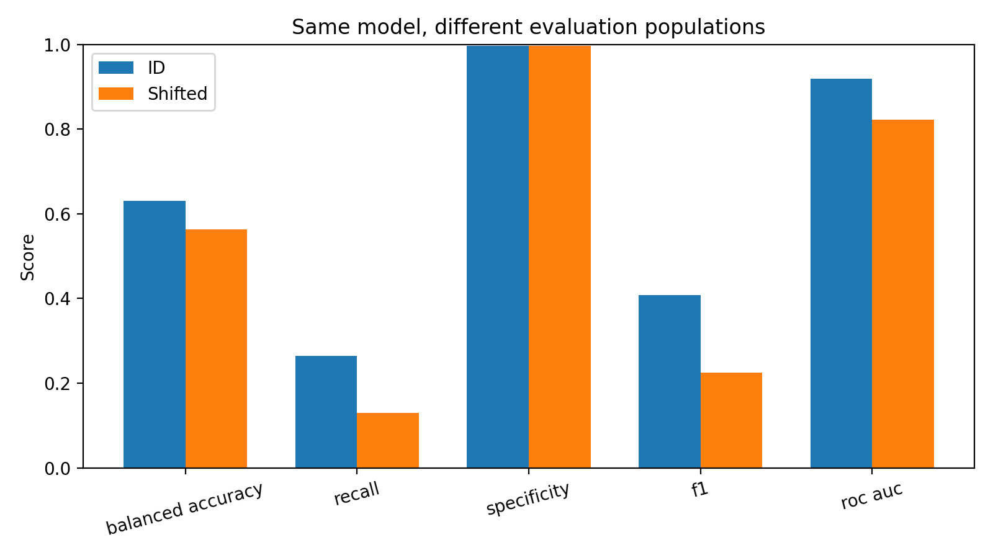
Figure 1: Fixed-model performance across the two evaluation populations. Source: original laboratory analysis.

6.2 Which performance dimension changes most?
Among the prespecified classification scores on the 0–1 scale, f1 has the largest absolute point change (-0.1818). The error pattern is more informative than the ranking alone: toxic recall falls while specificity changes little. The bootstrap intervals for precision and specificity include zero; this does not establish equivalence. Log-loss changes are not ranked against F1 changes because these quantities have different scales and meanings (Civil Comments Laboratory, 2026; Scikit-learn developers, n.d.-b).

7. Look Beneath the Average

7.1 Is degradation similar across relevant subgroups?
The shared length boundary is the cleaned training median: 35 words. Short means at or below this boundary; long means above it. This boundary is not selected from test outcomes (Civil Comments Laboratory, 2026).
length_group | metric | ID | shifted | change_shifted_minus_ID
short | balanced_accuracy | 0.6561 | 0.5568 | -0.0993
short | recall | 0.3157 | 0.1153 | -0.2004
short | specificity | 0.9965 | 0.9984 | 0.0018
long | balanced_accuracy | 0.6008 | 0.5667 | -0.0342
long | recall | 0.2042 | 0.1369 | -0.0673
long | specificity | 0.9974 | 0.9964 | -0.0010
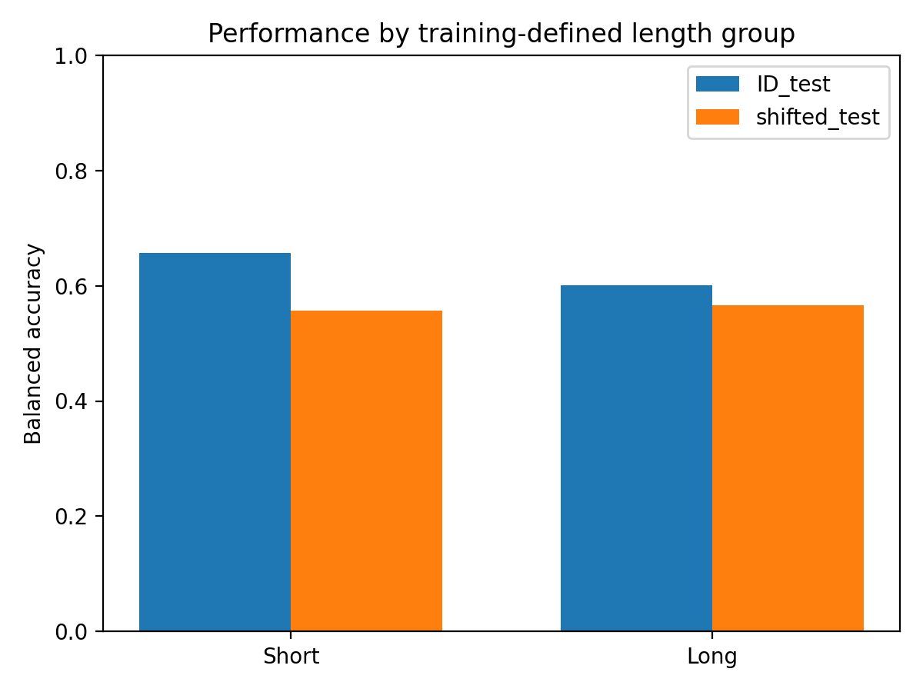
Figure 2: Balanced accuracy by a common training-defined comment-length boundary. Source: original laboratory analysis.
The observed balanced-accuracy change is -9.93 percentage points for short comments and -3.42 for long comments. Degradation is descriptively uneven, but a difference between subgroup changes has not been tested with its own interval. A larger change must also be distinguished from a lower final score (Civil Comments Laboratory, 2026).
identity | n | toxic_n | recall | specificity | balanced_accuracy
male | 14143 | 2171 | 0.1608 | 0.9959 | 0.5783
female | 16255 | 2240 | 0.1571 | 0.9970 | 0.5771
LGBTQ | 4377 | 1196 | 0.0736 | 0.9981 | 0.5358
christian | 13242 | 1243 | 0.0861 | 0.9988 | 0.5425
muslim | 6813 | 1588 | 0.0963 | 0.9956 | 0.5460
other_religions | 3438 | 513 | 0.0760 | 0.9990 | 0.5375
black | 4812 | 1510 | 0.1066 | 0.9942 | 0.5504
white | 7796 | 2182 | 0.1247 | 0.9945 | 0.5596
Within shifted test, the lowest observed toxic recall is 7.36% for LGBTQ mentions: 88 of 1,196 toxic comments are detected. Identity groups overlap and are not additive. They describe mentions, not authors, and their differences are descriptive rather than uncertainty-adjusted. These are local shifted-population failures, not matched identity-specific ID-to-shifted changes (Civil Comments Laboratory, 2026; WILDS contributors, n.d.).
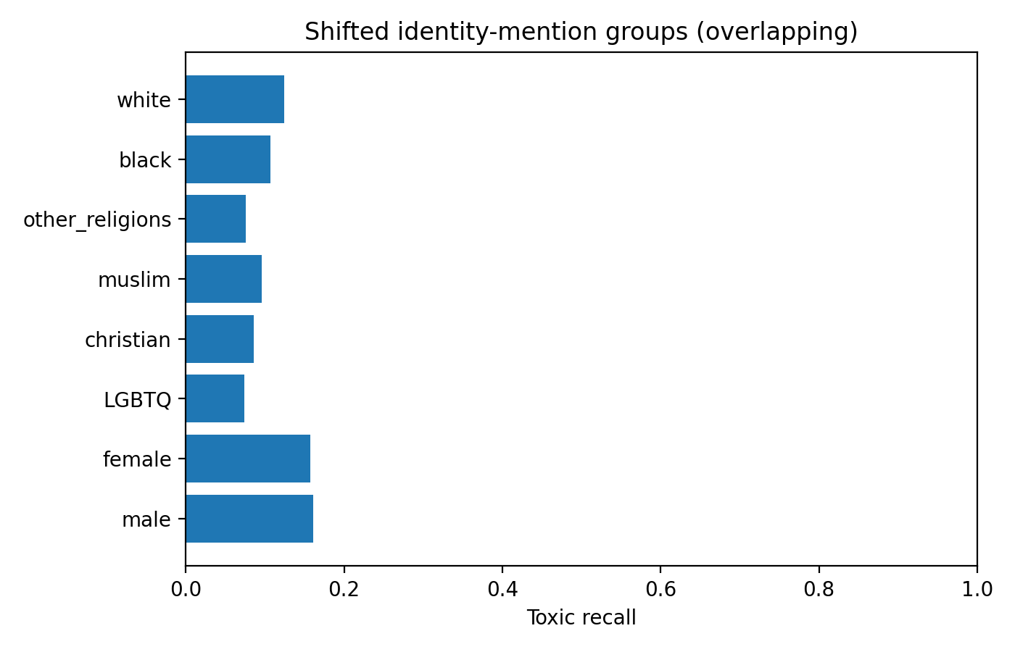
Figure 3: Toxic recall within overlapping identity-mention groups in shifted test. Source: original laboratory analysis.

8. Diagnose

8.1 What evidence suggests a possible explanation?

8.1.1 Outcome and predictor composition
partition | observed_toxicity_prevalence | mean_words | median_words | fraction_short
ID_test | 0.0793 | 50.3095 | 35.0000 | 0.5068
shifted_test | 0.1661 | 75.8077 | 63.0000 | 0.2830
The shifted population differs in outcome prevalence and length composition. The earlier length subgroup comparison shows lower shifted balanced accuracy within both coarse length categories, so merely identifying more long comments is not a sufficient explanation. Nonetheless, these strata do not isolate a causal length effect or hold all other text properties constant (Civil Comments Laboratory, 2026).

8.1.2 Representation by the training vocabulary
partition | outside_vocabulary_ngram_fraction | zero_feature_comment_fraction
ID_test | 0.2627 | 0.0023
shifted_test | 0.2744 | 0.0001
The outside-vocabulary fraction counts analyzer-generated unigrams and bigrams absent from the retained vocabulary. It includes terms excluded by minimum frequency and the feature cap, not only terms never encountered during training. The modest coverage difference and low featureless-comment rates do not establish vocabulary failure as the main explanation. They also do not rule out changes in term frequencies, context, or feature–outcome relationships (Civil Comments Laboratory, 2026; Scikit-learn developers, n.d.-d).

8.1.3 Probability behavior
partition | observed_toxicity_prevalence | mean_predicted_toxicity | mean_probability_minus_prevalence
ID_test | 0.0793 | 0.0768 | -0.0024
shifted_test | 0.1661 | 0.0920 | -0.0741
Next Image
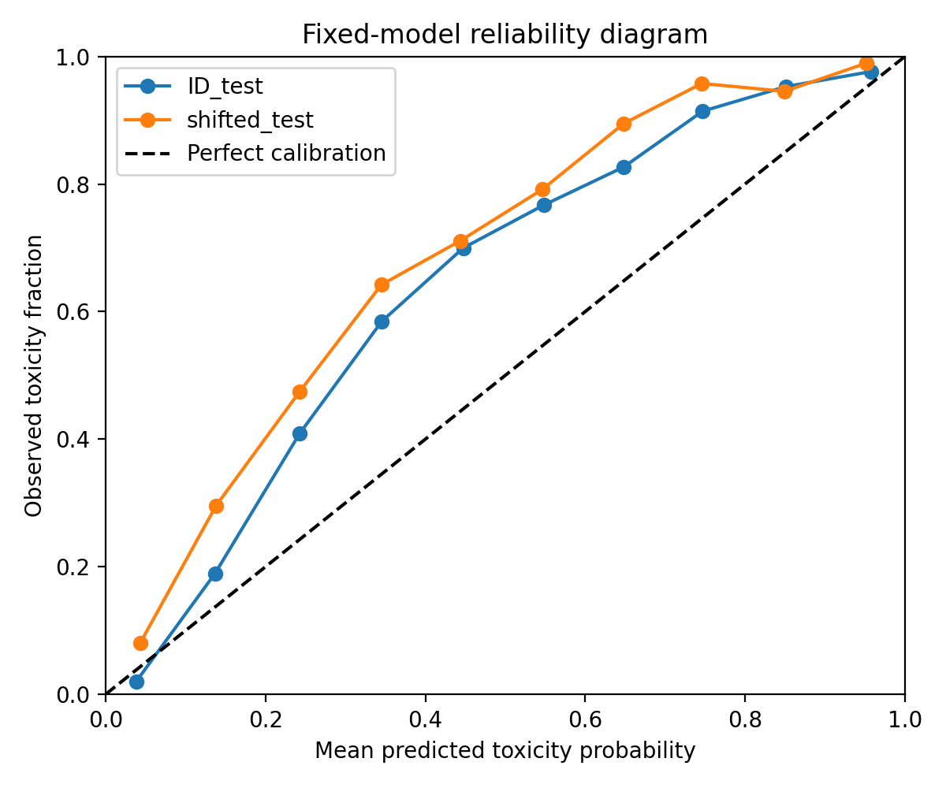
Figure 4: Reliability diagram using ten equal-width bins; empty bins are omitted. Bin counts are saved in calibration_bins.csv. Source: original laboratory analysis.
Mean predicted probability is below observed prevalence in shifted test, supporting aggregate underprediction. This mean is not the fraction classified as toxic, and its discrepancy does not imply underprediction in every probability bin. The reliability diagram compares within-bin probability means and observed fractions; sparse bins require particular caution (Civil Comments Laboratory, 2026; Scikit-learn developers, n.d.-c).

8.1.4 Standardizing the class mixture
Using ID toxic prevalence (_{ID}), define the diagnostic standardized accuracy as
[ {shifted,std} = {ID}{shifted} + (1-{ID})_{shifted}. ]
This calculation retains shifted class-conditional error rates while replacing only the class mixture. It is neither an adapted model nor a causal decomposition (Civil Comments Laboratory, 2026; Scikit-learn developers, n.d.-b).
quantity | value
ID accuracy | 0.9389
Raw shifted accuracy | 0.8528
Shifted accuracy at ID prevalence | 0.9281
Raw shifted-minus-ID gap | -0.0861
Standardized shifted-minus-ID gap | -0.0108
The accuracy gap changes from -8.61 to -1.08 percentage points under this standardization. Class composition is therefore important for interpreting raw accuracy. This does not remove the observed recall and balanced-accuracy declines or establish a pure label-shift mechanism (Civil Comments Laboratory, 2026).

8.1.5 Measurement and unresolved explanations
The analysis uses existing annotations, applies common thresholds, and preserves the supplied splits. It does not audit crowdworker procedures, establish annotation invariance across groups, or identify whether predictor–outcome relationships changed causally. Poor representation of identity-present comments in development is imposed by the design, but its contribution cannot be separated from topic, wording, prevalence, and annotation differences in this comparison (Civil Comments Laboratory, 2026; Jigsaw, 2019; Koh et al., 2021).

9. Make an Evidence-Based Judgment

9.1 What does the experiment allow us to conclude about generalization?
This fitted pipeline does not retain its ID performance in the selected identity-present evaluation population. The primary metric’s article-cluster interval supports lower shifted balanced accuracy under the stated resampling assumptions. High ID accuracy alone was also insufficient: ID toxic recall was low before the environment changed. Generalization evidence must therefore be tied to the population and performance dimension actually evaluated (Civil Comments Laboratory, 2026; Koh et al., 2021).

9.2 What does it not allow us to conclude?
The experiment does not identify identity mentions as a cause, infer authors’ demographics, establish discrimination against people, guarantee future platform/time performance, or show that other model classes would behave similarly. Subgroup heterogeneity is descriptive. The confidence intervals do not capture training variability or all possible dependence, and repeated-text exclusion restricts the evaluated population. The processed CSV’s exact equivalence to the official WILDS release and compliance with a separately prescribed course model remain unverified (Civil Comments Laboratory, 2026; Koh et al., 2021).

9.3 Deployment judgment
Judgment: do not deploy this fixed model at threshold 0.5 as a standalone toxicity-detection or autonomous moderation system. It misses most toxic comments even in ID evaluation, performs worse in shifted evaluation, and has particularly low recall in several identity-mention groups. This is an evidence-based laboratory judgment for the stated use, not a universal claim that the model has no possible value in a separately evaluated human-assisted workflow. The experiment itself does not specify an operational cost function or validate a safe deployment threshold (Civil Comments Laboratory, 2026).

9.4 What additional evidence is needed before deployment?
Before considering deployment, obtain representative external and prospective labels from the intended platform; specify acceptable missed-toxicity and false-positive costs; inspect annotation reliability and disagreement; obtain adequate subgroup and intersectional coverage; repeat training across seeds and development samples; and evaluate calibration and threshold trade-offs using development data rather than repeatedly reusing the final test set. Human-review capacity, appeals, monitoring, drift triggers, and rollback procedures also need operational evaluation. These are proposed evidence requirements, not benefits demonstrated by the current experiment (Civil Comments Laboratory, 2026; Koh et al., 2021).

References
Cameron, A. C. (2022). Bootstrap methods.
Civil Comments Laboratory. (2026). Civil Comments population-shift laboratory: Analysis code and generated results.
Jigsaw. (2019). Jigsaw unintended bias in toxicity classification: Data.
Koh, P. W., Sagawa, S., Marklund, H., Xie, S. M., Zhang, M., Balsubramani, A., Hu, W., Yasunaga, M., Phillips, R. L., Gao, I., Lee, T., David, E., Stavness, I., Guo, W., Earnshaw, B. A., Haque, I. S., Beery, S., Leskovec, J., Kundaje, A., … Liang, P. (2021). WILDS: A Benchmark of in-the-Wild Distribution Shifts (arXiv:2012.07421). arXiv. https://doi.org/10.48550/arXiv.2012.07421
Scikit-learn developers. (n.d.-a). LogisticRegression.
Scikit-learn developers. (n.d.-b). Metrics and scoring: Quantifying the quality of predictions.
Scikit-learn developers. (n.d.-c). Probability calibration.
Scikit-learn developers. (n.d.-d). TfidfVectorizer.
WILDS contributors. (n.d.). CivilComments dataset loader and evaluator.

