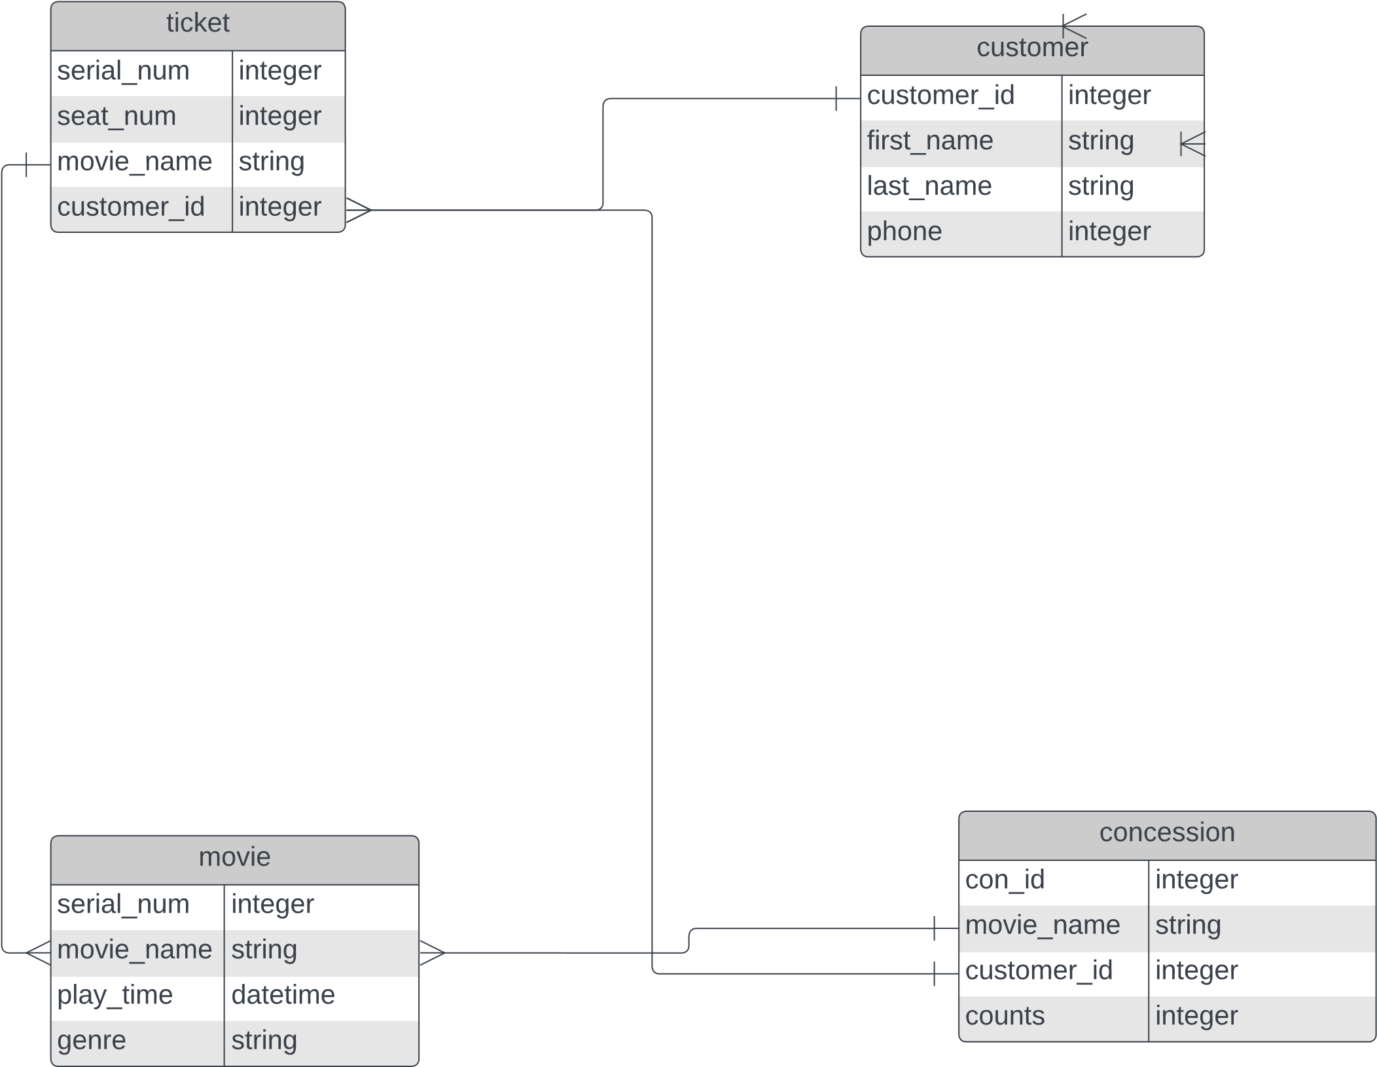

*m*

*o*

*v*

*i*

*e*

*T*

*h*

*e*

P

a

r

m

a

A

c

h

a

r

y

a

|

J

u

n

e

2

3

,

2

0

2

3