How to use O-Droid app

1. Install the app. You may use Google Play or o-droid.apk file to do this. You’ll also need maps (.png, .jpg or .gif pictures)
2. Start the app. During the first start app creates the O-Droid Maps folder on SD-card. Put your maps to this folder (use standard file manager)
3. Map affixment. Choose a map from the list. You’ll need the geographical coordinates of two points of this map. You may use Google Maps. Long press to input the coordinates of the point (pic. 1). The same with the second point. Affixment file is a text file, which will be automatically created in O-Droid Maps folder. Do not delete it.

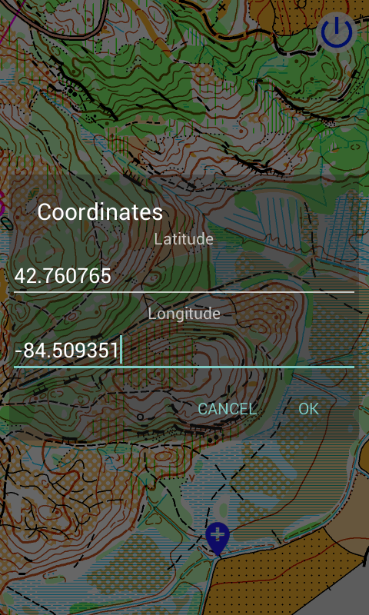 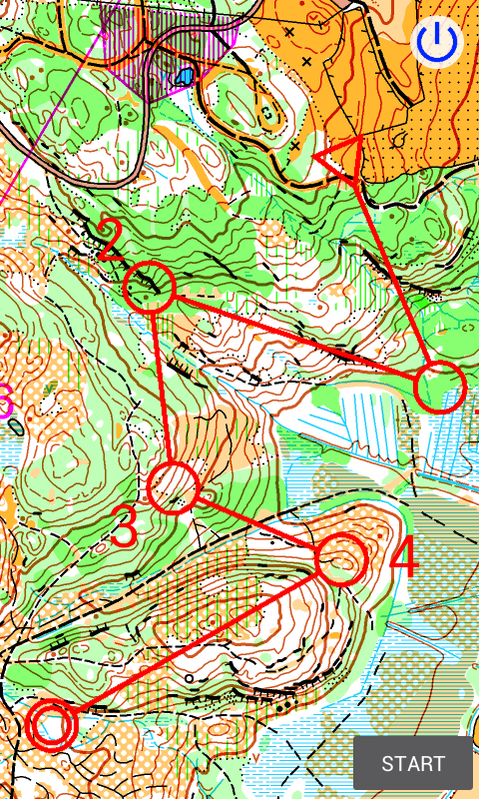

1. In the Explore (or Training) mode you see your location on the map and you can turn on track visibility. App centers the map by your location. In settings you can choose natural scale (for more precise scale calculation state your screen width and height), dragging map ability, track color.
2. In the Competition mode you set control points (CP) by long press (pic. 2), choose level and start to take CP sequentially. When your location is close to CP (you may set the distance in settings), app will play standard messaging sound. To correctly turn off GPS quit app by pushing the blue button in the top right corner.

This is simple orienteering training app.

To use it you need: smartphone (or tablet), map (.png, .jpg or .gif picture) and some fantasy.

For map binding, set coordinates of only two points (in opposite corners, if possible).

That’s all. Take smartphone and go training.

When you come to map area, turn on smartphone GPS and launch the app. In the simplest way you can see your location on the map and, if necessary, track. If it’s not enough, set route directly in app, choose level (simple – with the track and your location, hard – just map and route), press «Start» and go to first control point. When you will be not far from it, smartphone will play massage sound. Then go to the next CP and so on.

App is totally free, no ads.

Do not use at official competition. Follow the fair play principle.

Detailed instructions

<https://drive.google.com/open?id=0B9T2LZVMeEPXNU1TbVJ3S0NlM1E>

Also you can download apk from

<https://drive.google.com/open?id=0B9T2LZVMeEPXYjlXQWViVGIzelE>