Project 2 – Exploratory Data Analysis (EDA)
E-Commerce Sales Dataset | Data Analytics Internship Project

1. Objective
Analyze the prepared e-commerce dataset to understand patterns, trends, distributions, and relationships using descriptive statistics, grouping, trend analysis, and outlier detection.

2. Dataset Overview
The dataset contains 1,200 order records and 14 original columns. The analysis period is 2023-01-01 to 2025-06-30.

3. Key KPIs
- Total recorded order value: ₹1,264,761.96
- Total orders: 1,200
- Unique customers: 1,189
- Total quantity sold: 3,535
- Average order value: ₹1,053.97
- Median order value: ₹823.62

4. Descriptive Statistics
Mean, median, minimum, maximum, standard deviation and quartiles were calculated for Quantity, UnitPrice, ItemsInCart and TotalPrice.

5. Trend Analysis
The highest monthly order count occurred in 2024-06 with 53 orders. The highest monthly recorded sales occurred in 2024-06 with ₹68,068.54.
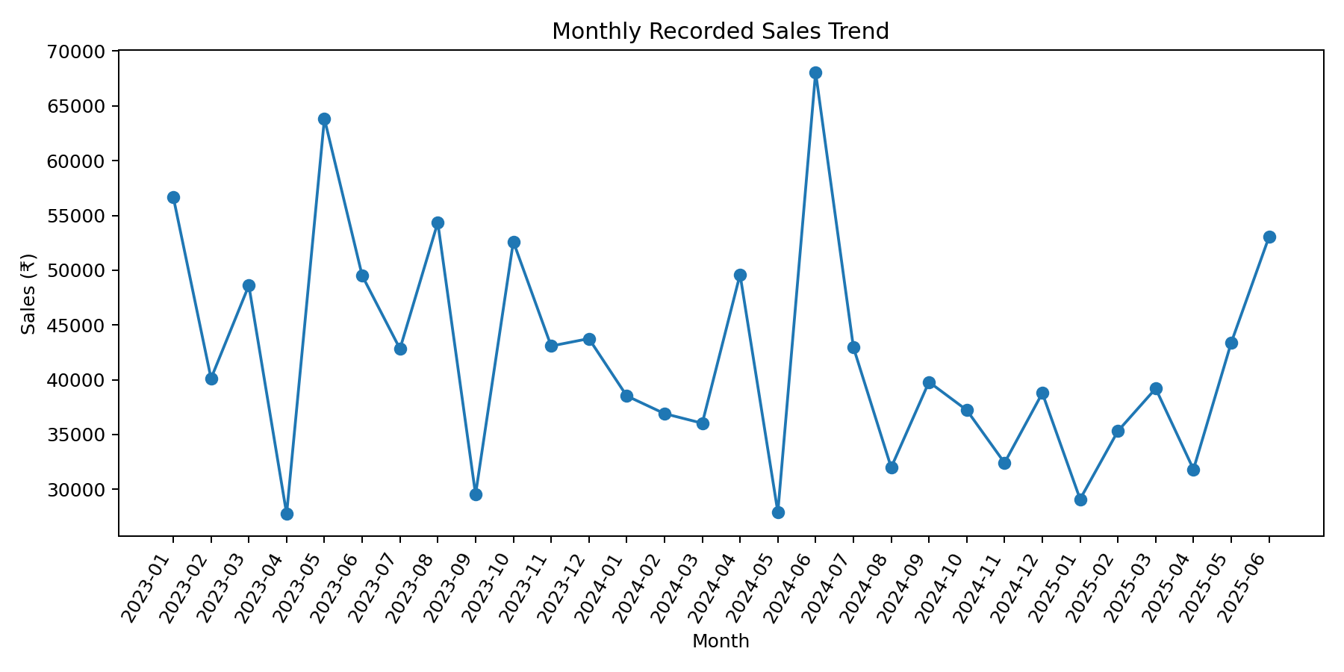

6. Product Analysis
Chair is the highest-sales product with ₹195,620.11. Product-level sales and order counts were compared to identify stronger-performing products.
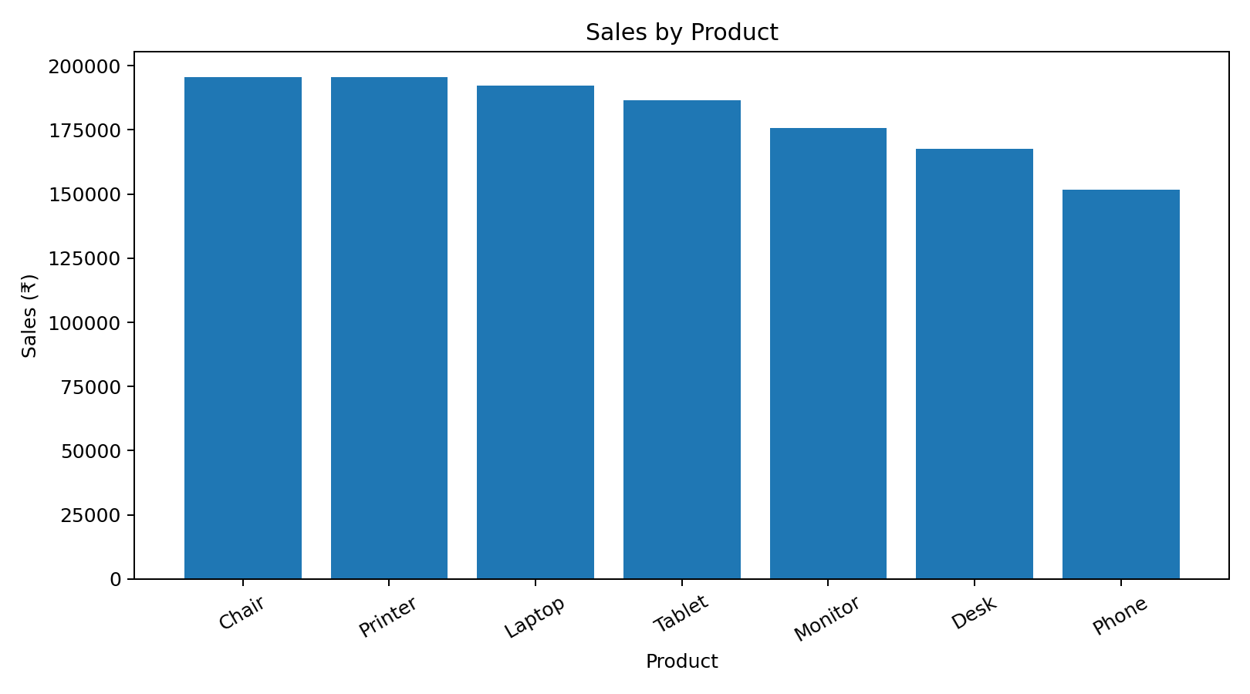

7. Order Status Analysis
Cancelled has the highest number of orders at 250.
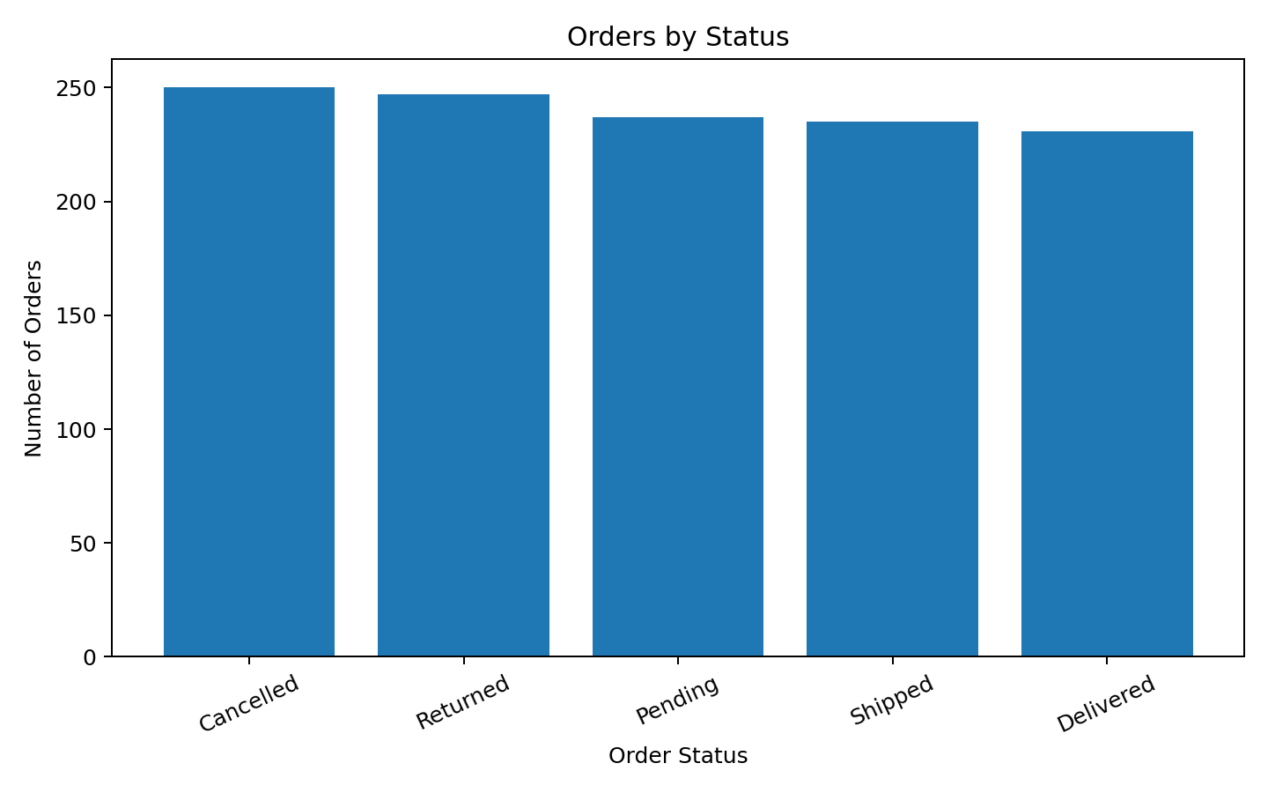

8. Referral Source Analysis
Instagram generated the highest recorded sales at ₹275,285.45.
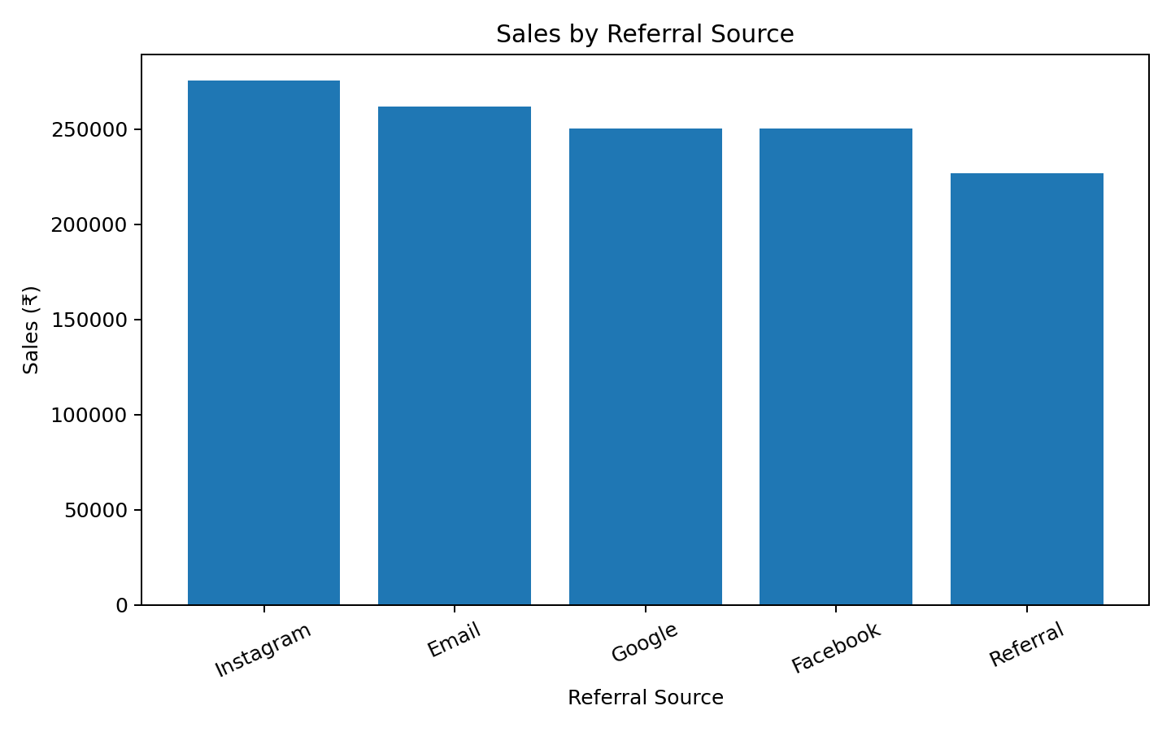

9. Distribution & Outlier Analysis
The IQR method was used to identify potential outliers. A value below Q1 − 1.5×IQR or above Q3 + 1.5×IQR was flagged as a potential outlier. Outliers are not automatically deleted; they should be investigated using business context.
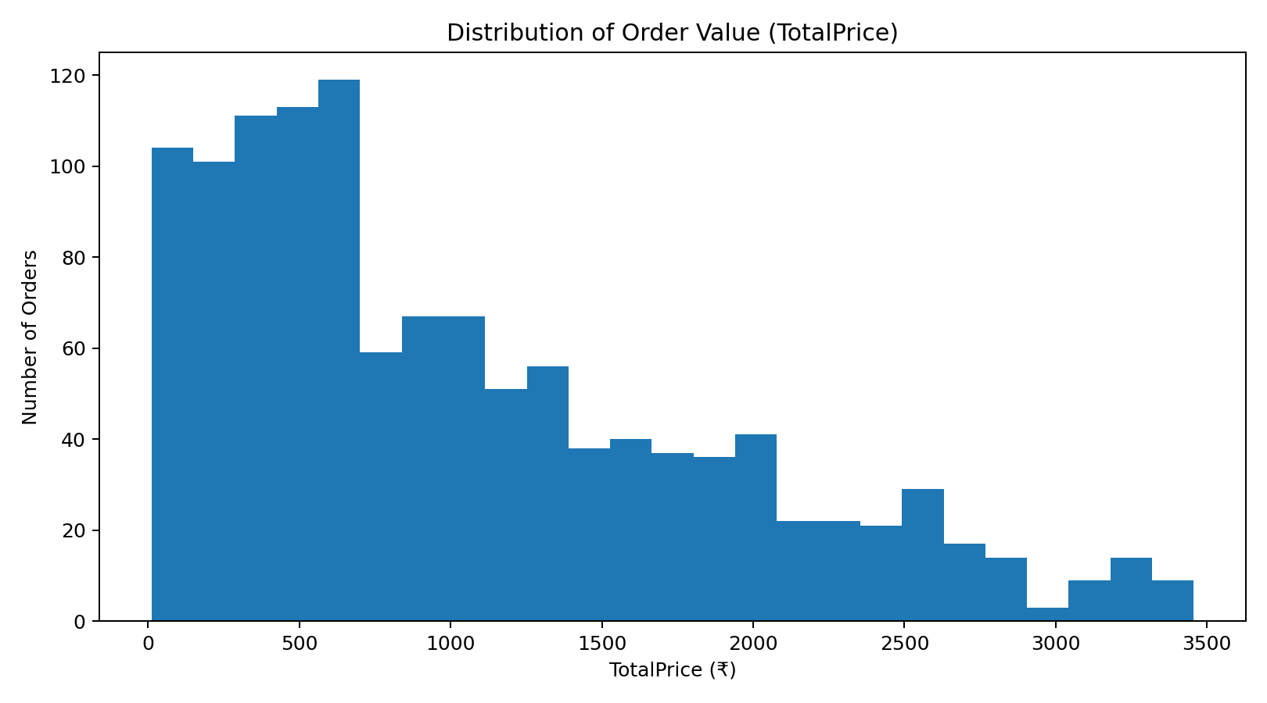

10. Important Business Interpretation
The dataset contains 497 orders marked Cancelled or Returned. The analysis currently reports TotalPrice as recorded order value. These records should only be removed from revenue calculations if the business defines cancelled/returned orders as non-revenue.

11. Key Findings
- Overall: Recorded order value is ₹1,264,761.96 across 1,200 orders.
- Customer base: 1,189 unique customers are represented in 1,200 orders.
- Order value: Average order value is ₹1,053.97; median is ₹823.62.
- Top product by sales: Chair leads with ₹195,620.11 sales across 178 orders.
- Top referral source: Instagram generated the highest recorded sales at ₹275,285.45.
- Top payment method: Credit Card has the highest recorded sales at ₹263,847.63.
- Peak month by orders: 2024-06 had the highest order count (53).
- Peak month by sales: 2024-06 had the highest recorded sales (₹68,068.54).
- Order status: Cancelled has the largest number of orders (250).
- Status caution: 497 orders are marked Cancelled or Returned; these should be excluded from net revenue only if the business defines them as non-revenue.

12. Conclusion
EDA converted the cleaned dataset into actionable descriptive insights. The analysis covered KPIs, descriptive statistics, monthly trends, product performance, payment methods, order statuses, referral sources, coupon usage and potential outliers. The dataset is now ready for SQL-based analysis and Power BI dashboard development.

