***Dairy Information System***

**A Project Report On:**

Dairy Information System

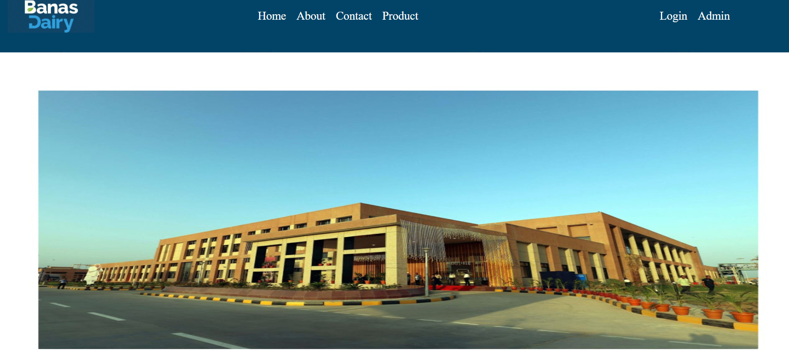

**Submitted To:**

***SHREE ADARSH B.C.A COLLEGE RADHANPUR***

***Managed By: AKHIL ANJANA KELAVNI MANDAL***

**Affiliated To:**

**HEMCHANDRACHARYA NORTH GUJARAT UNIVERSITY, PATAN**

**As a Partial fulfilment of the course of**

**BACHELOR OF COMPUTER APPLICATION**

**RADHANPUR, Year 2024-2025.**

**Submitted by:**

**Parmar Rohit R**

**Ramanandi Dipak K**

**Project Guide**

**Mr.Maheshbhai Chaudhary**

***Index***

***INDEX***

|  |  |  |
| --- | --- | --- |
|  |  |  |
|  |  |  |
|  |  |  |
|  |  |  |
|  |  |  |

**PROJECT PROFILE**

|  |  |
| --- | --- |
|  |  |
| Project Title | Dairy Information System |
|  |  |
| Developed For | Shree Adarsh BCA College Radhanpur |
|  |  |
| Front-End Tool | Asp Dot Net, CSS, Bootstrap, JavaScript |
|  |  |
| Back-End Tool | SQL |
|  |  |
| Operating System | Windows, |
|  |  |
| Prepared By | 1. Parmar Rohit 2. Ramanandi Dipak |
|  |  |
| Project Guide | Maheshbhai Chaudhary |
|  |  |

**Minimum Server Side Requirement**

* **Hardware Requireme**

**➢** Ram : 2GB

➢ Processor : Pentium (R) Dual CoreProcessor

➢ Hard Disk: 128 GB

• **Software Requirement**

* **Application Software**

**➢**Front-End Tool :HTML, CSS, JavaScript, PHP,

Bootstrap

**➢**Back-End Tool : MySQL

**➢**Other Tool : Adobe Photoshop cs

**Minimum Client Side Requirement**

|  |  |  |
| --- | --- | --- |
| • | **Hardware Requirement** |  |
|  | ➢ Ram | :2GB |
|  | ➢ Processor | : Pentium (R) Dual Core Processor |
|  | ➢ Hard Disk | : 128 GB |
| • | **Software Requirement** |  |
|  | ➢ Operating System | : Windows |
|  | ➢ Application Software | : Internet Explorer 5.0 OR Above |