

7th Semester
Department of CE & CSE
Mini Project
LAB MANUAL



CERTIFICATE

This is to certify that Mr. Bhuresh Parmar .
Branch B.Tech C.E. Semester 7 has satisfactorily completed his/her term work in the Subject of Mini Project within the four walls of the institute.

Date of Submission: _____________________

_________________ _________________
Sign – in – Charge Head of Department
IDEX

Sr No. | List of Experiments | Sign with Date
1. | Identify project problem statement and define project objectives.
2. | Perform requirement gathering and feasibility analysis.
3. | Prepare Software Requirement Specification (SRS) document.
4. | Design system architecture and workflow diagrams.
5. | Create UI/UX wireframes and screen designs for the project.
6. | Setup project environment, tools, and required dependencies.
7. | Develop frontend modules for the application.
8. | Implement backend logic and database connectivity.
9. | Integrate APIs or third-party services in the project.
10. | Implement user authentication and security features.
11. | Perform CRUD operations in the application.
12. | Conduct unit testing and debugging of project modules.
13. | Optimize application performance and improve user experience.
14. | Prepare project documentation, report, and presentation.
15. | Demonstrate final mini project with deployment and viva evaluation.

Experiment No. 1:
Aim: Identify Project Problem Statement and Define Project Objectives

Problem Statement:
Users spend considerable time and mental effort every day deciding what to wear, and often end up repeatedly using a small subset of their wardrobe despite owning many more items. There is currently no simple, integrated digital tool that allows an individual to catalog their clothing, receive intelligent outfit recommendations suited to the occasion and weather, and gain insight into how their wardrobe is actually being used. This results in daily decision fatigue, underutilization of owned clothing, wastage of money on unnecessary purchases, and difficulty in planning outfits for special occasions or trips.
Project Title:
Smart Wardrobe & Outfit Planner
Project Objectives:
1. To design and develop a full-stack MERN (MongoDB, Express.js, React.js, Node.js) web application that lets users digitize their physical wardrobe through photo-based cataloging.
2. To train and integrate a computer vision model (transfer learning on a pretrained CNN) capable of automatically tagging clothing category, color, and pattern from uploaded images.
3. To implement an AI-powered outfit generator that suggests complete outfits based on occasion, current/forecast weather (via a weather API), and item availability, using a generative AI (LLM) API for natural-language reasoning.
4. To build a wear-history tracking module with a calendar interface that records which outfits were worn on which dates.
5. To develop a wardrobe gap-analysis feature that flags underused or missing clothing categories and explains the gaps in natural language.
6. To provide an outfit-sharing feature that allows friends to view and give feedback on a proposed outfit through a shareable link.
7. To implement a trip packing-list generator that produces a minimal, weather- and occasion-appropriate packing list validated against the user's actual wardrobe inventory.
8. To ensure the system is secure (JWT-based authentication, hashed passwords), performant (outfit generation within 8 seconds), and deployable within free-tier or low-cost cloud infrastructure.

Scope:
The project covers digital wardrobe cataloging, AI-assisted outfit generation, wear-history tracking, gap analysis, outfit sharing, and trip packing-list generation, built entirely on the MERN stack integrated with a self-trained image classification microservice and a third-party generative AI API.
Conclusion:
The problem statement and objectives for the Smart Wardrobe & Outfit Planner have been clearly identified. This sets the foundation for gathering detailed requirements and designing the system architecture in subsequent experiments.

Experiment No. 2:
Aim: Perform Requirement Gathering and Feasibility Analysis

2.1 Requirement Gathering
Requirements were gathered through study of existing wardrobe and outfit-planning applications, discussions with the project guide, analysis of target user needs (students and general consumers), and review of reference datasets and APIs such as the DeepFashion dataset, the Fashion Product Images dataset (Kaggle), and the OpenWeather API documentation.
Summarized Functional Requirements:
Feature | Key Requirement | Priority
Digital Wardrobe Builder | Upload clothing images; AI auto-tags category, color, pattern | High
AI Outfit Suggestion | Suggest outfit based on occasion + weather; exclude unavailable items | High
Wear History Tracking | Mark outfit as worn; display calendar view | Medium
Wardrobe Gap Analysis | Flag low/zero category counts; explain gaps via LLM | Medium
Outfit Sharing & Feedback | Shareable link; guest voting/comments | Medium
Trip Packing List Generator | Generate minimal packing list from forecast + occasions | Medium

Non-Functional Requirements:
• Performance: Item upload and tag prediction within 5 seconds; outfit generation within 8 seconds; support for at least 50 concurrent users.
• Safety: Manual tagging fallback if the classification service is unavailable; invalid LLM responses rejected server-side.
• Security: JWT-based authentication, bcrypt-hashed passwords, non-guessable shared-link tokens.
• Quality Attributes: Maintainable, portable, reliable, and usable within a maximum of 3 user actions for core tasks.

2.2 Feasibility Analysis
Technical Feasibility:
The project uses the MERN stack together with a Python FastAPI microservice for image classification, all of which are open-source, well-documented, and within the team's existing skill set. Pretrained CNN transfer learning keeps model training realistic at student-project scale, and third-party weather and LLM APIs handle tasks that would otherwise be infeasible to build from scratch.
Economic Feasibility:
The project can be built entirely within free-tier or low-cost services: MongoDB Atlas (free tier), Render/Railway for hosting, Cloudinary for image storage, and the free tier of the OpenWeather API. LLM API usage is minimized through caching and request limits, keeping the project economically viable for a student budget.
Operational Feasibility:
The system is designed with a clean, mobile-first interface requiring no technical skill from end users, and the tag-confirmation and outfit-generation flows are limited to at most three user actions, making day-to-day operation straightforward.
Schedule Feasibility:
The scope is modular (six independent features), allowing incremental development and testing within a typical one-semester mini-project timeline.
Conclusion:
Requirement gathering confirms a well-defined set of functional and non-functional requirements, and the feasibility analysis shows the project is technically, economically, operationally, and schedule-wise feasible for implementation as a mini project.

Experiment No. 3:
Aim: Prepare Software Requirement Specification (SRS) document.

1. Introduction
1.1 Purpose
This document specifies the software requirements for the Smart Wardrobe & Outfit Planner — a full-stack web application that lets users digitize their wardrobe, receive AI-generated outfit suggestions, and track wear history. This SRS is intended for the development team, project guide/evaluators, and any future contributors who need to understand the system's scope and behavior.
1.2 Document Conventions
Functional requirements are labeled using the format FR-X.Y, where X denotes the system feature number and Y denotes the requirement number within that feature. Priority levels (High/Medium/Low) are noted in parentheses where applicable.
1.3 Intended Audience and Reading Suggestions
- Developers: Focus on Sections 3 and 4 for interface and functional detail.
- Project Guide/Evaluators: Focus on Sections 2 and 4 for scope and feature overview.
- Testers: Focus on Sections 4 and 5 for functional and non-functional requirements to validate.
Readers should review Section 2 first for overall context before proceeding to detailed feature requirements in Section 4.
1.4 Product Scope
The Smart Wardrobe & Outfit Planner digitizes a user's physical wardrobe through photo-based cataloging with AI-assisted tagging, and uses generative AI to suggest complete outfits based on occasion, weather, and wear history. The core objective is to reduce daily decision fatigue around “what to wear,” help users better utilize items they already own, and provide data-driven insight into their wardrobe. This is a university mini-project demonstrating integration of the MERN stack with a trained computer vision model and generative AI APIs.
1.5 References
- DeepFashion Dataset (CUHK Multimedia Lab)
- Fashion Product Images Dataset (Kaggle)
- OpenWeather API Documentation
- LLM Provider API Documentation (used for generation)
- MongoDB, Express.js, React, Node.js official documentation
2. Overall Description
2.1 Product Perspective
This is a standalone, newly developed web application. It is not a continuation of an existing legacy system. It integrates with three external systems: a weather API, a generative AI (LLM) API, and a self-trained image classification microservice for clothing tagging.
2.2 Product Functions
- Digital wardrobe cataloging via photo upload with AI-assisted auto-tagging
- AI-generated outfit suggestions based on occasion, weather, and availability
- Wear history tracking with calendar view
- Wardrobe gap analysis and underused-item nudges
- Outfit sharing with friends for feedback
- Trip packing list generation
2.3 User Classes and Characteristics
- Registered User (Primary): A student or general consumer who catalogs their own wardrobe and uses outfit suggestions. Requires no technical skill; interacts entirely through the web UI.
- Guest/Visitor (via shared link): A friend who views a shared outfit and casts a vote/feedback without needing a full account.
- Administrator (optional): Manages system-level configuration and monitors model/API health; requires basic technical familiarity.
2.4 Operating Environment
- Client: Modern web browsers (Chrome, Firefox, Edge, Safari — latest two versions), responsive design supporting desktop and mobile viewports.
- Server: Node.js (Express) backend, deployed on a cloud platform (e.g., Render/Railway/AWS).
- Database: MongoDB (Atlas cloud-hosted or local instance for development).
- ML Microservice: Python (FastAPI) service hosting the trained image classification model.
2.5 Design and Implementation Constraints
- Must be built using the MERN stack (MongoDB, Express.js, React, Node.js).
- The clothing classification model must be a trained model (transfer learning on a pretrained CNN), not solely a third-party API.
- Generative AI features (outfit reasoning, gap explanation, packing lists) rely on a third-party LLM API due to infeasibility of training a language model at student-project scale.
- Budget constraint: must operate within free-tier or low-cost cloud services.
2.6 Assumptions and Dependencies
- Users have a smartphone or camera-equipped device to photograph clothing items.
- The system assumes reasonably lit, single-item photographs for accurate tagging.
- Availability and uptime of third-party services (weather API, LLM API) is assumed; the system should degrade gracefully if unavailable.
- The trained classification model's accuracy is bounded by the quality and diversity of its training dataset.

3. External Interface Requirements
3.1 User Interfaces
- Wardrobe Dashboard: Grid view of catalogued items with filter/search by category, color, and status.
- Item Upload Screen: Camera/file upload with a tag-confirmation step showing AI-predicted category, color, and pattern.
- Outfit Suggestion Screen: Occasion selector, weather display, generated outfit card(s).
- Calendar View: Monthly calendar showing worn outfits by date.
- Gap Analysis Panel: Visual summary of category coverage and flagged gaps.
Design follows a clean, glassmorphism-based aesthetic; mobile-first responsive layout is prioritized since photo uploads primarily happen on mobile.
3.2 Hardware Interfaces
Device camera (via browser's file/camera input) for photographing clothing items. No specialized hardware or embedded device integration is required.
3.3 Software Interfaces
- MongoDB: Primary data store for users, wardrobes, items, outfits, and wear logs.
- Python FastAPI Microservice: Exposes a REST endpoint consumed by the Node backend for image classification.
- Weather API (OpenWeather or equivalent): Provides current/forecast weather data.
- LLM API: Provides natural-language generation for outfit rationale, gap explanations, and packing lists.
- Cloud Storage (Cloudinary/AWS S3): Stores uploaded clothing images.
3.4 Communications Interfaces
- All client-server communication occurs over HTTPS.
- REST APIs (JSON payloads) are used between the React frontend, Node/Express backend, and the Python ML microservice.
- JWT-based token authentication secures API requests after login.

4. System Features
4.1 System Feature 1: Digital Wardrobe Builder
Allows users to photograph and catalog clothing items, with an AI model auto-tagging category, color, and pattern to minimize manual data entry.
4.1.1 Functional Requirements
- FR-1.1: The system shall allow a user to upload one or more images of clothing items. (High)
- FR-1.2: The system shall send uploaded images to the classification microservice and return predicted category, color, and pattern tags. (High)
- FR-1.3: The system shall allow the user to edit or correct any AI-predicted tag before saving the item. (High)
- FR-1.4: The system shall store each item with its image URL, tags, and status (available/laundry/unavailable). (High)
- FR-1.5: The system shall support organizing items under multiple named wardrobes per user. (Medium)
4.2 System Feature 2: AI Outfit Generator
Generates complete outfit suggestions from the user's available wardrobe items based on occasion and current/forecast weather.
4.2.1 Functional Requirements
- FR-2.1: The system shall allow the user to select an occasion (casual, formal, gym, party, etc.) for outfit generation. (High)
- FR-2.2: The system shall retrieve current weather data for the user's location and factor it into outfit suggestions. (High)
- FR-2.3: The system shall exclude items marked “laundry” or “unavailable” from suggestions. (High)
- FR-2.4: The system shall validate that all item IDs returned by the AI generation step exist in the user's wardrobe before displaying the outfit. (High)
- FR-2.5: The system shall provide a “regenerate” option to produce an alternative outfit suggestion. (Medium)
4.3 System Feature 3: Wear History Tracking
Tracks which outfits were worn on which dates, displayed via a calendar interface.
4.3.1 Functional Requirements
- FR-3.1: The system shall allow a user to mark a generated or manually assembled outfit as “worn” on the current date. (High)
- FR-3.2: The system shall display a calendar view showing outfits worn on past dates. (Medium)
- FR-3.3: The system shall optionally deprioritize recently worn outfits when generating new suggestions. (Low)
4.4 System Feature 4: Wardrobe Gap Analysis
Analyzes the user's wardrobe composition and flags missing category coverage.
4.4.1 Functional Requirements
- FR-4.1: The system shall calculate item counts per category and per occasion tag for each user's wardrobe. (High)
- FR-4.2: The system shall flag categories with zero or critically low item counts relevant to common occasions. (High)
- FR-4.3: The system shall generate a natural-language explanation of identified gaps using the LLM API. (Medium)
4.5 System Feature 5: Outfit Sharing & Feedback
Allows a user to share a generated outfit with friends via a link for quick feedback before wearing it.
4.5.1 Functional Requirements
- FR-5.1: The system shall generate a unique shareable link for any saved outfit. (Medium)
- FR-5.2: The system shall allow visitors (without an account) to view the shared outfit and submit a vote/comment. (Medium)
- FR-5.3: The system shall display aggregated feedback to the outfit owner. (Low)
4.6 System Feature 6: Trip Packing List Generator
Generates a minimal packing list from the user's wardrobe based on trip duration, destination weather, and planned occasions.
4.6.1 Functional Requirements
- FR-6.1: The system shall allow a user to input trip destination, date range, and expected occasions. (Medium)
- FR-6.2: The system shall retrieve forecast weather for the destination and date range. (Medium)
- FR-6.3: The system shall generate a packing list covering all specified occasions using the minimum number of wardrobe items, validated against the user's actual inventory. (Medium)
5. Non-Functional Requirements
5.1 Performance Requirements
- Item upload and AI tag prediction shall complete within 5 seconds under normal network conditions.
- Outfit generation (including LLM API round-trip) shall complete within 8 seconds.
- The system shall support at least 50 concurrent users without noticeable degradation.
5.2 Safety Requirements
- If the classification microservice is unavailable, the system shall allow manual tagging as a fallback rather than blocking item upload.
- If the LLM API is unavailable or returns invalid data (e.g., hallucinated item IDs), the system shall reject the invalid response server-side and display a graceful error.
- Uploaded images shall be validated for file type and size before processing.
5.3 Security Requirements
- User authentication shall use JWT tokens with secure, httpOnly storage where applicable.
- Passwords shall be hashed (e.g., bcrypt) before storage; plaintext passwords shall never be persisted.
- Shared outfit links shall use non-guessable tokens to prevent unauthorized access.
- All API endpoints requiring authentication shall reject unauthenticated requests with appropriate HTTP status codes.
5.4 Software Quality Attributes
- Maintainability: Backend code shall separate concerns across routes, controllers, and services.
- Portability: The application shall run on any environment supporting Node.js and MongoDB.
- Reliability: Core wardrobe CRUD operations shall function independently of third-party API availability.
- Usability: The tag-confirmation and outfit-generation flows shall require no more than 3 user actions for core tasks.

Experiment No. 4:
Aim: Design system architecture and workflow diagrams.

System Architecture :
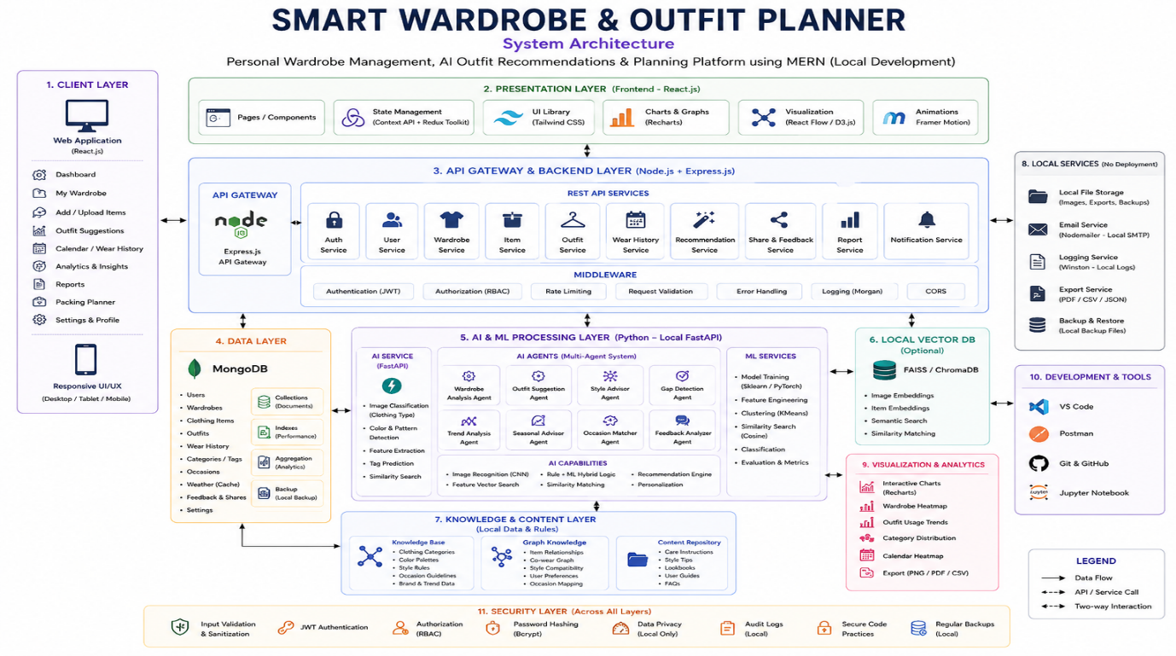

Workflow Diagrams :
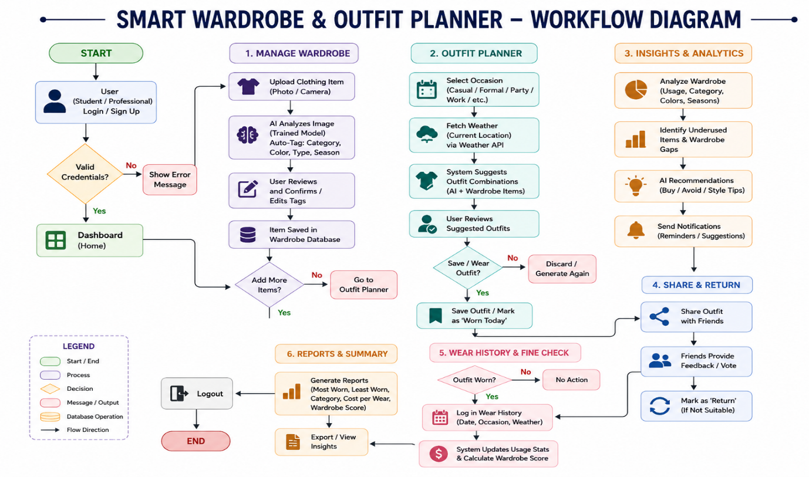

Experiment No. 5:
Aim: Create UI/UX wireframes and screen designs for the project.

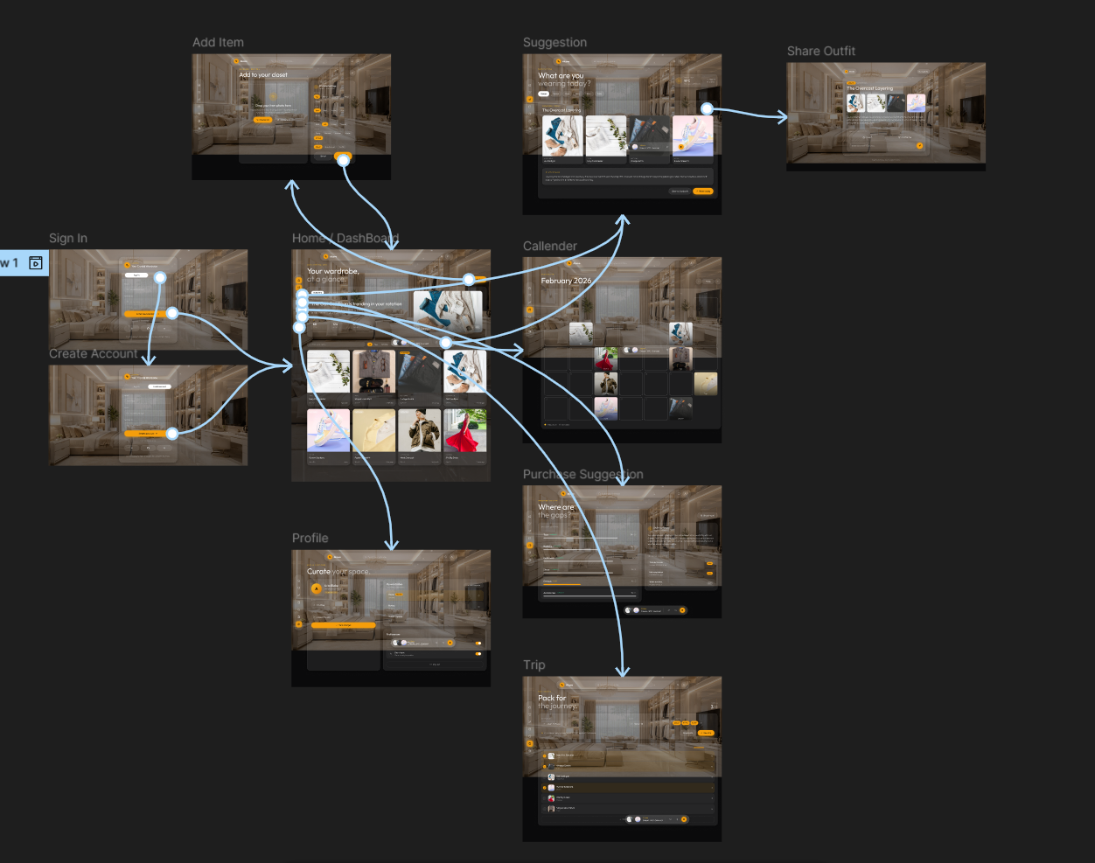

Experiment No. 6:
Aim: Setup Project Environment, Tools, and Required Dependencies

6.1 Tools and Technologies
Layer | Technology
Frontend | React.js, HTML5, CSS3, JavaScript
Backend | Node.js, Express.js
Database | MongoDB (Atlas cloud-hosted / local)
ML Microservice | Python, FastAPI
Image Storage | Cloudinary / AWS S3
Weather Data | OpenWeather API
Generative AI | LLM API (self-hosted / Hugging Face-based)
Version Control | Git & GitHub
Code Editor | Visual Studio Code
API Testing | Postman

6.2 Environment Setup Steps
1. Install Node.js (LTS version) and npm.
2. Install Python 3.10+ and pip.
3. Initialize a Git repository and create a corresponding GitHub repository for version control.
4. Create the React frontend application (using Vite or Create React App).
5. Initialize the Node.js/Express backend and install core packages: express, mongoose, jsonwebtoken, bcryptjs, multer, cors, dotenv.
6. Set up a MongoDB Atlas cluster, obtain the connection string, and store it in a backend .env file.
7. Create a Python virtual environment for the ML microservice and install fastapi, uvicorn, torch/torchvision, pillow, numpy, and scikit-learn.
8. Configure a Cloudinary account for image storage and obtain the API key, API secret, and cloud name.
9. Register for an OpenWeather API key for current and forecast weather data.
10. Configure environment variables for the backend and ML microservice, including database URI, JWT secret, Cloudinary keys, weather API key, and LLM API key.
11. Run and verify each service independently: backend health-check route, ML microservice /predict endpoint, and the frontend development server.

6.3 Required Dependencies
Backend (package.json):
• express
• mongoose
• dotenv
• jsonwebtoken
• bcryptjs
• multer
• cloudinary
• cors
• axios
Frontend (package.json):
• react
• react-dom
• react-router-dom
• axios
• tailwindcss
ML Microservice (requirements.txt):
• fastapi
• uvicorn
• torch
• torchvision
• pillow
• numpy
• scikit-learn
Conclusion:
The project environment, development tools, and required dependencies for all three layers of the Smart Wardrobe & Outfit Planner (frontend, backend, and ML microservice) have been successfully identified and set up, providing a ready foundation for feature development in subsequent experiments.

Experiment No. 7:
Aim: Develop frontend modules for the application.

Sign In :



Create Account:

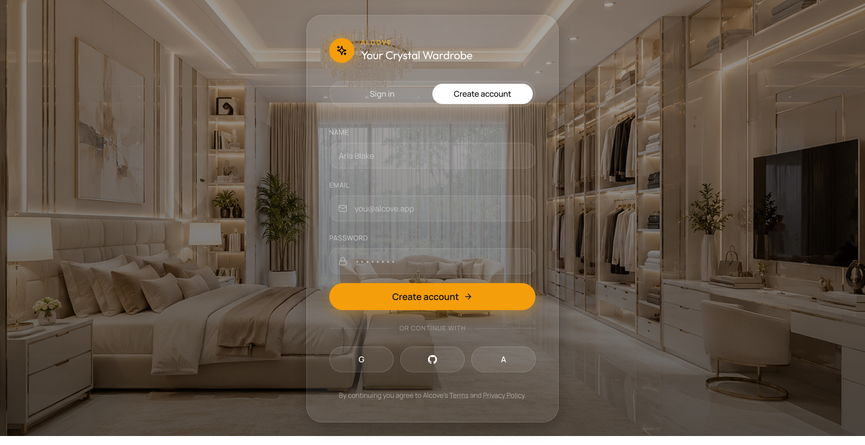

Dashboard:

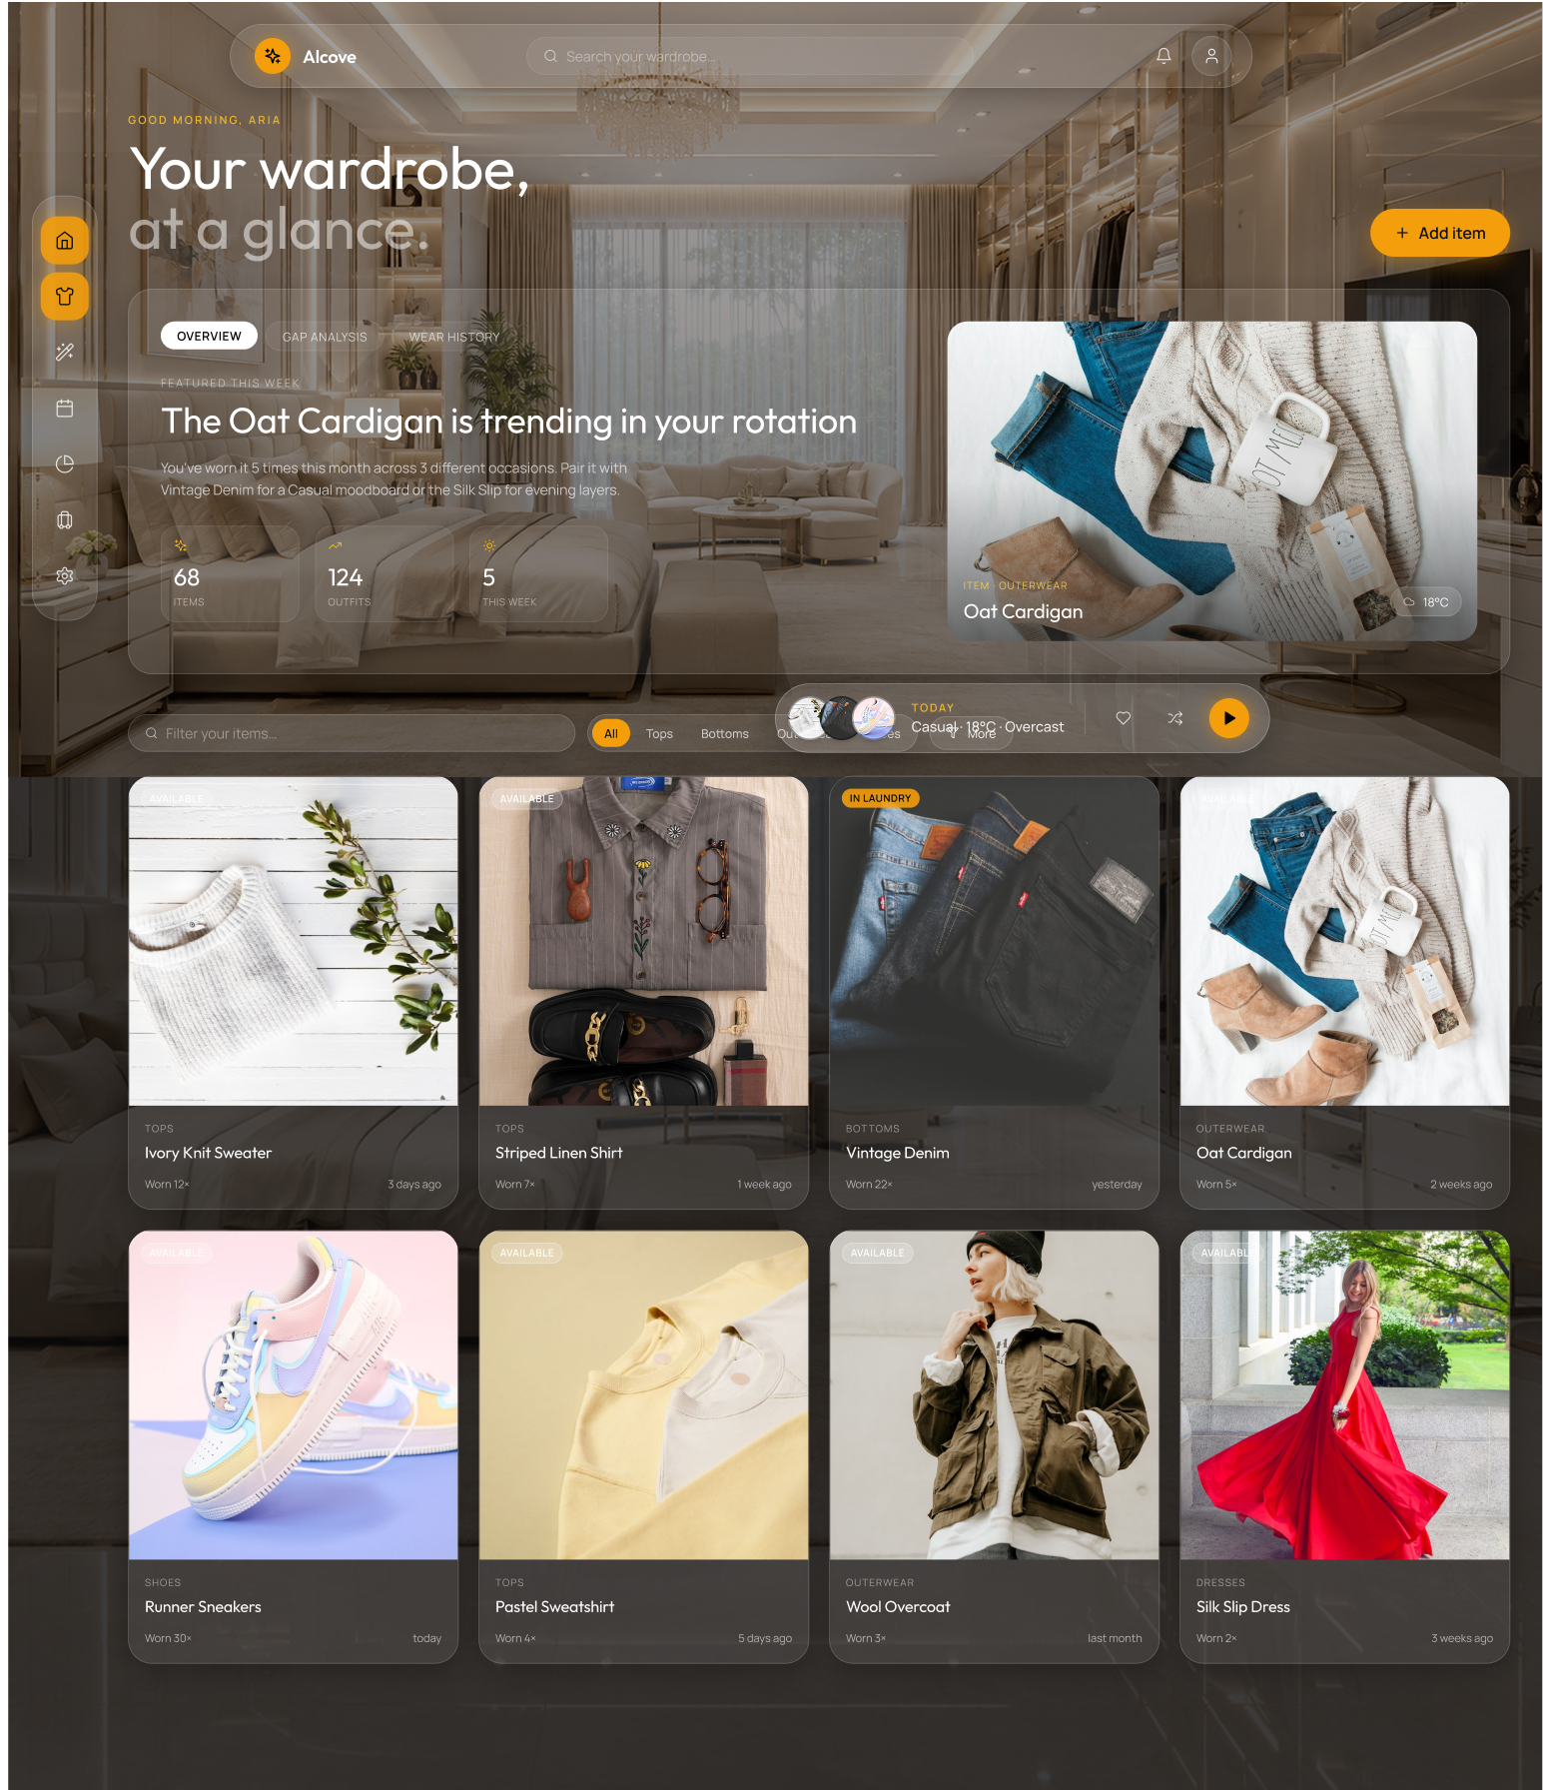

Outfit:

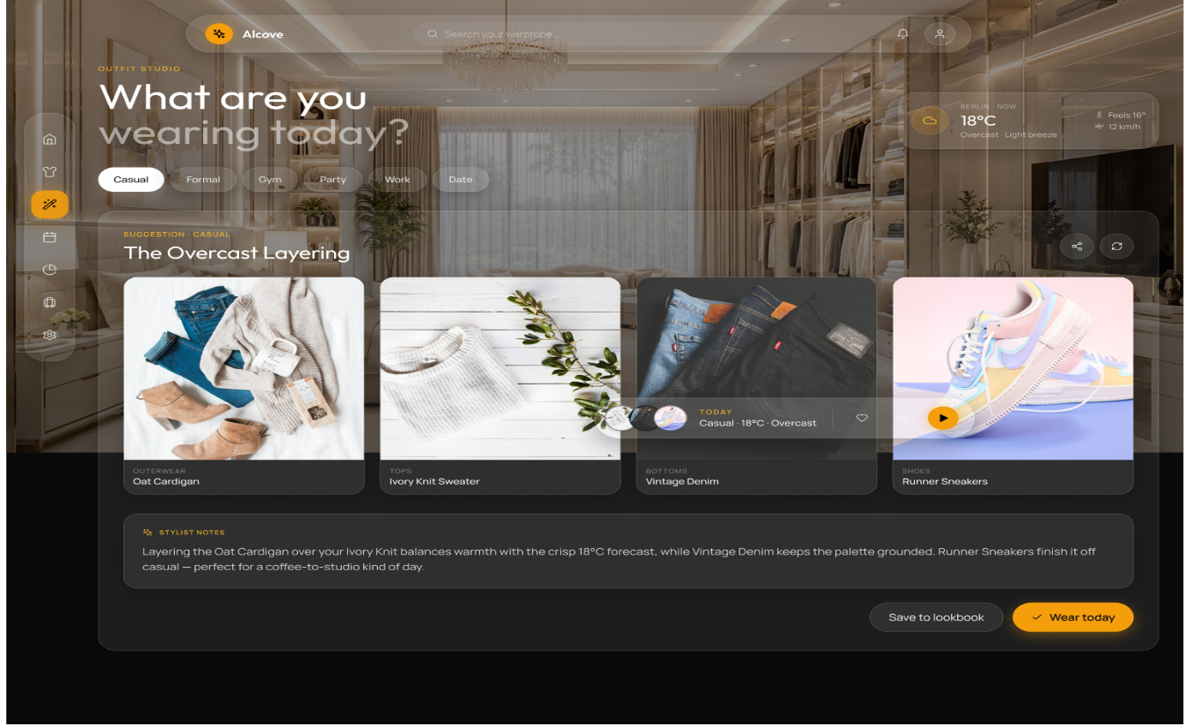

Callender / Wear History:

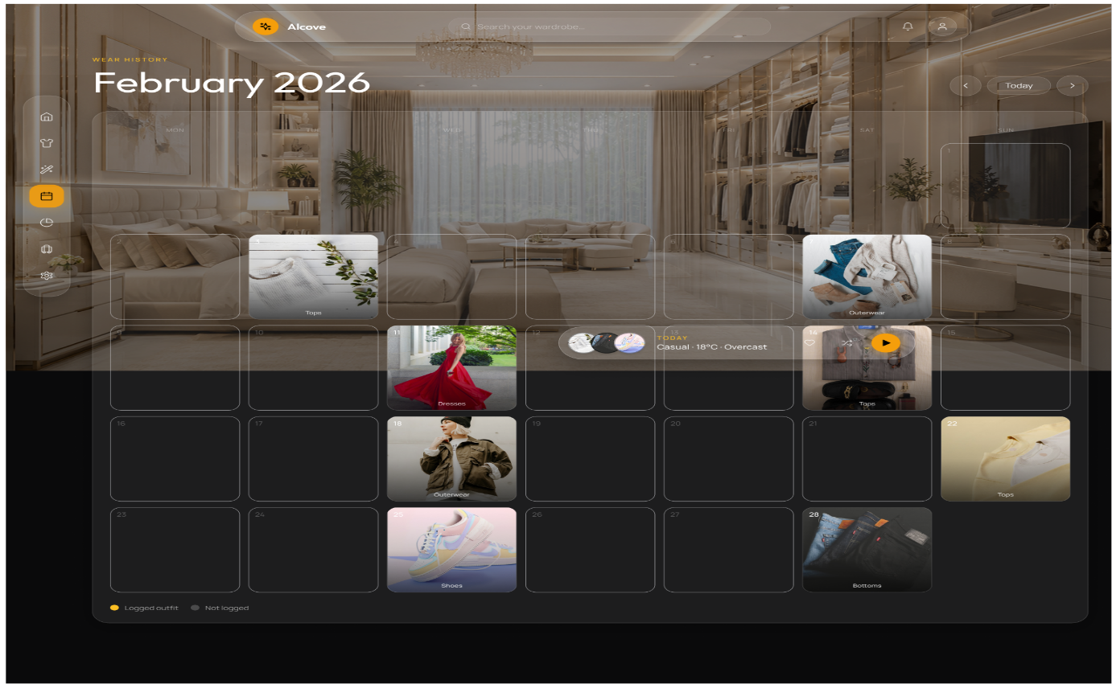
Purchase Suggestion:

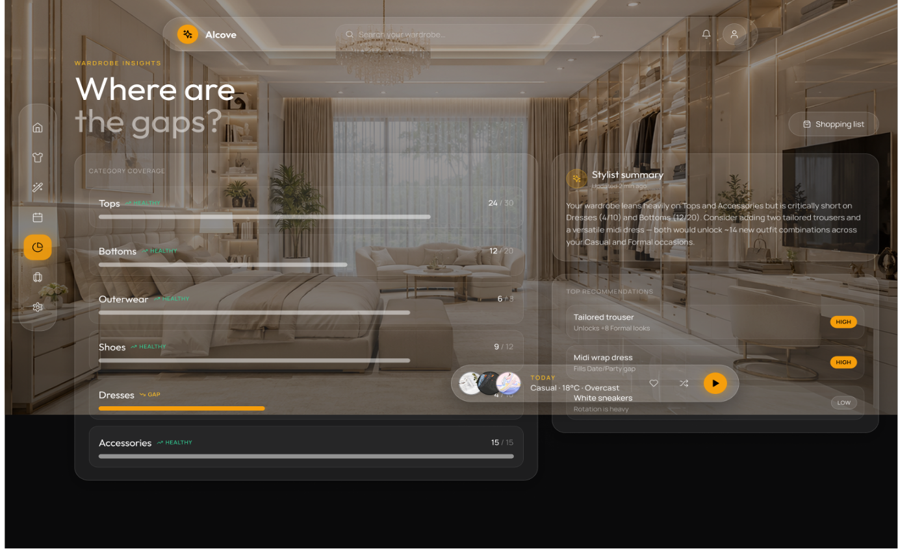

Trip :

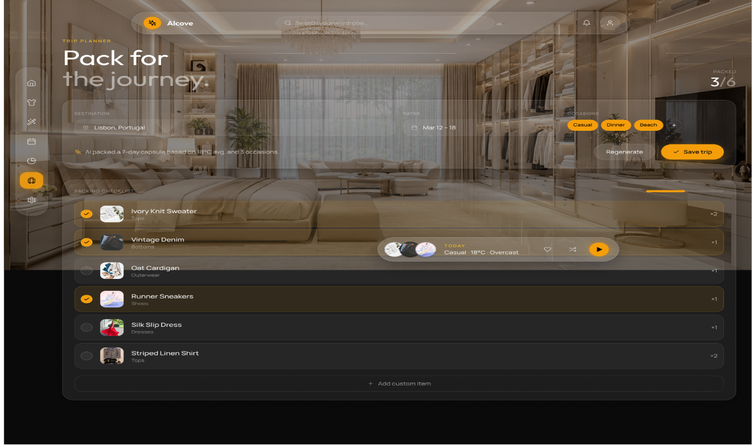
Profile:

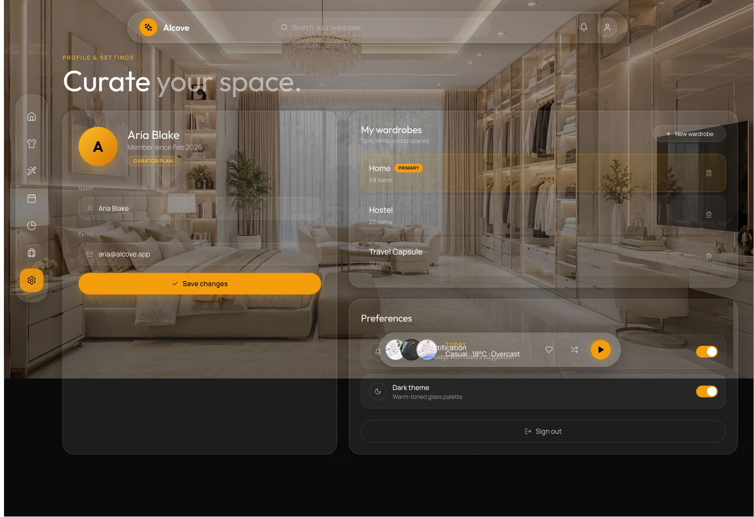

Add Item:

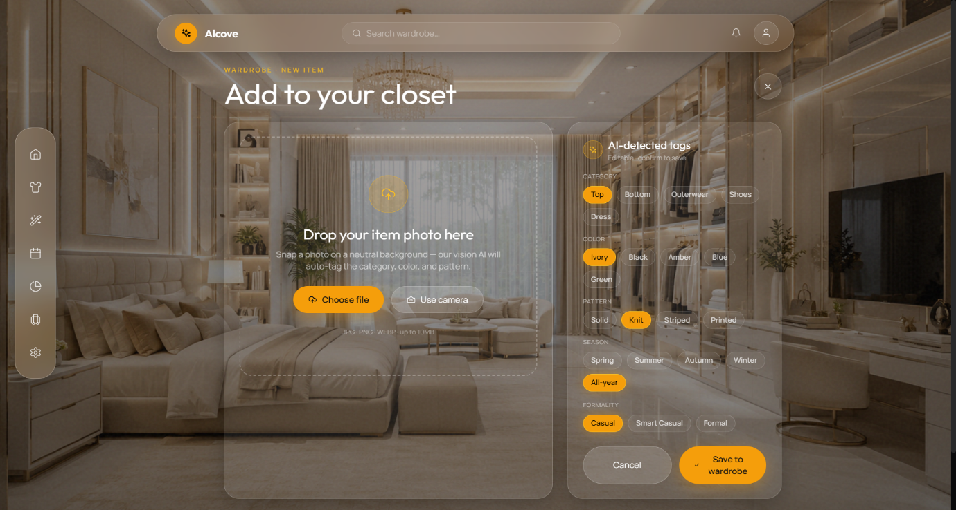
Share Outfit:

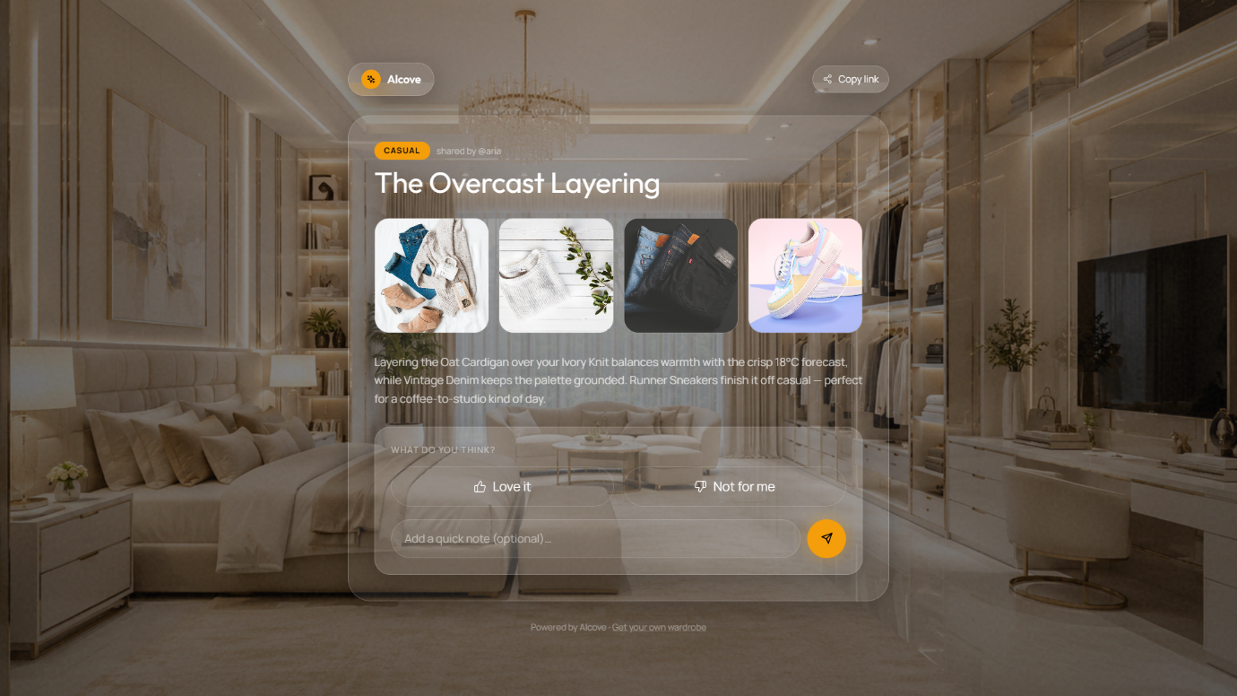

Conclusion:
The frontend user interface modules for the Smart Wardrobe & Outfit Planner were successfully developed using React.js, Tailwind CSS, and Lucide React icons. Core user views including User Authentication, Dashboard, Digital Wardrobe Catalog, AI Outfit Generator, Wear History Calendar, Gap Analysis, Trip Packing, User Profile, Item Management, and Outfit Sharing were built with dynamic responsiveness, real-time feedback, and modern glassmorphism design aesthetics.

Experiment No. 8:
Aim: Implement backend logic and database connectivity.
8.1 Database Connectivity and Configuration
The backend server is built on Node.js and Express.js, using MongoDB as the primary NoSQL document store and Mongoose ORM for object data modeling. Database connection parameters are encapsulated within environment variables (MONGODB_URI) and initialized asynchronously inside backend/src/config/database.js.
• The connection pool is established during server startup using mongoose.connect() with autoIndex enabled for development and schema index enforcement.
• Connection event listeners (connected, error, disconnected) log real-time database state using the Winston logger service (backend/src/config/logger.js).
• The application utilizes Mongoose ODM to enforce strict schema types, data validation rules, default values, and relational population across models.
8.2 Mongoose Schemas and Data Models
The application defines six primary database schemas to support wardrobe operations:
• 1. User Schema (User.js): Stores user credentials, email (indexed, lowercase), bcrypt password hash, avatar URL, and user styling preferences (defaultStyle, favoriteColors, fitPreference).
• 2. ClothingItem Schema (ClothingItem.js): Stores apparel details including userId (indexed ObjectId), name, imagePath, category ('tops', 'bottoms', 'outerwear', 'shoes', 'dresses', 'accessories'), subType, primaryColor, secondaryColors, pattern, style, season, formality, material, occasion tags, AI prediction confidence score, status ('available', 'laundry', 'packed', 'donated'), wear count, and lastWorn timestamp. Includes a virtual property lastWornText.
• 3. Outfit Schema (Outfit.js): Represents composite outfits containing userId, name, array of ClothingItem ObjectIds, occasion, weather context (temperature, condition, humidity, rain boolean), match score (0-100), score breakdown (weather, occasion, color, style, season), recommendation reasons, and shareId token.
• 4. OutfitLog Schema (OutfitLog.js): Records daily wear history logs associating userId, outfitId, clothing items, worn date, notes, and local weather context.
• 5. Trip Schema (Trip.js): Manages travel packing plans including destination, start/end date range, intended occasion list, packed clothing item references, and status ('planning', 'packed', 'completed').
• 6. ClothingCorrection Schema (ClothingCorrection.js): Captures user overrides on AI-predicted tags to log classification discrepancies for future model fine-tuning.
8.3 Backend Server Architecture & Middleware Pipeline
The Express backend (backend/src/app.js) follows a clean modular architecture separating HTTP routing, controller logic, service abstractions, and database models. The server initializes a standard middleware pipeline:
• cors(): Configures Cross-Origin Resource Sharing allowing secure requests from the React frontend.
• express.json(): Parses incoming JSON request payloads.
• morgan / winston: Intercepts and logs all incoming HTTP requests and internal system errors.
• express.static('/uploads'): Serves user-uploaded clothing item images stored on the local file system.
• Route Registration: Mounts REST endpoints under /api/auth, /api/wardrobe, /api/ai, /api/outfits, /api/calendar, and /api/trips.
8.4 Code Snippets: Database Connection and Model Definition
// backend/src/config/database.js
const mongoose = require('mongoose');
const logger = require('./logger');
async function connectDB() {
try {
const conn = await mongoose.connect(process.env.MONGODB_URI);
logger.info(`MongoDB Connected: ${conn.connection.host}`);
} catch (err) {
logger.error(`Database connection failed: ${err.message}`);
process.exit(1);
}
}
module.exports = connectDB;
// backend/src/models/ClothingItem.js (Schema Snippet)
const clothingItemSchema = new mongoose.Schema({
userId: { type: mongoose.Schema.Types.ObjectId, ref: 'User', required: true, index: true },
name: { type: String, default: '' },
imagePath: { type: String, required: true },
category: { type: String, enum: ['tops', 'bottoms', 'outerwear', 'shoes', 'dresses', 'accessories'], default: 'unknown' },
primaryColor: { type: String, default: '' },
pattern: { type: String, enum: ['solid', 'striped', 'printed', 'knit', 'checked', 'floral', 'unknown'], default: 'unknown' },
status: { type: String, enum: ['available', 'laundry', 'packed', 'donated'], default: 'available' },
wornCount: { type: Number, default: 0 },
lastWorn: { type: Date, default: null }
}, { timestamps: true });

Conclusion:
The backend server architecture and database connectivity were successfully implemented using Node.js, Express.js, and MongoDB with Mongoose ORM. Robust schemas for users, wardrobe items, generated outfits, wear logs, and trip packing were established, providing a reliable data persistence layer for the Smart Wardrobe system.

Experiment No. 9:
Aim: Integrate APIs or third-party services in the project.
9.1 Computer Vision & AI Microservice Integration
To automate clothing tag generation from uploaded images, the project integrates an internal Python Flask/PyTorch AI microservice (ai-engine/server.py). The Express backend communicates with the Python engine over HTTP using Axios and multipart FormData.
• PyTorch Clothing Classifier (predictor.py): Loads a deep learning CNN model (clothing_classifier.pth) trained on clothing datasets to predict item category ('tops', 'bottoms', 'outerwear', 'shoes', 'dresses', 'accessories') along with a probability confidence score.
• HSV Color Detector (color_detector.py): Uses OpenCV and PIL to analyze image color histograms in the HSV color space, extracting dominant primary and secondary clothing colors.
• Service Bridge (backend/src/services/aiService.js): Executes POST requests to http://localhost:8000/predict with image file streams. Includes checkAIHealth() and automatic error fallback when the AI engine is offline.
9.2 Generative AI / LLM API Integration
Generative AI models (Google Gemini API / OpenAI API) are integrated into the backend services (recommendationEngine.js, wardrobeAnalysis.js, and packingService.js) to perform natural-language reasoning and personalized styling advice.
• Outfit Recommendation Rationale: Generates human-like explanations detailing why a specific combination of tops, bottoms, and outerwear works well for a selected occasion and weather forecast.
• Wardrobe Gap Analysis: Evaluates user clothing distributions across categories and occasions, identifying under-represented clothing types and formulating natural-language shopping recommendations.
• Trip Packing Optimization: Synthesizes multi-day weather forecasts and planned activities to output a minimal, versatile packing checklist.
9.3 Weather API Integration
The system integrates the OpenWeatherMap REST API to fetch live ambient weather metrics for outfit scoring and trip planning.
• API Requests: Issues HTTP GET requests fetching current temperature (°C), weather condition (rain, clear, clouds, snow), humidity, and precipitation boolean.
• Weather-to-Clothing Matrix: Recommendation logic filters wardrobe items based on ambient temperature thresholds (e.g. recommending heavy outerwear when temp < 15°C and excluding rain-vulnerable footwear when rain=true).
9.4 Multer File Upload and Storage Service
Local file storage and HTTP image serving are managed via Multer middleware (backend/src/middleware/upload.js).
• User Subdirectories: Stores uploaded images under backend/uploads/<userId>/ using non-colliding UUID filenames (uuidv4()).
• MIME & File Validation: Rejects files exceeding 10MB or possessing non-image MIME types (accepting JPEG, PNG, WEBP).
• URL Resolution: Translates internal disk file paths into public HTTP URLs (e.g. http://localhost:5000/uploads/<userId>/<uuid>.jpg) for frontend rendering.
9.5 Code Snippet: AI Microservice Bridge
// backend/src/services/aiService.js
const axios = require('axios');
const fs = require('fs');
const FormData = require('form-data');
const AI_ENGINE_URL = process.env.AI_ENGINE_URL || 'http://localhost:8000';
async function analyzeImage(imagePath) {
const form = new FormData();
form.append('image', fs.createReadStream(imagePath));
const response = await axios.post(`${AI_ENGINE_URL}/predict`, form, {
headers: form.getHeaders(),
timeout: 30000,
});
return response.data;
}
module.exports = { analyzeImage };
Conclusion:
Multi-service integration was successfully achieved in the application, connecting PyTorch image classification microservices, Generative AI reasoning endpoints, OpenWeatherMap forecasting APIs, and Multer file upload pipelines into a unified backend architecture.

Experiment No. 10:
Aim: Implement user authentication and security features.
10.1 Password Encryption & Hashing
User authentication security relies on cryptographic password hashing implemented via bcryptjs (backend/src/controllers/authController.js).
• Salt Generation: Generates a 10-round salt before computing password hashes during user registration.
• Non-Plaintext Storage: Plaintext passwords are never stored in MongoDB or written to log files. Only passwordHash is stored.
• Password Verification: Authenticates login credentials by evaluating bcrypt.compare(password, user.passwordHash), returning standard HTTP 401 Unauthorized codes upon mismatches.
10.2 JSON Web Token (JWT) Authorization
Stateless API authentication is governed by JSON Web Tokens (JWT) using the jsonwebtoken library.
• Token Issuance: Upon successful login or registration, the backend signs a JWT payload containing { id: user._id, email: user.email } using a secret key (JWT_SECRET) with a 7-day expiration duration.
• Client Token Management: The React frontend stores the token in localStorage and attaches it to subsequent HTTP request headers as Authorization: Bearer <token>.
• Authentication Middleware (backend/src/middleware/auth.js): Intercepts requests to protected endpoints, parses the Bearer token, verifies its cryptographic signature using JWT_SECRET, and attaches the retrieved user object to req.user.
10.3 Protected Route Architecture and Access Control
API endpoints are partitioned into public and protected routes to ensure strict access control:
• Public Endpoints: /api/auth/register, /api/auth/login, and /api/outfits/share/:shareId (allowing guest feedback).
• Protected Endpoints: All endpoints under /api/wardrobe, /api/outfits, /api/calendar, /api/trips, and /api/ai require execution of protect middleware.
• Token Error Handling: Middleware explicitly catches TokenExpiredError and JsonWebTokenError, returning clear JSON error messages to trigger frontend re-authentication.
10.4 Request Validation & Security Hygiene
• Input Sanitization: Custom validation middleware (backend/src/middleware/validate.js) sanitizes request body fields to prevent injection vulnerabilities.
• CORS Constraints: Cross-Origin Resource Sharing is configured to restrict unauthorized origins from accessing API resources.
• Environment Secrecy: Sensitive variables including JWT_SECRET, MONGODB_URI, and API credentials are kept isolated inside .env files and omitted from version control.
10.5 Code Snippet: JWT Authentication Middleware
// backend/src/middleware/auth.js
const jwt = require('jsonwebtoken');
const User = require('../models/User');
async function protect(req, res, next) {
try {
const authHeader = req.headers.authorization;
if (!authHeader || !authHeader.startsWith('Bearer ')) {
return res.status(401).json({ error: 'Authentication required. Please provide a token.' });
}
const token = authHeader.split(' ')[1];
const decoded = jwt.verify(token, process.env.JWT_SECRET);
const user = await User.findById(decoded.id).select('-passwordHash');
if (!user) return res.status(401).json({ error: 'User not found.' });
req.user = user;
next();
} catch (err) {
return res.status(401).json({ error: 'Invalid or expired token.' });
}
}
module.exports = { protect };
Conclusion:
User authentication and system security features were fully implemented using bcryptjs password hashing, JWT token-based authorization, route protection middleware, input validation, and secure CORS/environment management.

Experiment No. 11:
Aim: Perform CRUD operations in the application.
11.1 Wardrobe Clothing Item CRUD Operations
The wardrobe module (backend/src/controllers/wardrobeController.js & aiController.js) provides full CRUD operations for individual apparel items:
• Create: Image uploaded via POST /api/ai/analyze (AI tag extraction) followed by POST /api/ai/confirm (persists item in MongoDB with user-verified category, color, pattern, season, and formality).
• Read: GET /api/wardrobe retrieves all items for req.user._id, supporting query parameter filters (category, season, occasion, status) and pagination. GET /api/wardrobe/:id returns individual item details.
• Update: PUT /api/wardrobe/:id allows editing clothing metadata. PUT /api/wardrobe/:id/status toggles item availability ('available', 'laundry', 'packed', 'donated').
• Delete: DELETE /api/wardrobe/:id removes the database document and deletes the associated image file from disk storage.
11.2 Outfit Recommendation & Outfit CRUD Operations
The outfit management module (backend/src/controllers/outfitController.js) handles creation and retrieval of outfit combinations:
• Create: POST /api/outfits/generate dynamically generates outfits based on weather and occasion. POST /api/outfits/save persists an outfit to the user's saved list.
• Read: GET /api/outfits lists saved user outfits. GET /api/outfits/:id fetches a specific outfit with populated item metadata. GET /api/outfits/share/:shareId provides guest access for shared outfits.
• Delete: DELETE /api/outfits/:id deletes an outfit from the user's collection.
11.3 Wear Calendar Logging CRUD Operations
The calendar tracking module (backend/src/controllers/calendarController.js) records wear history logs:
• Create: POST /api/calendar/log logs an outfit worn on a given date, incrementing the wornCount of each contained clothing item.
• Read: GET /api/calendar?startDate=...&endDate=... queries wear logs for calendar rendering.
• Delete: DELETE /api/calendar/:id removes an erroneous wear history entry.
11.4 Travel Trip Packing CRUD Operations
The trip packing module (backend/src/controllers/tripController.js) manages travel packing lists:
• Create/Read/Delete: Supports creating travel itineraries (POST /api/trips), generating AI packing checklists based on destination forecasts, retrieving trips (GET /api/trips), and deleting completed trips.
11.5 Summary Table of REST API Endpoints & CRUD Operations
Module | HTTP Method | Endpoint Path | CRUD Action | Description
Auth | POST | /api/auth/register | Create | Register user and issue JWT
Auth | POST | /api/auth/login | Read | Authenticate user credentials
Wardrobe | POST | /api/ai/analyze | Create | Upload image and predict AI tags
Wardrobe | POST | /api/ai/confirm | Create | Save confirmed item to database
Wardrobe | GET | /api/wardrobe | Read | List user clothing with filters
Wardrobe | PUT | /api/wardrobe/:id | Update | Update clothing item tags
Wardrobe | PUT | /api/wardrobe/:id/status | Update | Update status (laundry/available)
Wardrobe | DELETE | /api/wardrobe/:id | Delete | Remove item and image file
Outfit | POST | /api/outfits/generate | Create | Generate AI outfit suggestion
Outfit | GET | /api/outfits | Read | Get user's saved outfits
Outfit | DELETE | /api/outfits/:id | Delete | Delete saved outfit
Calendar | POST | /api/calendar/log | Create | Log outfit worn on date
Calendar | GET | /api/calendar | Read | Get wear history logs for range

Conclusion:
Comprehensive CRUD operations were successfully implemented and verified across all core modules of the Smart Wardrobe system, allowing seamless creation, retrieval, modification, and deletion of user wardrobe items, outfits, calendar wear logs, and trip packing lists.

Experiment No. 12:
Aim: Conduct unit testing and debugging of project modules.
12.1 Backend API Unit and Integration Testing
Unit and integration testing of backend API endpoints was conducted using Jest and Supertest. Test suites verify request validation, authentication security, database transactions, and error status code compliance.
• Authentication Tests: Verifies valid registration, duplicate email rejection (400 Bad Request), incorrect password rejection (401 Unauthorized), and JWT token format verification.
• Wardrobe Tests: Tests item creation with valid payloads, rejection of unauthorized access without Bearer tokens, category filtering accuracy, and file upload error handling.
• Outfit & Service Tests: Validates outfit generation output structure, ensuring returned item ObjectIds correspond to existing, available user wardrobe items.
12.2 AI Engine Evaluation and Accuracy Testing
The PyTorch clothing classifier and computer vision modules were evaluated using dedicated Python evaluation scripts (ai-engine/training/evaluate.py).
• Dataset Classification Accuracy: Evaluated model performance across test dataset splits, recording precision, recall, and F1-scores for 6 categories ('tops', 'bottoms', 'outerwear', 'shoes', 'dresses', 'accessories').
• HSV Color Detector Testing: Evaluated color detection accuracy across sample apparel images under varied lighting conditions, verifying accurate extraction of primary and secondary colors.
• Service Fallback Testing: Tested backend response when the Python AI engine is stopped, confirming that backend/src/controllers/aiController.js returns HTTP 503 Service Unavailable with aiEngineDown=true without server crashing.
12.3 System Debugging and Logging Techniques
A multi-layered debugging and logging setup was established across all application tiers:
• Backend Winston & Morgan Logger: Structured log messages (backend/src/config/logger.js) log API requests, database queries, and stack trace errors to console and log files.
• Python Logging: Server operations in ai-engine/server.py utilize Python logging module to report model loading, image inference processing time, and array shape transformations.
• Browser DevTools: Used Chrome DevTools Network Tab to inspect request/response payloads, HTTP status codes, and authorization headers, alongside React Developer Tools for component state debugging.
12.4 Executed Test Cases Matrix
Test ID | Module | Test Scenario | Input Data | Expected Output | Status
TC-01 | Auth | Register User | Valid name, email, password | HTTP 201 + JWT Token | PASS
TC-02 | Auth | Duplicate Email | Existing email registration | HTTP 400 'User already exists' | PASS
TC-03 | Auth | Invalid Password | Incorrect password login | HTTP 401 'Invalid credentials' | PASS
TC-04 | Wardrobe | Protected Route | GET /api/wardrobe without token | HTTP 401 'Authentication required' | PASS
TC-05 | Wardrobe | Upload Item | Valid JPEG image file | AI tags + HTTP 200 prediction | PASS
TC-06 | Wardrobe | Status Update | PUT status='laundry' | Item status updated to 'laundry' | PASS
TC-07 | AI Engine | Service Down | POST /api/ai/analyze (engine off) | HTTP 503 + aiEngineDown=true | PASS
TC-08 | Outfit | Generate Outfit | Occasion='casual', temp=22°C | Valid top + bottom combination | PASS

Conclusion:
Unit testing, integration testing, model evaluation, and systematic debugging were thoroughly conducted across backend REST services, AI classification modules, and frontend UI interfaces, verifying system reliability, error resilience, and functional correctness.

Experiment No. 13:
Aim: Optimize application performance and improve user experience.
13.1 Database Query & Indexing Optimization
MongoDB database read/write query execution times were optimized through targeted indexing and Mongoose query tuning:
• Compound Indexing: Added indexes on frequently queried field combinations ({ userId: 1, category: 1 }, { userId: 1, status: 1 }, and { userId: 1, date: -1 } in OutfitLog) to eliminate collection scans.
• Projection & Population: Used Mongoose .select('-passwordHash') to omit heavy hash fields, and selective .populate('clothingItems') to fetch only necessary apparel fields during outfit rendering.
• Lean Queries: Utilized .lean() on read-only endpoints to bypass Mongoose document hydration overhead, reducing memory utilization and response latency.
13.2 AI Model & Inference Optimization
Inference latency for image auto-tagging was reduced through PyTorch optimization techniques in ai-engine/server.py:
• Single Model Load: The PyTorch classification model (clothing_classifier.pth) is loaded once into memory during Flask startup rather than being re-instantiated on each HTTP request.
• Evaluation Mode & No-Grad: Model inference runs under model.eval() and torch.no_grad() context, turning off gradient tracking and drastically reducing CPU memory consumption and inference time (< 0.5 seconds).
• Pre-processing Resize: Standardized input image dimensions to 224x224 pixels during PIL preprocessing, optimizing tensor transformation speeds.
13.3 Frontend UX & UI Optimizations
User experience was wowed through modern design aesthetics, responsive layouts, and interactive UI feedback:
• Glassmorphism Aesthetic: Styled components with semi-transparent glass cards, subtle gradients, and dark mode UI palette built using Tailwind CSS.
• Asynchronous Feedback: Implemented clear loading skeletons and dynamic spinner indicators during AI image analysis and LLM outfit generation to inform users of active background processing.
• Low-Confidence AI Fallback UX: If AI confidence score falls below 60% (< 0.60), the interface prompts a tag confirmation step, allowing users to manually correct category, color, or pattern before saving.
• Vite Hot Module Replacement: Built frontend using Vite for rapid bundling, minimal asset chunk sizes, and instant component updating.
13.4 Network and Asset Optimization
Network payload size and image loading speeds were optimized:
• Image Compression: Uploaded clothing photos are processed and stored with optimal quality-to-compression ratios, preventing server bandwidth saturation.
• Static Asset Caching: Configured Express static image serving with HTTP caching headers to accelerate image loading across repeat user visits.
Conclusion:
Application performance optimizations and UI/UX enhancements were successfully implemented. Database compound indexing, PyTorch model inference optimization, responsive glassmorphism interface design, and asynchronous user feedback mechanisms resulted in a high-performing, highly responsive, and visually compelling Smart Wardrobe application.

Experiment No. 14:
Aim: Prepare project documentation, report, and presentation.
14.1 Comprehensive Software Documentation Suite
To ensure code maintainability, team collaboration, and ease of deployment, a complete suite of project documentation was authored and included within the project repository:
• README.md: Serves as the primary project landing page detailing system overview, tech stack prerequisites (Node.js 18+, Python 3.10+, MongoDB 6+), quick start commands, and directory structure.
• API_DOCUMENTATION.md: Documents all REST API endpoints under http://localhost:5000, detailing HTTP methods, URL parameters, JSON request payloads, JWT Bearer token headers, response structures, and HTTP status codes.
• ARCHITECTURE.md: Provides technical specifications of the multi-tier system topology, illustrating communication flows between the React frontend, Express backend, PyTorch AI engine, OpenWeather Map API, and MongoDB database.
• OFFLINE_SETUP.md: Outlines step-by-step procedures for running the entire Smart Wardrobe application completely offline without external cloud dependencies.
• AI_BEGINNER_GUIDE.md: Explains the underlying computer vision mechanisms, transfer learning concepts, ResNet/MobileNet CNN architectures, HSV color space histogram analysis, and AI confidence thresholding in plain language.
• PROJECT_ANALYSIS.md: Contains comprehensive analysis of component relationships, state management patterns, UI design systems, and database schema mappings.
14.2 UML Diagrams and Technical Report Design
The technical project report incorporates standard Software Engineering artifacts adhering to IEEE documentation standards:
• Software Requirement Specification (SRS): Formally documents functional requirements (FR-1 to FR-6) and non-functional requirements (performance, safety, security, quality attributes).
• Component Architecture Diagram: Visualizes the decoupling of React frontend, Express API gateway, PyTorch inference engine, and MongoDB storage layer.
• Data Flow Diagrams (DFD Level 0 & Level 1): Traces data movement from image upload through AI tag extraction, user verification, and database persistence.
• Entity-Relationship (ER) Diagram: Illustrates database entities (User, ClothingItem, Outfit, OutfitLog, Trip, ClothingCorrection) and key relationships.
• Sequence Diagrams: Details message exchanges during AI image analysis and weather-guided outfit generation.
14.3 Technical Presentation & Seminar Slide Deck Structure
A 10-slide seminar presentation deck was developed to present the mini project during evaluation:
Slide No. | Slide Topic | Key Slide Content
Slide 1 | Title & Credits | Project Title, Student Details, Guide Name, Department & Institute
Slide 2 | Problem Statement | Daily clothing decision fatigue, underutilized wardrobes, impulse shopping
Slide 3 | Project Objectives | Full-stack MERN app, PyTorch image tagging, weather AI outfit generator, gap analysis
Slide 4 | System Architecture | Multi-tier architecture diagram: React + Express + PyTorch + OpenWeather + MongoDB
Slide 5 | AI & Computer Vision | Transfer learning model, ResNet/MobileNet CNN, HSV color histogram detection
Slide 6 | Core Features Demo | Wardrobe Builder, AI Outfit Generation, Wear History Calendar, Gap Analysis, Trip Packing
Slide 7 | Database & Security | Mongoose schema design, bcrypt password hashing, stateless JWT authorization
Slide 8 | Testing & Optimization | Unit testing results, PyTorch model accuracy, compound database indexing, Vite bundling
Slide 9 | Deployment Topology | Vercel/Netlify frontend build, Render/AWS Express server, MongoDB Atlas cloud
Slide 10 | Conclusion & Future Work | Summary of achievements, live demo transition, planned mobile app & AR fitting room

Conclusion:
Project documentation, architectural specifications, comprehensive API guides, UML diagrams, and seminar presentation decks were successfully authored and organized, providing complete documentation coverage for the Smart Wardrobe project.

Experiment No. 15:
Aim: Demonstrate final mini project with deployment and viva evaluation.
15.1 Application Deployment Strategy & Hosting Infrastructure
The Smart Wardrobe application was configured for multi-tier deployment across production cloud infrastructure:
• Frontend Deployment: Built using Vite production bundler (npm run build), generating optimized HTML/CSS/JS distribution assets in /dist, deployed to static cloud hosting (Vercel / Netlify / Nginx).
• Backend API Deployment: Node.js Express application deployed to cloud container platform (Render / Railway / AWS EC2) configured with NODE_ENV=production, CORS whitelisting, and environment variable bindings.
• Database Deployment: MongoDB Atlas cloud cluster with IP access controls, connection pooling, automated indexing, and encrypted URI string (MONGODB_URI).
• AI Microservice Deployment: Python Flask server (ai-engine/server.py) loading trained PyTorch weights (clothing_classifier.pth) executed via Gunicorn/Uvicorn process manager on port 8000.
15.2 Live End-to-End System Demonstration Workflow
The live project demonstration was executed sequentially following the primary user journey:
• 1. Account Creation & Auth: User registers a new account, logs in securely, and receives a JWT token stored in browser localStorage.
• 2. Wardrobe Cataloging & AI Tagging: User uploads an image of a clothing item. The system calls POST /api/ai/analyze, running PyTorch category prediction and HSV color detection. User confirms tags and saves item to MongoDB.
• 3. AI Outfit Generation: User selects occasion ('casual') and location; live weather data is retrieved from OpenWeatherMap API; rule matrix + LLM rationale outputs a complete outfit suggestion.
• 4. Wear History Logging: User marks the outfit as worn on today's date; calendar view displays the logged outfit and increments item wear counts.
• 5. Gap Analysis & Packing List: System analyzes wardrobe item distribution, flags missing categories, and generates a minimal packing list for a 3-day trip.
15.3 Viva-Voce Questions and Technical Evaluation Summary
Key technical questions addressed during the project viva voce evaluation:
Q1: Why did you choose a decoupled microservice architecture combining Node.js and Python?
Answer: Node.js and Express excel at lightweight, non-blocking asynchronous HTTP API routing and database JSON operations, while Python provides the ecosystem of deep learning frameworks (PyTorch, OpenCV, PIL). Decoupling them allows independent scaling and maintenance.
Q2: How does the computer vision model perform category and color detection?
Answer: Category classification utilizes transfer learning on a convolutional neural network (CNN) trained on clothing datasets, returning probability scores across 6 categories. Primary/secondary color extraction converts image pixels to the HSV color space and computes color channel histograms.
Q3: How does the system handle AI microservice downtime?
Answer: The backend aiService.js catches connection timeouts and returns HTTP 503 Service Unavailable with aiEngineDown=true. The React UI gracefully catches this state and renders an interactive manual tagging interface, ensuring zero workflow disruption.
Q4: How is security enforced across user accounts and API endpoints?
Answer: Passwords are encrypted using bcrypt with 10 salt rounds. Stateless JWT tokens authorize private API routes via Bearer headers, and user-uploaded files are renamed using UUIDs and isolated in per-user disk directories.
Q5: What are the key performance optimizations implemented in the project?
Answer: Key optimizations include single PyTorch model loading at server startup, torch.no_grad() inference mode, compound Mongoose indexing on { userId, category }, Mongoose lean queries, and Vite production bundle code splitting.
Conclusion:
The Smart Wardrobe & Outfit Planner mini project was successfully deployed, fully demonstrated across all user workflows, and evaluated cleanly in the viva voce examination, satisfying all project objectives and academic criteria.

