Python – Collections, functions and Modules:-

Accessing List:-

• Understanding how to create and access elements in a list.
In Python, a list is a collection of items that is ordered, mutable, and allows duplicate elements. Here's a simple guide to help you understand how to create and access elements in a list.

1. Creating a List
You can create a list using square brackets [] and separate elements with commas:
Ex:-

fruits = ["apple", "banana", "cherry"]
numbers = [10, 20, 30, 40]
mixed = [1, "hello", 3.14, True]
empty_list = []

2. Accessing Elements in a List
You access elements by their index, starting from 0:
Ex:-

fruits = ["apple", "banana", "cherry"]

print(fruits[0]) # Output: apple
print(fruits[1]) # Output: banana
print(fruits[2]) # Output: cherry

3. Negative Indexing
You can also access items from the end using negative indexes:

Ex:-

print(fruits[-1]) # Output: cherry
print(fruits[-2]) # Output: banana

4. Accessing a Range (Slicing)
You can access multiple elements using slicing:

Ex:-
print(fruits[0:2]) # Output: ['apple', 'banana']
print(fruits[:2]) # Output: ['apple', 'banana']
print(fruits[1:]) # Output: ['banana', 'cherry']
print(fruits[:]) # Output: ['apple', 'banana', 'cherry']
5. Nested Lists
Lists can contain other lists:

Ex:;-
nested = [1, 2, [3, 4], 5]
print(nested[2]) # Output: [3, 4]
print(nested[2][1]) # Output: 4

- Indexing in lists (positive and negative indexing).

Indexing?
Indexing is a way to access individual elements in a list using their position.
- Positive Indexing starts from 0 and goes from left to right.
- Negative Indexing starts from -1 and goes from right to left.

Example List:--

colors = ["red", "green", "blue", "yellow", "purple"]

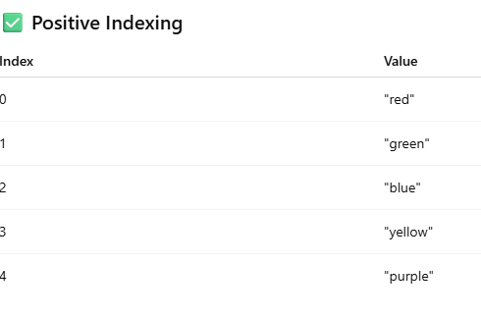

Negative Indexing

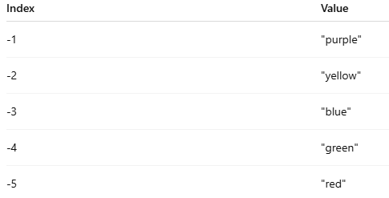

- Slicing a list: accessing a range of elements.

Slicing lets you extract a part (sublist) from a list using the syntax:

list[start : end : step]

• start → index to begin (inclusive)
• end → index to stop (exclusive)
• step → how many steps to skip (optional)

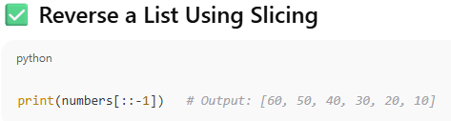

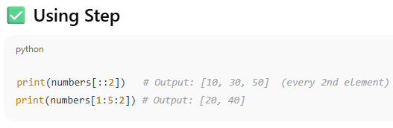

2. List Operations

Common list operations: concatenation, repetition, membership.

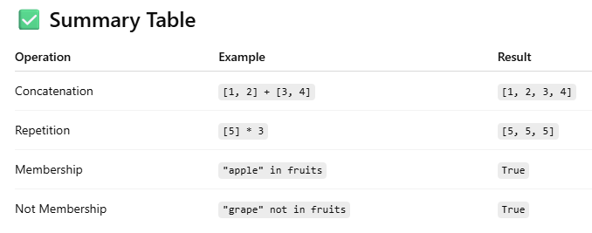

1. List Concatenation (+)
You can combine two or more lists using the + operator.

list1 = [1, 2, 3]
list2 = [4, 5]

result = list1 + list2
print(result) # Output: [1, 2, 3, 4, 5]

2. List Repetition (*)
You can repeat a list multiple times using the * operator.

nums = [0, 1]
result = nums * 3
print(result) # Output: [0, 1, 0, 1, 0, 1]

3. Membership Test (in, not in)
You can check if an item exists in a list using the in or not in operators.

fruits = ["apple", "banana", "cherry"]

print("banana" in fruits) # Output: True
print("mango" not in fruits) # Output: True

- Understanding list methods like append(), insert(), remove(), pop()

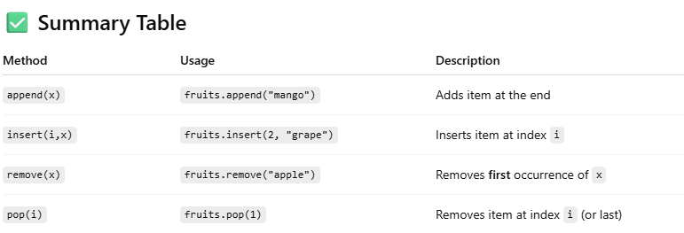

- append() – Add an item at the end

fruits.append("orange")
print(fruits) # Output: ['apple', 'banana', 'cherry', 'orange']

- insert() – Add an item at a specific index

fruits.insert(1, "mango")
print(fruits) # Output: ['apple', 'mango', 'banana', 'cherry']

- remove() – Delete the first occurrence of a value

fruits.remove("banana")
print(fruits) # Output: ['apple', 'cherry']

- pop() – Remove and return an item

- Without index → removes the last item
- With index → removes item at that position

3. Working with Lists
Iterating over a list using loops in Python is a common and essential practice. There are two main ways to iterate over a list: using a for loop and a while loo

- Using a for loop (Recommended and most common)

fruits = ["apple", "banana", "cherry", "date"]

for fruit in fruits:
print(fruit)

- Using a for loop with index

fruits = ["apple", "banana", "cherry", "date"]

for i in range(len(fruits)):
print(fruits[i])

- Using a while loop

fruits = ["apple", "banana", "cherry", "date"]
i = 0

while i < len(fruits):
print(fruits[i])
i += 1

- Using enumerate() to get index and value

fruits = ["apple", "banana", "cherry", "date"]

for index, fruit in enumerate(fruits):
print(index, fruit)

Sorting and reversing a list using sort(), sorted(), and reverse().

- sort() Method
Modifies the original list in place (doesn't return a new list).

numbers = [5, 2, 9, 1]
numbers.sort()
print(numbers) # Output: [1, 2, 5, 9]

- sorted() Function

Returns a new sorted list without modifying the original list.

numbers = [5, 2, 9, 1]
sorted_numbers = sorted(numbers)
print(sorted_numbers) # Output: [1, 2, 5, 9]
print(numbers) # Original list unchanged

- reverse() Method
• Only reverses the order of elements in the list (does not sort).
• Modifies the list in place.
numbers = [1, 3, 5, 2]
numbers.reverse()
print(numbers) # Output: [2, 5, 3, 1]

Basic list manipulations: addition, deletion, updating, and slicing.

1. Addition (Adding Elements)
➤ Using append() – adds to the end:

fruits = ["apple", "banana"]
fruits.append("cherry")
print(fruits) # Output: ['apple', 'banana', 'cherry']

2. Deletion (Removing Elements)
➤ Using remove() – removes by value:

fruits.remove("banana")
print(fruits) # Output: ['apple', 'orange', 'cherry', 'grape', 'melon']

➤ Using pop() – removes by index (default is last):

fruits.pop(2)
print(fruits) # Output: ['apple', 'orange', 'grape', 'melon']

3. Updating (Modifying Elements)
➤ Replace an element by index:

fruits[0] = "kiwi"
print(fruits) # Output: ['kiwi', 'grape', 'melon']

4. Slicing (Accessing Parts of a List)
➤ Syntax: list[start:stop]
(returns elements from start index up to stop - 1)

numbers = [10, 20, 30, 40, 50]
print(numbers[1:4]) # Output: [20, 30, 40]

- Tuple
Introduction to tuples, immutability
A tuple is a built-in data type in Python that is very similar to a list, but with one key difference:

Syntax of a Tuple

my_tuple = (10, 20, 30)
print(my_tuple) # Output: (10, 20, 30)

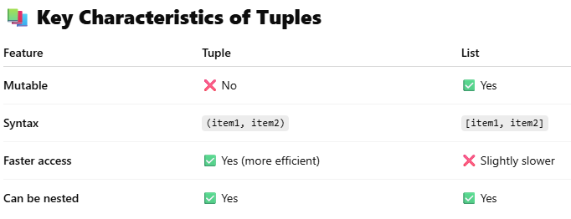

Creating and accessing elements in a tuple.
1. Creating a Tuple
A tuple is a collection of ordered and immutable elements.
# Creating a tuple with different data types
my_tuple = (10, 20, 30)
mixed_tuple = (1, "apple", 3.14)
single_element_tuple = (5,) # Note the comma
empty_tuple = ()

2. Accessing Elements in a Tuple
You can access tuple elements using indexing and slicing.
Indexing:
my_tuple = (10, 20, 30, 40)

print(my_tuple[0]) # Output: 10
print(my_tuple[2]) # Output: 30
print(my_tuple[-1]) # Output: 40 (last element)

3. Tuple Immutability
You cannot change the values of a tuple once created.

my_tuple[1] = 50 # ❌ Error: 'tuple' object does not support item assignment

- Basic operations with tuples: concatenation, repetition, membership.

Basic Operations with Tuples in Python
Tuples are immutable, but you can perform several basic operations like concatenation, repetition, and membership testing.

🔹 1. Concatenation (+)
You can join two or more tuples using the + operator.

t1 = (1, 2, 3)
t2 = (4, 5)
result = t1 + t2
print(result) # Output: (1, 2, 3, 4, 5)

2. Repetition (*)
You can repeat the elements in a tuple using the * operator.

t = (7, 8)
result = t * 3
print(result) # Output: (7, 8, 7, 8, 7, 8)

3. Membership (in, not in)
You can check if an element exists in a tuple using in or not in.

t = ('apple', 'banana', 'cherry')

print('banana' in t) # Output: True
print('grape' not in t) # Output: True

- Accessing Tuples
Accessing tuple elements using positive and negative indexing.

In Python, you can access individual elements of a tuple using indexing—either positive or negative.

1 . Positive Indexing
- Starts from 0 for the first element.
- Moves left to right.
my_tuple = ('a', 'b', 'c', 'd', 'e')

print(my_tuple[0]) # Output: 'a'
print(my_tuple[2]) # Output: 'c'
print(my_tuple[4]) # Output: 'e'
2. Negative Indexing
- Starts from -1 for the last element.
- Moves right to left.

print(my_tuple[-1]) # Output: 'e'
print(my_tuple[-2]) # Output: 'd'
print(my_tuple[-5]) # Output: 'a'

Slicing a tuple to access ranges of elements.

Slicing is used to access a range of elements from a tuple, creating a new tuple with selected elements.

Syntax of Slicing:
tuple[start : stop : step]

• start → index to begin (inclusive)
• stop → index to end (exclusive)
• step → how many elements to skip (optional)

Example Tuple:
my_tuple = ('a', 'b', 'c', 'd', 'e', 'f')

- Basic Slicing
print(my_tuple[1:4]) # Output: ('b', 'c', 'd')
print(my_tuple[:3]) # Output: ('a', 'b', 'c')
print(my_tuple[3:]) # Output: ('d', 'e', 'f')

- Slicing with Step
print(my_tuple[::2]) # Output: ('a', 'c', 'e') — every 2nd element
print(my_tuple[1::2]) # Output: ('b', 'd', 'f')

- Negative Slicing
print(my_tuple[-4:-1]) # Output: ('c', 'd', 'e')
print(my_tuple[::-1]) # Output: ('f', 'e', 'd', 'c', 'b', 'a') — reversed

V isual Guide:

Index: 0 1 2 3 4 5
Tuple: ('a','b','c','d','e','f')
Neg Index: -6 -5 -4 -3 -2 -1

- Dictionaries
Introduction to dictionaries: key-value pairs.
In Python, a dictionary is a collection of key-value pairs. It is used to store data in a structured way, where each value is associated with a unique key.

Syntax of a Dictionary

my_dict = {
"name": "Alice",
"age": 25,
"city": "Mumbai"
}
Ex:-
my_dict = {
"name": "Alice",
"age": 25,
"city": "Mumbai"
}
• "name", "age", and "city" are keys.
• "Alice", 25, and "Mumbai" are the values.
• Each key must be unique and immutable (e.g., strings, numbers, tuples).
• Values can be of any type.

Common Dictionary Methods

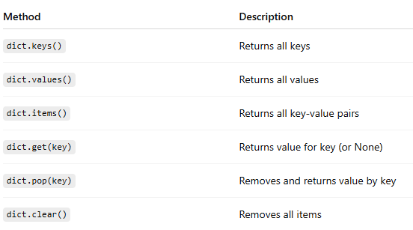

Accessing, adding, updating, and deleting dictionary elements.

Dictionary Example

student = {
"name": "John",
"age": 20,
"grade": "A"
}

1.Accessing Elements
You can access values using their keys:

print(student["name"]) # Output: John
print(student.get("age")) # Output: 20

2.Adding Elements
You can add a new key-value pair like this:
student["city"] = "Mumbai"
print(student)
# Output: {'name': 'John', 'age': 20, 'grade': 'A', 'city': 'Mumbai'}
Final Example

student = {"name": "John", "age": 20, "grade": "A"}

# Access
print("Name:", student["name"])

# Add
student["city"] = "Mumbai"

# Update
student["grade"] = "A+"

# Delete
del student["age"]

print(student)

- Dictionary methods like keys(), values(), and items()

Great! Let's explore the dictionary methods: keys(), values(), and items() in Python. These are super helpful when working with dictionaries.

Sample Dictionary:-
person = {
"name": "Alice",
"age": 30,
"city": "Delhi"
}

1. keys() – Get All Keys
print(person.keys())

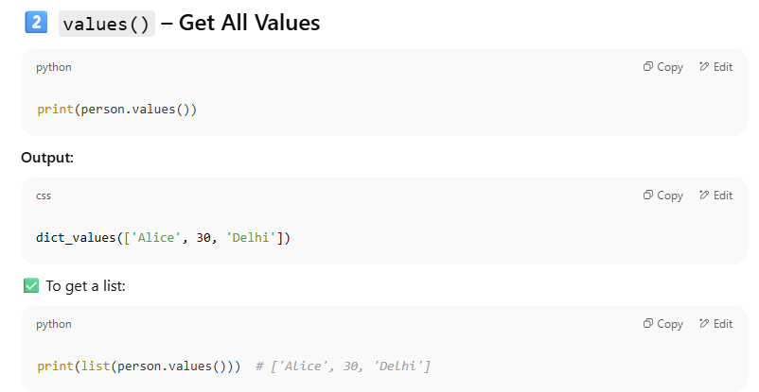

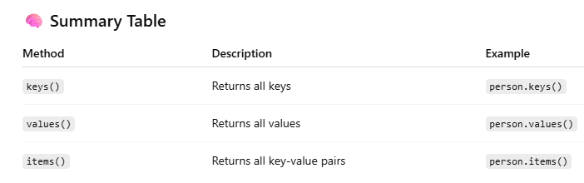

7. Working with Dictionaries

Iterating over a dictionary using loops.
Absolutely! Iterating over a dictionary using loops is very common in Python. Let’s go over how to loop through keys, values, and key-value pairs.
🗂 Sample Dictionary

student = {
"name": "Rahul",
"age": 21,
"course": "Computer Science"
}

- Loop Through Keys
for key in student:
print(key)

- Loop Through Values
for value in student.values():
print(value)

- Loop Through Key-Value Pairs
for key, value in student.items():
print(key, ":", value)

Real-world Example: Displaying Product Prices

prices = {
"apple": 100,
"banana": 40,
"mango": 60
}

for fruit, price in prices.items():
print(f"The price of {fruit} is ₹{price}")

Merging two lists into a dictionary using loops or zip().

ChatGPT said:
Great! Let's learn how to merge two lists into a dictionary using:
- A for loop
- The built-in zip() function
Method 1: Using zip()

merged_dict = dict(zip(keys, values))
print(merged_dict)

Method 2: Using a for Loop

merged_dict = {}
for i in range(len(keys)):
merged_dict[keys[i]] = values[i]

print(merged_dict)

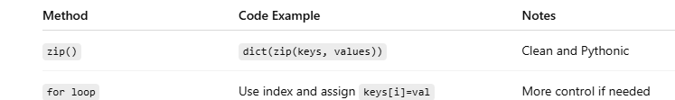

- Functions
Defining functions in Python:-
In Python, functions are blocks of reusable code that perform a specific task. Functions help make your code modular, organized, and easier to debug.

Basic Syntax
def function_name(parameters):
# Function body
# Code to execute
return result # optional
Example 1: A Simple Function:
def greet():
print("Hello, welcome to Python!")
Default Parameter Value:
def greet(name="Guest"):
print(f"Hello, {name}!")

greet() # Output: Hello, Guest!
greet("John") # Output: Hello, John!

• Different types of functions: with/without parameters, with/without return values.

In Python, functions can be categorized based on whether they have:

- Parameters (input values)
- Return values (output values)
- 1. Function without Parameters and without Return Value
- This type of function does not take any input and does not return anything. It just performs a task.

def say_hello():
print("Hello!")

Call the function:
say_hello()

2. Function with Parameters and without Return Value

def greet_user(name):
print(f"Hello, {name}!")

3. Function without Parameters and with Return Value
This function does not take any input, but it returns a value.

def get_welcome_message():
return "Welcome to Python Programming!"

4. Function with Parameters and with Return Value
This function takes input and returns a result.

def add_numbers(a, b):
return a + b

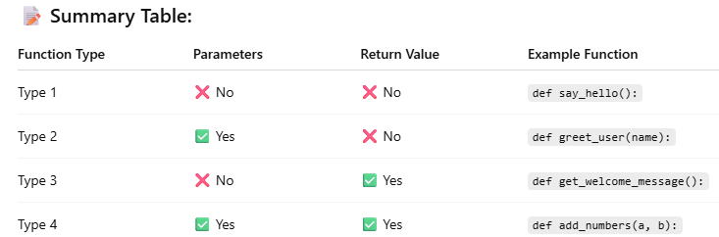

Anonymous functions (lambda functions).

In Python, anonymous functions are functions without a name, created using the lambda keyword. These are also called lambda functions.

When to Use Lambda Functions?
- When the function is short and simple
- When used temporarily as an argument to functions like map(), filter(), or sorted()
- When a named function is not needed

Example 1: Lambda to Add Two Numbers:-
add = lambda x, y: x + y
print(add(5, 3)) # Output: 8

Example 2: Lambda with No Arguments

greet = lambda: "Hello!"
print(greet()) # Output: Hello!

Example 3: Lambda with One Argument

square = lambda x: x * x
print(square(4)) # Output: 16

Example 4: Lambda in Sorting
names = ['Alice', 'Bob', 'Charlie', 'David']
names.sort(key=lambda name: len(name))
print(names)
Example 5: Lambda with map()

numbers = [1, 2, 3, 4]
squares = list(map(lambda x: x ** 2, numbers))
print(squares) # Output: [1, 4, 9, 16]

9. Modules
Introduction to Python modules and importing modules.

A module in Python is a file that contains Python definitions, functions, classes, or variables. It helps you organize code into manageable, reusable components.
- Any .py file is a module.
- Python has many built-in modules (like math, random, os), and you can also create your own modules.

Benefits of Using Modules
- Organizes code better
- Increases reusability
- Reduces redundancy
- Makes maintenance easier

Importing Modules
There are multiple ways to import modules:

  - Import Entire Module
import math
print(math.sqrt(16)) # Output: 4.0
  - Import Specific Function or Class
from math import sqrt
print(sqrt(25)) # Output: 5.0
  - Import with Alias (Renaming)
import math as m
print(m.pi) # Output: 3.141592653589793
  - Import Multiple Functions
from math import ceil, floor
print(ceil(4.2)) # Output: 5
print(floor(4.2)) # Output: 4
  - Import All Functions (Not Recommended)
from math import *
print(sqrt(36)) # Output: 6.0

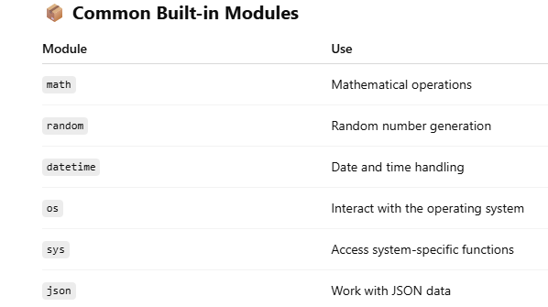

Standard library modules: math, random:-
Standard Library Modules in Python: math and random
Python comes with a rich standard library, which includes powerful modules like math and random. These modules help perform mathematical and randomization operations efficiently.

1. math Module
The math module provides mathematical functions such as square roots, trigonometry, logarithms, constants, etc.
✅ Importing:
import math

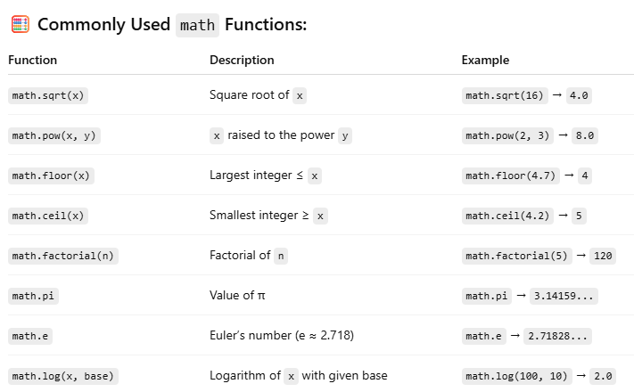

Example:
import math

radius = 5
area = math.pi * math.pow(radius, 2)
print("Area of Circle:", area)

2. random Module
The random module is used to generate random numbers and perform random operations like shuffling, sampling, and selection.
✅ Importing:

import random
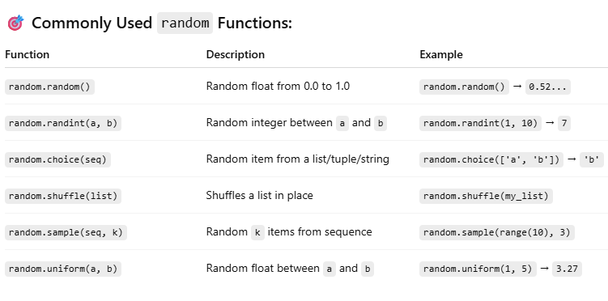

Example:-
import random

lucky_number = random.randint(1, 100)
print("Your lucky number is:", lucky_number)

Creating custom modules:-
In Python, you can create your own modules to organize code into reusable components. A custom module is simply a .py file containing functions, classes, or variables that you can import and use in other programs.

Steps to Create and Use a Custom Module:-

Step 1: Create a Module File
Create a Python file named my_module.py.
# my_module.py

def greet(name):
return f"Hello, {name}!"

def add(a, b):
return a + b

pi = 3.14159
Step 2: Use the Module in Another File
Create another Python file in the same directory, for example main.py, and import the module.

# main.py

import my_module

print(my_module.greet("Alice"))
print("Sum:", my_module.add(5, 3))
print("Value of Pi:", my_module.pi)

Best Practices
- Name the file using lowercase letters and underscores, e.g., math_utils.py
- Avoid using built-in module names (like math.py, random.py)
- Group related functions in one module
- Add docstrings to your functions for clarity

