3. Advance Python Programming

- Printing on Screen:-
- Introduction to the print() function in Python.
The print() function in Python is a built-in function used to display output to the console or terminal. It's one of the most commonly used functions in Python programming, especially for debugging or interacting with users.

✅ Basic Syntax:-
print(object1, object2, ..., sep=' ', end='\n')

• object1, object2, ...: One or more objects to be printed.
• sep=' ' (optional): Separator between the objects (default is a space).
• end='\n' (optional): What to print at the end (default is a newline).

Examples
1. Printing Text
print("Hello, World!")

Output:
Hello, World!

- Formatting outputs using f-strings and format():-
Python provides multiple ways to format strings, and two of the most popular and modern methods are:
- f-strings (formatted string literals) — introduced in Python 3.6+
- .format() method — available in Python 2.7 and 3+

1. Using f-strings
Syntax:
name = "Alice"
age = 25
print(f"My name is {name} and I am {age} years old.")
Features:
- Easy to read
- Directly embed expressions inside {}
Example 1 – Basic usage:
name = "Bob"
score = 92
print(f"Student {name} scored {score} marks.")

- Using .format() Method
Syntax:
"My name is {} and I am {} years old.".format(name, age)

Features:
- Flexible for older versions of Python
- Allows positional and keyword arguments
Example 1 – Positional formatting:
print("Hello, {}!".format("Alice"))

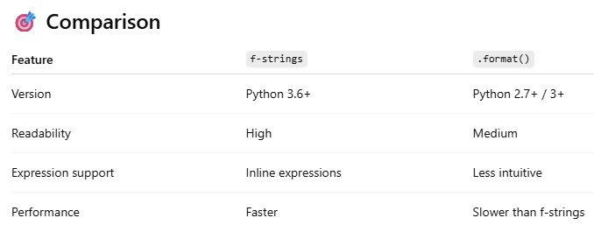

- Reading Data from Keyboard
- Using the input() function to read user input from the keyboard.
The input() function is used to read data from the user through the keyboard during program execution. It always returns the input as a string.

Basic Syntax:-
variable = input("Your prompt message here: ")

• The prompt message is optional, but helpful for guiding the user.
• The input is stored as a string in the variable.

Examples
1. Reading a Name
name = input("Enter your name: ")
print(f"Hello, {name}!")

2. Reading and Converting Numbers
Since input() returns a string, you need to convert it using int(), float(), etc., if working with numbers

age = int(input("Enter your age: "))
print(f"You will be {age + 1} next year.")

Combining with Control Statements
password = input("Enter password: ")
if password == "admin123":
print("Access granted")
else:
print("Access denied")

- Converting user input into different data types (e.g., int, float, etc.).

By default, the input() function returns everything as a string.
To use input as a number (like for calculations), you must convert it to the appropriate data type.

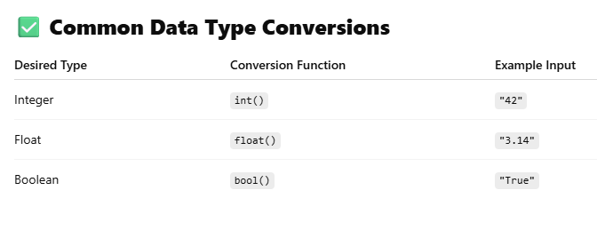

Examples
1. String (Default)
name = input("Enter your name: ")
print("Name is:", name)

2.Integer Conversion
age = int(input("Enter your age: "))
print("Next year, you will be", age + 1)

- Float Conversion
height = float(input("Enter your height in meters: "))
print("You are", height, "meters tall.")

- Boolean Conversion (Manual)
response = input("Do you want to continue? (yes/no): ")
is_continue = response.lower() == "yes"
print("User wants to continue:", is_continue)

5. Convert Multiple Inputs
x, y = input("Enter two numbers separated by space: ").split()
x = int(x)
y = int(y)
print("Sum is:", x + y)

3.pening and Closing Files
- Opening files in different modes ('r', 'w', 'a', 'r+', 'w+').

In Python, files can be opened in different modes depending on what you want to do (read, write, append, etc.). Here's a quick explanation of the most common modes:

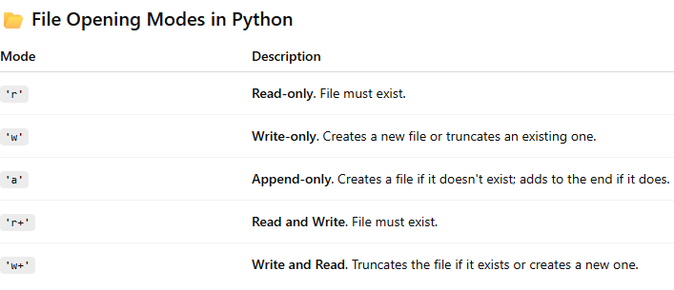

Examples:-

# 'r' - Read only
with open('file.txt', 'r') as f:
data = f.read()
print(data)

# 'w' - Write only (will erase existing file)
with open('file.txt', 'w') as f:
f.write("Hello World!")

# 'a' - Append
with open('file.txt', 'a') as f:
f.write("\nAdding another line")

# 'r+' - Read and write (must exist)
with open('file.txt', 'r+') as f:
content = f.read()
f.seek(0)
f.write("Modified: " + content)

# 'w+' - Write and read (file is cleared if it exists)
with open('file.txt', 'w+') as f:
f.write("New content")
f.seek(0)
print(f.read())

- Using the open() function to create and access files.

Here’s a simple guide on how to create and access files using the open() function in Python:
Syntax of open() Function:-
file_object = open(file_name, mode)

• file_name: Name (and path) of the file (e.g., "example.txt")
• mode: File mode (like 'r', 'w', 'a', etc.)

Example 1: Creating a File and Writing to It
# Open file in write mode ('w') — creates the file if it doesn't exist
file = open("example.txt", "w")
file.write("Hello, this is a test file.")
file.close()

Example 2: Reading a File

file = open("example.txt", "r")
content = file.read()
print(content)
file.close()

Example 3: Appending to a File

file = open("example.txt", "a")
file.write("\nThis line is added using append mode.")
file.close()

Best Practice: Use with Statement
Using with automatically closes the file:

- Closing files using close().
When you open a file using the open() function, it’s important to close the file after you're done with it. This frees up system resources and ensures that all data is written (flushed) properly.

If you forget to call close(), the file may remain open and locked by the program, which can lead to:
- Data not being saved properly
- Memory/resource leaks
- File access issues in other programs

4.Reading and Writing Files
- Reading from a file using read(), readline(), readlines().

1. read()
- Reads the entire contents of a file as a single string.
- Useful when you want to load the whole file into memory.

# Example: read entire file content
with open("example.txt", "r") as file:
content = file.read()
print(content)

🔹 Returns a string containing the whole file content.

2. readline()
- Reads only one line at a time from the file.
- Useful when you want to process the file line-by-line, especially for large files.

# Example: read line by line using readline()
with open("example.txt", "r") as file:
line1 = file.readline()
line2 = file.readline()
print("Line 1:", line1)
print("Line 2:", line2)

Returns a string of the current line (including \n if present).

3. readlines()
- Reads all lines of a file and returns them as a list of strings.
- Each line becomes an item in the list.

# Example: read all lines into a list
with open("example.txt", "r") as file:
lines = file.readlines()
print(lines)

- Writing to a file using write() and writelines()

1. write()
- Writes a single string to the file.
- You must add newline characters (\n) manually if needed.
- Use mode 'w' (overwrite) or 'a' (append).
📌 Example: Writing with write()
with open("output.txt", "w") as file:
file.write("Hello, World!\n")
file.write("This is the second line.\n")
2. writelines()
- Writes a list of strings to the file.
- Does not automatically add newline characters – you must include them.
📌 Example: Writing with writelines()

lines = ["Line 1\n", "Line 2\n", "Line 3\n"]

with open("output.txt", "w") as file:
file.writelines(lines)

5. Exception Handling
- Introduction to exceptions and how to handle them using try, except, and finally.
Here's a clear explanation of exceptions in Python and how to handle them using try, except, and finally
Exceptions are errors that occur during the execution of a program. They interrupt the normal flow of a program unless handled properly.
🔸 Example of an exception:
X=10/0

Handling Exceptions with try, except, and finally
Python provides a way to handle exceptions using:
try block:
- Contains the code that might raise an exception.
except block:
- Contains the code that runs if an exception occurs.
finally block (optional):
- This block always runs, whether an exception occurs or not. It's often used to clean up resources like files or connections.
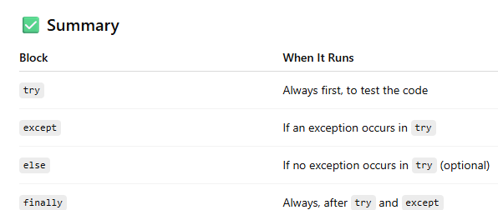
🔸 Basic Example:

try:
num = int(input("Enter a number: "))
result = 10 / num
print("Result:", result)
except ZeroDivisionError:
print("You can't divide by zero.")
except ValueError:
print("Invalid input! Please enter a number.")
finally:
print("This block always runs.")

- Understanding multiple exceptions and custom exceptions.

1. Understanding Multiple Exceptions in Python
In real-world programs, different types of errors can happen. You can handle multiple exceptions using separate except blocks or by grouping them.
A. Multiple except Blocks (Recommended)
try:
num = int(input("Enter a number: "))
result = 10 / num
print("Result:", result)
except ZeroDivisionError:
print("You can't divide by zero.")
except ValueError:
print("You must enter a valid number.")
except Exception as e:
print("Unexpected error:", e)

• Python will check each except block from top to bottom and execute the first one that matches.
• Exception is the base class for all built-in exceptions.

B. Handling Multiple Exceptions in One Block
You can also handle multiple exception types in a single block:
try:
# some code
except (ZeroDivisionError, ValueError) as e:
print("Caught an exception:", e)
2. Creating and Using Custom Exceptions
Sometimes, built-in exceptions aren't enough. You can create your own custom exception classes to describe specific error conditions in your application.
A. Creating a Custom Exception
class MyCustomError(Exception):
"""Custom Exception for special cases."""
Pass

B. Using a Custom Exception
def check_age(age):
if age < 18:
raise MyCustomError("Age must be at least 18!")
else:
print("Access granted.")

try:
user_age = int(input("Enter your age: "))
check_age(user_age)
except MyCustomError as e:
print("Custom Exception:", e)

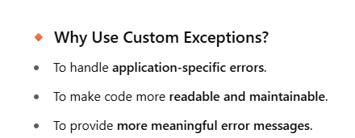

6.Class and Object (OOP Concepts)

Understanding classes, objects, attributes, and methods in Python is key to mastering Object-Oriented Programming (OOP). Here's a clear and simple explanation with examples:

1. Class
A class is a blueprint or template to create objects.
It defines the structure and behavior (data and functions).
######
class Car:
# Class attribute
wheels = 4

# Constructor (initializes the object)
def __init__(self, brand, color):
self.brand = brand # Instance attribute
self.color = color # Instance attribute

# Method (function inside a class)
def start_engine(self):
print(f"The {self.color} {self.brand} car's engine is started.")

2. Object
An object is an actual instance of a class.

• car1 and car2 are objects created from the Car class.
• Each object has its own values for brand and color.

3. Attributes
Attributes are variables associated with a class or object.
- Class Attribute: Shared across all instances (e.g., wheels)
- Instance Attribute: Unique for each object (e.g., brand, color)
print(car1.brand) # Toyota
print(car2.color) # Blue
print(car1.wheels) # 4 (shared by all cars)

4. Methods
Methods are functions defined in a class that describe the behaviors of the object

• start_engine is a method.
• self refers to the object calling the method.

car1.start_engine() # The Red Toyota car's engine is started.
car2.start_engine() # The Blue Honda car's engine is started.

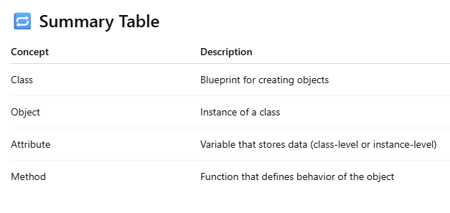

class Student:
def __init__(self, name, roll_no):
self.name = name
self.roll_no = roll_no

def show(self):
print(f"Name: {self.name}, Roll No: {self.roll_no}")

s1 = Student("Dharmraj", 101)
s2 = Student("Pari", 102)

s1.show() # Name: Dharmraj, Roll No: 101
s2.show() # Name: Pari, Roll No: 102

- Difference between local and global variables
- The difference between local and global variables in Python lies in where they are declared and where they can be accessed.
1. Global Variables
- Declared outside of all functions.
- Can be accessed anywhere in the program.
- If you want to modify a global variable inside a function, you must use the global keyword.
Example:
x = 10 # Global variable
def show():
print("Inside function:", x)
show()
print("Outside function:", x)

2. Local Variables
- Declared inside a function.
- Can be accessed only within that function.
- They don’t affect global variables with the same name.
Example:
def display():
y = 15 # Local variable
print("Inside function:", y)
display()
# print(y) # Error: y is not defined outside

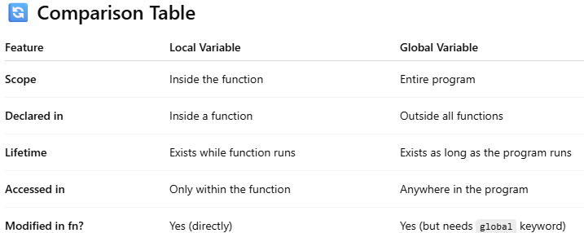

7. Inheritance
- Single, Multilevel, Multiple, Hierarchical, and Hybrid inheritance in Python.
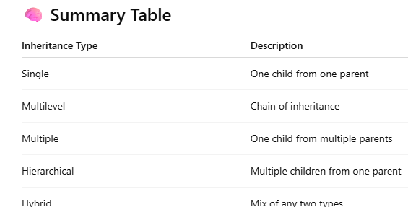

1. Single Inheritance
One child class inherits from one parent class.
Example:
class Animal:
def sound(self):
print("Animal makes a sound")
class Dog(Animal): # Inherits from Animal
def bark(self):
print("Dog barks")
d = Dog()
d.sound()
d.bark()
2. Multilevel Inheritance
A class is derived from another derived class (chain of inheritance).
✅ Example:
class Animal:
def eat(self):
print("Animal eats")

class Dog(Animal): # Inherits from Animal
def bark(self):
print("Dog barks")

class Puppy(Dog): # Inherits from Dog
def weep(self):
print("Puppy weeps")

p = Puppy()
p.eat()
p.bark()
p.weep()

3. Multiple Inheritance
A class inherits from more than one base class.
Example:
class Father:
def skill(self):
print("Gardening")

class Mother:
def talent(self):
print("Painting")

class Child(Father, Mother): # Inherits from both
def hobby(self):
print("Playing guitar")

c = Child()
c.skill()
c.talent()
c.hobby()

4. Hierarchical Inheritance
Multiple child classes inherit from a single parent class.
Example:
class Animal:
def move(self):
print("Animal moves")

class Bird(Animal):
def fly(self):
print("Bird flies")

class Fish(Animal):
def swim(self):
print("Fish swims")

b = Bird()
f = Fish()
b.move()
b.fly()
f.move()
f.swim()

5. Hybrid Inheritance
Combination of two or more types of inheritance.
Example (Combination of Multiple + Hierarchical):
class A:
def show(self):
print("Class A")

class B(A):
def show_b(self):
print("Class B")

class C:
def show_c(self):
print("Class C")

class D(B, C): # Hybrid: Multilevel (A → B → D) and Multiple (B, C → D)
def show_d(self):
print("Class D")

d = D()
d.show() # From A
d.show_b() # From B
d.show_c() # From C
d.show_d() # From D

- Using the super() function to access properties of the parent class.
The super() function in Python is used to access methods and properties of a parent (super) class from a child class. It is especially useful in inheritance, particularly when overriding methods.

Why Use super()?
- To call the parent class’s constructor (__init__).
- To reuse methods or behavior from the parent class.
- Helps maintain clean and DRY (Don't Repeat Yourself) code.

- Basic Example: Calling Parent Constructor:-
class Person:
def __init__(self, name):
self.name = name
print("Person class constructor called")
class Student(Person):
def __init__(self, name, roll_no):
super().__init__(name) # Call parent class constructor
self.roll_no = roll_no
print("Student class constructor called")
s = Student("Dharmraj", 101)
print(s.name) # Dharmraj
print(s.roll_no) # 101

- Calling a Method from the Parent Class
class Animal:
def speak(self):
print("Animal speaks")
class Dog(Animal):
def speak(self):
super().speak() # Call parent method
print("Dog barks")
d = Dog()
d.speak()
# Output:
# Animal speaks
# Dog barks
3.With Multilevel Inheritance:-
class A:
def show(self):
print("Class A")

class B(A):
def show(self):
super().show()
print("Class B")

class C(B):
def show(self):
super().show()
print("Class C")

c = C()
c.show()
# Output:
# Class A
# Class B
# Class C

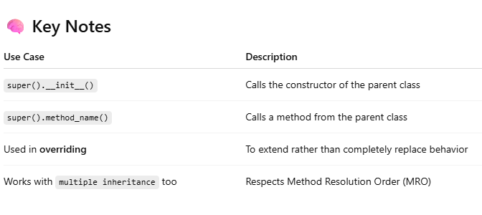

8. Method Overloading and Overriding
Method overloading: defining multiple methods with the same name but different parameters

- Method Overloading in Python
Method overloading refers to defining multiple methods with the same name but different parameters (type, number, or order).
- Note: Python does not support traditional method overloading like Java or C++.
Instead, Python uses default arguments and variable-length arguments to simulate overloading behavior.

  - Simulating Method Overloading using Default Arguments
class Calculator:
def add(self, a=0, b=0, c=0):
return a + b + c

calc = Calculator()
print(calc.add()) # 0
print(calc.add(5)) # 5
print(calc.add(5, 10)) # 15
print(calc.add(5, 10, 15)) # 30

The same method add() works with 0, 1, 2, or 3 arguments.
  - Using *args (Variable-Length Arguments)
class Calculator:
def add(self, *numbers):
return sum(numbers)
calc = Calculator()
print(calc.add(1, 2)) # 3
print(calc.add(5, 10, 15)) # 30
print(calc.add(2, 4, 6, 8)) # 20

*args lets you pass any number of arguments to the method.

  - Example with Conditional Logic
class Display:
def show(self, a=None, b=None):
if a is not None and b is not None:
print(f"Two arguments: {a}, {b}")
elif a is not None:
print(f"One argument: {a}")
else:
print("No arguments")
d = Display()
d.show() # No arguments
d.show(10) # One argument: 10
d.show(10, 20) # Two arguments: 10, 20

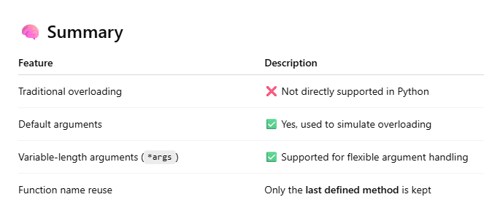

Method overriding: redefining a parent class method in the child class
- Method Overriding in Python
Method overriding allows a child class to provide a specific implementation of a method that is already defined in its parent class.
This is a key concept in polymorphism and helps in customizing behavior for derived classes.
Key Points:
- Method name must be the same as in the parent class.
- The child class method replaces (overrides) the parent's method.
- Use super() if you still want to call the parent method.

Basic Example of Method Overriding
class Animal:
def speak(self):
print("Animal makes a sound")
class Dog(Animal):
def speak(self): # Overriding method
print("Dog barks")
d = Dog()
d.speak() # Output: Dog barks

Dog class overrides the speak() method of Animal.

Using super() to Access Parent’s Method

class Animal:
def speak(self):
print("Animal speaks")
class Cat(Animal):
def speak(self):
super().speak() # Call parent method
print("Cat meows") # Custom behavior
c = Cat()
c.speak()
# Output:
# Animal speaks
# Cat meows

Real-World Analogy
- Printer is a base class with a method print_document()
- ColorPrinter overrides it to print in color
- LaserPrinter overrides it to print with laser tech

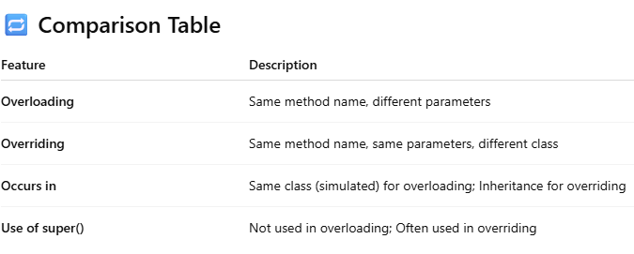

9. SQLite3 and PyMySQL (Database Connectors)

Part 1: SQLite3 – Built-in, Lightweight SQL Database
What is SQLite3?
- SQLite3 is a lightweight, serverless database engine.
- It comes pre-installed with Python.
- Great for small to medium applications, local apps, testing.
- Steps to Use SQLite3 in Python

1. Import and Connect to a Database

import sqlite3

conn = sqlite3.connect("students.db") # Creates a new file-based DB

cursor = conn.cursor()

2.Create a Table

cursor.execute("""

CREATE TABLE IF NOT EXISTS student (

id INTEGER PRIMARY KEY,

name TEXT,

marks INTEGER

)

""")

3. Insert Data
cursor.execute("INSERT INTO student (name, marks) VALUES (?, ?)", ("Dharmraj", 90))
conn.commit()

4.Fetch Data
cursor.execute("SELECT * FROM student")
for row in cursor.fetchall():
print(row)

5. Close Connection
conn.close()

Part 2: PyMySQL – Connecting to MySQL Database
✅ What is PyMySQL?
- A third-party Python library used to connect Python with a MySQL database server.
- You need to install it using pip:

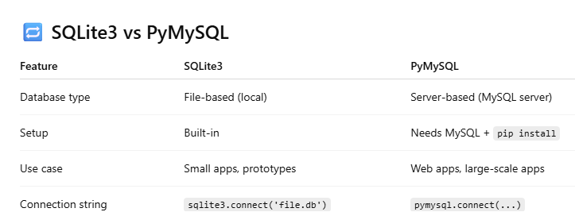
- creating and executing SQL queries from Python using these connectors.
To create and execute SQL queries from Python, you typically use connectors (or libraries) that allow Python to communicate with a specific database. Two commonly used libraries are:
- SQLite3 – for SQLite databases (built-in, no installation needed)
- PyMySQL – for MySQL databases (requires installation)
Below are examples for both connectors:
1. Using SQLite3 (for SQLite Databases)
SQLite is a serverless, lightweight database engine, and Python includes the sqlite3 module by default.

Step-by-step example:
import sqlite3
# Step 1: Connect to a database (or create one if it doesn't exist)
conn = sqlite3.connect("my_database.db")# Step 2: Create a cursor object to execute SQL commands
cursor = conn.cursor()
# Step 3: Create a table
cursor.execute('''
CREATE TABLE IF NOT EXISTS students (
id INTEGER PRIMARY KEY AUTOINCREMENT,
name TEXT NOT NULL,
age INTEGER
)
''')
# Step 4: Insert data
cursor.execute("INSERT INTO students (name, age) VALUES (?, ?)", ("Alice", 21))
# Step 5: Fetch data
cursor.execute("SELECT * FROM students")
rows = cursor.fetchall()
for row in rows:
print(row)
# Step 6: Commit and close connection
conn.commit()
conn.close()

2. Using PyMySQL (for MySQL Databases)
To use PyMySQL, first install it:

import pymysql

# Step 1: Connect to the MySQL database
conn = pymysql.connect(
host='localhost',
user='root',
password='your_password',
database='your_database'
)

# Step 2: Create a cursor object
cursor = conn.cursor()

# Step 3: Create a table
cursor.execute('''
CREATE TABLE IF NOT EXISTS students (
id INT AUTO_INCREMENT PRIMARY KEY,
name VARCHAR(100),
age INT
)
''')

# Step 4: Insert data
cursor.execute("INSERT INTO students (name, age) VALUES (%s, %s)", ("Bob", 22))

# Step 5: Fetch data
cursor.execute("SELECT * FROM students")
rows = cursor.fetchall()
for row in rows:
print(row)

# Step 6: Commit and close connection
conn.commit()
conn.close()

Notes for Both:
- Always use parameterized queries (? for SQLite, %s for MySQL) to prevent SQL injection.
- Always call commit() after INSERT, UPDATE, or DELETE.
- Use try-except blocks for better error handling in production.

10. Search and Match Functions
- Using re.search() and re.match() functions in Python’s re module for pattern matching.
In Python, the re module provides powerful tools for pattern matching using regular expressions. Two commonly used functions are:
- re.match() — checks for a match only at the beginning of the string.
- re.search() — checks for a match anywhere in the string.
- re.match() – Match at the beginning:-
import re
text = "Hello, world!"
# This will match only if 'Hello' is at the beginning
result = re.match(r'Hello', text)
if result:
print("Match found:", result.group())
else:
print("No match found.")

- re.search() – Match anywhere in the string:-

import re
text = "Hello, world!"
# This will search for 'world' anywhere in the string
result = re.search(r'world', text)
if result:
print("Match found:", result.group())
else:
print("No match found.")

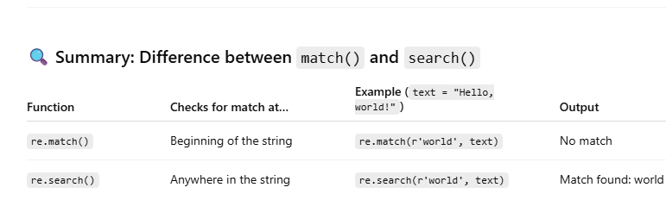

- Difference between search and match.

Difference Between re.search() and re.match() in Python
Both re.search() and re.match() are used for pattern matching using regular expressions, but they behave differently:

Summary:
- Use re.match() if you want to ensure the string starts with a pattern.
- Use re.search() if you want to find the pattern anywhere in the string.
