Hello!

My Name is Harsh Parmar. I am from Rajkot City in Gujarat, India.

I had enrolled into the course CS50x INTRODUCTION TO COMPUTER SCIENCE.

This has helped me flourish the very basics required to cope up in the field of Computer Science in which I will be moving.

As taught during this phase of learning. I was fascinated with the Games Track when I learnt How to make PONG Game.

Although I failed to make Mario with its update, I submitted the WEB Track Successfully.

Learning LOVE 2D and creating game with Lua was fun so I chose it as my Final Project.

FINAL PROJECT:

THE BIRD GAME

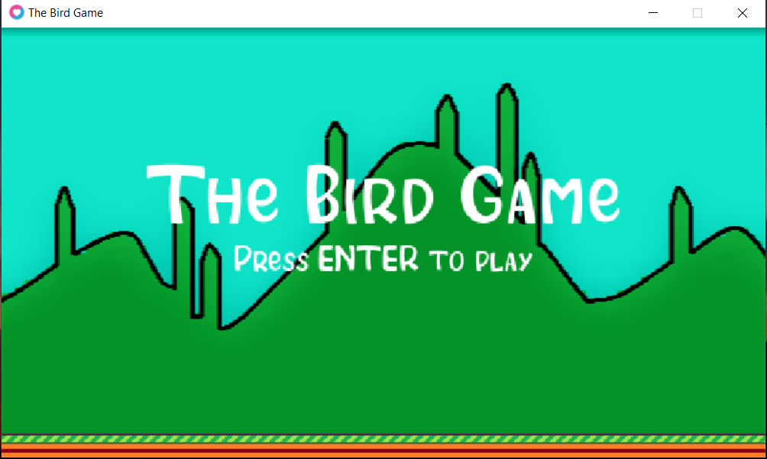

This is a remake of the game popularly called as ‘Flappy Bird’.

This game is programmed such that when the key ‘Enter’ is tapped, the game will Start.

We have to dodge through the pipes on the upper and lower ends end will each pipe cross will result into increment of the Score.

The Bird flap is set to be controlled by ‘Spacebar’.

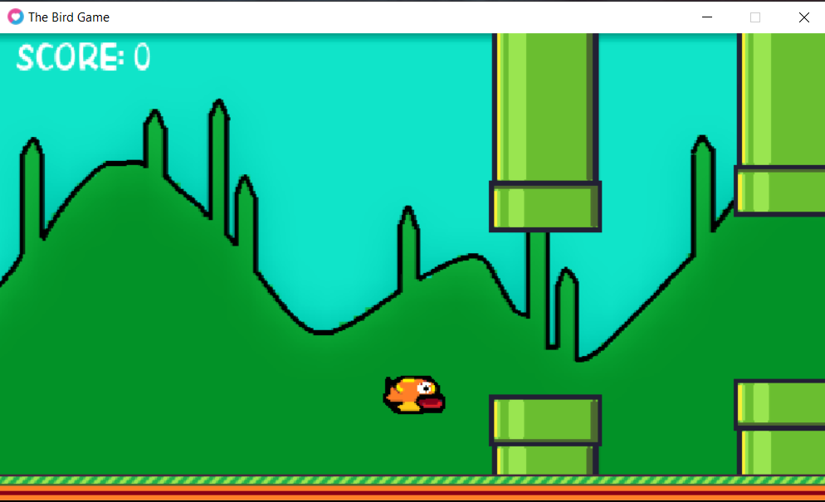

When the bird collides with the pipes, it indicates ‘Game Over’ and shows the final score.

