Practical No.2: Study and implementation of Infrastructure as a Service

Study and implementation of Infrastructure as a Service
- OpenStack Computing Components
- Install OpenStack on Ubuntu 18.04 with DevStack
Link : https://www.openstack.org/
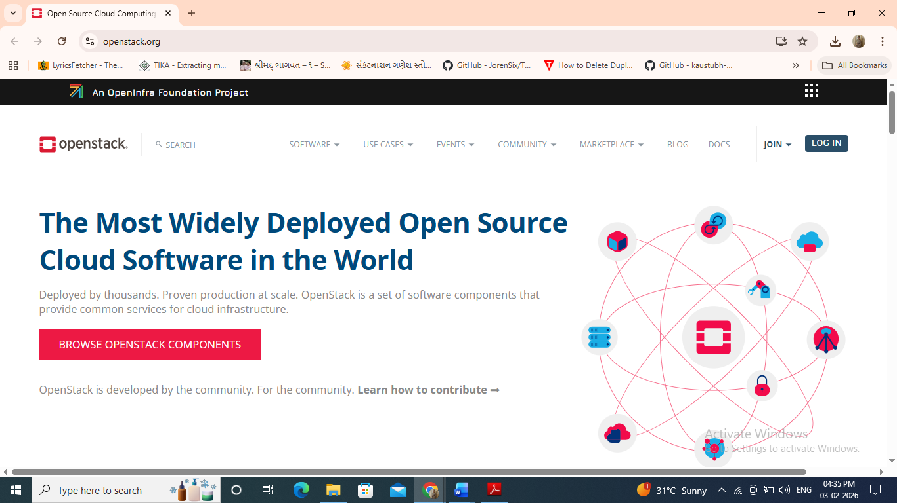
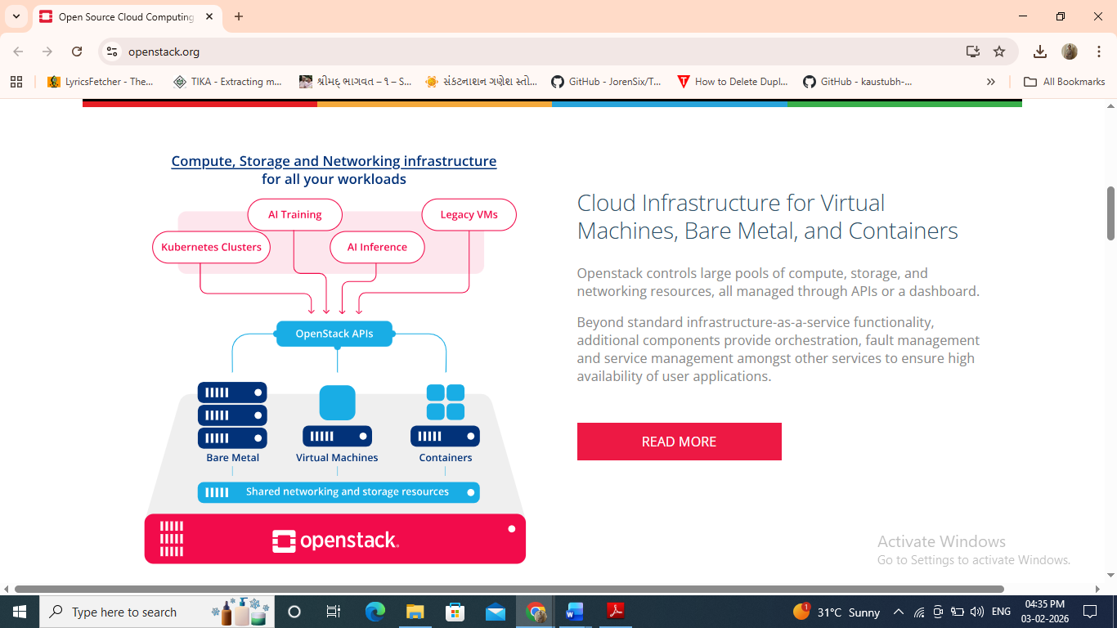

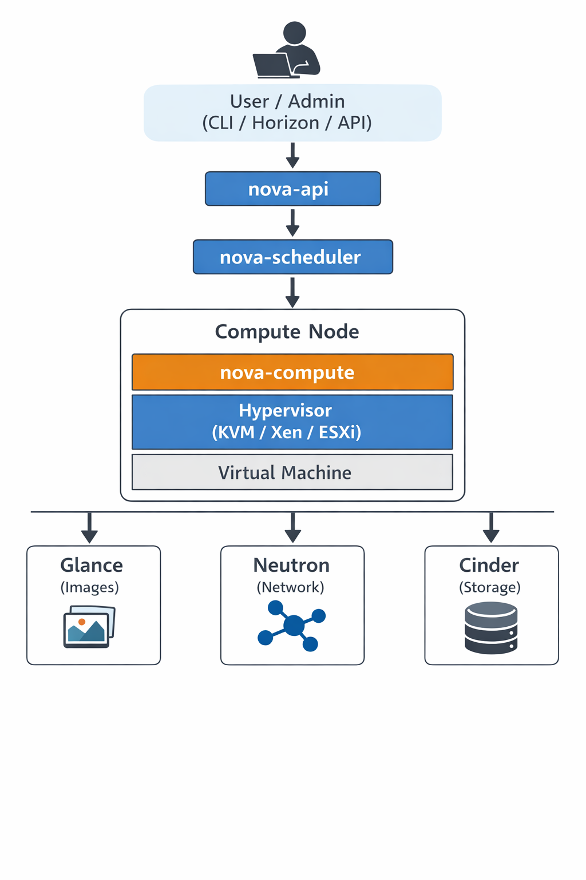
Installation Steps:
Add user
useradd -s /bin/bash -d /opt/stack -m stack
apt-get install sudo -y
echo "stack ALL=(ALL) NOPASSWD: ALL" >> /etc/sudoers
login as stack user
Download DevStack
sudoapt-getinstallgit -y || sudoyuminstall -ygit
gitclonehttps://git.openstack.org/openstack-dev/devstack
cddevstack

Components
OpenStack Computing Components mainly revolve around the Nova service, which manages the lifecycle of virtual machines (instances).
Below is the diagram representation and explanation of OpenStack computing architecture.
Explanation:
1. User / Admin:
The user initiates a request to create or manage a virtual machine using Horizon dashboard, OpenStack CLI, or REST API.
2. Nova-API:
It acts as the entry point for all compute requests. It validates the request and forwards it to the scheduler.
3. Nova-Scheduler:
The scheduler selects the most suitable compute node based on available CPU, RAM, and disk resources using the placement service.
4. Compute Node:
This is where the virtual machine is created and executed.
- Nova-Compute communicates with the hypervisor.
- Hypervisor performs virtualization and runs the VM.
5. Glance (Image Service):
Stores and provides operating system images required to boot virtual machines.
6. Neutron (Networking Service):
Handles IP addressing, network connectivity, routing, and security groups.
7. Cinder (Block Storage):
Provides persistent block storage volumes that can be attached or detached from virtual machines.

Installation Steps
Installation Steps for OpenStack using DevStack
Step 1: Create Stack User
DevStack should not be installed as root.
sudo useradd -s /bin/bash -d /opt/stack -m stack

Step 2: Install Sudo Package
sudo apt-get install sudo -y
(For Ubuntu/Debian systems)

Step 3: Provide Sudo Privileges to Stack User
echo "stack ALL=(ALL) NOPASSWD: ALL" | sudo tee -a /etc/sudoers
This allows the stack user to execute sudo commands without password.

Step 4: Switch to Stack User
sudo su - stack

Step 5: Install Git
For Ubuntu / Debian:
sudo apt-get install git -y
For CentOS / RHEL:
sudo yum install git -y

Step 6: Download DevStack
git clone https://opendev.org/openstack/devstack

Step 7: Move to DevStack Directory
cd devstack

(Optional but Recommended) Create local.conf
nano local.conf
Basic content:
[[local|localrc]]
ADMIN_PASSWORD=stack
DATABASE_PASSWORD=stack
RABBIT_PASSWORD=stack
SERVICE_PASSWORD=stack
HOST_IP=127.0.0.1
Save and exit.

Step 8: Start DevStack Installation
./stack.sh
Practical No.3: Study and implementation of Storage as a Service
Implement storage as a service using its own cloud/AWS S3 and azure storage

Storage as a Service (STaaS) is a cloud computing model where storage resources are provided to users on-demand over the internet. Users can store, retrieve, and manage data without worrying about underlying hardware or infrastructure.
Key Features
- On-demand storage
- Scalability
- High availability
- Pay-as-you-use
- Accessible from anywhere

2. Types of Storage as a Service
- Object Storage (AWS S3, Azure Blob Storage)
- File Storage (OwnCloud, NFS-based storage)
- Block Storage (Cloud disks)
Objective
To implement STaaS using OwnCloud in a private cloud environment.
Requirements
- Ubuntu Server
- Apache / Nginx
- PHP
- MySQL / MariaDB
- OwnCloud package
Implementation Steps
- Install web server and PHP
- Install database server
- Download and configure OwnCloud
- Create admin user
- Configure data directory
- Access storage via web browser
Outcome
- Users can upload, download, and share files
- Acts as private cloud storage
- Suitable for organizations and institutes
Advantages
- Full data control
- No dependency on third-party cloud
- Enhanced security
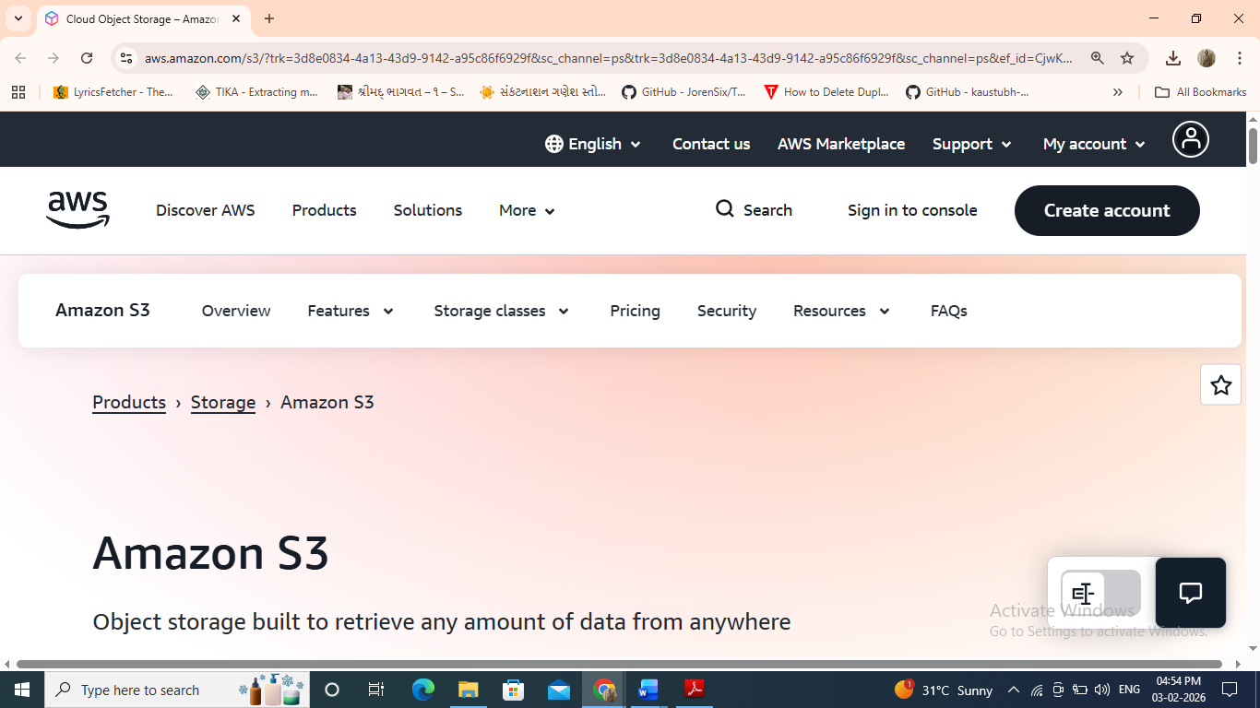

Practical 4: Discuss key drivers influencing the choice of a specific cloud deployment model
Key Drivers Influencing the Choice of a Cloud Deployment Model
Selecting an appropriate cloud deployment model (Public, Private, Hybrid, or Community) depends on several technical, business, and regulatory factors.

1. Data Security and Privacy
- Organizations handling sensitive or confidential data (healthcare, finance, defense) prefer private clouds.
- Public clouds are suitable when data sensitivity is low and strong encryption/compliance is available.
Impact:
High security needs → Private / Hybrid cloud

2. Compliance and Regulatory Requirements
- Laws such as GDPR, HIPAA, RBI, ISO standards may require data locality and strict access control.
- Private or community clouds help meet regulatory mandates.
Impact:
Strict compliance → Private / Community cloud

3. Cost Considerations
- Public cloud offers pay-as-you-go pricing with no upfront infrastructure cost.
- Private cloud requires higher capital investment but may be cost-effective at scale.
Impact:
Low budget / startup → Public cloud

4. Scalability and Flexibility
- Public clouds provide rapid scalability and elasticity.
- Private clouds have limited scalability due to hardware constraints.
- Hybrid clouds combine both advantages.
Impact:
Highly variable workloads → Public / Hybrid cloud

5. Performance and Latency
- Applications requiring low latency and high performance benefit from private or on-premise clouds.
- Public cloud performance depends on internet connectivity.
Impact:
Performance-critical apps → Private cloud

6. Control and Customization
- Private cloud allows full control over:
  - Infrastructure
  - Network
  - Security policies
- Public cloud offers limited customization.
Impact:
Need for full control → Private cloud

7. Business Continuity and Disaster Recovery
- Hybrid cloud enables:
  - On-premise operations
  - Cloud-based backup and disaster recovery
Impact:
High availability needs → Hybrid cloud

8. Organizational Size and IT Expertise
- Large enterprises often have skilled IT teams for private clouds.
- SMEs and startups prefer managed public cloud services.
Impact:
Limited IT staff → Public cloud

9. Workload Characteristics
- Stable workloads → Private cloud
- Dynamic, unpredictable workloads → Public cloud
- Mixed workloads → Hybrid cloud

PRACTICAL 5 : Comparative Analysis of Cloud Service Providers
comparative Table
Feature | AWS | Azure | GCP | IBM Cloud | Oracle Cloud
Market Share | Very High | High | Medium | Low | Low
Compute | EC2 | VM | Compute Engine | Virtual Servers | OCI Compute
Storage | S3 | Blob | Cloud Storage | Object Storage | Object Storage
Database | RDS | Azure SQL | BigQuery | Db2 | Autonomous DB
Hybrid Support | Medium | Strong | Medium | Strong | Medium
Pricing | Pay-as-you-go | Pay-as-you-go | Competitive | Moderate | Competitive
Best For | General purpose | Enterprises | Data & AI | Hybrid | Oracle apps

