ATM Simulator Documentation

# Overview:

The ATM Simulator is a Python program that replicates the functionality of an Automated Teller Machine (ATM). It allows users to interact with their bank accounts by providing a 4-digit Personal Identification Number (PIN). Users can check their account balance, withdraw money, deposit money, and exit the ATM.

# Usage

To use the ATM Simulator, follow these steps:

Run the Program: Execute the Python script atm_simulator.py.

Enter PIN: Enter your 4-digit PIN when prompted.

Select Option:

Option 1: Check Balance - View your account balance.

Option 2: Withdraw Money - Withdraw a specific amount from your account.

Option 3: Deposit Money - Deposit a specific amount into your account.

Option 4: Exit - Exit the ATM.

# Features

**Secure PIN System**: Users must enter a valid 4-digit PIN to access their accounts.

**Account Operations**: Allows users to check balance, withdraw money, and deposit money.

**Error Handling**: Provides informative messages for invalid PINs and insufficient funds during withdrawal.

**User-Friendly Interface**: Simple menu-driven interface for ease of use.

# Code Structure

**check_balance(pin)**: Function to check the account balance based on the provided PIN.

**withdraw(pin, amount)**: Function to handle money withdrawal from the account.

**deposit(pin, amount)**: Function to handle money deposit into the account.

**main()**: The main function to drive the ATM simulation, including user input and option selection.

## Example:

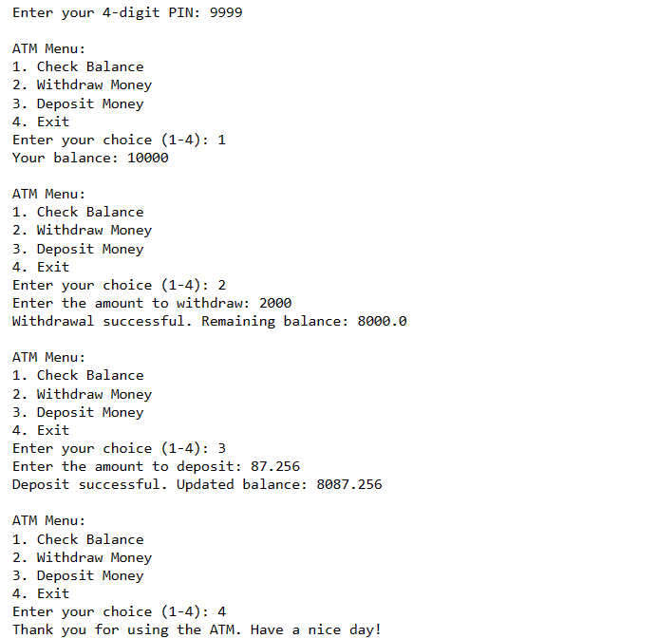

# Error Handling:

**Invalid PIN**: If the user enters an incorrect PIN, the program displays an error message.

**Insufficient Funds**: If the user attempts to withdraw more money than their account balance, the program informs the user about the insufficient funds.

# Author:

Raj Jain

[Parmarraj088@gmail.com](mailto:Parmarraj088@gmail.com)

[Github](https://github.com/Parmarraj088/Data-Science)