Survival Calculator Documentation

# Overview:

The Survival Calculator is a Python program designed to calculate the duration of how long a person has lived by converting age into different time units like months, weeks, days, hours, minutes, and seconds. The user will input his/her age and will select the time unit, output will come as per the time unit that the user has selected.

# Usage

To use the Survival Calculator, follow these steps:

Run the Program: Execute the Python script survival_calculator_Raj_Jain.py.

Enter Age: Enter your current age when prompted.

Select Time Unit: Choose one of the following time units: months, weeks, days, hours, minutes, or seconds.

View Result: The program will calculate and display the converted time unit based on your input.

# Features

**Input Validation**: The program validates user input to ensure it is a valid age.

**Flexible Time Units**: Supports various time units, allowing users to choose the unit most convenient for them.

# Code Structure

**calculate_converted_time(age, time_unit)**: Function that calculates the converted time unit based on the user's age and the selected time unit.

**main()**: Main function that handles user input, calls the calculation function and displays the result.

## Example:

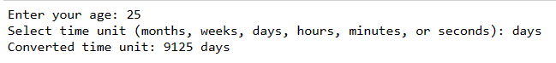

# Error Handling:

**Invalid Age:** If the user enters a non-numeric age, the program displays an error message.

**Invalid Time Unit:** If the user selects an unsupported time unit, the program informs the user about the invalid input.

# Author:

Raj Jain

[Parmarraj088@gmail.com](mailto:Parmarraj088@gmail.com)

[Github](https://github.com/Parmarraj088/Data-Science)