Parm Johal

V00787710

**Csc 350 Project 2:**

**IBM Summit Comparative analysis**

Supercomputer to compare: ***Germany’s SuperMUC-NG***

**Architecture Overview**

Ranking in at number eight in the world’s fastest supercomputers, Germany’s SuperMUC-NG is not only the top supercomputer in its country, but also one of the top supercomputers in Europe. It is located in Garchung at the Leibniz Supercomputing Center (LRZ) and developed by LRZ with the help of Lenovo and Intel. With the purpose of helping scientists and other users in research fields such as astronomy, physics and other engineering/science applicable fields, this supercomputer is capable of handling giant amounts of data from many simulations and experiments. The main features of the hardware design includes 48 cores per node, totaling to 311,040 cores over 6,480 nodes divided up into 6,336 thin nodes and 144 thick nodes. The total memory held is 719 terabytes with a parallel filesystem performance of 50 petabytes at 500 gigabytes per second. With a focus on energy efficiency and the innovative ideas of implementation given by the company Fahrenheit, the system is enveloped with a cooling and heat-reusing infrastructure that is unique amongst its competitors. Other notable hardware components can be seen in **figure 1(a)**.

Since this supercomputer is a high-performance computing (HPC) system, each node represents a computer and are linked together, with each node being distinguished as either a thin node, thick node, or cloud node. The thin and thick nodes are where the majority of the computing is done for the system. The cloud nodes are a newer edition to the system as it presents user friendly benefits for access to resources outside the scope of LRZ, such as software, virtual machines, and virtual networks. The layout can be seen in **figure 1(b)**, with compute nodes being “bundled into 8 domains (islands). Within one island, the Omnipath network topology is a 'fat tree' for highly efficient communication” **(4)**. The Omnipath network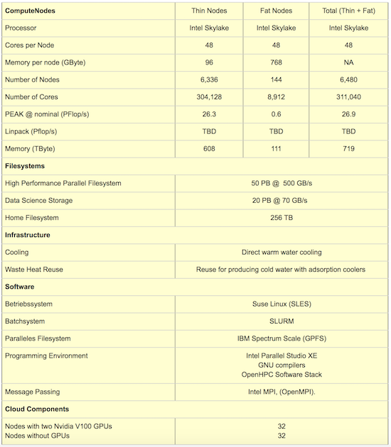 is what connects all these islands together to interact with each other to finish tasks for a certain job.

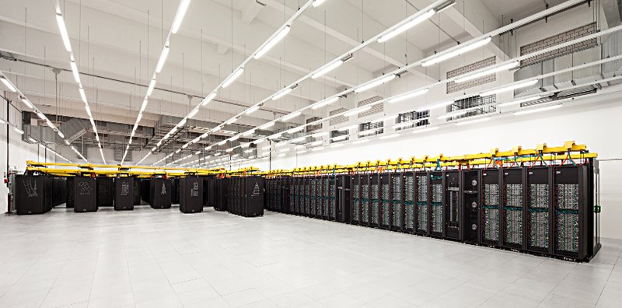

Figure 1: (a) Hardware components of the SuperMUC-NG; (b) The SuperMUC-NG at the LRZ data center.

**Strengths**

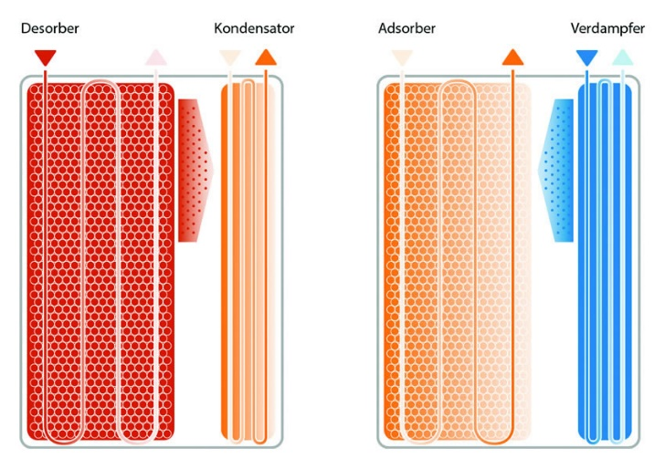When it comes to raising the computing speed of a computer, the negative impact is almost always overheating. One of the unique features of the SuperMUC-NG to counteract this is the adsorption cooling technology designed by the company Fahrenheit. They state that it “offers enormous potential for energy savings in data centers, as all computing power is converted into waste heat, which can be used for environmentally friendly cooling” **(16)**. Since cooling consumes so much power, reusing that same heat given off by the supercomputer to produce the cooling effect gives it a unique edge in energy efficiency. In the dual-chamber technology, there lies 2 adsorption modules, which is shown in figure 2. One acts as an adsorber/desorber while the other works as an evaporator/condenser. This not only generates cold temperature continuously, but does so with minimum maintenance needed, maximizing reliability **(15)**. Some users have criticized the design for the reason of it possibly flooding, which would be a major setback in the midst of large research-based computations. https://ssl.gstatic.com/ui/v1/icons/mail/images/cleardot.gif

Figure 2: Structure of the adsorption modules in each chiller.

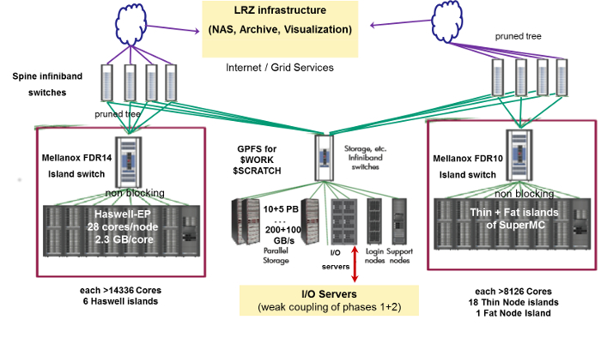The performance enhancement provided by parallelism is largely due to the IBM Spectrum Scale, a parallel computing filesystem designed to manage large amounts of data in an efficient manner. This software enables users to build their own storage infrastructure, which is useful because it accepts creativity from the user categorizing their data to be taken in and examined efficiently. Many users have their own way of organizing their data and the IBM spectrum scale is able to take any of these structured storages into account. A notable feature in this software is the Active File Management (AFM). This feature is a caching layer integrated with the spectrum scale as it "creates associations from a local Spectrum Scale cluster to a remote cluster or storage, defining the location and flow of file data and automating the data management" **(16)**. With the cluster of nodes and Omnipath design, the overall structure of the SuperMUC-NG is able to accelerate parallel accesses for large amounts of data with the help of the AFM interconnecting all of the cluster nodes (as seen in figure 3). The parallel read and writes in the AFM help to access large data blocks within a single I/O operation by "striping" blocks of data from different files **(16)**. This increases speed significantly when users bring in data broken up into many divided files to keep certain information separate from others.

Figure 3: Infrastructure/processes of the IBM Sprectrum Scale.

**Weaknesses**

Although the SuperMUC-NG is renowned for its energy-efficient infrastructure, the supercomputer does have some weaknesses within its hardware, specifically in the chosen CPU. The Intel Skylake processor has some notable issues, which are fixable, nevertheless should still be mentioned.  The issue occurs during hyper-threading in the CPU, and the results include “application and system misbehavior, data corruption, and data loss” (1). When short loops of less than 64 instructions are used in combination of certain registers, the CPU can lead the system to devastating drawbacks (1). One fix for this issue is to disable hyper-threading in the CPU. This solution is able to help keep the large amounts of data intact, but at a cost of losing speed and efficiency.

Another limitation that the supercomputer has is in the parallel filesystem when handling large amounts of data in a certain hierarchical design. It is “not optimal for handling large quantities of small files located in a single directory with parallel accesses” **(4)**. With an excessive amount of files per directory being accessed by parallel instructions and simultaneous jobs, the end result of the process will issue timeouts or crashes **(4)**. One approach to make users experience a more optimal performance is to increase the amount the subdirectories and limit the files in each subdirectory.

**Comparative Analysis (to the IBM Summit)**

When comparing the SuperMUC-NG to the IBM Summit, they both possess similar infrastructures. The node types on which they operate through are similar, using launch nodes, compute nodes, and cloud (or login) nodes for users to share information and processes simultaneously. Comparing stats alone, the IBM Summit is by far the superior supercomputer in terms of computing power and speed, having a far greater rate of floating point operations per second and the total amount of cores on which it operates. In terms of power, the SuperMUC-NG is overlooked by the mighty IBM Summit, as it is capable of being implemented on deep learning applications such as artificial intelligence. However, with the cooling technology implemented by Fahrenheit, the SuperMUC-NG remains the superior supercomputer in regards to being energy efficient as it is able to reuse all of the waste heat that it produces from computing for output, reducing the power consumption and its carbon footprint.

**References:**

1. https://www.theregister.co.uk/2017/06/25/intel_skylake_kaby_lake_hyperthreading/
2. https://www.extremetech.com/computing/251499-major-hyper-threading-flaw-can-destabilize-intel-cpus-based-kaby-lake-skylake
3. https://aloiskraus.wordpress.com/2018/06/16/why-skylakex-cpus-are-sometimes-50-slower-how-intel-has-broken-existing-code/
4. https://www.hlrs.de/fileadmin/sys/public/aboutus/media/InSiDE/InSiDE-Spring-2018.pdf
5. https://www.top500.org/news/germanys-most-powerful-supercomputer-comes-online/
6. <https://dl.gi.de/bitstream/handle/20.500.12116/17216/3032414_GI_P_285_16.pdf?sequence=1>
7. https://doku.lrz.de/display/PUBLIC/SuperMUC-NG
8. https://www.datacenterdynamics.com/news/germanys-supermuc-ng-supercomputer-goes-live/
9. https://insidehpc.com/2018/11/intel-powers-supermuc-ng-supercomputer-lrz-germany/
10. https://insidehpc.com/2018/10/300k-core-supermuc-ng-system-launches-lrz-germany/
11. https://www.lrz.de/services/compute/supermuc/parallelization/
12. https://epcced.github.io/hpc-intro/010-hpc-concepts/
13. https://eehpcwg.llnl.gov/assets/sc18_workship_install_huber.pdf
14. http://primeurmagazine.com/weekly/AE-PR-11-18-10.html
15. <https://fahrenheit.cool/en/data-centers-cooling-themselves-supermuc-ng-science-symposium-at-lrz/>
16. <http://www.redbooks.ibm.com/redbooks/pdfs/sg248254.pdf>