**Specifications:**

Main site for info:

<https://doku.lrz.de/display/PUBLIC/SuperMUC-NG>

* Built by Leibniz-Rechenzentrum (LRZ), or Leibniz Supercomputing Centre in partnership with Lenovo and intel
* Located in Garching, Germany
* funded through the Gauss Centre for Supercomputing by the Federal Ministry of Education and Research and the Bavarian Ministry of Science and the Arts.
* expanding the horizons of research in astrophysics, fluid dynamics, life sciences, and geophysics, among other scientific disciplines.
* SuperMUC-NG consists of Intel Xeon 'Skylake' processors
* 6336 Thin compute nodes each with 48 cores and 96 GB memory
* 144 Fat compute node each with 48 cores and 768 GB memory
* In total there are 311,040 compute cores with a main memory of  719 TB and a peak performance of 26.9 PetaFlop/s.
* In addition to the compute nodes there are 64 Cloud Nodes (half of them equipped with 2 GPUs each).
* The internal interconnect is a fast OmniPath network with 100 Gbit/s.
* The compute nodes are bundled into 8 domains (islands).   
  Within one island, the OmniPath network topology is a 'fat tree' for highly efficient communication. The OmniPath connection between the islands is pruned (pruning factor 1:4).

**CPU:**

**GPU:**

<https://www.hlrs.de/fileadmin/sys/public/aboutus/media/InSiDE/InSiDE-Spring-2018.pdf>

<https://www.top500.org/news/germanys-most-powerful-supercomputer-comes-online/>

<https://dl.gi.de/bitstream/handle/20.500.12116/17216/3032414_GI_P_285_16.pdf?sequence=1>

<http://sc13.supercomputing.org/sites/default/files/PostersArchive/tech_posters/post189s2-file3.pdf>

<https://www.top500.org/system/179566>

<https://doku.lrz.de/display/PUBLIC/SuperMUC-NG>

<https://www.datacenterdynamics.com/news/germanys-supermuc-ng-supercomputer-goes-live/>

<https://insidehpc.com/2018/11/intel-powers-supermuc-ng-supercomputer-lrz-germany/>

<https://insidehpc.com/2018/10/300k-core-supermuc-ng-system-launches-lrz-germany/>

<https://www.lrz.de/services/compute/supermuc/parallelization/>

**Parallelization:**

**Images:**

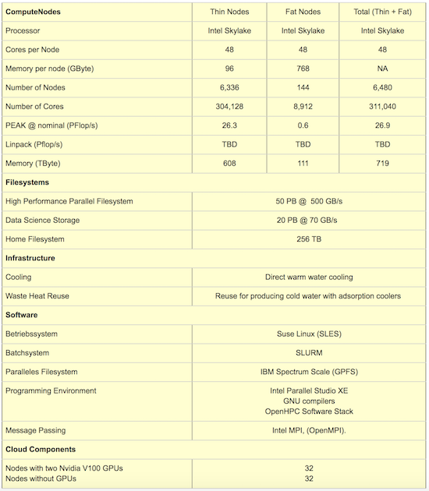

Figure 1 TAKEN FROM https://insidehpc.com/2018/10/300k-core-supermuc-ng-system-launches-lrz-germany/