TODO: If possible, find research on data processing optimizations (perhaps look at [9][15], etc.) Though this is a good start

System Overview
[1] https://www.ornl.gov/news/ornl-launches-summit-supercomputer
- Composed of 4,608 AC922 compute servers
  - Each containing two 22-core Power9 processors
  - Each containing six NVIDIA Tesla V100 GPU accelerators (auxiliary GPUs with nearby memory)
- Specialized for graph analytics, artificial intelligence, deep learning, machine learning, etc.
  - e.g., Simulating high-scale models of supernovae
    - Can be simulated several thousand times longer, 12x more elements than past projects
    - 100x more computation than ORNL’s earlier machines
  - e.g., Surveying patterns in health data
    - Using machine learning, can read large volumes of information, abstracting data, and find relationships between genetics, biological markers and external environments

[2] https://www.ibm.com/blogs/research/2018/06/summit/
- Breaking down Summit:
  - Number of Power9 CPUs: 9216
  - Number of Volta GPUs: 27648
  - Number of Nodes (AC922 Compute Servers): 4608 (See [1])
    - Each Node performs at 42 Tflops/s
    - See [13]
  - Weighs 340 tonnes
  - Surface Area: 5600 ft2
  - Can store up to 250PB of data
- Energy calculations (done by US DOE) are 5-10x faster than its predecessor

[3] https://www.olcf.ornl.gov/summit/
  - Operating System: Red Hat Enterprise Linux 7.4
    - ~1600GB of non-volatile memory
    - 512GB DDR4 RAM + 96 GB HBM2 VRAM

System Specifications
[4] https://www.top500.org/lists/2018/11/
- Located in Oak Ridge National Laboratory
- Composed of:
  - 2,397,824 Cores
  - 2,801,664 Gb of Memory
  - Maximal Achieved Performance (Rmax): 143,500 TFlops/s
  - Theoretical Peak Performance (Rpeak): 200,794.9 TFlops/s
    - 200 trillion floating point operations per second
  - Power Consumption: 9,783 kW
- Specifications (composed of the following, more than one of each):
  - IBM Power System AC922 (See [5])
  - IBM Power9 3.07Ghz CPU (See [6])
    - Uses Power 3.0 Instruction Set (See [9])
  - Nvidia Volta GV100 GPU (See [10])

CPU

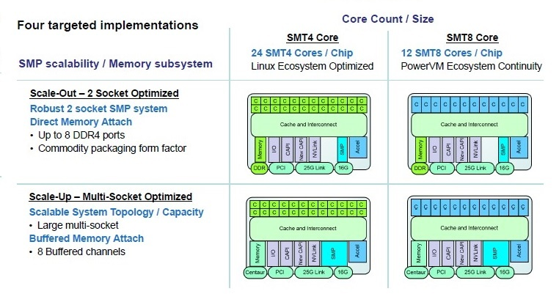
[5] https://www.ibm.com/ca-en/marketplace/power-systems-ac922/details
- Enterprise-grade server designed to eliminate I/O bottlenecking
  - CPU/GPU pairing improves performance (throughput) by a factor of 5.6 per pairing
- Increase multi-threaded performance
- Utilizes PCIe 4th generation, in comparison to home-systems commonly using 3rd generation PCIe
- Can be configured to use between 16 and 44 cores in conjunction with IBM’s multi-core processor (Power9)

[6] https://www.nextplatform.com/2016/08/24/big-blue-aims-sky-power9/
- Power9:
  - Four implementations:
    - “Scale Out – 2 Socket Optimized / SMT4 Core”
      - DMA
      - Up to 8 DDR4 ports per socket
      - 24 SMT4 cores per chip
      - 120 GB/s of memory bandwidth
      - Can support a maximum of 4TB RAM (using 256GB memory sticks), “practically will top out at 1 TB using 64GB memory”
      - Optimized for Linux systems
    - “Scale Up – Multi-Socket Optimized”
      - Backwards compatible with Power8 memory cards
      - Up to 8 DDR4 ports per socket
      - Multi-socket, compared to Scale Out
      - 8 buffered memory channels
      - Using 256GB sticks of RAM, can support up to 8TB of main memory. Practical limit is 2TB due to economics
      - Optimized for “PowerVM” - IBM’s virtualization software
      - Implements an L4 cache
      - Implements Chipkill
        - See [7]
      - Implements Lane sparing on Direct Media Interface
        - See [8]
    - The above can be either be SMT4 (24 total), or SMT8-cored (12 total).
      - Consequence: Scale Up is more optimized for multi-threaded computations
      - Scale-Up has fewer cores, but higher clock rate
    - Power9 CPU has 48 lanes of PCI-E 4.0, totalling 192 GB/sec.
    - Socket Performance: Power9 excels at graph analytics and scripting.

[7] http://www-05.ibm.com/hu/termekismertetok/xseries/dn/chipkill.pdf
- Calculates checksum when writing data to DIMM. If memory failure occurs, data integrity is recovered using checksum
- 99.4% reliability

[8] http://ibmsystemsmag.com/blogs/aixchange/february-2016/new-solutions-to-the-age-old-problem-of-memory-err/
- Repairs data lanes on fault

[9] https://ibm.ent.box.com/s/1hzcwkwf8rbju5h9iyf44wm94amnlcrv
Flexible ISA, add to Strengths.
- Power 3.0 ISA:
  - Instruction Fusion: Specific instruction sequences are re-interpreted and provide additional performance
  - Instruction support for Counting Trailing Zeroes, instructions for modulo operator
  - Improved/Added instructions for easy binary/decimal conversion using binary-coded decimal
    - Multiply-by-10 instructions
    - Formats supported:
      - BCD, National Decimal, Zoned Decimals
      - 128-bit signed integers
      - IEEE-754-2008 128-bit floating-point
  - Instructions for string operations:
      - Character testing functions
      - String processing, character extraction
  - PC-relative addressing
  - Atomic operations can be done directly in memory instead of through cache hierarchy
  - New system call for specifying one or more locations for execution
  - Multiply-add instructions
  - Better array indexing support (e.g., “Base + 32-bit index”)
  - wait instruction for multi-threaded processes and conditional branching
  - Random number generator: outputs one of three formats

GPU
[10] https://www.anandtech.com/show/11367/nvidia-volta-unveiled-gv100-gpu-and-tesla-v100-accelerator-announced
- Nvidia Volta GV100:
  - 5376 CUDA Cores
  - Opposed to GDDR5, uses HBM2 VRAM (High Bandwidth Memory, production announcement was Jan 19, 2016)
    - See [11]
  - 4096-bit bus width
  - 128kb of shared memory, which is configurable
  - 6MB L2 cache
  - 21.1 billion transistors, compared to NVidia’s previous flagship (GP100) which had 15.3 billion (increase of 5.8 billion transistors)

[11] https://www.samsung.com/semiconductor/dram/hbm2/
- HBM2:
  - 8x faster than GDDR5
  - 256 GB/s memory bandwidth delivered through 8 channels
  - 20% less power consumed compared to GDDR5
  - Uses less PCB space (94% less space used)
    - Done through stacked memory

Parallelization (Strengths)
Check out:
- https://ieeexplore.ieee.org/document/8392693
- https://www.semanticscholar.org/paper/HOMMEXX-1.0%3A-A-Performance-Portable-Atmospheric-for-Bertagna-Deakin/cc58fc6228447845ac4f7f7d8d6e713af8534a95
- https://www.olcf.ornl.gov/wp-content/uploads/2018/12/summit_workshop_thompto_smt.pdf

[12] https://www.olcf.ornl.gov/wp-content/uploads/2014/11/Summit_FactSheet.pdf
- Since the main application of Summit is deep learning, data processing and graph analytics, there is a heavy importance set upon being able to efficiently read/write to storage
  - The Summit itself has a file system named the “IBM general parallel file system (GPFS)”, consisting of 120PB of space, with 1TB/s I/O bandwidth
    - Also connected to the “OLCF High Performance Storage System (HPSS)”, which is a collection of tape and disk storage components, servers, etc.
      - Consequently, in concept information would be archived on the HPSS, while information actively being used or used soon would be stored in the GPFS.

[13] https://www.ibm.com/developerworks/community/wikis/form/anonymous/api/wiki/61ad9cf2-c6a3-4d2c-b779-61ff0266d32a/page/1cb956e8-4160-4bea-a956-e51490c2b920/attachment/5da74eae-eec1-4ada-b79d-527c904eac45/media/POWER9%20VUG%20Feb%202018.pdf
- Utilizes a 120MB NUCA L3
  - 12 x 20-way associative regions
  - Fed by 7 TB/s on-chip bandwidth
  - But the Scale Up SMT8 Power9 uses an L4 as well
    - SMT = Simultaneous Multi-threading, where on an SMT8 or SMT4, each core has 4 or 8 (respectively) hardware threads capable of running independently
      - All share L1 cache
    - As a result, this implementation will have a much higher hit rate than other implementations
      - Meaning less stalls, less time writing from secondary storage to caches, more potential for parallelization

[14] https://www.olcf.ornl.gov/for-users/system-user-guides/summit/summit-user-guide/
CPU
- Three types of Nodes:
  - Login:
    - Use two 16-core Power9s, four V100 GPUs
    - Users are connected to a Login node on connection
    - Handles most of the user-oriented work, including programming, compilation, data processing, job submission.
    - Shared resources, accessed by multiple users simultaneously
      - Parallel jobs or threaded jobs should never be launched here
  - Launch:
    - Batch jobs are executed here
    - Also shared
      - Parallel jobs or threaded jobs should never be launched here
  - Compute
    - Most Summit nodes are computing nodes
    - Parallel/threaded jobs are run here
    - Accessed using jsrun on a Launch node as an interactive job or batch script
      - Using jsrun on a Login node will interfere with other user’s login tasks
    - Have (2) 22-core Power9 CPUs and (6) V100s
      - Assuming Power9 processor is SMT4, that means there is a support for 22 x 4 x 2 = maximum 176 hardware threads per compute node.
- Hardware Threads / SMT
  - Assuming Power9 Processor used is of SMT4 variety, each physical core has 4 “slices”, and there are three multithreading modes, (SMT1, SMT2, SMT4).
    - SMT4: Each slice works independently, therefore each core could support 4 individual streams of execution (via OpenMP)
    - SMT2: Slices are paired up, allowing for half the amount of execution streams as SMT4, with the benefit of additional throughput.
    - SMT1: All four slices work together on a single thread assigned to the core.
[14] https://www.olcf.ornl.gov/for-users/system-user-guides/summit/summit-user-guide/
GPU:
- 640 tensor cores allow for faster training of neural networks
  - Each tensor core can individually perform a D = AB + C operation on 4x4 matrices, where AB is the result of a dot product.
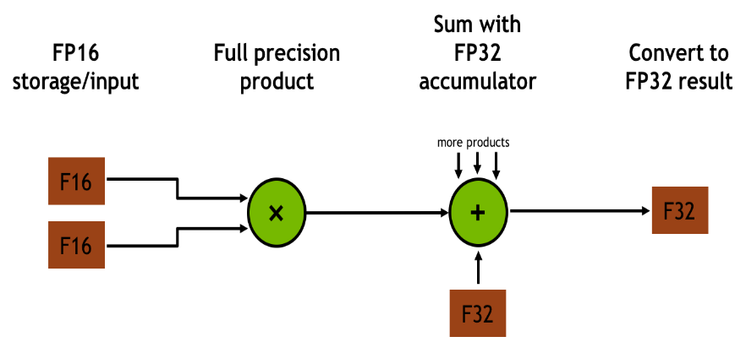
- Previously, Pascal chipset GPUs used Multi-Process Service (MPS), which allows for multiple processes to concurrently share resources on a GPU.
  - An MPS server process organizes work from several CUDA contexts into a single context.
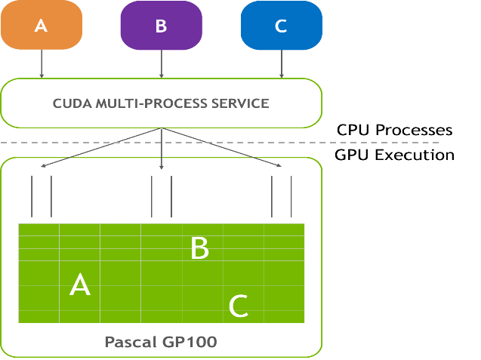
  - Now with Volta GPUs, each CUDA process can now work within its own address space, which protects each address space from out-of-bounds read/writes.
    - Consequently, a CUDA MPS server is no longer needed, since work can now be directly sent the GPU and each CUDA context can manage its own resources.
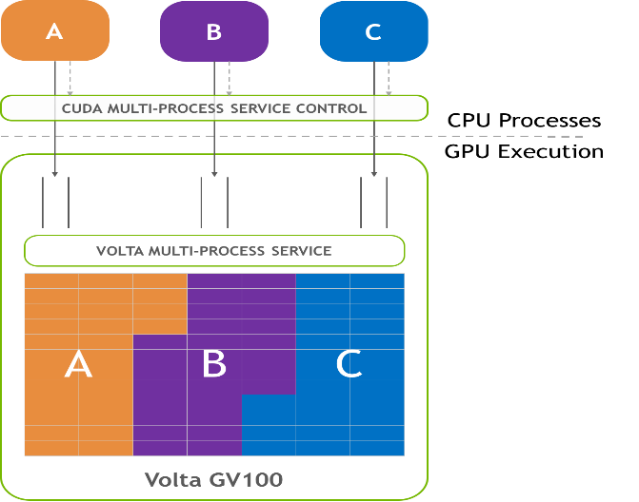
- Unified Memory
  - A single, virtual address space is made available to each node, therefore both CPUs and GPUs can access this single address space.
  - GPU page faulting and 49-bit virtual addressing allow for memory overcommitment and enables processing of large data sets.

[15] http://www.redbooks.ibm.com/redpieces/pdfs/sg248422.pdf (Over 400 pages long, may need to review)
- IBM Parallel ESSL, a scalable math library which supports parallel processing on node clusters
  - Supports SPMD (Single Program, Multiple Data)
    - Tasks split up and run simultaneously on multiple processors
  - Supports IBM’s Spectrum Message Passing Interface (MPI)
    - A program can be written within a small node cluster, and scale it to larger clusters using interconnects
      - Reduces development time
    - Consists of:
      - Message passing / communications API
        - Eases the burden of parallelism on programmers
      - libcollectives
        - A library consisting of a collection of message structures, either one-sided or active
          - Possible to enable GPU buffers, increasing performance and scalability
      - Parallel Active Messaging Interface (PAMI)
        - An API for end-to-end communication
- Parallel Performance Toolkit: A collection backend performance analysis tools
  - Can analyze FLOP/s performance (FLoating point Operations)
  - Trace MPI applications, analyzing communication patterns, finding performance problems
  - Application performance profiling
  - I/O analysis
  - Profile/trace OpenMP (Open Multi-processing) applications to analyze thread and synchronization performance/problems
  - Can find application hotspots, where the program spends most of its time
- Power9: SIMD instructions are provided to facilitate data parallelism at the CPU level (See [9])
  - called “Vectorization”
  - Can be used by compiler in auto-vectorization transformations or made available to applications using an API
- OpenMP uses shared memory parallelism

Weaknesses
- Login/Launch nodes are shared amongst people using the super computer.
  - Incorrect usage of Login/Launch nodes can result in the disruption for other users. E.g., performing tasks

